

JOINT INSTITUTE FOR NUCLEAR RESEARCH
Laboratory of Radiation Biology

FINAL REPORT ON THE
START PROGRAMME

‘’Study of Morphological Changes and Behavioral Reactions After Different Type of Irradiation in Small Intestine and The Brain of Laboratory Rodents’’

Supervisor:
Dr. Severiukhin Iurii

Student:
Zeliha EREN, Turkey
Ege University Institute of Nuclear Sciences

Participation period:
August 24 – October 04,
Summer Session 2025

Dubna, 2025
1. Abstract

In this study, morphological changes and behavioral responses were investigated in the small intestine and brain of Sprague-Dawley rats following proton (3 Gy) and X-ray (10 Gy) irradiation. Behavioral analysis was conducted using the Open Field Test (OFT), while histopathological alterations were assessed through hematoxylin–eosin (H&E) staining, Luxol Fast Blue (LFB), immunohistochemistry for zonulin, and TUNEL assay. OFT results revealed anxiety-like behaviors, including increased thigmotaxis, reduced exploration of the central zone, and elevated freezing and grooming activities, indicating heightened anxiety levels post-irradiation. Histological evaluation of the small intestine showed peak apoptosis at 4 hours after irradiation, which subsequently decreased over 24–48 hours, suggesting a pronounced early apoptotic response. Zonulin immunostaining indicated increased epithelial barrier permeability in the intestinal tissue, whereas hepatic staining was limited, with expression localized around the portal regions. TUNEL assay of brain sections demonstrated strong apoptotic signals at 4 hours, which diminished by 24 hours, reflecting the temporal resolution of radiation-induced apoptosis. Collectively, these findings indicate that ionizing radiation triggers both acute morphological and functional alterations in gastrointestinal and neural tissues, with implications for radiation-induced neuroinflammation, gut–brain axis disruption, and potential long-term health effects.

2. Introduction

Radiation is defined as the emission or transfer of energy from a source in the form of electromagnetic waves or particles. All living organisms on Earth are continuously exposed to radiation originating from naturally occurring radioactive substances and cosmic rays from space. Humans are affected by radiation to varying degrees through respiration and ingestion (via water and food). In general, radiation can be classified into natural and artificial sources. Natural radiation sources include high-energy cosmic rays interacting with the atmosphere as well as radioactive nuclei present in the Earth’s crust, air, water, soil, plants, and living organisms. Artificial radiation sources, on the other hand, are generated through human-made devices, instruments, and systems that emit radiation. The proportional distribution of radiation sources is presented in Figure 1 (Doğruluk et al., 2018).

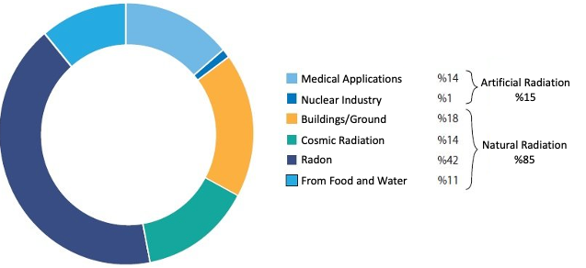
Figure 1 Radiation Sources (UNSCEAR, 2012)

Radiation can also be categorized according to its effects on matter as ionizing and non-ionizing radiation. Ionizing radiation possesses sufficient energy to remove electrons from the outer shells of atoms, thereby creating charged particles (ions) in the material it interacts with. Alpha, beta, and neutron particles, as well as gamma rays and X-rays, fall into this category. Conversely, non-ionizing radiation does not carry enough energy to detach electrons from atoms and exists solely in the form of electromagnetic waves. Radio waves, microwaves, and visible light are typical examples of non-ionizing radiation. The energy spectrum and the position of ionizing and non-ionizing radiation within it are illustrated in Figure 2 (Turkish Radiation Oncology Association, 2025).

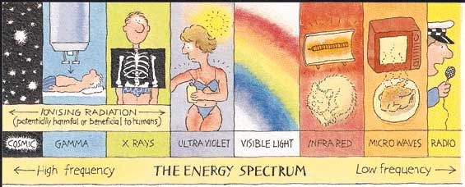
Figure 2 The Energy Spectrum
Exposure to ionizing radiation is not only an environmental or medical concern but also represents a significant occupational risk. Professions such as flight personnel, astronauts, nuclear reactor workers, radiologists, uranium miners, and radiotherapy technologists are exposed to varying levels of radiation. For instance, astronauts are exposed to cosmic rays and high-energy particles, whereas nuclear power plant workers and radiologists are primarily exposed to gamma radiation. The degree of exposure and its health effects vary depending on the occupation (Simon & Linet, 2014).

Cosmic radiation is identified as the primary radiation source encountered by astronauts in deep space, as seen in Figure 3a, and consists largely of high-energy protons, alpha particles, and heavy ions. Figure 3b shows the approximate energy ranges and spectra of the different components of the space radiation field. Proton radiation with its high penetrative capacity, can induce DNA damage, oxidative stress, and synaptic dysfunction in neuronal cells through ionization, exerting critical effects on the central nervous system. This leads to direct risks to brain function, including reduced cognitive performance and impairments in memory and learning processes, while also increasing the likelihood of triggering neurodegenerative processes during long-term missions. Consequently, astronauts constitute a distinct field of study due to the characteristics of cosmic radiation in space and its potential effects on the central nervous system (Hellweg, Berger, Matthiä, & Baumstark-Khan, 2020).

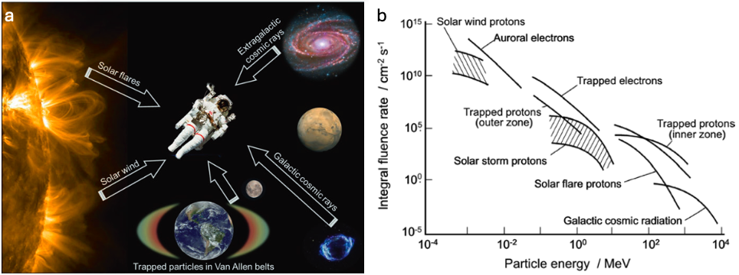
Figure 3 a) Sources of cosmic radiation that contribute to astronauts’ radiation exposure during. b) Approximate energy ranges and spectra of different components of the radiation field in space. (From Wilson 1978)
Radiotherapy, the medical application of ionizing radiation, has become a fundamental component in the treatment of various malignancies, including brain tumors. It is administered to more than half of all cancer patients for curative or palliative purposes and aims to destroy tumor cells while minimizing exposure to surrounding healthy tissues. However, due to the high radiosensitivity of the central nervous system (CNS), radiotherapy for brain tumors is frequently associated with adverse outcomes such as cognitive decline, cerebrovascular complications, endocrine disorders, and secondary malignancies (Ruysscher et al., 2019).

Among these late complications, demyelination represents a particularly serious consequence of radiotherapy, as it results from radiation-induced damage to the myelin sheath surrounding neuronal axons. This process can manifest with motor, sensory, and cognitive impairments, as well as balance disturbances and visual deficits. Guillemin et al. (2020) highlighted that post-irradiation demyelination in the brain may be misinterpreted as radionecrosis, underlining the importance of differential diagnosis, while Goyal et al. (2019) demonstrated that head and neck cancer patients receiving more than 50 Gy to the cervical spinal cord are at increased risk of demyelination, with some cases progressing to irreversible cord injury. These findings emphasize that although relatively rare, radiation-induced demyelination can significantly impair neurological function and quality of life.

The effects of radiation manifest not only directly on myelination but also at the systemic level. Recent studies, particularly on the gut–brain axis, have demonstrated that the bidirectional communication between the gastrointestinal microbiota and the central nervous system plays a critical role in neuroinflammation, myelination, and neurodegenerative processes (Jones, Davis, & Sfanos, 2020). Exposure to ionizing radiation disrupts the composition and function of the gut microbiota, weakening this communication network and thereby indirectly contributing to demyelination and cognitive impairments through the induction of neuroinflammation. Cosmic radiation encountered by astronauts during long-term missions threatens CNS integrity both through direct neural damage and secondary effects mediated via the gut microbiota. Therefore, assessing the effects of radiation on demyelination and the brain via the gut–brain axis in combination constitutes a critical area of research for both clinical applications and space biology. In this context, Figure 4 from Jones et al. (2020) summarizes the communication pathways between the gut microbiota and the brain, visually illustrating the complex structure of the gut–brain axis.
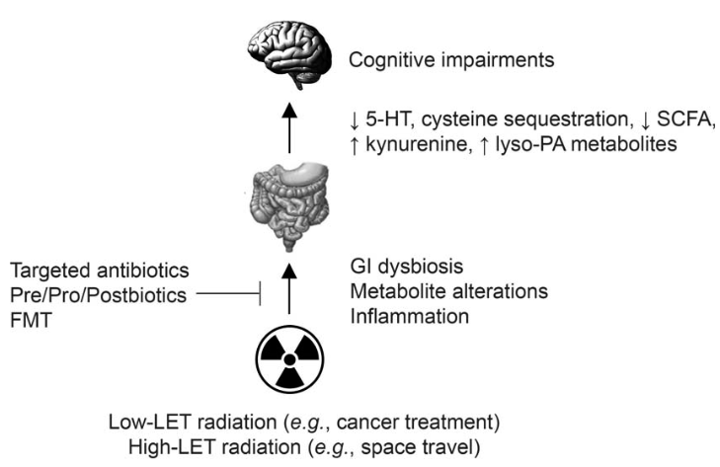
Figure 4 Potential mechanisms whereby low- and high-LET radiation may influence the gut-brain axis. Radiation exposure may cause dysbiosis of the intestinal microbiota, resulting in altered metabolite production and/or inflammation. These changes may further lead to cognitive impairments via signaling pathways that exist between the GI tract and the brain. Radiation-induced changes to the GI microbiota may be prevented via use of targeted antibiotics, pre/pro/postbiotics or fecal microbiota transplant (FMT) prior to or after irradiation.
3. Materials and Methods
3.1. Radiation Procedures
The animals were irradiated on the Phasotron of the LYAP JINR and the SARRP LRB JINR installation. The dose of total irradiation with protons was 3 Gy, and the dose of local irradiation with X-rays of the brain was 10 Gy. All experiments with animals complied with the norms of bioethics. Biomaterial was collected at different times. For rats irradiated with protons, the collection of brain and pouch was for 4, 24 hours and 3 and 9 months in different experiments. For rats irradiated with X-rays for 4 months after irradiation.

3.2. Animals and Study Design

This study used 8-week-old Sprague-Dawley (SD) male rat with an average weight of 300 g.

3.3. Brain Functions and Behavioral Test

In experimental models of neurodegenerative diseases, the evaluation of animal behavioral characteristics is crucial for understanding disease mechanisms and testing therapeutic approaches. Motor functions are assessed using Rotarod/Accelerod, learning and memory with radial maze and passive avoidance, anxiety with the open field and elevated plus maze, social behaviors with the social interaction test, sensorimotor gating with prepulse inhibition, pain sensitivity with hot plate and tail flick, and sensory functions with vision, hearing, and olfaction tests. In this way, alterations in motor, cognitive, and emotional domains can be systematically identified (Urbach et al.,2009). In the present study, we conducted the open field test.

3.3.1. The Open Field Test (OFT)

The Open Field Test (OFT) is one of the most widely used behavioral assays in animal studies to assess locomotor activity, exploratory behavior, and anxiety-like responses. When placed in the apparatus, the animal’s behavior provides information about both its exploratory motivation and its avoidance tendencies in response to stress factors. Parameters such as locomotor activity, rearing, grooming, time spent in the center versus the periphery of the arena, and total distance traveled are commonly recorded. Wall-hugging behavior (thigmotaxis) is considered an indicator of anxiety-like responses, whereas spending more time in the central area reflects lower anxiety levels. Due to its simplicity and ability to simultaneously evaluate multiple behavioral parameters, the OFT remains a widely used method (Horka et al., 2024). In our study, the behavior of experimental animals was recorded for 6 minutes.

3.4. Histopathological Examination

3.4.1 Fixation

The essential goal of sample fixation consists in stopping, as fast and efficiently as possible, all metabolic reactions occurring inside the cells and in their environment, maintaining also the morphological and molecular characteristics the sample had before its separation from the experimental animal (Sampedro-Carrillo, 2021). We performed the fixation as shown in Table 1.

Table 1 Fixation Stages
10% Formalin | 24 hours.
Top Water | Half an hour
%10 Ethanol | 2 hours
%80 Ethanol | 2 hours
%100 Ethanol | Overnight
%100 Ethanol (second) | 2 hours
Ksilen | 2 hours
Ksilen + paraffin mix | 2 hours

3.4.2. Paraffin Embedding

The samples were placed into a mold and oriented. Liquid paraffin at 60–62 °C was poured over them to embed the samples into a block. The mold was then left to cool at room temperature overnight to allow the paraffin and the block containing the samples to solidify. Some steps are shown in figure 5.

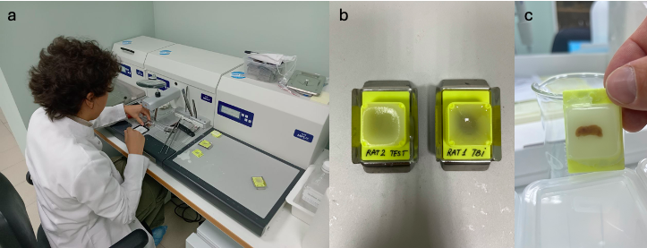
Figure 5 Paraffin Embedding Steps. a) Embedding the samples b) Letting them cool at room temperature c) The block is ready for sectioning.
3.4.3. Sectioning

Sectioning is the most important factor over the permanent slide preparation as it plays a crucial role as the tissue sample for the slide is being cut at this stage. Sectioning should be done by cutting the block with the help of Microtome in the thickness of 4-6μm so that the tissue sections can be stained accurately and easily (Hasan et al., 2021). As shown in Figure 6a, the block was placed in the microtome, which was set to 5 μm, and sectioning was initiated. The thin sections were then floated in a 42 °C water bath to flatten the paraffin, as illustrated in Figure 6b, after which glass slides were placed underneath to allow the tissue slices to adhere. Finally, as shown in Figure 6c, the samples were first left to dry at approximately 42 °C and subsequently kept at room temperature for about 24 hours to ensure optimal fixation.

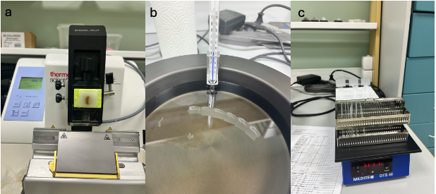
Figure 6 Sectioning process a) Microtome placement of the block. b) The flattening process of slices over the surface of the warm water. c) Drying of the slides.
3.4.4. Staining

3.4.4.1. Hematoxylin and Eosin (H&E)
Table 2 Hematoxylin and Eosin Staining Steps
Solution / Step | Time(min.)
Xylene (3 times- fresh solution) | 4-4-4
Isopropanol 3 times- fresh solution) | 3-3-3
Tap Water | 2
Hematoxylin | 2
Tap Water | 1-2
Eosin | 40 sec.
Tap Water | 1
Isopropanol (2 times- fresh solution) | 2-2
Xylene | 2

Hematoxylin–eosin (H&E) staining was applied in two steps. Hematoxylin stains acidic structures such as nuclear DNA, ribosomal RNA, and rough endoplasmic reticulum in blue-purple (basophilic), while eosin, used as a counterstain, marks basic structures such as the cytoplasm in pink-red (eosinophilic) (Europe PMC, 2016). H&E staining steps are shown in Table 2.

3.4.4.2. Luxol Fast Blue

Luxol fast blue (LFB) is a copper phthalocyanine dye used for staining myelin structures in paraffin-embedded tissue sections. This method is particularly applied in brain tissue examinations to assess the degree of demyelination (Sigmaaldrich 2016). The procedure steps are presented in Table 3.

Table 3 Luxol Fast Blue Staining Steps
Reagent / Step | Time(min)
Xylene (3 times- fresh solution) | 3-3-3
Ethanol abs (Absolute) | 3
Ethanol 95% | 3
Luxol fast blue | 4 h
Ethanol 95% | 3
Dist. water | 2
0.05% Lithium Carbonate | 30 sec
Ethanol 70% | 3
Dist. water | 2
Ethanol 96% | 2
Ethanol abs (Absolute) | 2
Xylene (3 times- fresh solution) | 3-3-3
DPX

3.4.4.3. ICH Test Staning Zonulin

Zonulin immunohistochemistry (IHC) was applied to demonstrate the localization and expression of zonulin protein, a regulator of tight junctions, in intestinal and liver tissues. Zonulin plays a critical role in maintaining epithelial barrier integrity, and its increase is associated with impaired intestinal permeability (Fasano, 2012). This method, as presented in Table 4, was employed to evaluate radiation-induced barrier damage in epithelial tissues and to reveal permeability alterations within the gut–liver axis.

Table 4 Zonulin Staining Steps
Reagent / Step | Time (min)
Xylene (2 times- fresh solution) | 6-6
Ethanol 100% | 5
Ethanol 100% | 5
Ethanol 96% | 5
Ethanol 96% | 5
Ethanol 70% | 5
Dist. water | 3
TBS Tween | 3
HIER (Heat-induced epitope retrieval) | 20
Tap water | 15
Dist. water | 3
TBS Tween (3 times - fresh solution) | 3-3-3
Hydrogen peroxide 3% | 15
TBS Tween (3 times - fresh solution) | 3-3-3
Primary antibodies  (HP/zonulin – 1:50, 1:100, 1:200, 1:300, 1:500) | overnight
TBS Tween (3 times - fresh solution) | 3-3-3
Polymer Helper | 20
TBS Tween (3 times - fresh solution) | 3-3-3
Secondary antibodies | 40
TBS Tween (3 times - fresh solution) | 3-3-3
Substrate Buffer FLEX 1 ml + DAB 1 drop | 10 (checking in microscope)
Dist. water (STOP reaction) | 3
Hematoxylin | 1
Ethanol 96% | 5
Ethanol 100% | 5
Xylene (2 times- fresh solution) | 5-5
Cover

3.4.4.4. TUNEL Assay

To detect apoptosis, the Abcam TUNEL Assay Kit - HRP-DAB (ab206386) was used. This method is based on the labeling of DNA strand breaks generated during apoptosis at their 3’-OH ends with biotin by Terminal deoxynucleotidyl Transferase (TdT). The labeled regions were visualized as brown signals using streptavidin-HRP and DAB substrate, and cellular morphology was assessed by counterstaining with methyl green. The procedural steps are presented in Table 5.
Table 5 Tunnel Assay Kit Steps
Reagents / Step | Time (min) | Comments
Xylene (2 times- Fresh solution) | 5-5
Ethanol 100% | 5
Ethanol 100% | 5
Ethanol 90% | 3
Ethanol 80% | 3
Ethanol 70% | 3
TBS | 5
Proteinase K 1:100 (1 µl Proteinase K + 99 µl dH2O per specimen)- Gently wipe and dry a bit | 20 | 30 specimens – (30 µl Proteinase K + 2970 µl dH2O)
30% Hydrogen Peroxide + Methanol (10 µl H2O2 + 90 µl methanol per specimen) | 5 | 30 specimens – (300 µl H2O2 + 2700 µl methanol per specimen)
TBS- Gently wipe and dry a bit | 5
TdT Equilibration Buffer - Gently wipe. | 30 | 50 -100 µl per specimen
TdT Labeling reaction mixture (1 µl TdT Enzyme + 39 µl Labeling reaction Mix per specimen) | 1.5 hours  (With Cover glasses) | Shake TdT Enzyme 30 specimens (Add 30 µl TdT Enzyme + 1170 µl Labeling reaction Mix) Keep in ice
TBS | 5
Stop Buffer (37 deg) | 5 | 50 -100 µl per specimen
TBS - Gently wipe and dry a bit | 5
Blocking Buffer | 10 | 50 -100 µl per specimen
25X Conjugate + Blocking Buffer (4 µl Conjugate + 96 µl Blocking Buffer per specimen) | 30 | Keep in ice - 30 specimens (Add 120 µl Conjugate + 2880 µl Blocking Buffer µl)
TBS- Gently wipe and dry a bit | 5
DAB1+DAB2 (4 µl DAB1 + 116 µl DAB2 per specimen) | 15 | 30 specimens (Add 120 µl DAB1 + 3480 µl DAB2)
Distill. WATER | 2
Methyl Green Counterstaining | 1-3
Ethanol %100 (2 times- Fresh solution) | Rinse
Xylene | Rinse
Cover
4. Results and Discussion

4.1. Open Field Test

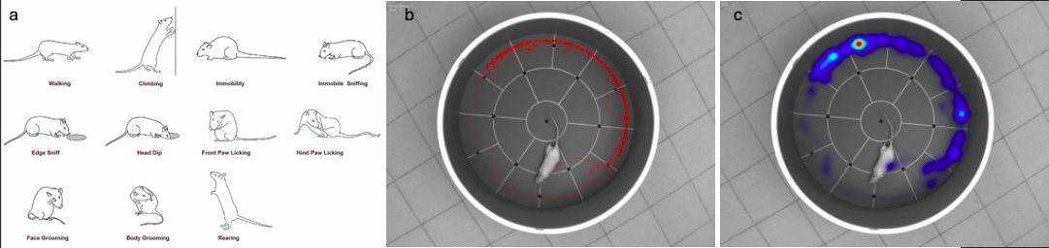
Figure 7 a) Rodent behavior b) Track visualization image c) Heatmap

In the open field test, the animal’s behaviors are shown in Figure 7a. The results indicate that the animal exhibited a pronounced anxiety-like behavioral profile. The heatmap analysis presented in Figure 7c revealed that the animal predominantly spent time along the periphery while avoiding the central zone. Similarly, the track visualization output in Figure 7b supported this finding, demonstrating a distinctly peripheral-oriented locomotor pattern. These outcomes (prolonged thigmotaxis, reduced center exploration, prominent freezing and grooming behaviors, and decreased rearing and exploratory activity) strongly suggest that the animal displayed an elevated level of anxiety under the experimental conditions.

4.2. Hematoxylin and Eosin (H&E)

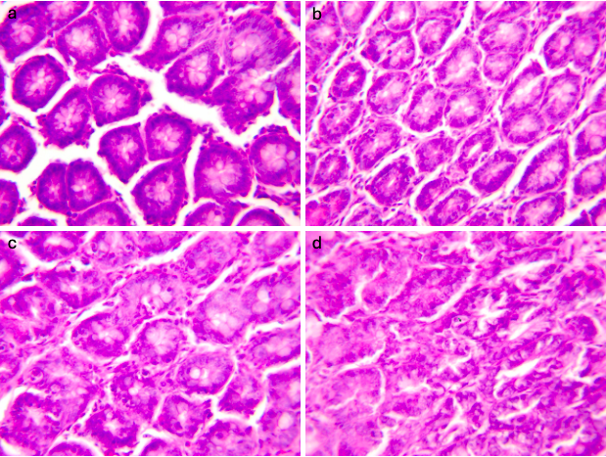
Figure 8 H&E-stained small intestinal cells. a) Control cells. b) 4th hour after radiation. c) 24 hours after radiation. d)48 hours after radiation.
The temporal changes in apoptosis in the irradiated small intestine tissue are shown in Figure 8. Compared to the control cells presented in Figure 8a, the irradiated cells exhibited the highest number of apoptotic cells at 4 hours (Figure 8b). Subsequently, the number of apoptotic cells began to decrease at 24 hours (Figure 8c) and declined to the lowest level at 48 hours (Figure 8d). These findings indicate that radiation induces a pronounced early apoptotic response in the intestinal mucosa, which progressively diminishes over time.
4.3. Luxol Fast Blue
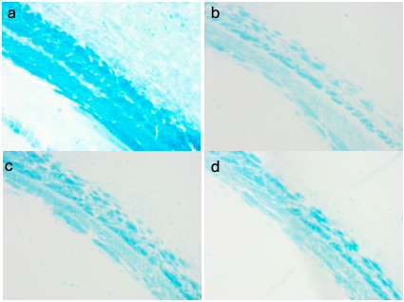
Figure 9 Luxol fast blue staning. a) Control cells. b) 2Gy radiation c) 5Gy radiation d) 7Gy radiation
Luxol Fast Blue staining results are shown in Figure 9. While the control group exhibited intense and homogeneous myelin integrity, radiation exposure induced a dose-dependent reduction in staining intensity. At 2 Gy, mild myelin loss was observed, which became more pronounced at 5 Gy and reached a severe level of demyelination at 7 Gy.

4.4. ICH Test Staning Zonulin
a
b
a
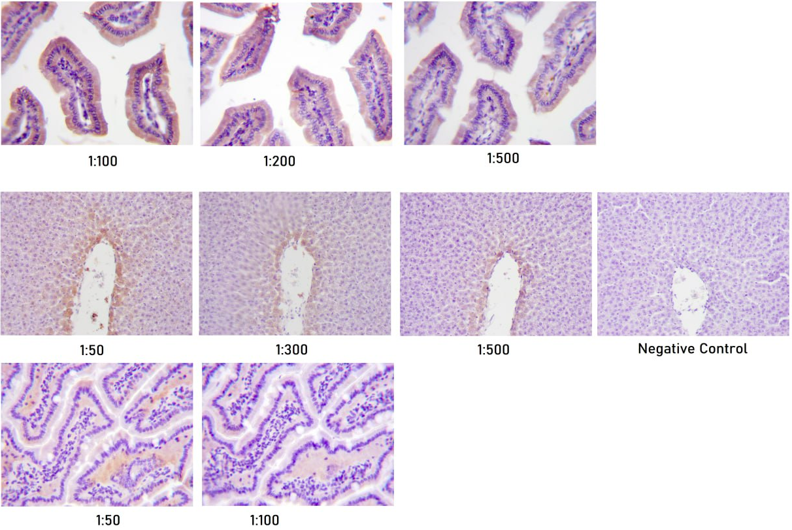
Figure 10 Liver and small intestine cells treated with primary antibodies at different concentrations. a) Small intestine cells. b) Liver cells
Figure 10 shows liver and small intestine cells treated with primary antibodies at different concentrations. Immunohistochemical analysis revealed that zonulin expression in the intestinal tissue was predominantly detected with strong staining at the apical membrane of the villus epithelium. Signal intensity was stronger and more specific at antibody dilutions of 1:50–1:100. In the liver tissue, zonulin expression was more limited, with staining mainly observed around the portal areas and in the bile duct epithelium. The absence of staining in the negative control confirmed the specificity of the method. These findings suggest that zonulin expression in the intestine reflects epithelial barrier integrity, while its presence in the liver may be related to permeability changes along the gut–liver axis.
4.5. TUNEL Assay

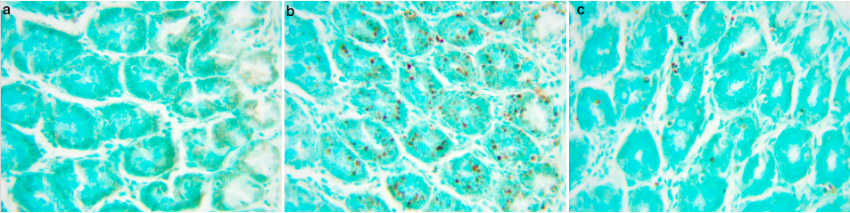
Figure 11 brain cells a) Control cells. b) 4th hour after radiation. b) 24th hour after radiation.
TUNEL staining results are presented in Figure 11. Examination of the results showed a marked increase in brown signal intensity at 4 hours post-radiation (Figure 11b), indicating that radiation induced a strong apoptotic response in the early phase. In contrast, at 24 hours (Figure 11c), the apoptotic signal decreased and appeared more similar to the control group, suggesting that apoptotic processes had been completed over time or that the damaged cells had been eliminated from the tissue.

5. Conclusion

The results of this study highlight the profound impact of ionizing radiation on both peripheral and central biological systems. Behavioral analyses revealed heightened anxiety and reduced exploratory activity, consistent with radiation-induced stress responses in the central nervous system. Histopathological examinations confirmed that radiation rapidly induced apoptosis in the intestinal epithelium and brain tissue, with a peak at early post-exposure stages and subsequent decline, indicating dynamic tissue responses to radiation damage. Zonulin expression further suggested alterations in epithelial barrier integrity, supporting the hypothesis that radiation disrupts gut–brain communication through increased intestinal permeability. Taken together, the findings underline the dual nature of radiation-induced injury, combining direct apoptotic effects in target tissues with systemic consequences mediated via the gut–brain axis. These insights may contribute to a deeper understanding of radiation toxicity in clinical radiotherapy and space biology, providing a foundation for developing strategies to mitigate adverse outcomes.

6. Acknowledgments

My participation in the Student Advanced Research Training (START) program was an invaluable experience, and I wish to express my sincere gratitude to the Joint Institute for Nuclear Research (JINR) for providing this opportunity. I am especially grateful to my supervisor, Mr. Iurii Severiukhin, for his guidance, knowledge, expertise, patience, and for giving me the chance to be part of this project. Finally, I would like to extend my appreciation to the entire Radiation Biology Laboratory (LRB) team for their support, encouragement, and the knowledge they shared throughout the experimental work.

7. References

https://www.trod.org.tr/app_society_patient?id=2

https://www.afad.gov.tr/kbrn/radyasyon-kaynaklari

https://dergipark.org.tr/tr/download/article-file/575978

Simon, S. L., & Linet, M. S. (2013). Radiation-Exposed Populations. Health Physics, 106(2), 182–195. https://doi.org/10.1097/hp.0000000000000006
‌Hellweg, C. E., Berger, T., Matthiä, D., & Baumstark-Khan, C. (2020). Radiation in Space: Relevance and Risk for Human Missions. In SpringerBriefs in Space Life Sciences. Cham: Springer International Publishing. https://doi.org/10.1007/978-3-030-46744-9

Hellweg, C. E., Berger, T., Matthiä, D., & Baumstark-Khan, C. (2020). Radiation in Space: Relevance and Risk for Human Missions. In SpringerBriefs in Space Life Sciences. Cham: Springer International Publishing. https://doi.org/10.1007/978-3-030-46744-9
‌
Ruysscher, D. D., Niedermann, G., Burnet, N. G., Siva, S., Anne, & Hegi-Johnson, F. (2019). Radiotherapy toxicity. Nature Reviews Disease Primers, 5(1). https://doi.org/10.1038/s41572-019-0064-5
‌
Guillemin, F., Biau, J., Conde, S., Clavelou, P., & Guillaume Dupic. (2020). Multiple sclerosis as differential diagnosis of radionecrosis for post-irradiation brain lesions: A case report. Clinical and Translational Radiation Oncology, 21, 44–48. https://doi.org/10.1016/j.ctro.2020.01.001
‌
Goyal, H., Singh, N., Gurjar, O. P., & Tanwar, R. K. (2019). Radiation Induced Demyelination in Cervical Spinal Cord of the Head and Neck Cancer Patients after Receiving Radiotherapy. Journal of Biomedical Physics and Engineering. https://doi.org/10.31661/jbpe.v0i0.1055
‌
Jones, C. B., Davis, C. M., & Sfanos, K. S. (2020). The Potential Effects of Radiation on the Gut-Brain Axis. Radiation Research, 193(3), 209. https://doi.org/10.1667/rr15493.1
‌
Urbach, Y. K., Bode, F. J., Nguyen, H. P., Riess, O., & von Hörsten, S. (2009). Neurobehavioral Tests in Rat Models of Degenerative Brain Diseases. Methods in Molecular Biology, 333–356. https://doi.org/10.1007/978-1-60327-389-3_24
‌
Horka, P., Langova, V., Hubeny, J., Vales, K., Chrtkova, I., & Horacek, J. (2024). Open field test for the assessment of anxiety-like behavior in Gnathonemus petersii fish. Frontiers in Behavioral Neuroscience, 17. https://doi.org/10.3389/fnbeh.2023.1280608
‌
Sampedro-Carrillo, E. A. (2021). Sample Preparation and Fixation for Histology and Pathology. Methods in Molecular Biology, 2422, 33–45. https://doi.org/10.1007/978-1-0716-1948-3_3
‌
Hasan, M., Das, S., & Chowdhury, E. (2021). A better and copacetic protocol for histopathological slide preparation using H&E stain: A review. 2021. https://doi.org/10.18801/jflvs.020121.07
‌
Europe PMC. (2016). Europe PMC. Retrieved October 1, 2025, from Europepmc.org website: https://europepmc.org/article/nbk/nbk557663#__NBK557663_dtls__
‌
Luxol® fast blue solution. (2016). Sigmaaldrich.com. https://doi.org/Dogri
‌
Fasano, A. (2012). Zonulin, regulation of tight junctions, and autoimmune diseases. Annals of the New York Academy of Sciences, 1258(1), 25–33. https://doi.org/10.1111/j.1749-6632.2012.06538.x

