

JOINT INSTITUTE FOR NUCLEAR RESEARCH
Veksler and Baldin laboratory of High Energy Physics

FINAL REPORT ON THE
START PROGRAMME

Application of Differential Geometry Methods for Analyzing Experimental Data on Multiple Particle Production in Relativistic Nuclear Physics

Supervisor:
Ekaterina Klevtsova
Student:
Anastasia Ponomareva, Russia
Don State Technical University
Participation period:
July 06 – August 30,
Summer Session 2025

Dubna, 2025

Abstract
This report summarizes the research internship at the Laboratory of High Energy Physics. The work began with an introduction to key experimental facilities, such as the synchrophasotron and the Nuclotron. The central focus of the project was to explore the application of Lobachevskian (hyperbolic) geometry as a novel framework for analyzing particle collision data. It is argued that the observed curved trajectories and boundary structures in experimental plots naturally align with the properties of spaces of constant negative curvature. The mathematical foundation of hyperbolic geometry is presented, and its potential for revealing hidden patterns in high-energy physics data is discussed. The detailed results of this analysis are intended for publication in a forthcoming scientific paper.

Introduction
My introduction to the Laboratory of High Energy Physics began with a tour given to me by A.V. Belyaev. From the very first day, he not only showed me around the site but also told me about the installations that have been at the core of many discoveries in particle physics. This tour allowed me to feel the spirit of big science and to see how historical heritage is combined with modern research. I am sincerely grateful to Alexander Vasilyevich for taking the time to explain in such detail the past and present of the laboratory.
The first object I was introduced to be the bubble chamber. This device occupies a special place in the history of physics, as it was with its help, in the mid-20th century, that elementary particles and their interactions were studied. The principle of operation is based on a liquid in a metastable state, which “boils” along the tracks of passing charged particles, leaving visible traces of their motion. These tracks were photographed, and from them the characteristics of the particles could be reconstructed. Bubble chambers played an enormous role in the discovery of new resonances, mesons, and baryons, becoming a real “window” into the microworld.
The next stage of the tour was the Booster of the Nuclotron. This modern accelerator is a key element of the NICA accelerator complex. Its principle of operation is to effectively accelerate and accumulate intense beams of charged particles, such as protons and nuclei, before injecting them into the larger Nuclotron ring. The Booster plays a crucial role in preparing beams of the required energy and intensity for cutting-edge experiments, allowing scientists to study the properties of nuclear matter under extreme conditions.

Figure 1. Booster of the Nuclotron
After that, Alexander Vasilyevich showed me the Nuclotron — the modern installation that became the successor of the synchrophasotron. The Nuclotron is based on superconducting magnet technology, which ensures more efficient acceleration and stable operation. Today, it is the heart of many experimental programs at the Laboratory of High Energy Physics, connected with the study of nuclear matter at high densities and temperatures, as well as with preparations for future megascience projects.
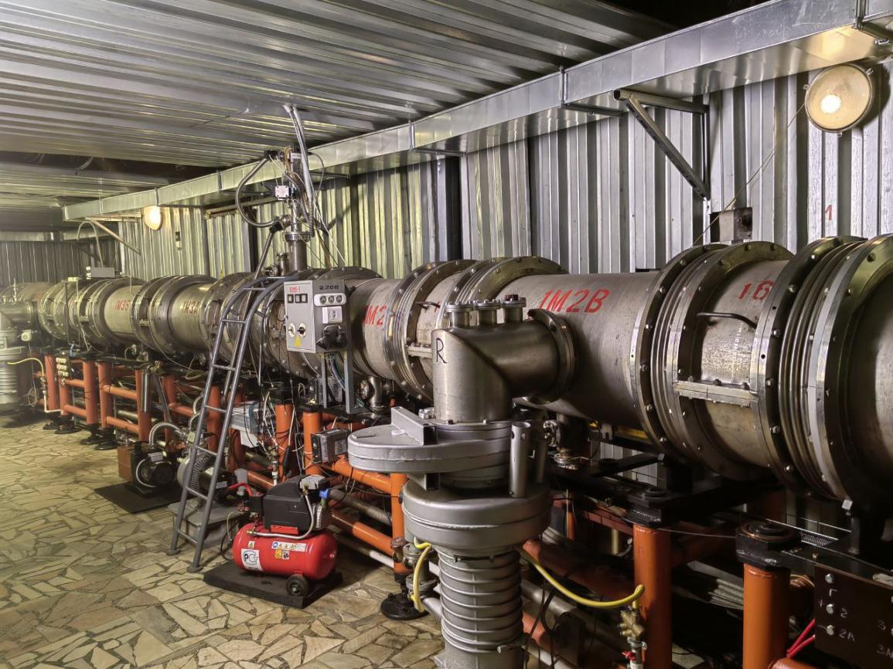
Figure 2. Nuclotron
This tour was not only an introduction to unique scientific installations but also a true journey through the history of high-energy physics. I am deeply grateful to Alexander Vasilyevich for generously sharing his knowledge and helping me to feel the connection between generations of scientists who, for decades, have been creating and developing this field of science.
After being introduced to the experimental side of high-energy physics during my first days at the Laboratory, I soon realized that the theoretical framework was equally essential for understanding the data. While particle tracks and detector signals give us the raw experimental picture, interpreting these patterns requires a solid mathematical foundation. This is where geometry, and more specifically differential geometry, becomes indispensable.

Project Goals
However, the raw experimental picture provided by particle tracks and detector signals often reveals complex structures — stretched trajectories, distinct boundaries, and specific angular distributions — that cannot be fully captured or interpreted within the framework of classical Euclidean space. A more sophisticated mathematical language is required to describe these patterns.
Therefore, the aim of this work is to argue for the application of Lobachevskian (hyperbolic) geometry as a powerful framework for analyzing and interpreting experimental data in high-energy physics. This approach naturally incorporates concepts such as negative curvature and the angle of parallelism, whose characteristic behaviors appear to mirror the observed features in the data, potentially uncovering hidden geometric order.

Methods
Differential geometry provides the language to describe curved spaces, surfaces, and trajectories. In high-energy physics, collisions and resonances often reveal structures that cannot be fully understood within the limits of classical Euclidean space. Instead, one must turn to non-Euclidean geometries, where notions such as curvature, parallelism, and distance take on new forms.

Transition to Effective Geometric Parameters in Data Analysis
While classical differential geometry deals with smooth manifolds, experimental data, such as particle distributions in multiple production events, often form discrete sets that can be approximated by surfaces. A key characteristic of any surface is its curvature.
Gaussian curvature$K$, an intrinsic invariant of a surface, defines its local geometry:
$− ( K > 0)$ (positive curvature): the surface is locally sphere-like; the sum of the angles of a triangle exceeds π.
$− ( K = 0)$ (zero curvature): the surface is locally Euclidean; the sum of the angles of a triangle equals π.
$− ( K < 0)$ (negative curvature): the surface is locally hyperbolic; the sum of the angles of a triangle is less than π.

A surface is also characterized by its principal curvatures $k_{1}$ and $k_{2}$, which measure the maximum and minimum bending at a given point. The Gaussian curvature is their product: $k_{1,2}$. The signs of the principal curvatures determine the type of surface: both positive for a convex sphere-like point, both negative for a concave "saddle" point, and opposite signs unequivocally indicate a saddle point with negative Gaussian curvature.

In this work, we consider structures corresponding to surfaces with a predominantly negative curvature. However, the direct use of principal curvatures $k_{1,2}$ calculated from the raw data is inconvenient, as they do not reflect the specific hyperbolic nature of the observed configurations and are not directly related to objects such as hyperbolic triangles.
To build an adequate model, we transition to effective geometric parameters inspired by hyperbolic geometry. Our approach, based on ideas stemming from the Gauss-Bonnet theorem (which relates the integral of the Gaussian curvature over a surface to its topology, particularly to the angular defect of triangles), allows us to introduce the following dimensionless quantities:
1. Hyperbolic module, acting as a scale analog, characterizing the "size-to-height ratio" in hyperbolic geometry:
$$\text{module}=\frac{sh(h_{2})}{sin(α_{2})};$$
2. Effective Gaussian curvature $K_{\text{eff}}$, calculated via the angular defect normalized by the module, which follows directly from the geometric interpretation of the Gauss-Bonnet theorem for a hyperbolic region:
$$K_{\text{eff}}=\frac{\sum_{i=1}^{3}{α_{i}}−π}{\text{module}};$$
3. Effective mean curvature $H_{\text{eff}}$, defined via the hyperbolic sines of the heights and sides, reflecting the non-Euclidean nature of the metric:
$$H_{\text{eff}}=\frac{1}{3}\frac{∑sinh(h_{i})}{∑sinh(a_{i})};$$
Using the computed $K_{\text{eff}}$and $H_{\text{eff}},$we then find the effective principal curvatures $k_{1,2}$ for our modeled surface:
$$k_{1,2}=H_{\text{eff}}±\sqrt{H_{\text{eff}}^{2}−K_{\text{eff}}}.$$
These parameters are not curvatures in the classical sense, but they carry information about the curvature of the data configuration in terms of hyperbolic geometry. A critical step in the analysis is the calculation of the critical angle $ν$ , which determines the stability boundary for a surface with an angular point and is calculated from the ratio of the principal curvatures:
$$δ=\sqrt{\left|\frac{k_{2}}{k_{1}}\right|}, k_{1}>k_{2}$$
$$ν=arccos\left(\frac{1}{1+δ}\right).$$
Thus, the proposed set of parameters allows for a transition from the abstract concepts of differential geometry to a quantitative analysis of the stability of structures observed in experimental data within a consistent hyperbolic model.
Among these, hyperbolic geometry — the geometry of Lobachevsky — plays a central role. It not only offers a mathematical description of spaces with constant negative curvature, but also establishes deep connections with modern physics, particularly in the relativistic regime. Thus, before analyzing my own results, it is necessary to present the foundations of Lobachevskian geometry, both from a historical and a theoretical perspective.
The geometry of Lobachevsky, also known as hyperbolic geometry, arose in the early nineteenth century when mathematicians tried to understand the independence of Euclid’s fifth postulate, the statement about parallel lines. For more than two thousand years, geometers had suspected that this axiom was not as self-evident as the others. Lobachevsky, working independently of János Bolyai, realized that if one replaces the Euclidean parallel postulate with a new rule, one obtains a consistent and self-contained geometry. Later, Beltrami, Klein, and Poincaré built explicit models of this geometry and proved its logical consistency. Thus it became clear that Euclidean geometry is not unique but rather a special case corresponding to zero curvature, while Lobachevskian geometry describes a space of constant negative curvature.
The essential difference lies in the nature of parallelism. In Euclidean geometry, through a point not on a line there passes exactly one parallel to that line. In Lobachevsky’s geometry, through such a point there exist infinitely many non-intersecting geodesics. Among them are two limiting parallels, which “touch” the given line at infinity, and infinitely many ultraparallels, which never intersect the line and have a unique common perpendicular. This property changes the behavior of triangles in a fundamental way: the sum of the angles of a triangle is always less than π. The difference π − (A + B + C) is called the defect, and the area of the triangle is directly proportional to it:
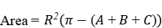,
where R is the radius of curvature of the hyperbolic plane. The larger the triangle in the hyperbolic sense, the smaller its angle sum, and the more “stretched” it appears.
One of the most important concepts introduced by Lobachevsky is the angle of parallelism. Consider a line l and a point P at distance d from l. The angle of parallelism Π(d) is the angle between the perpendicular from P to l and the limiting parallel through P. It can be expressed by remarkably simple formulas:
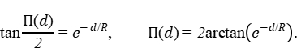
or equivalently,
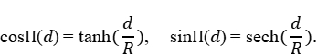
At distance zero, Π(0) = π/2, and as the distance increases, the angle decreases monotonically to zero. This function connects the metric of the hyperbolic plane (distances) with angular measures and plays a role very similar to that of the exponential function in analysis. It is also strikingly similar to the formulas for rapidity in relativistic kinematics, where hyperbolic functions naturally appear.
Hyperbolic trigonometry provides further tools. For a triangle with sides a, b, c and opposite angles A, B, C, one has the hyperbolic law of cosines:
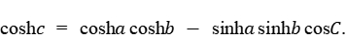
And the law of sines:
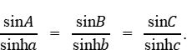
These identities govern the relation between sides, heights, and angles, and they explain why quantities such as sinh(h/R) appear naturally in formulas. Heights and radii of inscribed or circumscribed circles can be written in terms of sinh and cosh, so it is not surprising that in data analysis functions like sinh(h₃/R) emerge as stable descriptors of the geometry.
To visualize hyperbolic geometry, mathematicians use models. In the Poincaré disk or upper half-plane, geodesics are represented as arcs of circles orthogonal to the boundary or as vertical lines. This model preserves angles, so figures appear conformally correct. In the Beltrami–Klein disk model, geodesics are straight chords, but angles are distorted. Both models are consistent and highlight different aspects of the same geometry. These representations help one understand why certain curves on diagrams appear as smooth arcs or “boundaries” resembling hyperbolic geodesics.
The parameter R, the radius of curvature, acts as a scaling factor. When one divides all lengths by R, the formulas simplify and become dimensionless. In physics this is especially useful, since quantities measured in GeV or MeV can be normalized against such a geometric parameter, making the mathematics compatible with experimental data.
What makes Lobachevsky’s geometry especially relevant here is that many observed features resemble its characteristic behaviors. Triangles tend to become stretched, their angles approach small values, and quantities cluster near π/2 in ways that mirror the properties of the angle of parallelism. Clear boundaries on plots can be interpreted as isometric curves of constant hyperbolic distance, and envelopes in the data follow the smoothness dictated by hyperbolic functions. Even the separation of “soft” and “hard” regimes resembles the way hyperbolic sine naturally divides different scales of growth.
Finally, a caution about notation. In this work, symbols such as K, H, k₁, and k₂ are used as working parameters in the analysis. Although they are named by analogy to Gaussian curvature, mean curvature, and principal curvatures from differential geometry, they do not coincide exactly with those classical definitions. It is important to emphasize this so as to avoid misunderstanding.
In summary, Lobachevsky’s geometry provides both the historical framework and the mathematical language that fits remarkably well with the observed structures. Its functions sinh, cosh, and tanh appear naturally, the angle of parallelism explains limiting behaviors, and the concept of negative curvature captures the stretching and boundary-like features seen in the data. This theoretical background lays the foundation for interpreting the diagrams and for distinguishing between different regimes in the experimental results.
The history of hyperbolic geometry is itself one of the most fascinating chapters in mathematics. For more than two millennia, the fifth postulate of Euclid, the so-called parallel axiom, resisted all attempts at proof. Many great mathematicians, from Proclus to Gauss, attempted to deduce it from the other four axioms, always without success. The suspicion gradually grew that this postulate might be independent, but few were willing to embrace such a radical idea.
In the early nineteenth century, Nikolai Ivanovich Lobachevsky, working at Kazan University, took the bold step of replacing Euclid’s axiom with a new principle. He asserted that through a point outside a given line there pass not just one, but infinitely many non-intersecting lines. With this change, he built an entirely new geometry. Independently, the Hungarian mathematician János Bolyai reached similar conclusions. Although their discoveries were initially met with skepticism, later developments confirmed the validity of their work. Gauss himself had discovered aspects of the same geometry but had never published his ideas, fearing controversy.
The true vindication of Lobachevsky and Bolyai came later in the nineteenth century. Eugenio Beltrami constructed explicit models of hyperbolic geometry inside Euclidean space, showing that the system was logically consistent. Felix Klein introduced the projective model, in which geodesics are chords of a circle, and Henri Poincaré developed the conformal disk and half-plane models, which later became central in complex analysis and topology. These models not only demonstrated that hyperbolic geometry was as rigorous as Euclidean geometry, but also opened new areas of research, such as group theory and non-Euclidean tessellations.
From that point forward, Lobachevsky’s geometry became more than a curiosity; it turned into a powerful tool in mathematics and physics. In the twentieth century, it appeared naturally in relativity, where rapidity replaces velocity as the additive parameter of motion. Rapidity is measured in terms of hyperbolic functions, precisely the same sinh and cosh that arise in Lobachevsky’s trigonometry. Hyperbolic geometry also underlies the mathematics of curved spacetimes and plays an essential role in modern theoretical physics, from cosmology to quantum field theory.
The legacy of Lobachevsky, therefore, extends far beyond pure mathematics. His insight revealed that the geometry of space is not uniquely Euclidean, but depends on curvature. By constructing the first consistent model of a space of constant negative curvature, he showed that the structure of geometry itself is subject to generalization. This idea resonates deeply with modern physics, where the geometry of space and time is determined by matter and energy. In this sense, Lobachevsky anticipated by almost a century the conceptual revolution of Einstein’s relativity.

DISCUSSION OF ANALISIS
The analysis of the experimental data revealed a number of non-trivial patterns that find a consistent explanation within the proposed geometric formalism. The key object of the study was the parameter v, calculated via the ratio of the effective principal curvatures and serving as an indicator of the local geometric stability of triangular particle configurations in Lobachevsky space.

Critical Behavior and Geometric Instability
The most significant result is the observation of pronounced peaks in the distributions of $sinh(h_{3})$ against the parameter $∆_{12}^{3}=2Π(h_{3})−α_{3}$ for secondary pions. It is important to emphasize that the shape and position of these peaks demonstrate remarkable stability both with respect to changes in collision energy and when transitioning from the (n+p) reaction to the (p+C) reaction. However, the most intense peaks correlate with specific, narrow ranges of the parameter v: approximately 0.71 for the n+p reaction and 0.69 for p+C.

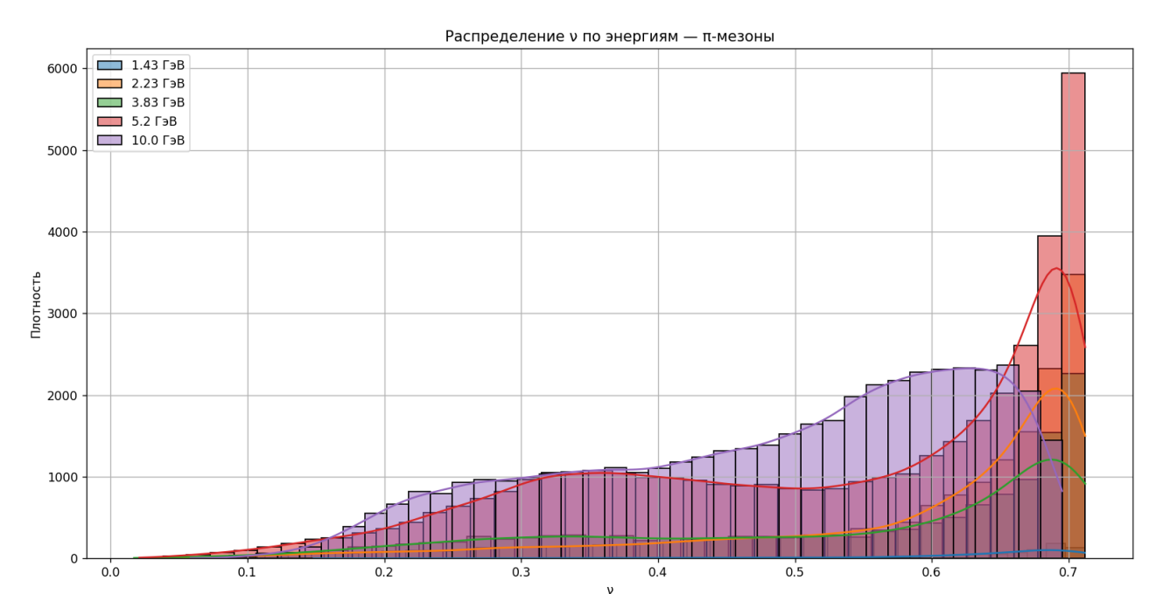
Figure 3. Distribution of ν versus energy

Table 1. Distribution of ν versus energy
reactions | energy | min | max
n+p | 1.43 | 0.148336 | 0.711792
n+p | 2.23 | 0.027055 | 0.712069
n+p | 3.83 | 0.017137 | 0.712084
n+p | 5.2 | 0.021034 | 0.712090
p+C | 10 | 0.058474 | 0.695243

According to the theoretical basis outlined in Section “Methods”, it is precisely in this range of v values that the solution to the corresponding boundary value problem (the Riemann-Hilbert problem for canonical domes) loses stability. In terms of differential geometry, this corresponds to the emergence of a singularity — a point where the smooth description of the geometric configuration ceases to be adequate.
Thus, the observed peaks in the particle distributions are not random fluctuations. We interpret them as direct experimental manifestations of the system transitioning into a critical state, as predicted by the geometric model. At the moment of reaching the critical value v, the geometric configuration formed by the particle rapidities becomes unstable, which is registered by the detector as an abrupt change in the behavior of the secondary particles—the formation of a peak.

Physical Interpretation: Particle Birth as a Geometric Singularity
Transferring this mathematical concept into the domain of relativistic nuclear physics allows us to propose a fundamental hypothesis. The moment of loss of geometric stability, described by the parameter v, may correspond to the act of particle birth from the vacuum.
In this interpretation, the vacuum is represented not merely as emptiness, but as a complex medium whose properties can be described by the geometry of the state space. The violation of the stability of the geometric configuration (the singularity) is the trigger that leads to a "phase transition" in the vacuum, resulting in the birth of a real particle. Consequently, the peaks in the distributions mark those kinematic conditions under which the vacuum becomes "unstable" with respect to the birth of a specific type of particle (in this case, a pion).

Comparative Analysis of n+p and p+C Reactions
A comparison of the parameter v distributions for the two studied reactions (5.2 GeV n+p and 10 GeV p+C) reveals important features.
In the case of n+p collisions, a significant proportion of events concentrate in the immediate vicinity of the upper theoretical stability boundary (v ≈ 0.71). This may indicate that in "simpler" nucleon-nucleon collisions, the system more often evolves towards a critical state characterized by this specific geometric threshold.
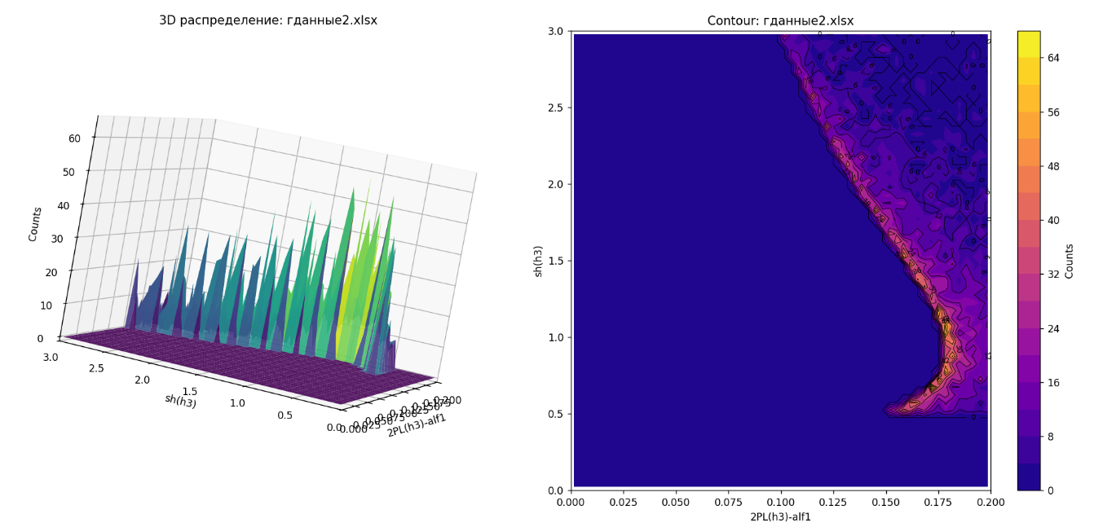
Figure 4. $sinh(h_{3})$ as a function of $∆_{12}^{3}=2Π(h_{3})−α_{3}$ for the 5.2 GeV n+p reaction.
For p+C interactions, the distribution of events over v is more uniform, and the critical value shifts to 0.69. This difference can be explained by the influence of the nuclear medium. A collision with a carbon nucleus represents a more complex process involving multiple nucleons, leading to a "smearing" of the clear geometric picture and, possibly, to the presence of several competing mechanisms for the emergence of instability.
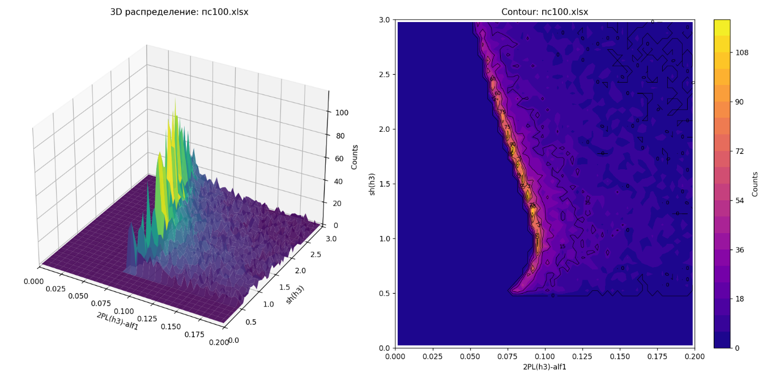
Figure 5. $sinh(h_{3})$ as a function of$∆_{12}^{3}=2Π(h_{3})−α_{3}$ for the 10 GeV p+C reaction

Results

The application of the geometric methodology outlined in Section “Methods” to the experimental data on pion production in (n+p) and (p+C) interactions yielded the following key results.

Critical Value of the Stability Parameter $ν$
The calculation of the stability parameter $ν$ for various collision energies and systems revealed a consistent and sharp peak in its distribution, indicating a critical region of geometric instability.
For the n+p reaction, a pronounced maximum was observed at a value of $ν$ ≈ 0.71. This peak was consistently present across the studied energy range from 1.43 to 5.2 GeV, with the upper boundary of the theoretical instability interval converging to approximately 0.71209 (see Table 1).
For the p+C reaction at 10 GeV, the critical value was found to be slightly lower, at $ν$ ≈ 0.69, with the corresponding theoretical upper boundary at 0.69524.
This concentration of events near a specific critical value of $ν$ suggests that the system exhibits a preferred geometric configuration at the point of instability, independent of the initial energy to a significant degree.

Correlation between Hyperbolic Height and Angular Parameter
Analysis of the relationship between the hyperbolic height $sinh(h_{3})$ (related to the transverse momentum) and the angular parameter $∆_{12}^{3}=2Π\left(h_{3}\right)−α_{3}$ revealed distinct, well-defined structures.
- In the n+p reaction at 5.2 GeV, the distribution of $sinh(h_{3})$ versus $∆_{12}^{3}$ shows a clear, intense peak (Fig. 4). This peak is located precisely in the kinematic region corresponding to the critical value of $ν$ ≈ 0.71.
- A similar, pronounced peak is observed in the p+C reaction at 10 GeV (Fig. 5), corresponding to its critical value of $ν$ ≈ 0.69.
The persistence of these peak structures in different reactions (n+p vs. p+C) and at different energies indicates their origin is not random but is linked to a fundamental mechanism, which we interpret as a loss of geometric stability.

System Dependence of the $ν$ Distribution
The distribution of the parameter $ν$ itself shows a notable dependence on the collision system, as illustrated in Fig. 3.
In the simpler n+p (nucleon-nucleon) collisions, event distribution is highly asymmetric, with a significant accumulation of events near the upper critical boundary ($ν$ ≈ 0.71).
In the more complex p+C (nucleus-nucleus) collisions, the event distribution with respect to $ν$ is more uniform and shifted towards a lower critical value.
This difference suggests that the geometric pathway to instability is sharper and more defined in elementary collisions, while in nuclear collisions, the presence of multiple scattering centers and the nuclear medium leads to a broader dispersion of geometric configurations.
In conclusion, the results demonstrate a robust correlation between the observed peaks in particle distributions and the critical values of the geometric stability parameter $ν$. The experimental values of $ν$ are in close proximity to the theoretical boundaries of instability derived from the differential geometry model, providing strong evidence for the proposed interpretation of particle production as a manifestation of geometric instability.
Conclusions and Limitations
The proposed geometric approach demonstrates its heuristic power by linking kinematic observables (rapidities, transverse momenta) with the fundamental concept of solution stability. The coincidence of the experimentally found critical values of the parameter v with the theoretically predicted instability interval is a strong argument in favor of the plausibility of this model.
At the same time, it is necessary to note the limitations of the current study: the analysis was performed only for pions in two types of reactions. To affirm the universality of the hypothesis, further research is needed, including other types of secondary particles (kaons, protons), heavier target nuclei, and a wider range of energies. Nevertheless, the obtained results open a new perspective for understanding the mechanisms of multiple particle production, in which the dynamics of the process turn out to be closely related to the geometry of the phase space.

Acknowledgments
I would like to express my deepest gratitude to everyone who supported me during my internship.
Special thanks to Alexander Yuryevich for the trust he placed in me by selecting me for the team, and for his patient mentorship in particle physics.
I am particularly grateful to the head of the laboratory, Anton Baldin, and Elina Baldina for the opportunity to work in this outstanding team, for their willingness to share their profound knowledge, support my research ideas, and guide the scientific direction.
And, of course, I am thankful to my supervisor Ekaterina Anatolyevna for her invaluable support during challenging times.

Reference
- Балдин, А. А. Пространство Лобачевского в релятивистской ядерной физике / А. А. Балдин // Применение и развитие идей Лобачевского в современной физике : сб. ст. — Дубна : ОИЯИ, 2004. — С. 103–116.
- Векуа И. Н. Основы тензорного анализа и теории ковариантов / И. Н. Векуа. — Москва : Наука, 1978. — 256 с.
- Любимов, А. Введение в экспериментальную физику частиц / А. Любимов, Д. Киш. — М. : Наука, Гл. ред. физ.-мат. лит., 1983. — 295 с.
- Тайманов И. А. Лекции по дифференциальной геометрии / И. А. Тайманов. – 2-е изд., доп. – Новосибирск : Изд-во Ин-та математики, 2013. – 203 с. – (Современная математика). – ISBN 978-5-901873-98-9.
- Широков, П. А. Краткий очерк основ геометрии Лобачевского / П. А. Широков. — Казань : Изд-во Казан. ун-та, 1983. — 56 с.

