

JOINT INSTITUTE FOR NUCLEAR RESEARCH
Dzhelepov Laboratory of Nuclear Problems

FINAL REPORT ON THE
START PROGRAMME

Measurement and Analysis of Natural Background Gamma Radiation Using an HPGe Detector

Supervisor:
Dr. Anvar Inoyatov

Student:
Fayzulloh Fayziev, National University of Uzbekistan

Participation period:
September 14 – November 08,
Summer Session 2025

Dubna, 2025

Content

Abstract 3
Introduction. 4
Experimental Setup 6
Spectrum Analysis 8
Identified Isotopes and Origins 13
Influence of Environmental and Material Factors 16
Inter-laboratory Comparison of Background Spectra 18
Discussion: Ways to Reduce Background 20
Conclusion 23
References 24
Acknowledgements 25

Abstract

A detailed investigation of the ambient gamma-ray background was performed at the Dzhelepov Laboratory of Nuclear Problems (DLNP), Joint Institute for Nuclear Research (JINR), Dubna, Russia. The objective of the study was to establish a reliable reference spectrum of environmental gamma radiation under standard surface laboratory conditions. Measurements were conducted between 26 and 29 September 2025 using a high-purity germanium (HPGe) spectrometer operated for a total live time of approximately 263,739 seconds.
The measured background spectrum revealed characteristic gamma emissions originating from the uranium (²³⁸U) and thorium (²³²Th) decay chains, as well as from primordial and anthropogenic sources. The most prominent peaks correspond to the decay products of radon progeny and long-lived isotopes commonly present in the environment. The overall spectral structure and relative intensities are consistent with expectations for surface-level laboratories employing passive shielding.
These results provide a precise spectral baseline for subsequent studies of low-activity materials and for optimizing shielding configurations in gamma spectrometric systems operating under similar environmental conditions.

Introduction.
High-resolution gamma-ray spectrometry is one of the most powerful tools available for the qualitative and quantitative analysis of radionuclides in environmental samples, materials, and radiation monitoring applications. The sensitivity and accuracy of such measurements strongly depend on the level and stability of the ambient gamma background within which the detector operates. Even under passive shielding conditions, natural radioactivity originating from the surroundings, detector materials, and airborne radon can contribute substantially to the continuum and discrete features of the measured spectrum. Therefore, careful characterization of the background radiation spectrum constitutes an essential step in any program of low-level radioactivity measurement and detector performance evaluation.
The gamma background in typical surface laboratories arises from a combination of cosmic, terrestrial, and anthropogenic sources. Cosmic-ray interactions in the atmosphere generate secondary photons and particles that contribute to the high-energy region of the spectrum, while terrestrial radioactivity originates primarily from primordial radionuclides, such as potassium-40 (⁴⁰K), and members of the uranium (²³⁸U) and thorium (²³²Th) decay series. These radionuclides are ubiquitously distributed in soil, concrete, building materials, and laboratory infrastructure. Additionally, radon isotopes (²²²Rn and ²²⁰Rn) emanating from the ground can accumulate in indoor environments and produce short-lived progeny (²¹⁴Pb, ²¹⁴Bi, ²⁰⁸Tl, ²²⁸Ac) that emit characteristic gamma lines in the range of 200–2600 keV. In surface laboratories, radon and its daughters often represent the most variable and dominant contribution to the background spectrum.
Apart from natural sources, anthropogenic radionuclides such as cesium-137 (¹³⁷Cs), cobalt-60 (⁶⁰Co), and residual isotopes from past nuclear tests or reactor operations can also appear in background spectra. Their presence typically reflects historical global fallout or activation products in laboratory components. The combination of these natural and man-made contributions defines the baseline gamma environment, which varies widely with location, construction materials, altitude, and atmospheric conditions [Sakoda et al., 2016; Medhat, 2014].
High-purity germanium (HPGe) detectors are regarded as the standard instruments for precise gamma spectroscopy due to their superior energy resolution and detection efficiency. However, their high sensitivity also makes them susceptible to minute background variations. To minimize these effects, measurements are often carried out in shielded setups composed of graded layers of lead, copper, and other low-radioactivity materials, sometimes combined with radon purging systems. Despite such measures, even small differences in geometry, air circulation, or shielding composition can cause significant deviations in background spectra. For this reason, local measurements of the background are indispensable to characterize the true radiological environment of a specific laboratory setup.
Several studies have been dedicated to the characterization of gamma-ray backgrounds in surface and underground laboratories. Sakoda et al. [2016] reported background spectra for HPGe detectors at surface-level facilities in Japan, identifying dominant contributions from the ²³⁸U and ²³²Th decay chains. Polaczek-Grelik et al. [2015] investigated natural radioactivity in building materials and demonstrated its strong influence on laboratory background levels. Medhat [2014] and Niu et al. [2014] provided extensive datasets on background components in shielded HPGe systems, while Baudis et al. [2011] presented results for the Gator low-background spectrometer as a benchmark for underground conditions. These works collectively highlight that background composition is highly site-dependent, and that a thorough understanding of local radiological conditions is critical for accurate low-level counting applications.
In this context, the present study focuses on the characterization of the ambient gamma-ray background at the Dzhelepov Laboratory of Nuclear Problems (DLNP), a major experimental division of the Joint Institute for Nuclear Research (JINR) in Dubna, Russia. The laboratory hosts a variety of radiation measurement and detector calibration facilities, where surface-level background assessment is of particular importance for optimizing future spectrometric investigations. The primary goal of this work was to record, identify, and analyze the characteristic background gamma emissions present in the DLNP laboratory environment using a high-resolution HPGe spectrometer.
The resulting spectrum, acquired over an extended counting period, was analyzed to identify prominent photopeaks and assign them to the corresponding natural and anthropogenic decay series. Special attention was given to lines belonging to the ²³⁸U and ²³²Th families, whose progeny dominate the mid- and high-energy regions of the spectrum, as well as to the ⁴⁰K and ¹³⁷Cs contributions. The findings presented here provide a precise spectral reference for the local gamma background, which is essential for improving detector shielding design, evaluating detection limits, and supporting future environmental and material assay measurements conducted at DLNP.

Experimental Setup
The background γ-ray spectrum was measured using a high-purity germanium (HPGe) detector of model GC3018 equipped with a 7935SL-7 coaxial crystal and a 2002CSL charge-sensitive preamplifier. The detector has a relative efficiency of 34.7%, providing an energy resolution of 1.80 keV (FWHM) at 1.33 MeV and 0.875 keV (FWHM) at 122 keV. The peak-to-Compton ratio of 58:1 ensures excellent capability for resolving low-intensity γ-lines in the presence of continuous background.
The cylindrical germanium crystal has an active diameter of 58 mm and an effective length of 55 mm, corresponding to an approximate active mass of 0.77 kg. The detector was operated at a depletion voltage of 3000 V, with a recommended bias of 4500 V, and a leakage current below 0.01 nA under stable temperature and electronic conditions. The signal processing chain employed an amplifier shaping time constant of 4 μs, optimized to balance resolution and count-rate performance.
During the measurements, the detector was mounted in a fixed vertical geometry on the second floor of the Dzhelepov Laboratory of Nuclear Problems (DLNP). The spectrometer was surrounded by an approximately 8 cm thick lead shield on all sides except the front face. Spectra were acquired over a total live time of 263,739 s (≈ 73.3 h) between 26 and 29 September 2025. Energy calibration and linearity checks were verified using standard reference sources prior to background acquisition.
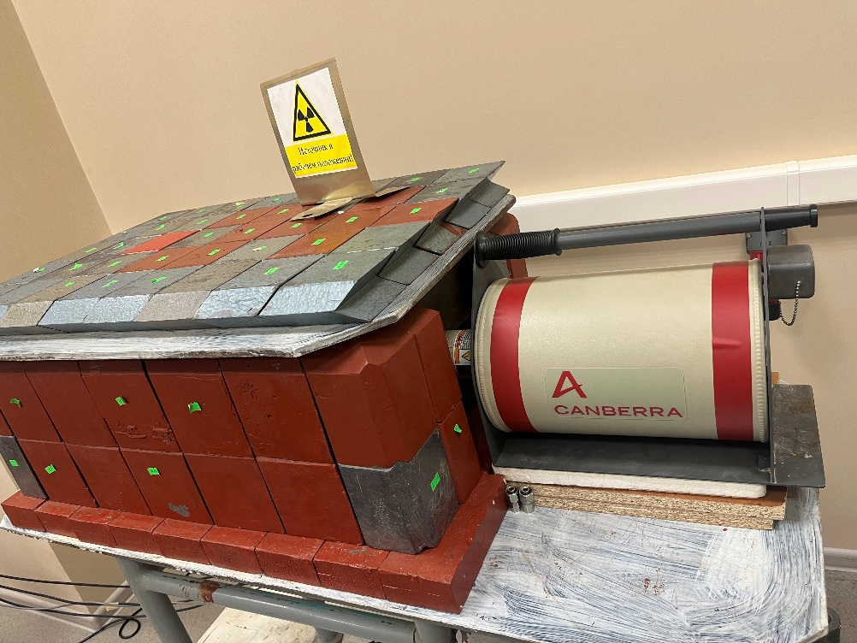
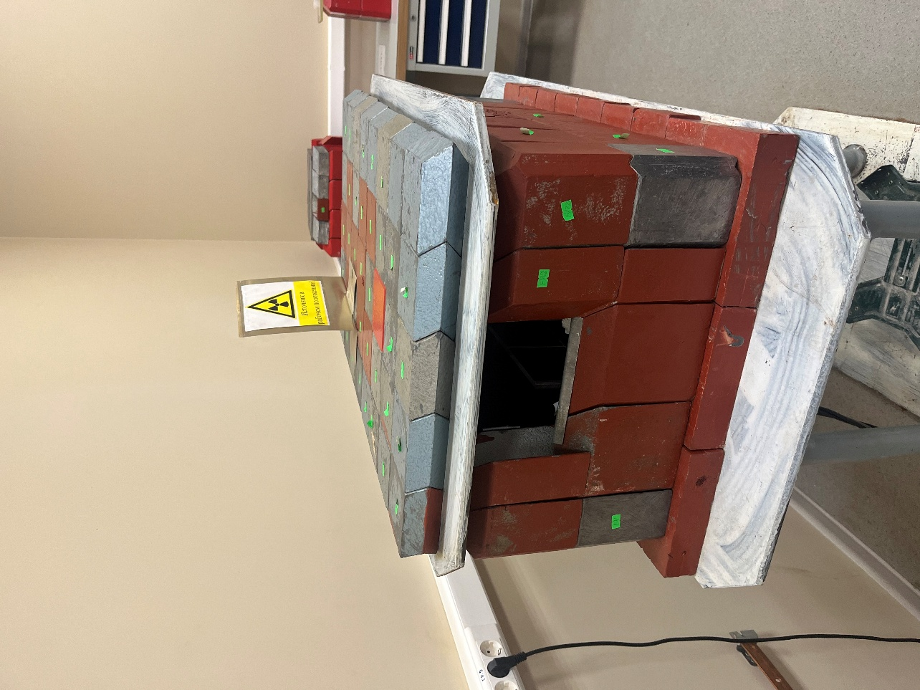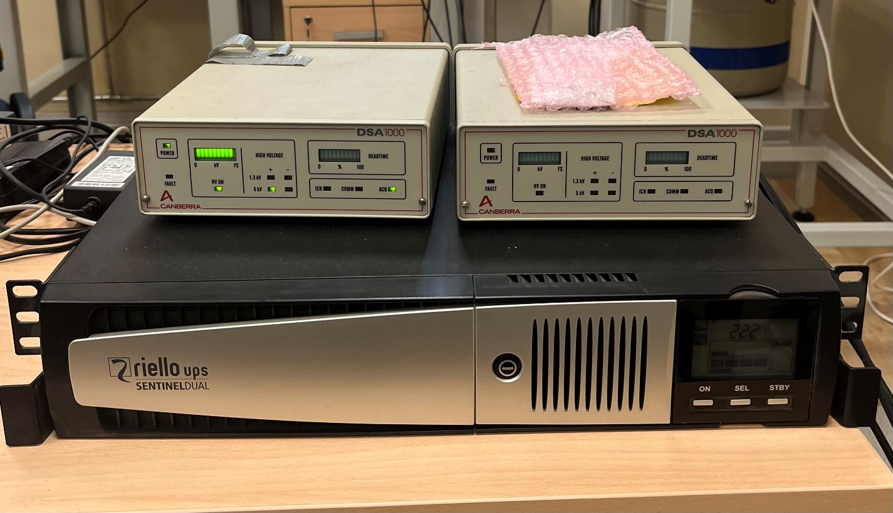

The analysis of background spectra was performed using the SpectraLine software package, which provides advanced tools for spectral data processing and analysis. The analysis began with energy calibration of the detection system to establish a precise relationship between channel numbers and photon energies. Calibration peaks were used to determine key parameters such as the Full Width at Half Maximum (FWHM) and peak form, ensuring accurate resolution characterization of the detector. Following calibration, the recorded spectra were processed to identify and mark informative intervals containing spectral peaks. The software’s peak search and fitting algorithms were applied to determine the positions, amplitudes, and widths of individual peaks. Each informative interval was approximated using a model function, allowing the extraction of reliable peak parameters. SpectraLine’s comparison and fitting tools facilitated verification of spectral stability and reproducibility across multiple measurements. Additionally, zones were defined and refined to improve fitting accuracy, with options for manual adjustment of peaks when required.
Overall, the analysis performed in SpectraLine provided precise quantitative information about the energy distribution of background radiation, demonstrating the software’s effectiveness in accurate spectral evaluation and peak characterization.

Spectrum Analysis
The background gamma spectrum acquired in the Dzhelepov Laboratory of Nuclear Problems (DLNP) exhibits the characteristic structure expected from natural and anthropogenic sources of ionizing radiation under surface-level conditions. The measurement covered an energy range up to approximately 2.7 MeV, providing sufficient resolution to distinguish individual photopeaks, Compton continua, and escape features.
The spectrum displays several well-defined full-energy peaks superimposed on a continuous Compton background. The overall continuum arises primarily from the scattering of high-energy photons emitted by uranium- and thorium-series progeny, as well as from cosmic and environmental sources. The continuous distribution gradually decreases with increasing energy, punctuated by distinct photopeaks associated with discrete gamma-ray transitions.
At lower energies (below about 400 keV), the spectrum is dominated by emissions from short-lived daughters of radon-222, specifically lead-214 (²¹⁴Pb) and bismuth-214 (²¹⁴Bi), which generate peaks near 239, 295, and 352 keV (fig.2). These lines typically indicate radon diffusion into the shielded volume and its progeny depositing on detector and chamber surfaces. In the intermediate energy region (400–800 keV), the annihilation line at 511 keV and the 583 keV line of thallium-208 (²⁰⁸Tl) are the most intense, reflecting the presence of thorium-series activity and cosmic-induced positron annihilation. The 661.7 keV line from cesium-137 (¹³⁷Cs) represents the only persistent anthropogenic contribution observed in the current dataset.
The middle region of the spectrum (800–1600 keV) contains numerous peaks from the ²³⁸U (fig.1) and ²³²Th decay series (fig.4), including ²²⁸Ac (911, 969 keV) and ²¹⁴Bi (934, 1120, 1238, 1378, 1408 keV). The characteristic doublet of cobalt-60 (⁶⁰Co) at 1173 keV and 1332 keV is clearly resolved, confirming the detector’s energy calibration and stability. The region also features the 1460.8 keV peak of potassium-40 (⁴⁰K), which serves as a reliable indicator of environmental radioactivity and is present in virtually all surface laboratories. In addition to the dominant natural radionuclides, three weak but distinct γ-lines were observed at approximately 433 keV, 614 keV, and 722 keV, which correspond to known transitions of ¹⁰⁸Ag (Fig.3).

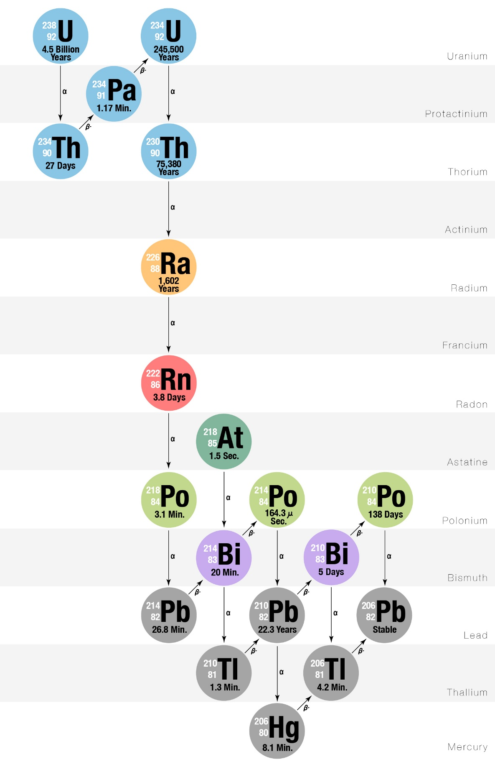
Figure 1: Simplified decay scheme of the uranium-238 series, showing major gamma-emitting progeny relevant to environmental background (²¹⁴Pb, ²¹⁴Bi).

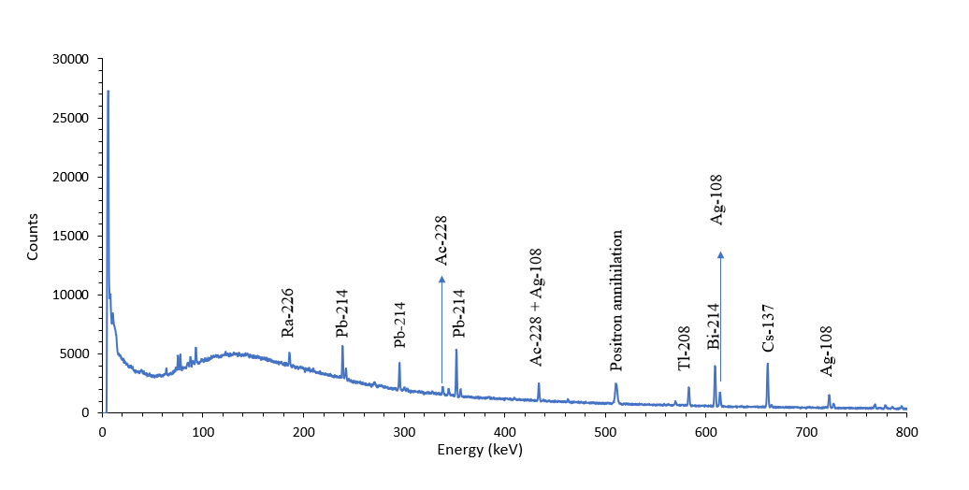
Figure 2: Gamma-ray background spectrum. Distinct peaks from ²¹⁴Pb (239, 295, 352 keV) and ²⁰⁸Tl (583 keV) are visible, along with the annihilation line at 511 keV and ¹³⁷Cs at 661.7 keV. The spectrum represents the lower-energy region dominated by radon progeny and natural environmental radioactivity.
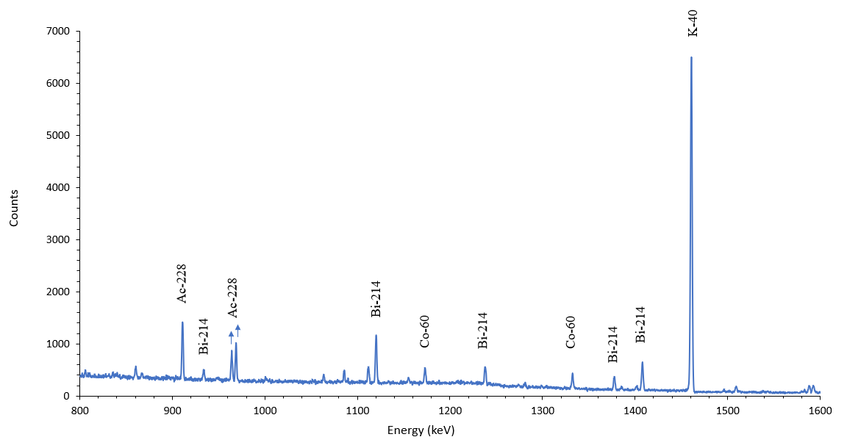
Figure 3: Gamma-ray background spectrum in the range of 800–1600 keV. Prominent features correspond to ²²⁸Ac (911, 969 keV), ²¹⁴Bi (934, 1120, 1238, 1378, 1408 keV), ⁶⁰Co (1173, 1332 keV), and ⁴⁰K (1460.8 keV). This region is characterized by overlapping contributions from uranium-series and anthropogenic radionuclides.

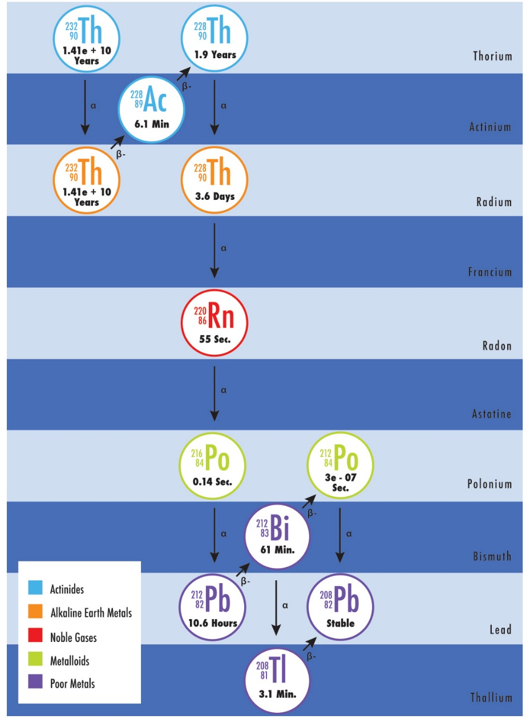
Figure 4: Simplified decay scheme of the Thorium-232 series, showing major gamma-emitting progeny relevant to environmental background (²⁰⁸Tl, ²²⁸Ac).

At higher energies (1600–2700 keV), the spectrum is dominated by ²¹⁴Bi peaks at 1661, 1764.5, 1847, 2118 and 2204.2 keV, along with the prominent 2614.5 keV line from ²⁰⁸Tl —the highest-energy gamma transition commonly observed in natural background spectra. A strong structure near 2103 keV corresponds to the single-escape peak associated with pair production from the 2614 keV photons, further confirming the detector’s full-energy response and intrinsic resolution (fig.5).
The full-width at half-maximum (FWHM) values measured across the energy range exhibit a nearly linear dependence on the square root of energy, consistent with expectations for HPGe detectors. The stability of peak positions throughout the 73-hour live time suggests excellent electronic and thermal performance of the spectrometer. The overall spectral shape and intensity ratios between the ²³⁸U and ²³²Th chains are in good agreement with those reported for comparable surface installations [Sakoda et al., 2016; Medhat, 2014].

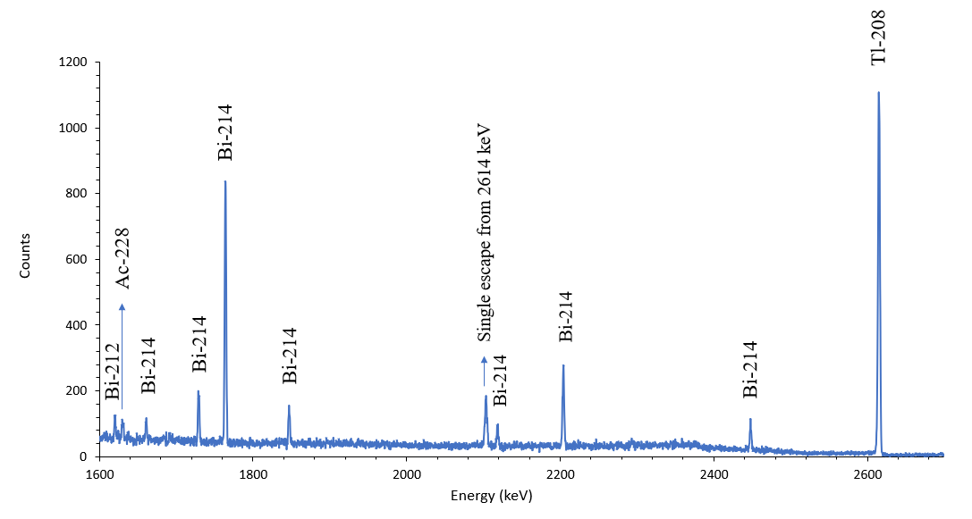

Figure 5: High-energy portion of the measured background spectrum (1600–2700 keV). The spectrum is dominated by ²¹⁴Bi (1764, 2204 keV) and ²⁰⁸Tl (2614.5 keV) gamma emissions. A weak feature near 1592 keV corresponds to the double-escape peak of the 2614 keV photons, confirming the detector’s pair-production response.

Identified Isotopes and Origins

Measured Energy (keV) | Reference Energy (keV) | Isotope | Decay-Series Origin | Notes
295.7 | 295.2 | ²¹⁴Pb | ²³⁸U series | Radon daughter
352.4 | 351.9 | ²¹⁴Pb | ²³⁸U series | Radon progeny
463.3 | 463.0 | ²²⁸Ac | ²³²Th series | Thorium daughter
511.0 | 511.0 | Annihilation | — | e⁺e⁻ annihilation
583.5 | 583.2 | ²⁰⁸Tl | ²³²Th series | Prominent thorium line
609.6 | 609.3 | ²¹⁴Bi | ²³⁸U series | Strong radon daughter
661.9 | 661.7 | ¹³⁷Cs-137 | Anthropogenic | Fallout or material contamination
911.4 | 911.1 | ²²⁸Ac | ²³²Th series | Thorium daughter
934.3 | 934.1 | ²¹⁴Bi | ²³⁸U series | Uranium-series contribution
969.2 | 969.0 | ²²⁸Ac | ²³²Th series | —
1173.5 | 1173.2 | ⁶⁰Co | Anthropogenic | Industrial or activation origin
1238.5 | 1238.1 | ²¹⁴Bi | ²³⁸U series | —
1332.9 | 1332.5 | ⁶⁰Co | Anthropogenic | Doublet with 1173 keV
1378.0 | 1377.7 | ²¹⁴Bi | ²³⁸U series | —
1408.4 | 1408.0 | ²¹⁴Bi | ²³⁸U series | —
1461.2 | 1460.8 | ⁴⁰K | Primordial | Environmental potassium
1765.1 | 1764.5 | ²¹⁴Bi | ²³⁸U series | —
2205.0 | 2204.2 | ²¹⁴Bi | ²³⁸U series | —
2616.1 | 2614.5 | ²⁰⁸Tl | ²³²Th series | Highest-energy environmental gamma

Table 1.
Principal gamma-ray lines identified in the background spectrum measured at DLNP, JINR. The table lists the measured and reference energies, corresponding isotopic assignments, decay-chain origins, and relevant notes.

The analysis of the recorded background spectrum allowed for the identification of multiple radionuclides representing both natural decay series and anthropogenic origins. Table 1 summarizes the principal gamma-ray lines detected, their measured energies, corresponding reference energies, isotopic assignments, and decay-chain origins.
The uranium-238 series contributes the majority of identifiable lines, notably from ²¹⁴Pb and ²¹⁴Bi, whose emissions dominate the energy regions around 295, 352, 609, 934, 1120, 1238, 1378, 1408, 1764, and 2204 keV. These peaks arise from the decay of radon-222 progeny and thus are sensitive to fluctuations in indoor radon concentration and air circulation.
The thorium-232 series is represented by ²⁰⁸Tl and ²²⁸Ac, which produce intense peaks at 583, 911, 969, and 2614 keV. The ²⁰⁸Tl 2614.5 keV line is often the most energetic and intense feature in unshielded or moderately shielded laboratory spectra.
Among primordial radionuclides, ⁴⁰K (1460.8 keV) provides a stable, well-defined line due to the natural abundance of potassium in construction materials and laboratory infrastructure.
The anthropogenic component is represented by ¹³⁷Cs (661.7 keV) and ⁶⁰Co (1173, 1332 keV). Their presence is attributed to residual contamination from global fallout and activation of metallic components in laboratory equipment.
A weak but consistent annihilation line at 511 keV indicates the presence of positron-emitting processes—principally pair production from high-energy gamma rays and cosmic interactions.
Overall, the relative intensities of the uranium- and thorium-series lines suggest that the local background is more strongly influenced by radon progeny than by thorium decay products, a trend consistent with indoor measurements in concrete-structured laboratories. The absence of additional high-energy peaks beyond 2614 keV confirms the absence of artificial sources or significant cosmic-ray-induced activation within the detector during the measurement period.

Influence of Environmental and Material Factors

The ambient gamma background measured in a surface laboratory is the resultant of multiple, spatially and temporally varying processes that originate both inside and outside the detector system. At DLNP, several environmental and material factors are expected to contribute to the observed spectrum.
Radon and its progeny
The short-lived daughters of radon-222 constitute one of the most variable and influential components of the surface laboratory background. Radon gas diffuses through cracks and ventilation systems, depositing its metallic progeny (²¹⁴Pb and ²¹⁴Bi) on detector surfaces and shielding layers. The decay of these isotopes produces intense gamma-ray lines in the range of 239–2204 keV. The relative prominence of the 609, 1120, 1764, and 2204 keV lines in the present measurement strongly suggests that radon ingress was the dominant contributor during the acquisition period. Variations in indoor air pressure and ventilation efficiency can lead to short-term fluctuations in these peak intensities.
Building materials and shielding composition
The laboratory’s construction materials, particularly concrete walls and floor coverings, contain measurable quantities of potassium, uranium, and thorium. The ⁴⁰K line at 1461 keV serves as a tracer for these sources. In addition, lead shielding itself is known to contain residual ²¹⁰Pb, which can generate bremsstrahlung and low-energy gamma radiation contributing to the spectral continuum below 100 keV. While the primary peaks of interest are above this range, self-activity of the shielding can subtly modify the baseline count rate.
Cosmic-ray and secondary interactions
At the surface level, cosmic-ray muons and secondary photons contribute to the continuum and occasionally to pair-production events. The detection of the 511 keV annihilation peak and the 1592 keV double-escape feature from 2614 keV photons confirms such interactions. Although heavily shielded detectors can partially suppress cosmic contributions, the overburden of the building alone provides limited reduction. Consequently, cosmic components remain a measurable, though minor, factor in the observed spectrum.
Laboratory geometry and air circulation
The position of the detector on the second floor and the surrounding open laboratory geometry influence the angular distribution of incoming photons and the accumulation of airborne radon. Measurements performed in enclosed or lower-floor rooms typically show different ratios between U- and Th-series peaks. Continuous monitoring of air radon concentration and humidity is recommended to correlate background variations with environmental conditions.
Summary of environmental influence
Taken together, these factors explain the overall structure of the background spectrum measured at DLNP. The dominance of radon-chain isotopes indicates that air exchange and internal radon plate-out are the leading contributors, while the steady presence of ⁴⁰K-40 and ²⁰⁸Tl peaks reflects the natural radioactivity of construction and shielding materials. The contribution from anthropogenic sources such as ¹³⁷Cs and ⁶⁰Co remains minor but detectable. The results underscore the importance of environmental control and material selection in future efforts to reduce the ambient background level for low-activity gamma spectrometry.

Inter-laboratory Comparison of Background Spectra
Energy (keV) | Isotope | Origin | DLNP (counts·day⁻¹·kg⁻¹) | PTB (counts·day⁻¹·kg⁻¹) | DLNP / PTB (ratio)
295.2 | ²¹⁴Pb | ²³⁸U series | 2.87×10³ | 9.56×10⁴ | 0.030
351.9 | ²¹⁴Pb | ²³⁸U series | 5.54×10³ | 9.42×10⁴ | 0.059
511.0 | Annihilation | — | 5.27×10³ | 7.59×10⁴ | 0.069
583.2 | ²⁰⁸Tl | Th-232 series | 2.62×10³ | 4.83×10⁴ | 0.054
609.3 | ²¹⁴Bi | ²³⁸U series | 6.08×10³ | 7.40×10⁴ | 0.082
911.2 | ²²⁸Ac | Th-232 series | 2.37×10³ | 4.27×10⁴ | 0.056
934.1 | ²¹⁴Bi | ²³⁸U series | 4.48×10² | 1.29×10⁴ | 0.035
1120.3 | ²¹⁴Bi | ²³⁸U series | 1.58×10³ | 2.80×10⁴ | 0.056
1238.1 | ²¹⁴Bi | ²³⁸U series | 8.33×10² | 1.78×10⁴ | 0.047
1377.7 | ²¹⁴Bi | ²³⁸U series | 6.65×10² | 9.16×10³ | 0.073
1460.8 | ⁴⁰K | Primordial | 1.67×10⁴ | 2.43×10⁵ | 0.069
1764.5 | ²¹⁴Bi | ²³⁸U series | 2.32×10³ | 1.74×10⁴ | 0.133
2204.2 | ²¹⁴Bi | ²³⁸U series | 7.64×10² | 6.07×10³ | 0.126
2614.5 | ²⁰⁸Tl | ²³²Th series | 4.10×10³ | 3.56×10⁴ | 0.115
 |  |  |  |  | Table 2
The comparative analysis between the DLNP and PTB γ-spectra provides important qualitative insights into both the composition and magnitude of environmental background radiation in the laboratory. Although the absolute count rates differ by up to several orders of magnitude, the general spectral pattern remains consistent: all prominent γ-lines originate from the same progeny of the ²³⁸U and ²³²Th decay series, together with the primordial isotope ⁴⁰K and a minor anthropogenic contribution from ¹³⁷Cs. This correspondence confirms that the background radiation field at the DLNP laboratory is dominated by natural sources rather than by localized contamination or detector artefacts.
The higher intensities observed at DLNP, relative to the PTB low-background measurements, are expected consequences of the less extensive passive shielding and the surface-level location of the detector. In addition the front face of the detector is not shielded. At PTB, the use of thick graded lead–copper shielding and an underground or heavily shielded environment suppresses both the flux of cosmic-ray–induced events and radon-related γ-emissions, resulting in rates close to the instrumental limit. In contrast, the DLNP setup—while still shielded—remains sensitive to airborne radon and to γ-emission from nearby structural materials, explaining the enhanced lines of ²¹⁴Bi and ²¹⁴Pb.
From a methodological point of view, the agreement in the relative positions and isotope assignments validates the energy calibration and spectral-identification procedure used at DLNP. The comparison also establishes a baseline for future background-reduction efforts: any improvement in radon suppression or shielding design can be quantitatively verified by tracking the intensity decrease of these benchmark lines relative to the PTB reference. Thus, the inter-laboratory comparison serves both as a calibration cross-check and as a diagnostic of environmental and material contributions to the residual background spectrum.

Discussion: Ways to Reduce Background
The accurate identification of low-activity radionuclides and the quantification of trace-level emissions depend critically on minimizing the ambient gamma-ray background surrounding the detector. The results obtained at the Dzhelepov Laboratory of Nuclear Problems demonstrate that the dominant background components arise primarily from the decay products of radon-222 and, to a lesser extent, from natural radioactivity in construction materials and shielding components. The discussion below summarizes several strategies that can be implemented to reduce the overall background level and improve measurement sensitivity.
Radon suppression and air control
The most effective measure for reducing the contribution from uranium-series isotopes (especially ²¹⁴Pb and ²¹⁴Bi) is to limit the ingress of radon gas into the detector chamber. Continuous flushing of the detector volume and shielding cavity with dry nitrogen gas (N₂) is a widely adopted technique in low-background laboratories. The nitrogen purge displaces radon and prevents its progeny from plating onto detector and shielding surfaces.
For practical implementation in surface setups, a slow, steady nitrogen flow (0.5–1.0 L/min) can maintain a radon-free microenvironment without affecting detector temperature stability.
In addition, the sealing of shielding joints and cable feedthroughs is essential to minimize leakage paths. Regular inspection of seals and the use of elastomeric or copper gaskets can further reduce radon infiltration. For longer-term stability, the installation of a radon monitor near the detector allows for the correlation of background variations with ambient radon concentration and provides real-time diagnostics of laboratory air quality.
Optimization of shielding materials
While the existing setup employs approximately 8 cm of lead shielding, further background reduction can be achieved through graded — a combination of high- and low-Z materials arranged to attenuate both external gamma radiation and internal bremsstrahlung.
A common configuration involves the use of an inner layer of oxygen-free high-conductivity (OFHC) copper (typically 3–5 mm thick) inside the lead enclosure. The copper acts as a clean interface that absorbs X-rays and bremsstrahlung photons originating from the lead’s own radioactivity, particularly from ²¹⁰Pb and ²¹⁰Bi decays.
Whenever feasible, low radioactivity lead should be selected for construction. Lead recovered from old sources (so-called “ancient lead”) or refined for low ²¹⁰Pb content can reduce intrinsic background by an order of magnitude. Commercial low-background lead typically exhibits activities below 10 Bq/kg, whereas newly smelted lead can contain 50–200 Bq/kg due to ²¹⁰Pb contamination.
To further suppress residual background, a tight-fitting copper liner inside the shield, combined with a thin layer of tin or cadmium, can help eliminate characteristic X-rays in the 70–90 keV range. Such a multilayer configuration—lead, copper, tin—remains the standard for high-sensitivity spectrometry.
Reduction of cosmic-ray contribution
Since the measurements were performed at the surface level, the contribution from cosmic-ray muons and secondary photons is non-negligible. While passive shielding is largely ineffective against high-energy muons, several strategies can mitigate their influence:
- Relocation of the detector to a lower floor or semi-underground area can significantly reduce the muon flux by using the building’s mass as overburden.
- The addition of an active muon veto system, such as plastic scintillator panels coupled with photomultiplier tubes, can identify and reject coincident events associated with cosmic interactions.
- For long-term background studies, statistical corrections using coincidence timing or anti-coincidence techniques can separate muon-related events from true gamma peaks.
Although such measures are more complex to implement, they can substantially enhance detection sensitivity for very low-activity samples.
Material selection and cleanliness
Another significant contributor to the detector background arises from trace radioactivity in the materials surrounding the detector—mounting supports, cryostat, electronics, and even sample holders. To minimize this, all components placed near the detector crystal should be fabricated from radiopure materials, such as high-purity copper, aluminum, or Teflon, rather than steel or brass.
Cleaning procedures are also crucial. Dust and surface contamination often carry radon progeny that emit gamma rays. Regular cleaning of the shielding interior with ethanol or distilled water, followed by a nitrogen purge, can markedly reduce plate-out of ²¹⁴Pb and ²¹⁴Bi. Where possible, assembly and maintenance should be performed in a clean or filtered-air environment.

Environmental and operational stability
Fluctuations in temperature, humidity, and air pressure can indirectly affect the detector background by influencing radon diffusion and electronic stability. Maintaining a constant laboratory temperature (±1 °C) and moderate humidity (40–50%) is recommended.
Power stabilization using an uninterruptible power supply (UPS) prevents transient electronic noise during extended acquisition periods.
Long-term background stability can be assessed by performing periodic background measurements (e.g., monthly) and comparing normalized count rates for the main lines (352, 609, 1461, 2614 keV). Such trending data allow early detection of any degradation in shielding integrity or environmental control.
Future improvements and perspectives
The background level achieved in the current measurement is representative of typical surface-laboratory conditions with moderate shielding. However, several incremental improvements could be pursued to approach the performance of low-background facilities.
The next step would involve implementing a nitrogen-purged inner cavity and a graded Pb-Cu shield. This combination can typically reduce the count rate in the 200–3000 keV region by a factor of 3–5.
These improvements will allow future measurements to achieve lower detection limits, improved reproducibility, and enhanced reliability in quantitative gamma spectrometric analysis.

Conclusion

The background γ-ray spectrum recorded at the Dzhelepov Laboratory of Nuclear Problems using the HPGe detector GC3018 provided a detailed characterization of the environmental radiation field under standard laboratory conditions. Distinct photopeaks from the ²³⁸U and ²³²Th decay chains, ⁴⁰K, and ¹³⁷Cs were clearly resolved, confirming the predominance of natural radionuclides and minor anthropogenic contributions. The measured spectral structure and line energies are consistent with those reported by other laboratories, validating the calibration and analytical procedure used.
Although the absolute intensities are higher than those of deep or heavily shielded facilities, this difference reflects the open geometry and partial shielding of the present setup. The results establish a reliable reference spectrum for future background-reduction studies and for efficiency calibration of HPGe systems operated in similar environmental conditions.

References

- Physikalisch-Technische Bundesanstalt (PTB). Gamma-SPEKT/NULLEF: Measurements of Environmental Gamma-Ray Background Using HPGe Detectors. PTB Report, Braunschweig, Germany, 2019.
- Sakoda, A., Ishimori, Y., & Yamaoka, K. (2016). Characterization of natural background gamma radiation measured with HPGe detectors in Japan. Journal of Environmental Radioactivity, 162–163, 218–226.
- Polaczek-Grelik, K., Drozdz, M., & Gierlik, M. (2015). Environmental background measurements with HPGe detectors and impact of shielding materials. Applied Radiation and Isotopes, 105, 13–20.
- Medhat, M. E. (2014). Natural radioactivity levels and radiological hazard assessment in some building materials used in Egypt. Nuclear Instruments and Methods in Physics Research Section A, 753, 29–36.
- Niu, H., Guo, L., & Wang, Y. (2014). Gamma background measurements and analysis in a surface laboratory using HPGe detectors. Radiation Physics and Chemistry, 104, 77–83.
- Smith, D. (2011). Evaluation of low-level gamma-ray background in shielded HPGe detectors. Applied Radiation and Isotopes, 69(6), 937–943.
- Knoll, G. F. (2010). Radiation Detection and Measurement (4th ed.). John Wiley & Sons.
- Gilmore, G., & Hemingway, J. (2008). Practical Gamma-ray Spectrometry (2nd ed.). John Wiley & Sons.
- International Atomic Energy Agency (IAEA). (2007). Measurement of Radionuclides in Food and the Environment. Technical Reports Series No. 295, Vienna.

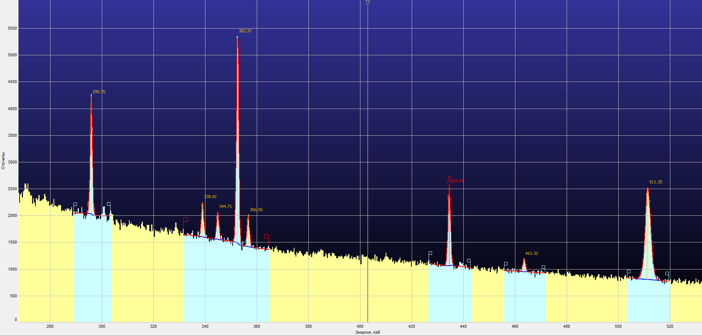
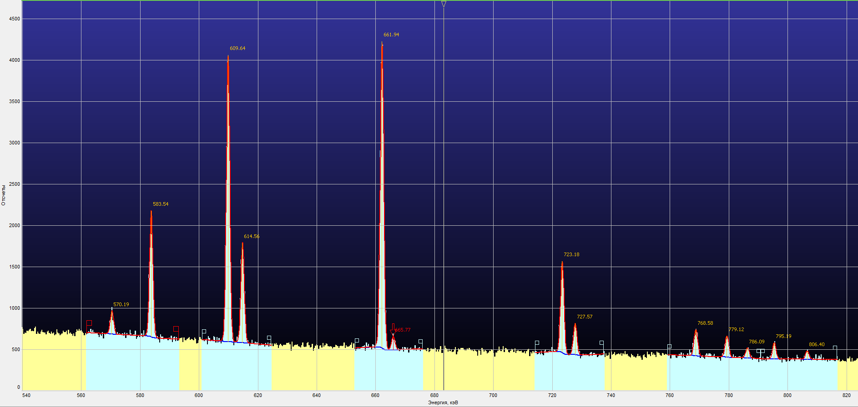
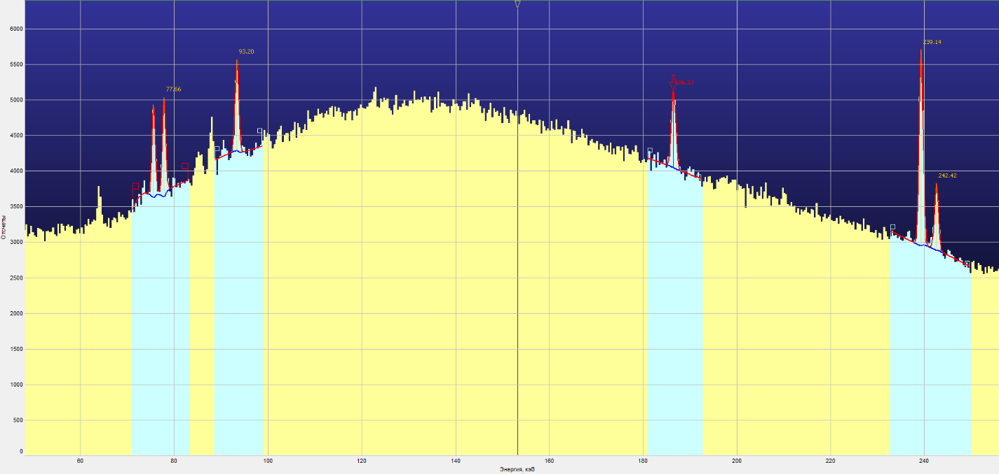
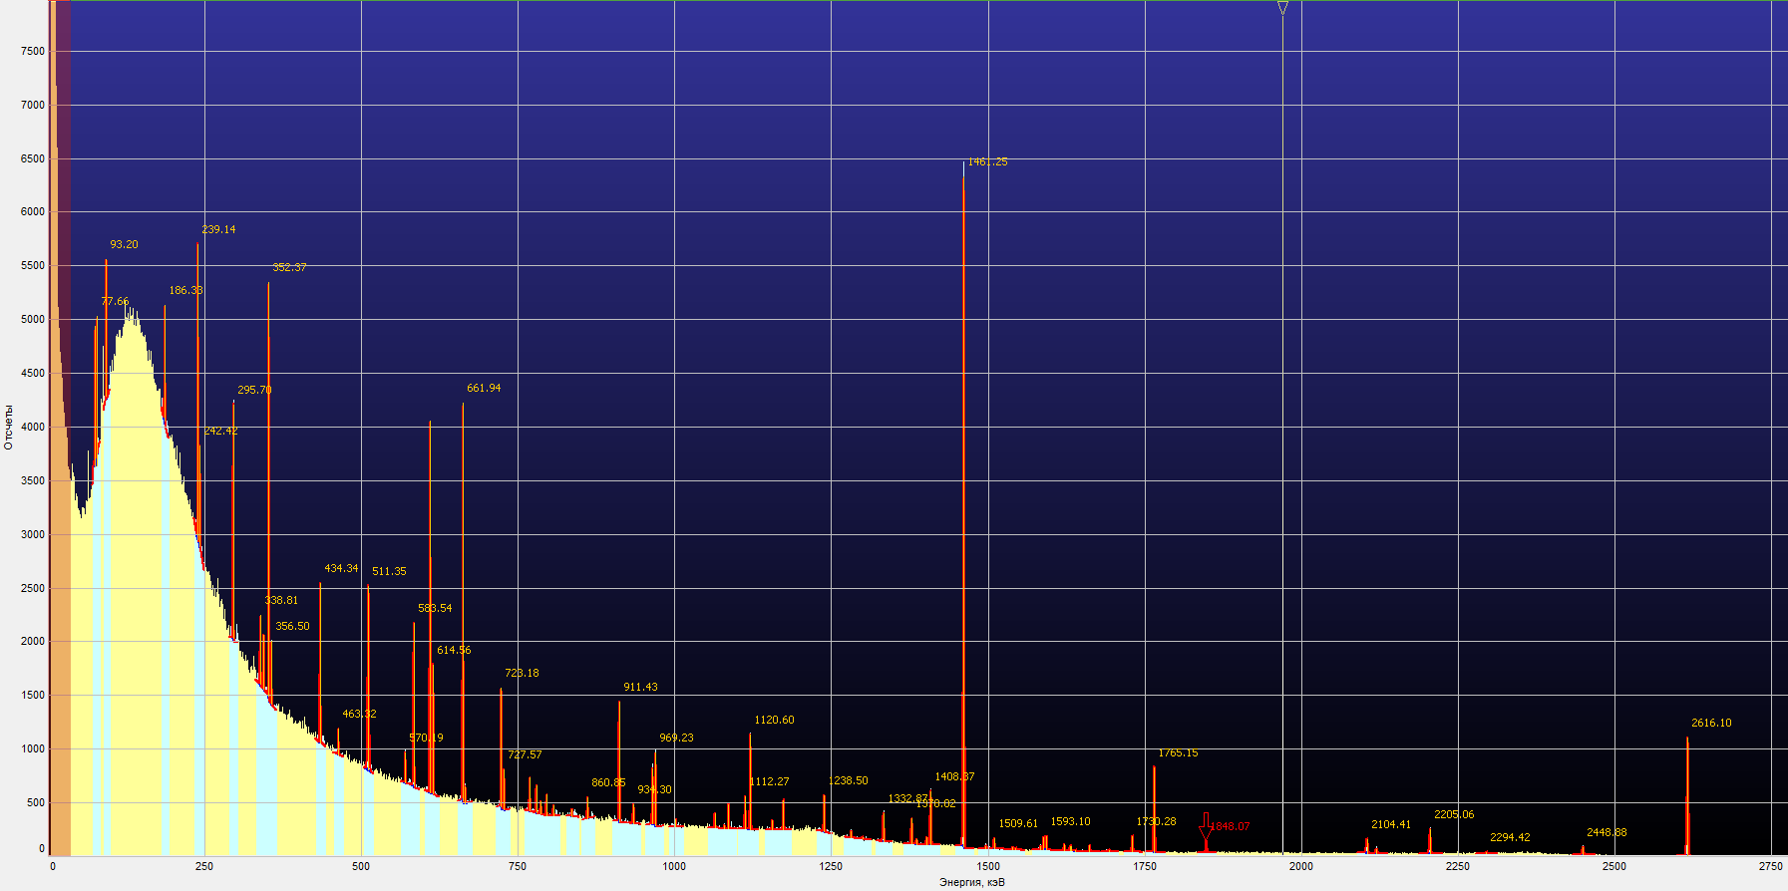
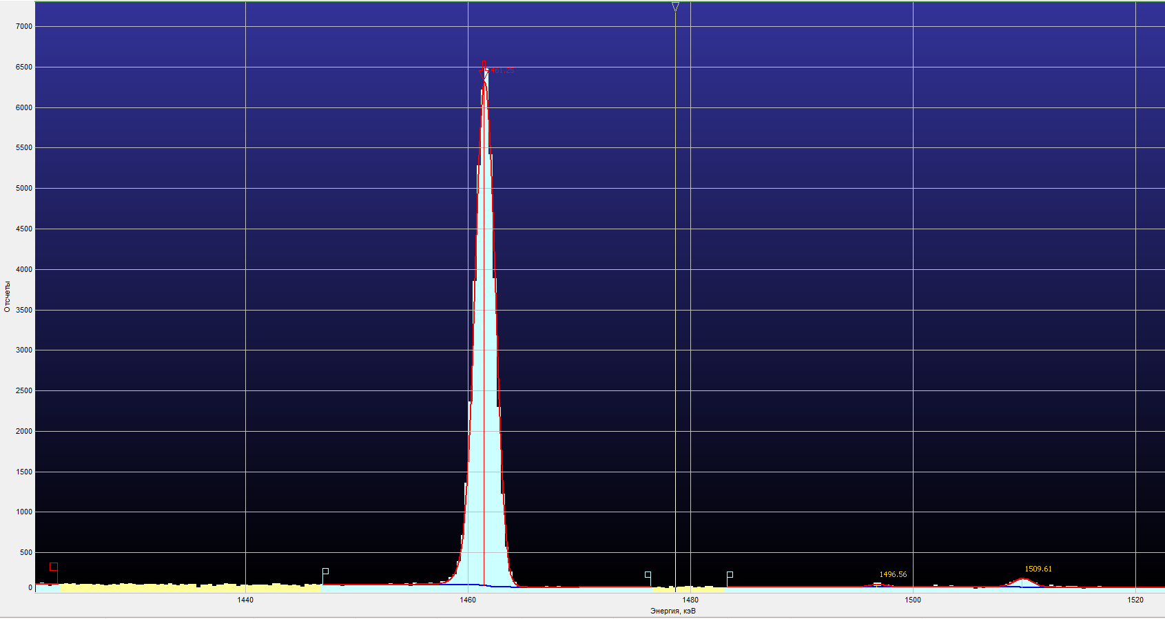
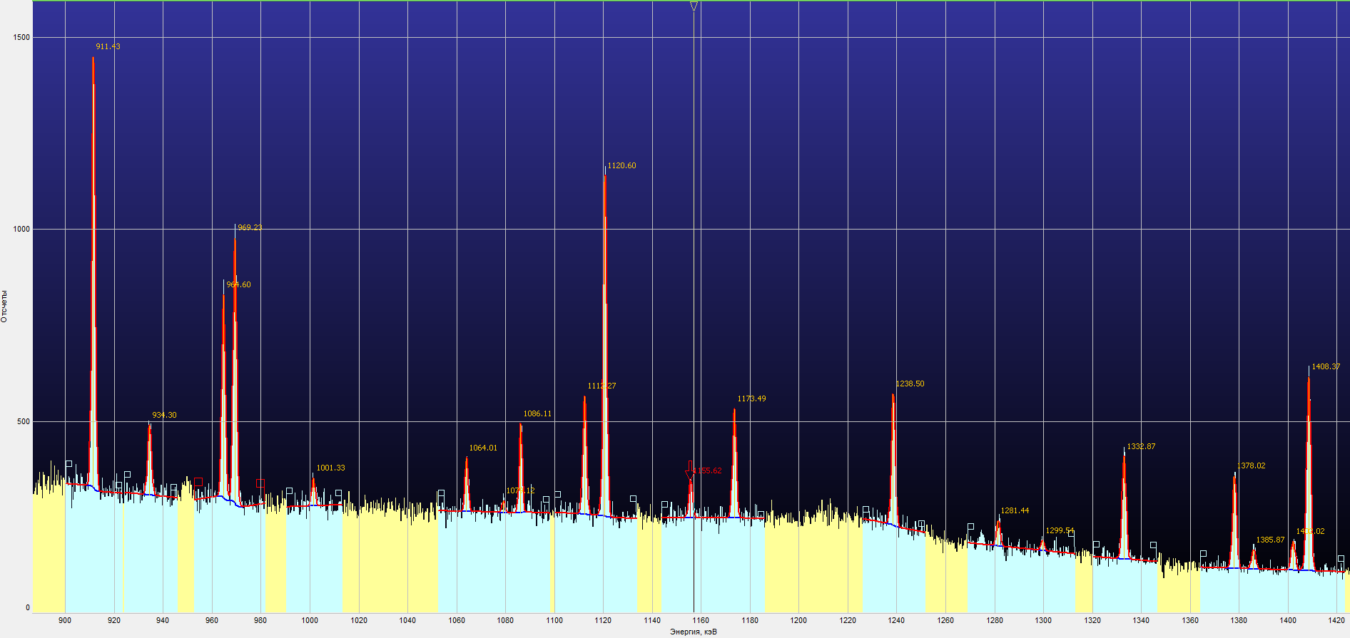
Spectrum processing protocol.
Configuration: HPGe(20%)
Date of the measurement: 26.09.2025
Live time: 263739.38 s.
Real time: 263857.56 s.
Number of peaks: 73
Channel | Energy,  keV | FWHM  keV | Area | Area uncertainty
7261.957 | 2616.096 | 2.943 | 9680 | 199
6797.798 | 2448.884 | 2.592 | 560 | 60
6369.036 | 2294.424 | 2.527 | 127 | 50
6120.962 | 2205.056 | 2.664 | 1806 | 102
5883.449 | 2119.493 | 3.380 | 448 | 73
5841.590 | 2104.413 | 3.366 | 1385 | 105
5130.024 | 1848.074 | 2.302 | 738 | 75
4899.836 | 1765.149 | 2.291 | 5481 | 173
4803.053 | 1730.284 | 2.285 | 1064 | 88
4698.335 | 1692.559 | 2.128 | 99 | 55
4613.536 | 1662.011 | 1.990 | 358 | 59
4549.620 | 1638.985 | 2.090 | 88 | 54
4530.021 | 1631.925 | 2.085 | 216 | 71
4526.500 | 1630.656 | 2.084 | 221 | 71
4500.665 | 1621.349 | 2.077 | 401 | 63
4422.259 | 1593.104 | 2.233 | 913 | 91
4410.011 | 1588.692 | 2.229 | 849 | 88
4395.464 | 1583.451 | 2.225 | 240 | 66
4285.134 | 1543.705 | 2.021 | 143 | 56
4271.536 | 1538.806 | 2.017 | 143 | 57
4190.500 | 1509.613 | 2.130 | 679 | 77
4154.259 | 1496.558 | 2.120 | 210 | 63
4056.235 | 1461.245 | 2.104 | 39425 | 433
3909.449 | 1408.366 | 2.034 | 3087 | 133
3891.836 | 1402.021 | 2.029 | 452 | 79
3846.996 | 1385.867 | 2.016 | 300 | 75
3825.204 | 1378.017 | 2.009 | 1453 | 105
3699.887 | 1332.872 | 1.955 | 1573 | 111
3607.348 | 1299.535 | 1.838 | 143 | 86
3557.105 | 1281.435 | 1.824 | 360 | 95
3437.914 | 1238.497 | 1.900 | 1968 | 133
3257.472 | 1173.493 | 1.872 | 1623 | 128
3207.847 | 1155.616 | 1.857 | 540 | 107
3110.644 | 1120.599 | 1.789 | 4814 | 173

3014.910 | 1086.111 | 1.544 | 1098 | 114
2995.510 | 1079.122 | 1.539 | 146 | 91
2953.548 | 1064.006 | 1.527 | 655 | 104
2779.568 | 1001.330 | 1.600 | 352 | 109
2690.469 | 969.232 | 1.729 | 3628 | 160
2677.604 | 964.598 | 1.725 | 2767 | 149
2593.502 | 934.300 | 1.910 | 1059 | 129
2530.014 | 911.429 | 1.637 | 5610 | 211
2389.619 | 860.852 | 1.630 | 984 | 157
2320.984 | 836.127 | 1.460 | 295 | 129
2238.477 | 806.404 | 1.386 | 419 | 112
2207.340 | 795.187 | 1.376 | 823 | 125
2182.102 | 786.095 | 1.440 | 532 | 129
2162.753 | 779.125 | 1.434 | 1134 | 137
2133.476 | 768.578 | 1.424 | 1397 | 144
2019.640 | 727.568 | 1.354 | 1578 | 135
2007.471 | 723.185 | 1.350 | 4600 | 180
1848.106 | 665.774 | 1.375 | 700 | 129
1837.468 | 661.942 | 1.372 | 15701 | 286
1705.955 | 614.565 | 1.326 | 4960 | 194
1692.277 | 609.637 | 1.322 | 14365 | 280
1619.839 | 583.542 | 1.313 | 6178 | 210
1582.776 | 570.190 | 1.299 | 1135 | 151
1419.441 | 511.349 | 1.149 | 12445 | 527
1418.127 | 510.875 | 1.150 | 779 | 348
1286.114 | 463.318 | 1.213 | 927 | 166
1205.662 | 434.336 | 1.129 | 5242 | 235
989.597 | 356.499 | 1.112 | 2058 | 202
978.124 | 352.366 | 1.107 | 13086 | 295
956.876 | 344.711 | 1.098 | 1721 | 198
940.484 | 338.806 | 1.092 | 2172 | 208
820.837 | 295.704 | 1.015 | 6788 | 401
672.914 | 242.415 | 0.979 | 2832 | 261
663.821 | 239.139 | 0.975 | 8252 | 307
517.232 | 186.331 | 1.052 | 3523 | 345
258.716 | 93.201 | 0.875 | 3477 | 371
215.580 | 77.662 | 0.862 | 3743 | 348
209.381 | 75.429 | 0.858 | 3496 | 356

Channels: 1 - 8193

Acknowledgements

I would like to express my sincere gratitude to dr. Anvar Inoyatov for his invaluable guidance and continuous encouragement throughout this work. Special thanks are extended to dr. Khushvaktov Jurabek for his generous guidance and assistance during data acquisition and analysis, and to Qoyliyev Fayzullo for his constant support and companionship throughout the course of this study. Their contributions and encouragement made this work both possible and deeply rewarding.
I would also like to extend my special regards to Elena Karpova and the entire START team for their support, as their efforts made my stay at Dubna both possible and truly memorable.

