

JOINT INSTITUTE FOR NUCLEAR RESEARCH
Dzhelepov Laboratory of Nuclear Problems

FINAL REPORT ON THE
START PROGRAM

Identification of sponge species in Lake Sevan based on ITS sequence analysis

Supervisor:
Dr. Elena Kravchenko
Student:
Vladimir Gorev, Russia
Irkutsk State University

Participation period:
July 06 – August 16,
Summer Session 2025

Dubna, 2025
Abstract
The article presents a genetic analysis of sponges found in Lake Sevan (Armenia). The ITS fragment of ribosomal DNA was amplified by PCR, then cloned and sequenced. Comparison of the sequences with the NCBI (BLAST) database showed that the samples belong to the species Ephydatia fluviatilis. Based on these data, a phylogenetic reconstruction was constructed demonstrating the place of this species among other representatives of the order Porifera. The results of the study confirm that the analysis of the ITS region is an effective tool for taxonomic identification of sponges, and also indicate the presence of E. fluviatilis in the ecosystem of Lake Sevan.

Keywords: Ephydatia fluviatilis, Lake Sevan, ITS region, Porifera, PCR, cloning, DNA sequencing, phylogeny, NCBI BLAST.
INTRODUCTION
Lake Sevan, being one of the largest high-mountain freshwater bodies, plays an important role in maintaining regional biodiversity. However, despite its ecological significance, many aspects of the lake biota remain poorly studied. In particular, this concerns the species composition of sponges (Porifera), which, being key filter feeders, make a significant contribution to aquatic ecosystems. They occupy a key position in the food chain, consuming a large number of single-celled organisms and organic matter. In addition, the sponge serves as a permanent or temporary home for many organisms in symbiosis with it. The community associated with sponges includes a variety of microorganisms: fungi, algae, archaea, bacteria and viruses [6].
The main problem of the study is the insufficient study of the species diversity of sponges in Lake Sevan. Traditional morphological identification methods often do not allow for accurate differentiation between closely related species, especially in freshwater sponges, which are characterized by high morphological plasticity [7]. Modern molecular genetic methods, such as ITS (Internal Transcribed Spacer) region analysis, allow for more accurate species identification, which is especially important for taxonomically complex groups.
The use of ITS sequencing will not only help clarify the taxonomic composition, but will also allow comparison of the obtained data with global genetic databases, which may reveal new species for science or confirm the presence of previously described ones. Thus, this study is aimed at filling the gaps in knowledge about the biodiversity of Lake Sevan and creating a basis for further ecological and evolutionary research.
PROJECT GOAL
The main objective of this study is to accurately identify sponge species inhabiting Lake Sevan using molecular genetic analysis of ITS sequences. The ITS region, which is highly variable, is one of the most suitable tools for species differentiation, which is especially important for freshwater sponges, which are characterized by high morphological plasticity.
The project goal defined the following tasks:
1) Select optimal conditions for PCR amplification of the ITS region, including the choice of primers and amplification temperature conditions.
2) Clone the PCR products into the pAL2-T plasmid vector followed by sequencing to obtain high-quality sequences for further analysis.
3) Comparison of the obtained genetic sequences with data from international databases such as NCBI.
4) Process the obtained data using bioinformatics methods: alignment and editing of sequences using specialized software, and construction of phylogenetic trees

RESEARCH METHODS
PCR amplification
The PCR method uses artificial multiplication of DNA fragments, which makes it possible to isolate and study the desired section of genetic material. This process is carried out thanks to the enzyme DNA polymerase, which creates new copies of DNA based on the original sample [9].
To perform PCR, it is necessary to prepare a MasterMix mixture consisting of (Table 1):
Table 1
Reagents for MasterMix
Reagents | Per 1 sample (µl) | For 5 samples (µl) | For 11 samples (µl)
Primer mix: forward and reverse | 5.5 | 1 | 12.1
Dilluent | 55 | 10 | 121
H2O | 44 | 8 | 96.8

19 µl of the ready-made MasterMix mixture and 1 µl of DNA from the samples under study are added to test tubes with dehydrated DNA polymerase. After thoroughly mixing the components, the test tubes are shaken and loaded into the amplifier, where the programmed multi-stage PCR process is launched.
Amplification stages:
- Denaturation (95 °C) – cleavage of the double strand of DNA into individual strands.
- Annealing of primers (55 °C) – binding of short DNA fragments (primers) to target sites.
- Elongation– the synthesis of new copies of DNA using polymerase, leading to doubling of the desired fragment.
The cycles are repeated many times (usually 30–40 times), which ensures the exponential accumulation of DNA copies necessary for further research.
Electrophoresis
In molecular biology studies, it is often necessary to separate DNA fragments of different lengths, for example, after treatment with restriction enzymes. Due to the negative charge of DNA molecules, they can be effectively separated by size using gel electrophoresis [1]. Under the influence of an electric field, fragments migrate to the positive electrode (anode), and the speed of their movement is inversely proportional to the length: shorter fragments move faster, while longer ones are retained by the pores of the gel. After electrophoresis is complete, discrete bands are formed in the gel, corresponding to fragments of a certain size, which can be identified by comparison with a DNA marker.
Agarose Gel Electrophoresis Protocol
- Preparation of 1% agarose gel:
0.3 g of agarose was dissolved in 30 ml of TAE buffer (1X). The mixture was heated in a microwave oven until complete dissolution. Ethidium bromide was added to a final concentration of 0.5 μg/ml.
- Formation of gel:
The melted agarose was poured into a gel mold. A comb was installed to form wells. It was left for 30 minutes for polymerization. After solidification, the comb was carefully removed.
- Carrying out electrophoresis:
The gel was placed in an electrophoresis chamber filled with TAE buffer (1X). DNA samples were mixed with loading dye (6x TriTrack DNA Loading Dye). Prepared samples and 2 µl of GeneRuler DNA Ladder Mix marker were added to the wells. Electrophoresis was performed at a voltage of 1-10 V/cm of gel length.
- Visualization and DNA isolation:
After separation was complete, the gel was analyzed under UV light on a transilluminator. The target DNA fragments were excised with a sterile scalpel.
Ligation
Ligation was performed according to the Quick-TA kit protocol. The pAL2-T vector was resuspended in 25 μl deionized water to a concentration of 50 ng/μl, after which the purified PCR products were mixed with the vector at a molar ratio of 1:3 for single amplicons or 1:8-10 for amplicon mixtures. The reaction mixture (10 μl) was incubated for 14-16 h at 14°C using 1 μl vector, 1 μl 10X Overnight ligation buffer, 1 μl Quick-TA T4 DNA ligase (200 units/μl), and deionized water. After incubation, the ligate was stored at -20°C until transformation into competent E. coli XL1-Blue cells by adding 5-10 μl ligate per 100 μl bacterial suspension.
Preparation of Petri dishes and seeding of transformants
After the ligation procedure is completed, the Petri dishes are prepared by sterilization in a dry-heat thermostat at 115°C for 20 minutes. Lennox LB Agar with ampicillin (100 μg/ml) is used to prepare the nutrient medium; 40 mg per 1 liter of medium is used to ensure selective growth of transformed cells. After heating and cooling the medium to approximately 50°C, it is poured into sterile Petri dishes in a 3-4 mm thick layer. After the agar has solidified, the ligated sample is applied to the surface of one of the dishes using a sterile spatula, evenly distributing it over the entire surface of the agar to obtain isolated colonies. The dishes are incubated in an inverted position at 37°C for 12-16 hours to grow transformants.
Cultivation and selection of recombinant clones of E. coli
To cultivate the selected colonies, a liquid nutrient medium with ampicillin is prepared. 5-7 ml of the prepared medium is poured into sterile test tubes, after which only white colonies, characteristic of successful cloning, are carefully selected using sterile disposable plastic nozzles, since blue colonies contain a vector without an insert. Test tubes with inoculated medium are set at an angle of 45° and incubated at 37°C with constant stirring for 12-16 hours for active growth of the bacterial culture. This incubation mode ensures optimal aeration and uniform distribution of cells in the nutrient medium, which contributes to their active reproduction and accumulation of the target product.
Isolation of plasmid DNA
To isolate plasmid DNA, 1–2 ml of bacterial culture were collected and centrifuged at 1,700 g for 1 minute to pellet the cells. The supernatant was removed, the cell pellet was resuspended in 250 μl of buffer P1 (containing RNase), after which 250 μl of buffer P2 were added for cell lysis and gently mixed by inverting the tube until a viscous lysate was formed. Next, 350 μl of cooled buffer N3 was added and gently mixed until a curdled suspension was formed, and centrifuged at 13,000 g for 10 minutes. The cleared supernatant was transferred to a spin column, centrifuged for 1 minute at 7,000 g, after which the column was washed with 700 μl of buffer PB and 750 μl of buffer PE. Final DNA elution was performed with 30 µl deionized water.
Sanger sequencing
The reaction was carried out in a mixture containing:
1) Specific primer - a short single-stranded DNA complementary to the beginning of the target region (serves as a "primer" for DNA polymerase);
2) Standard deoxynucleotides (dATP, dCTP, dGTP, dTTP);
3) Fluorescently labeled dideoxynucleotides (ddNTPs), the random inclusion of which in the growing chain stops synthesis.

The reaction products were separated by capillary electrophoresis. DNA fragments were detected in real time by fluorescence of ddNTP labels. The data were analyzed programmatically, obtaining a chromatogram with peaks of four colors (A, C, G, T) (Fig. 1). The method provides reading of sequences 500–1000 nucleotides long in one run [8].
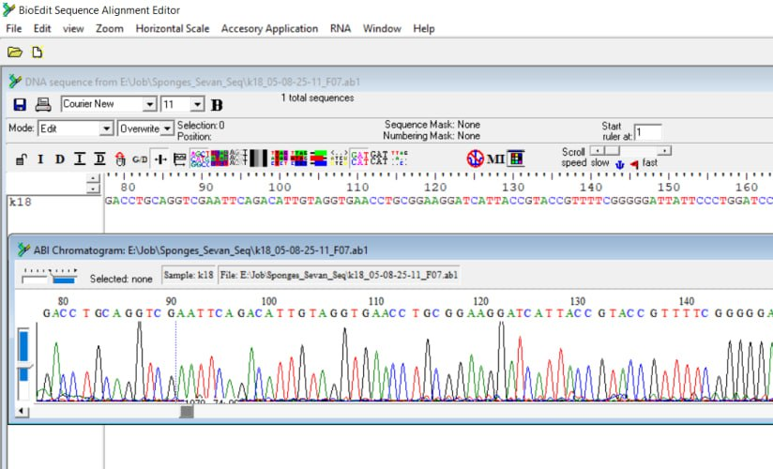
Fig. 1. Example of a chromatogram

Bioinformatics analysis
The samples obtained from sequencing were processed in the BioEdit program [3], where the chromatograms were visually checked for noise and sequencing errors. If necessary, manual correction was performed by removing areas with low-quality reading. Then, contigs were assembled from forward and reverse readings to obtain the full sequence of the ITS region.
For taxonomic identification, the obtained sequence was analyzed using the BLASTn algorithm in the NCBI databases [2]. Reference sequences similar in length but with different degrees of homology were selected to cover possible variants of species affiliation. The selected sequences were loaded into BioEdit, where a multifile was formed for further analysis.
Multiple alignment of nucleotide sequences was performed on the MAFFT server [5] using the L-INS-i algorithm for accurate accounting of homologous regions. Phylogenetic analysis was performed on the IQ-TREE platform [4] with the selection of the optimal evolutionary model (determined by the BIC or AIC criterion) and the assessment of node support using the ultrafast bootstrap support method.
The final phylogenetic tree was visualized in FigTree, where the display of branches was adjusted and node support values were noted.

RESULTS
The phylogenetic tree (Fig. 2), constructed based on the analysis of ITS sequences, demonstrates the position of the studied sponge sample (Sponge_sample) relative to the reference taxa.
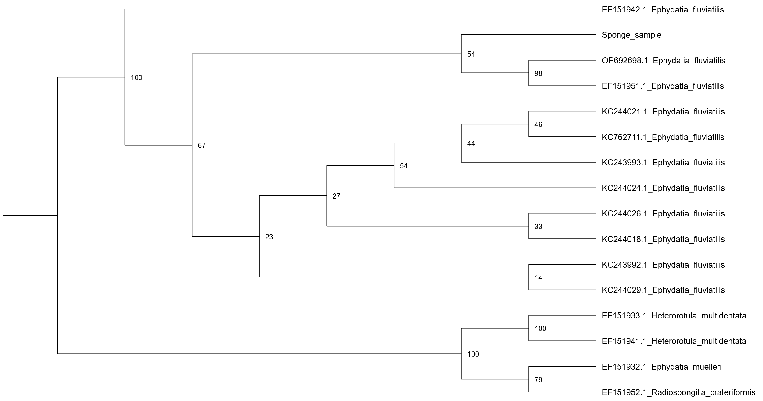
Fig. 2. Phylogenetic tree, support in UFBoot nodes (%)
Ultrafast Bootstrap Support (UFBoot)— is a statistical measure used to assess the reliability of branches in a phylogenetic tree. The higher the percentage, the more confidently one can assert that a given branch reflects true evolutionary relationships.
1. High support (95–100%)
The branches leading to groups with such values (EF151941.1 and EF151933.1_Heterorotula_multidentata) have the highest support. This means that these taxa are consistently grouped together in all replicates of the analysis, and their position in the tree is highly reliable. And the high reliability of OP692698.1_Ephydatia_fluviatilis shows its correct position.
2. Moderate support (70–95%)
The branch for EF151932.1_Ephydatia_muelleri and EF151952.1_Radiospongilla_crateriformis shows moderate. This may indicate some ambiguities in the data (e.g. limited number of informative sites in the alignment).
3. Low support (<70%)
A branch with support of 44 (node for KC243993.1_Ephydatia_fluviatilis) or 14 (node for KC244029.1_Ephydatia_fluviatilis) indicates weak statistical support. This may be due to an insufficient number of phylogenetically informative positions in the gene or limitations of the method (insufficient number of bootstrap replicates). Such groups should be considered preliminary and their position may change with the addition of more data.

CONCLUSIONS
Using molecular genetic analysis of the ITS region of ribosomal DNA, carried out using the Sanger method, and subsequent comparison with data from the NCBI (BLAST) database, it was established that the studied freshwater sponges from Lake Sevan belong to the species Ephydatia fluviatilis.
The methods used showed high efficiency: PCR amplification with selected primers made it possible to isolate the target fragment of ITS (approximately 900 nucleotide pairs long), which was confirmed by electrophoretic analysis in agarose gel.
The study is significant because it is the first time that molecular methods have confirmed the presence of the E. fluviatilis species in the ecosystem of the high-mountain Lake Sevan (Armenia). In addition, the effectiveness of the ITS marker for the taxonomic identification of freshwater sponges has been proven. This is especially important for organisms with high morphological variability, where classical methods for species identification are often insufficiently accurate.
It is worth noting that the moderate support of the node (54%) on the phylogenetic tree indicates the need for further research to confirm the species assignment of the specimen. This may include the analysis of additional genetic markers or morphological studies that will help clarify the taxonomic status of the sponge under study.

LIST OF REFERENCES
1) Alberts Bruce. Essential cell biology / Bruce. Alberts, Garland Science, 2010. 845 p.
2) Basic Local Alignment Search Tool // National Library of Medicine URL: https://blast.ncbi.nlm.nih.gov/Blast.cgi (access date: 08/05/2025).
3) BioEdit 7.7 // Software Informer URL: https://bioedit.software.informer.com/ (accessed: 05.08.2025).
4) FigTree v1.4.5 pre-release // GitHub URL: https://github.com/rambaut/figtree/releases (accessed: 05.08.2025).
5) MAFFT version 7 // Research Institute of Microbial Diseases URL: https://mafft.cbrc.jp/alignment/server/index.html (accessed: 05.08.2025).
6) Metagenomic analysis of viral communities in diseased Baikal sponge Lubomirskia baikalensis / TV Butina, Yu. S. Bukin, IV Khanaev [et al.] // Limnology and Freshwater Biology. – 2019. – No. 1. – P. 155–162.
7) Itskovich, Valeria Borisovna. Molecular phylogeny and systematics of freshwater sponges: Abstract of a candidate of biological sciences dissertation: 03.00.15 / Institute of Marine Biology, Far Eastern Branch of the Russian Academy of Sciences. - Vladivostok, 2005. - 22 p.
8) Sanger Method // RUWIKI URL: https://ru.ruwiki.ru/wiki/Метод_Сэнгера (date of access: 08.08.2025).
9) PCR in diagnostics: principles, application and preparation for research // EURODON URL: https://eurodon61.ru/about/articles/ptsr-v-diagnostike-printsipy-primenenie-i-podgotovka-k-issledovaniyu/ (date of access: 06.08.2025).

ACKNOWLEDGEMENTS
I would like to express my sincere gratitude to all those who contributed to the completion of this work. First of all, I would like to thank my supervisor, Doctor of Sciences Elena Kravchenko, for her professional guidance and valuable advice at all stages of the work. Her critical comments and support were invaluable for the successful completion of the project.
Special thanks to Kirill Antonovich Tarasov for help in mastering molecular biology methods (PCR, electrophoresis, cloning), patient teaching of the intricacies of experiments and prompt resolution of technical issues.
I would like to sincerely thank Alena Sergeevna Yakhnenko for her key contribution to bioinformatics analysis: training in working with programs for processing sequences, constructing phylogenetic trees and interpreting molecular results.
Special thanks to the START program administration and the Joint Institute for Nuclear Research (JINR) for the unique opportunity to undergo an internship at a world-class scientific center. The professional atmosphere and access to modern equipment became the basis for gaining invaluable experience.

