

JOINT INSTITUTE FOR NUCLEAR RESEARCH
Laboratory of Nuclear Problems named after V.P. Dzhelepov

FINAL REPORT ON THE
START PROGRAMME

Measuring the attenuation length of light in water

Supervisor:
Borodin Artur Nikolaevich

Student:
Kanzyuba Daria, Russia
Irkutsk State University

Participation period:
July 20 – August 30,
Summer Session 2025

Dubna 2025

Annotation

This scientific paper discusses a technique for measuring the attenuation length of light in water, which is a key step for calibrating a muon detector. The main purpose of the study is to master this technique and obtain accurate data on the attenuation coefficient of light in purified water prepared for pouring into the detector. The data obtained will be directly applied to calibrate the muon detector. Accurate calibration of the detector will ensure a high degree of reliability of its operation, which is important for research in the field of cosmic ray physics and astrophysics. The results of the work can contribute to improving detection methods and separating the gamma ray flux from the rest of the charged particle flux.

Introduction

The TAIGA gamma-ray observatory is located in the Tunka Valley at the astrophysical training ground near the southern tip of Lake Baikal. Currently, there is an expansion of the types of detectors to improve event registration. One of the prospects is a muon water detector. In it, the main criterion is clean water. The main volume is 55 cubic meters. For this purpose, a scaled-down installation was built to measure the purity of water, so that we could conduct experiments and use several methods. During the experiments, we calculated the attenuation length of the light in several ways and compared it with theoretical values.

Project objectives:

- Measurement of light attenuation length: Conducting experiments to measure the length of light attenuation in water using various methods

- Comparison of experimental and theoretical values: Comparing the results of experimental measurements of the attenuation length of light with theoretical values in order to assess the consistency of the data and identify possible sources of errors.

- Development of a method for measuring the absorption and scattering of light of a given wavelength

- Study of methods for measuring water purity

1.How is the installation for measuring the purity of water

The design for measuring the purity of water is a plastic tube with holes on both sides. A light source with a length of 365nm is installed at one end of the tube, and a camera is located at the opposite end that records changes in the level of the luminous flux. In addition, glass plates are fixed perpendicularly at the ends of the pipe. This system allows you to determine the length of the attenuation of light in the water in order to evaluate the detector's performance.

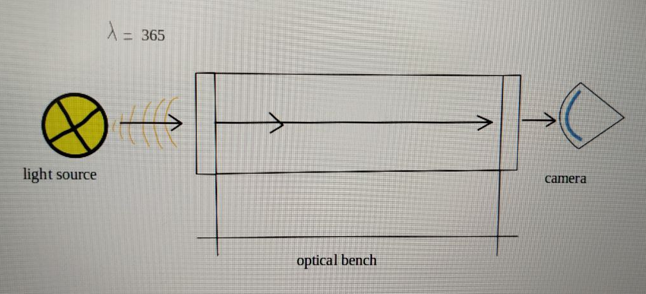

2. How the experiment was conducted

In addition to the installation, we also used improvised dimming tools to avoid unnecessary background light. During the experiment, a flashlight is turned on, and the light passes through a tube filled with air. In this case, we measure one intensity, and it should be noted that there is no absorption and scattering in the air, which is practically discharged. The attenuation length for this wavelength range of light - 365 nm — is approximately 3 km.

Then we conducted an experiment with tap water. We poured tap water into the pipe and observed similar changes. It is important to note that tap water meets only drinking standards, not measurement standards. However, the attenuation length for water is much longer, which allowed us to observe a noticeable decrease in intensity in the light image.
As a result, we carried out measurements for two different pipe lengths and then performed a relative calculation of the data obtained. This allowed us to better understand the behavior of light in various media and its interaction with them.

3.Data processing

During the experiment, we obtained photos with water and air

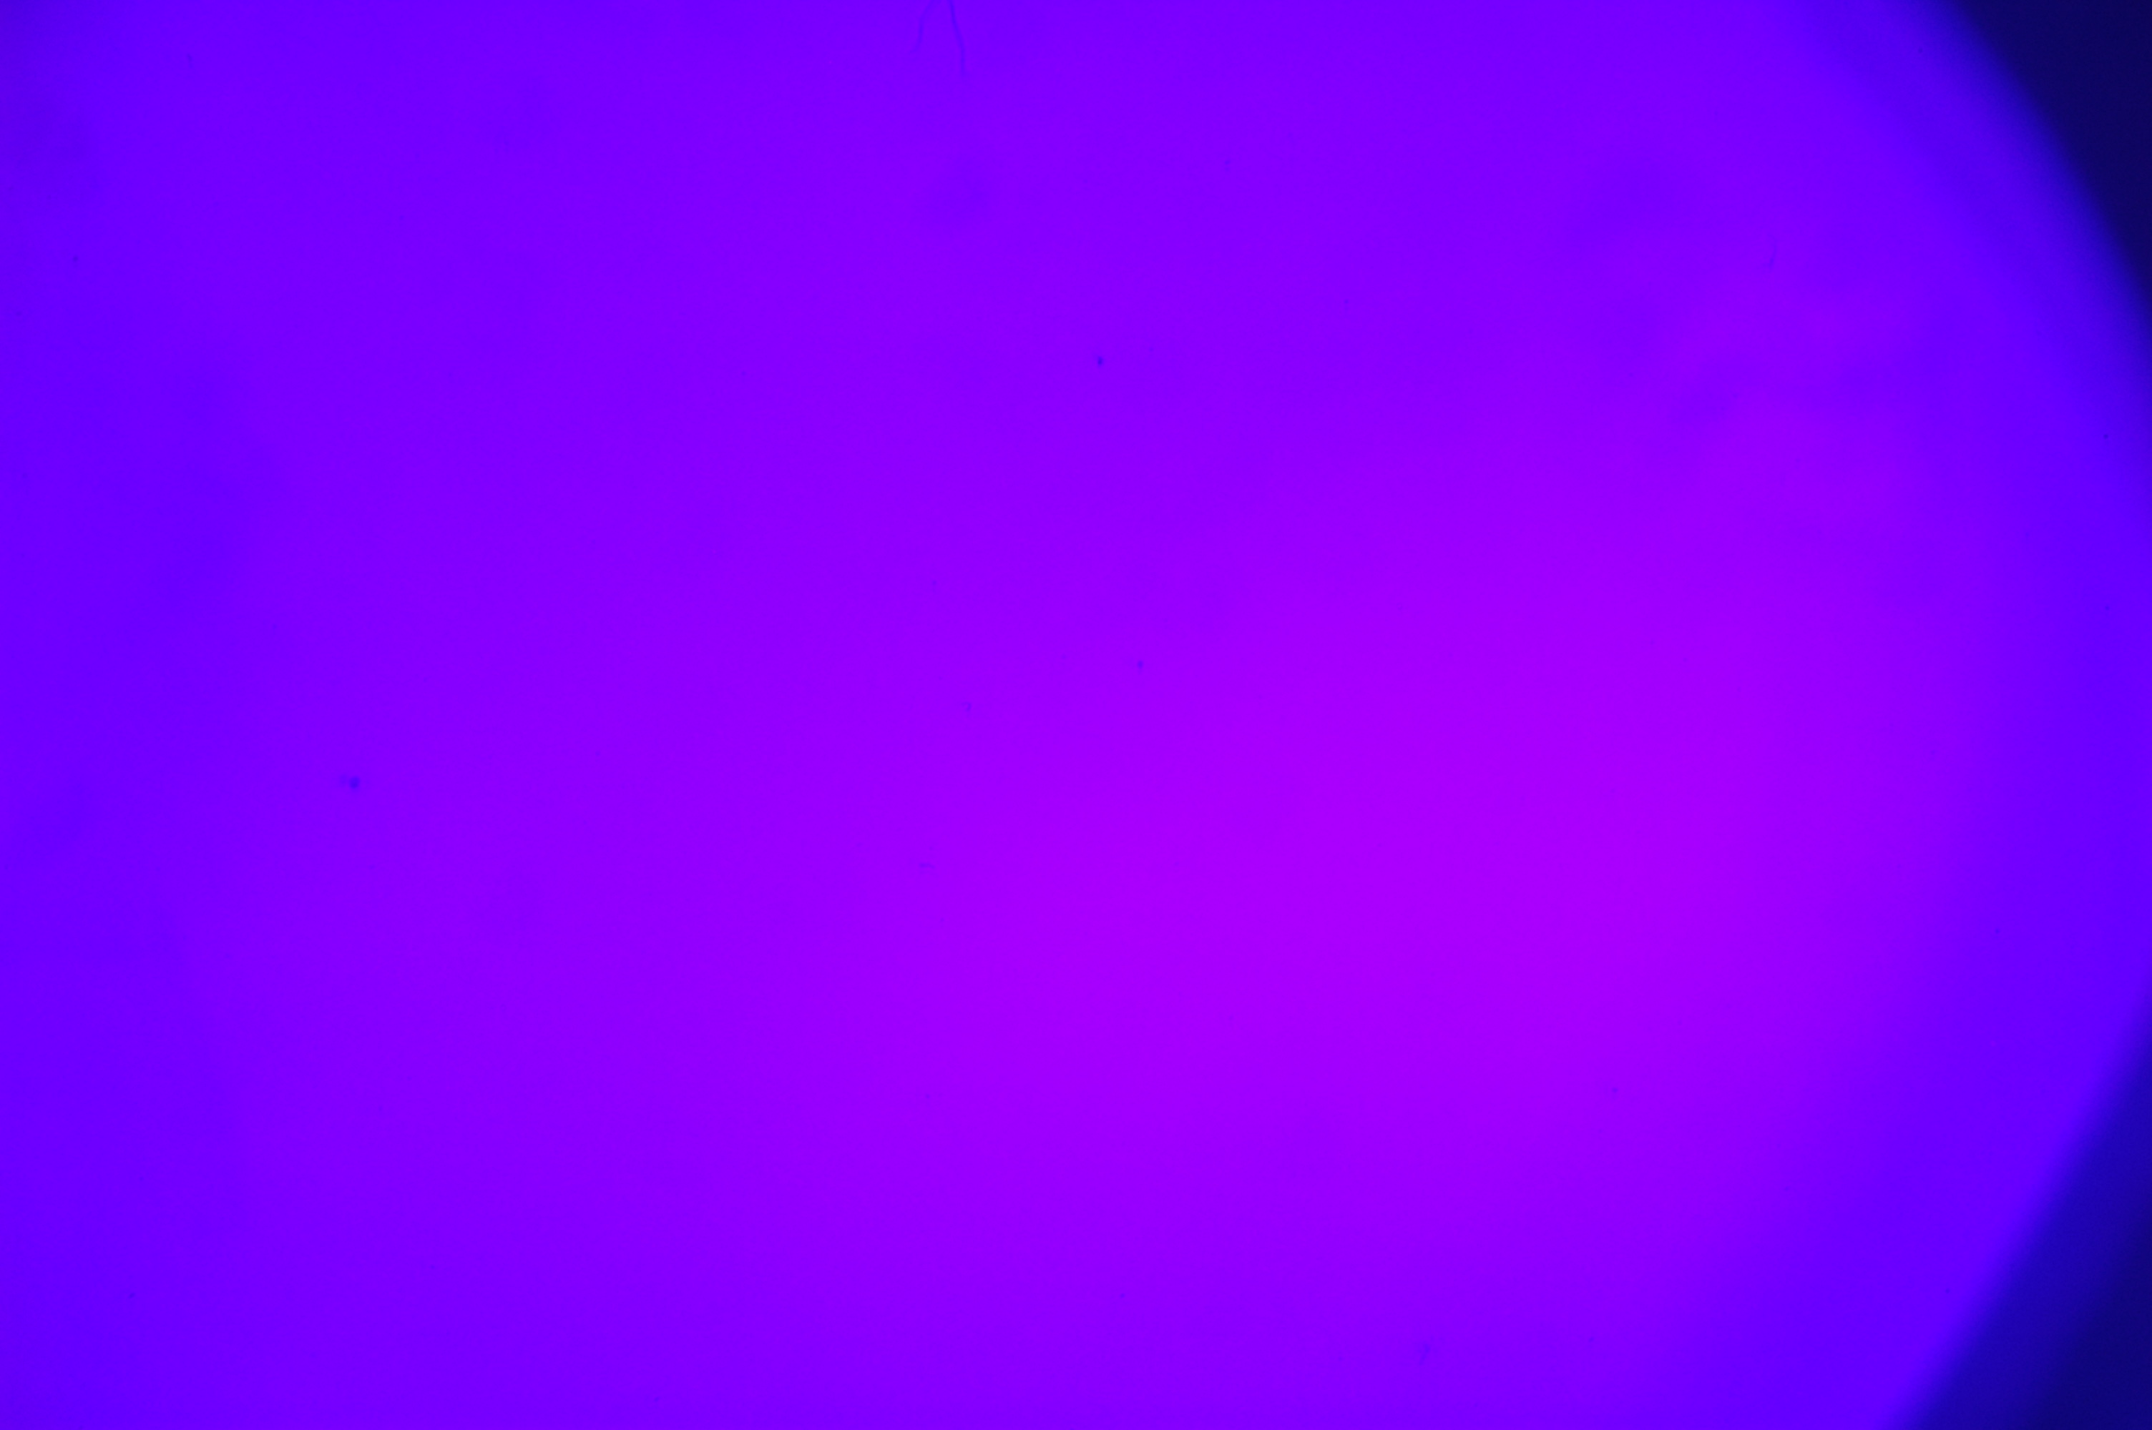

with water without water

Then we started processing the photos and found out what our light intensity was without water and with water at different camera exposures. Knowing these intensities, we can calculate the attenuation length of light in water using the following formula:

I_{w}=I_{air}*e^^{L/λw}

Where:

I_{w} – intensity in water
I_{air} – intensity in the air
L – distance from the source to the camera
λ_{w} – the length of light attenuation in water

From where λ_{w} is equal to:

λ_{w}=$\frac{L}{ln⁡(\frac{Iw}{Iair})}$

The average value of the attenuation length of the light turned out to be 1.96

excerpt | time | intensity without water | intensity with water | light attenuation length
2000 | 0,0005 | 220 | 83 | 2,05173
2500 | 0,0004 | 191 | 65 | 1,855484
3200 | 0,000313 | 157 | 59 | 2,04351
4000 | 0,00025 | 133 | 49 | 2,002947
5000 | 0,0002 | 109 | 50 | 2,566324
6400 | 0,000156 | 92 | 34 | 2,009186
8000 | 0,000125 | 78 | 15 | 1,213107

Now we check the transition to intensity

The dependence turned out to be not quite linear, in the future we will correct this and achieve a linear dependence.

4. The second experiment
In order to make sure that our technique works, we conducted another experiment.
We take a camera without a lens and put glass on top. Then we cover this structure with an opaque lid. Then we take photos at different shutter speeds. We also take the same photos, but without the lid, and then without the glass.

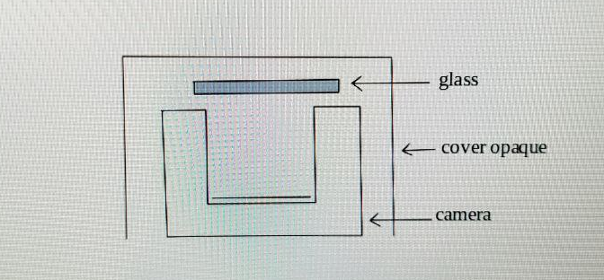

The following photographs were obtained for each case




without glass




with glass


dark background

The photos were also processed and the intensity was obtained for a dark background, without glass and with glass. For a dark background, all the intensities turned out to be equal to 1. These values are obtained from the file data. For a typical 8-bit single-channel image, the bytes are divided by 255.0.
The conversion of these values into intensity is a non-linear transfer function, which is a combination of a linear function for low brightness values and an offset power law for the rest of the range. Linear intensities are calculated as follows (the same for all channels):

I=$(\frac{Io+0,055}{1,055})$^2,4
Где:
I- linear intensity
I0- initial intensity

without glass
number | excerpt | time | intensity | linear intensity
1873 | 2000 | 0,0005 | 0,047 | 0,003671
1874 | 1600 | 0,000625 | 0,086 | 0,007986
1875 | 1250 | 0,0008 | 0,129 | 0,015127
1876 | 1000 | 0,001 | 0,188 | 0,029488
1877 | 800 | 0,00125 | 0,263 | 0,056237
1878 | 640 | 0,001563 | 0,353 | 0,102277
1879 | 500 | 0,002 | 0,439 | 0,16186
1880 | 400 | 0,0025 | 0,522 | 0,234972
1881 | 320 | 0,003125 | 0,596 | 0,313898
1882 | 250 | 0,004 | 0,702 | 0,450842
1883 | 200 | 0,005 | 0,824 | 0,645309
1884 | 160 | 0,00625 | 0,957 | 0,904956

with glass
number | excerpt | time | intensity | linear intensity
1910 | 1000 | 0,001 | 0,024 | 0,001988
1911 | 800 | 0,00125 | 0,039 | 0,003018
1912 | 640 | 0,001563 | 0,067 | 0,005642
1913 | 500 | 0,002 | 0,098 | 0,009715
1914 | 400 | 0,0025 | 0,145 | 0,018478
1915 | 320 | 0,003125 | 0,216 | 0,038311
1916 | 250 | 0,004 | 0,31 | 0,078288
1917 | 200 | 0,005 | 0,404 | 0,135689
1918 | 160 | 0,00625 | 0,486 | 0,201311
1919 | 125 | 0,008 | 0,604 | 0,323236
1920 | 100 | 0,01 | 0,702 | 0,450842
1921 | 80 | 0,0125 | 0,8 | 0,603827
1922 | 60 | 0,016667 | 0,957 | 0,904956

These calculations were made in order to obtain a linear dependence of intensity on exposure time.

At the boundary of refraction of media, we have a loss of 8%. To check whether this is really the case in our experiment, we need to perform the following calculations:

_{∆I=8%}$=\frac{Ig-Id }{Iwg-Id }$
_{Iwithout glass -Idark}
_{Iwith glass -Idark}

Where:
_{Id}- the intensity is dark
_{Iwg}- intensity without glass
_{Ig-} intensity with glass
∆I | excerpt
0,702 | 100
0,8 | 80
0,957 | 60

As a result of the calculations, it turned out that the closest results are obtained at shutter speeds of 100, 80, 60. It was a test object in order to understand in which exposure range to work.

4. What other ways are there to measure the purity of water

There are several methods for measuring water purity, each of which is suitable for different types of pollution and conditions. We will use some of these methods in the future to compare the results obtained by indirect methods. Indirect methods are faster and more convenient to use, but they require calibration.

- Physico-chemical methods:

- pH-metric: determination of the level of the hydrogen index (Ph), which characterizes the acidity or alkalinity of an aqueous solution. Devices equipped with a special glass electrode are used, the potential of which depends on the concentration of hydrogen ions in the solution.

- Conductometry: measurement of electrical conductivity of liquids and solutions. Determination of the ability of a substance to conduct electric current, which depends on the concentration of ions in the liquid, the nature of the solute and solvent
- Titration: an analytical method used to determine the concentration of a solute (analyte component) in a solution. This method is based on a reaction between a titran (a solution of known concentration) and the analyte. In some cases, an indicator is added to the solution, which changes color when the end point of the reaction is reached.

2.Optical methods:

- Spectrophotometry: Measures the absorption of light in certain wavelength ranges, which allows you to determine the concentration of pollutants.

- Turbidimetry: a method used to measure the turbidity of a solution. It is based on an estimate of the amount of light scattered by particles in a liquid. Measures the amount of light that passes through the sample and compares it with the intensity of the light that passed through the control sample (usually pure water). This allows you to determine the degree of turbidity of the solution.

Conclusion

In conclusion, the research carried out within the framework of the project to measure the attenuation length of light in water at the TAIGA astrophysical test site in the Tunka Valley confirmed the relevance and necessity of developing a muon water detector that requires a high degree of purity of water. An experimental setup designed to measure the purity of water has made it possible to effectively use various methods to obtain data on the attenuation length of light.

Overall, the results of this study provide a solid foundation for further experiments and improvements in the technologies used at the TAIGA gamma-ray Observatory, as well as contribute to the deepening of knowledge in the field of astrophysics and optics.

In the future, it is planned to conduct additional experiments with increasing the size of the installation, which will significantly improve the accuracy of the results obtained. In the future, these data will need to be compared with the results obtained during the calibration of indirect measurements, which will further improve the accuracy and reliability of the studies.

Many thanks to my colleagues from the Scientific and Energy Department of Elementary Particle Physics, Sector No. 4 Astrophysical Research, for their help and collaboration

List of literature

- Alekseev K.V., Chaplina T.O., Chashechkin Yu.D. Optics of the ocean
https://ocean.phys.msu.ru/courses/optics/optics.pdf
- I. A. Khvostikov THEORY OF LIGHT SCATTERING AND ITS APPLICATION TO THE TRANSPARENCY OF THE ATMOSPHERE AND FOGS https://ufn.ru/ufn40/ufn40_6/Russian/r406a.pdf
- Light scattering and absorption https://studopedia.ru/11_180273_rasseyanie-i-pogloshchenie-sveta.html
- D.Y. IVANOV, L.I. VASILYEVA DISPERSION, LIGHT ABSORPTION AND MOLECULAR REFRACTION https://library.voenmeh.ru/cnau/0sw80l5Gi1ihTFE.pdf
- K.S.Shifrin Introduction to Ocean Optics http://elib.rshu.ru/files_books/pdf/img-09055.pdf
- An apparatus to measure water optical attenuation length for LHAASO-MD Cong Li a,b,*, Gang Xiao a , Shaohui Feng a , Lingyu Wang a , Xiurong Li a , Xiong Zuo a , Ning Cheng a , Hui Wang c , Bo Gao a , Zhihao Duan d , Jia Liu a , Huihai He a,b , Mohsin Saeed a , for the LHAASO Collaboration
https://doi.org/10.1016/j.nima.2018.03.029
- Measuring the optical parameters for LHAASO-MD Hui Wang a,b , Cong Li b,∗ , Gang Xiao b,∗ , Yi Zhang b , Shaohui Feng b , Lingyu Wang b , Xiurong Li b , Xiong Zuo b , Ning Cheng b , Wenxiong Wu a , Yuelei Zhang b , Huihai He b,c , Huanyu Jia a , for the LHAASO Collaboration
https://doi.org/10.1016/j.nima.2020.163416

