

JOINT INSTITUTE FOR NUCLEAR RESEARCH
Frank Laboratory of Neutron Physics

FINAL REPORT ON THE
START PROGRAMME

Systematic study of wall painting of the fourteenth-fifteenth centuries from three Cathedrals and their comparison by complementary physico-chemical methods

Supervisor:
Dr Andrey Yurievich Dmitriev

Student:
Elena Nikiforova, Stroganov University

Participation period:
August 03 – September 27,
Summer Session 2025

Dubna, 2025

Abstract

The fourteenth-fifteenth centuries wall painting from three Cathedrals: Annunciation Cathedral, Moscow (Russia); Assumption Cathedral in Gorodok, Zvenigorod (Russia); Trinity Cathedral of the Trinity Lavra, Sergiyev Posad (Russia) have been investigated. 150 XRF spectra were collected in situ by portable spectrometer. Moreover some samples were subjected to additional in-depth laboratory analysis by six complimentary physico-chemical methods: X-ray fluorescence analysis (XRF), neutron activation analysis (NAA), polarized microscopy, optical microscopy of polished cross-sections, micro-Raman spectroscopy and Fourier transform infrared spectroscopy. Pigments and plasters from the interior painting and fragments found during archaeological excavations were analyzed. The composition of pigments and the number of painting layers were determined. The results obtained will be used for attribution.

Content

Abstract 2
Content 3
1. Introduction 4
1.1 Annunciation Cathedral, Moscow (Russia) 4
1.2 Assumption Cathedral in Gorodok, Zvenigorod (Russia) 5
1.3 Trinity Cathedral of the Trinity Lavra, Sergiyev Posad (Russia) 6
2. Materials and methods 8
2.1 X-ray fluorescence analysis (XRF) 8
2.2 Neutron activation analysis (NAA) 8
2.3 Polarized microscopy 8
2.4 Optical microscopy of polished cross-sections 9
2.5 Micro-Raman spectroscopy 9
2.6 Fourier transform infrared spectroscopy 9
3. Results 10
4. Conclusion 18
5. References 19

- Introduction

The work is devoted to the study and comparison of fourteenth-fifteenth century wall paintings from three Cathedrals: Annunciation Cathedral, Moscow (Russia); Assumption Cathedral in Gorodok, Zvenigorod (Russia); Trinity Cathedral of the Trinity Lavra, Sergiyev Posad (Russia) have been investigated.
The aim of the study.
Visual and stylistic comparison of paintings is not enough for attribution. A comprehensive physical and chemical analysis of the paint layer and plaster is also necessary.

1.1 Annunciation Cathedral, Moscow (Russia)

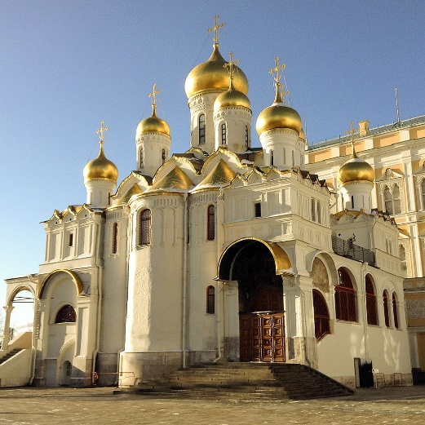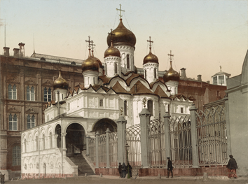
Figure 1 Annunciation Cathedral, 2025/1896
The first written mentions of a stone church date back to the end of the 14th century, where the foundation of the church was laid around 1393, by the son of Grand Duke Dmitry Donskoy, Grand Duke Vasily Dmitrievich. It was a single-domed pillarless house church of a great family, made of white stone blocks on a basement, which has survived to this day.
In 1404-1405, as the chronicle stated, the church was decorated with wall paintings by the artists Theophanes the Greek, Prokhor of Gorodets and Andrei Rublev.
In 1416, the building was dismantled and a new, four-pillar, three-apse cathedral was erected, expanded to its current size. The cathedral became three-domed with large central and two small eastern domes. In style, it was close to the monuments of ancient Moscow architecture.
In 1482, Prince Ivan III Vasilyevich, soon after the overthrow of the Tatar-Mongol yoke, wishing to decorate the place of his residence with new buildings, began work on dismantling the temple down to the base.
In 1484, construction began on a new stone building of the temple. The construction was completed five years later. The plan and general dimensions of the building of 1416 were repeated in the new form. From the previous buildings, the basements used to store the prince's execution were preserved.
The cathedral of 1484-1489 became the center of the composition of the existing building. In 1508, by decree of the cathedral of Vasily III, Theodosius, son of Dionysius, and Fyodor Edikeev were painted.
The temple suffered during a fire in July 1547: the carved decoration and documents were damaged, the icons of Andrei Rublev, Greek masters, books, and wall paintings were destroyed. The last time the temple was rebuilt was in 1564-1566 during the reign of Ivan the Terrible. Single-domed annexes of the church were built on the vaults of the galleries. The temple became nine-domed. The roofs were covered with gilded copper.
Under Alexei Mikhailovich, the cathedral porch and porch were ordered to be painted with different colors, the work was carried out by the icon painter Ivan Filatyev, the work was supervised by Simon Ushakov.
The last alteration of the porch took place in 1696, when it was ordered to clean the porch, vaults and walls, coat with gesso and whitewash.
At the end of the 18th century, the Treasury Chamber was dismantled, the southern porch was rebuilt, the arched openings between the semi-columns were blocked up. In 1800, the fields in the extensions were replaced with white-stone carved ones with a black mastic ornament. In 1822, the chapel in the name of the Great Martyr George was rebuilt and re-consecrated in the name of Alexander Nevsky. He installed an iconostasis in the Empire style, blocked up the old window and punched a new one. In 1836, according to the design of the architect Ivan Mironovsky, a sacristy was added to the southwestern cathedral and the southern facade of the porch was reconstructed, decorating it with an arcade.
In 1836, a chapel in the name of St. Nicholas the Wonderworker was created in the southern part of the temple. In 1863-1867, the cathedral was restored under the direction of Fyodor Richter. As a result of the work, the roof was replaced, the rafters, the instructions of the vaults and chapters were repaired.
During the October Revolution of 1917, the Kremlin was shelled with heavy artillery - the atmosphere got into the cathedral and destroyed its porch. In May 1918, a committee for the preservation and disclosure of monuments of ancient painting was established, headed by Igor Grabar. On his initiative, a restoration group began working in the Kremlin cathedrals under the leadership of the Department of Museum Affairs under the People's Commissariat of Education. They managed to clear the icons from the Deesis and Festive Rows of the iconostasis, presumably by Andrei Rublev and Theophanes the Greek.
Large-scale restoration work was carried out in 1980-1984 by artist-restorers of the All-Union Association "Soyuzrestavratsiya" under the leadership of Leonid Sergeevich Muravyov-Moiseenko.
  - Assumption Cathedral in Gorodok, Zvenigorod (Russia)
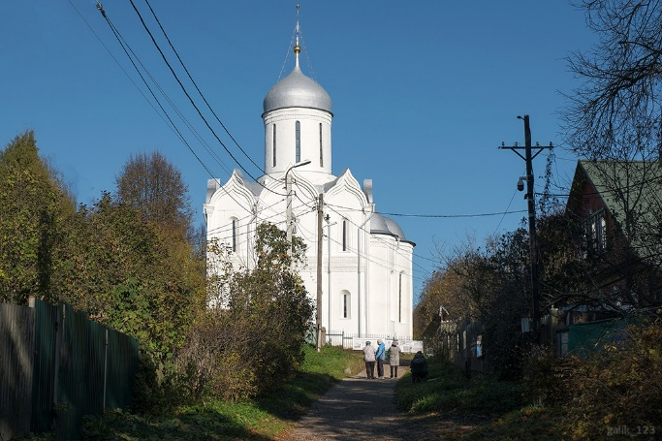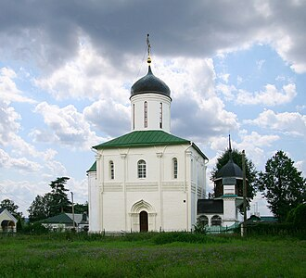
Figure 2 Assumption Cathedral, 2025/2012

The cathedral was built in the ancient part of Zvenigorod, on the so-called Gorodok, a fortress surrounded by ramparts that have partially survived to this day. The customer of the construction was the Zvenigorod prince Yuri Dmitrievich, the younger brother of the Moscow prince Vasily I.
The bell tower of the cathedral was built at the beginning of the 19th century. In the same century, the chapel in honor of the great martyr George, which originally existed in the deacon's room, was abolished. In 1837, the temple was reconstructed: the original keeled zakomaras and kokoshniks were cut down and replaced with a hipped wooden roof over the vaults, some windows were widened, and the old painting were mostly knocked down.
In 1918, restorers led by Igor Grabar partially dismantled the late iconostasis, revealing the remains of the original paintings. The cathedral was closed in the 1930s and reopened in 1946. Since the late 1990s, it has been a courtyard of the Savvino-Storozhevsky Monastery.
After 2009, a comprehensive restoration began, largely completed by the end of 2024. During the restoration, all nine zakomaras and four corner kokoshniks were restored, using the fragments that had survived under the later roof. The window openings were made narrow again, the carved frieze, capitals of the half-columns, and other decorations were repaired.
The Dormition Cathedral is the first of four surviving white-stone Moscow churches from the late 14th - first quarter of the 15th century.
Immediately after its construction, the Assumption Cathedral was painted with murals, the creators of which apparently came from the Moscow court environment. Only separate fragments of the paintings survived, uncovered in 1918 by an expedition of the Commission for the Preservation and Disclosure of Old Russian Painting under the leadership of Nikolai Protasov and artist-restorer Grigory Chirikov. In the same year, in a report compiled by Igor Grabar, the first assumption about the authorship of the painting was made: "... the paints give a rich range of tones, which, in connection with the general character of the drawing and types of faces, suggests the hand of a master of the Rublev’s school".
The uncovered fragments of the original painting are located in the drum of the dome, in the altar, on the eastern pillars-pylons and the northern wall of the temple, in the northwestern corner of the choir. The remaining surviving paintings of the temple were made in the 30s of the XIX century. In 1918, during the restoration of the cathedral's wall painting, three icons were found here that were once part of the half-length Deesis tier: Christ the Almighty, Archangel Michael, and Apostle Paul. They are currently kept in the collection of the Tretyakov Gallery.
  - Trinity Cathedral of the Trinity Lavra, Sergiyev Posad (Russia)
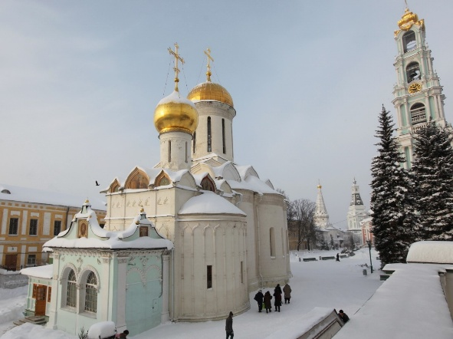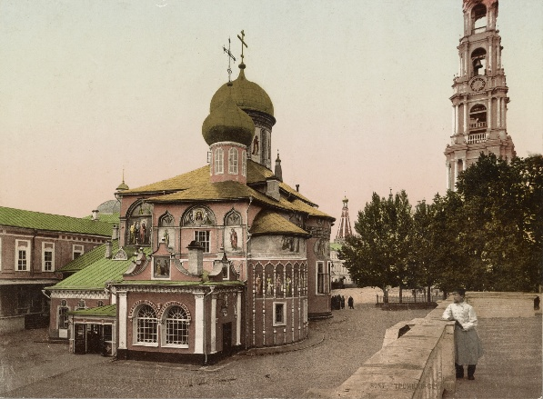
Figure 3 Trinity Cathedral, 2025/1896
Trinity Cathedral is an Orthodox church in the city of Sergiev Posad in the Moscow Region, a cathedral and the oldest surviving building of the Trinity Lavra of St. Sergius. The main shrine of the cathedral is the relics of St. Sergius of Radonezh. Inside the cathedral, there are preserved paintings from the early 15th century, attributed to Andrei Rublev and Daniil Cherny. For the iconostasis of the cathedral, Andrei Rublev created the famous icon "Trinity".
The cathedral was erected in 1422-1423 by Nikon of Radonezh in honor of the founder of the monastery, St. Sergius of Radonezh. Typologically, Trinity Cathedral is one of the few surviving monuments of early Moscow architecture of the late 14th - early 15th centuries.
The formation of the architectural ensemble of the monastery began with the Trinity Cathedral. On the western facade in the 16th century, a porch was added, and on the south-eastern side in 1548, over the tomb of Abbot Nikon, a pillarless single-apse Nikon chapel was built. In 1623, the upper part of the chapel was rebuilt.
The icons and wall paintings of the Trinity Cathedral were made by a team of craftsmen under the direction of the Reverend Andrei Rublev and Daniil Cherny in 1425-1427. The icon "Trinity" was painted as the main temple icon "in praise of the Reverend Sergius" – the great work of Andrei Rublev and the most famous work of Russian icon painting in the world.
Andrei Rublev and his workshop painted the icons of the three rows of the iconostasis: the Deesis, the Festive, and the Prophetic ranks.
Unlike the iconostasis, the original wall painting of the Trinity Cathedral has been almost completely lost, with the exception of a small fragment in the altar of the church. In 1635, the murals of the cathedral were restored while preserving the iconographic scheme of the ancient painting. In the following centuries, the painting was repeatedly renewed and covered with new paintings (the last time was in 2002-2004).
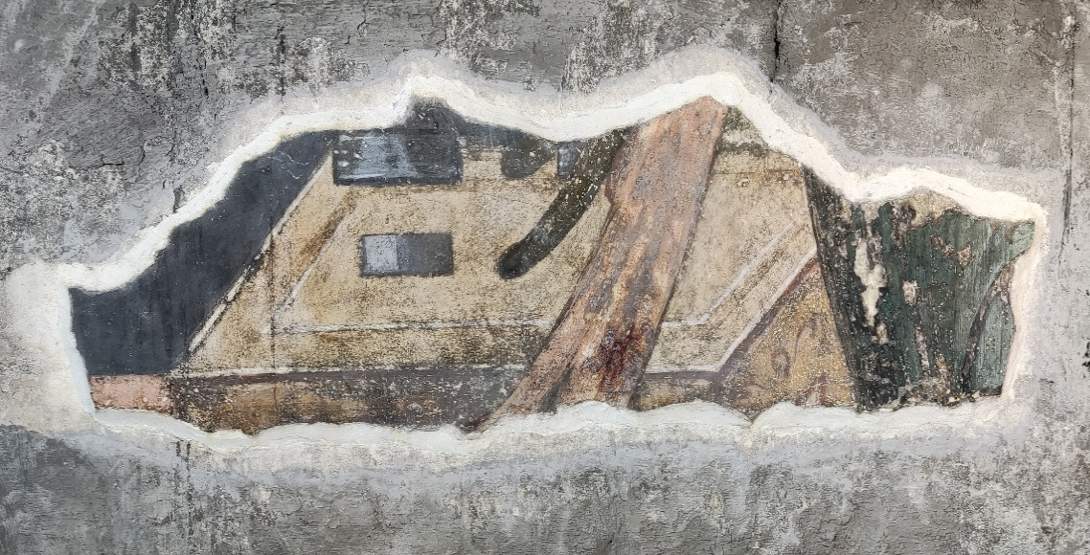
Figure 4 Composition "Annunciation"

The restoration of the Trinity Cathedral began in 1925 with the dismantling of the later northern porch and the restoration of the white stone masonry of the northern facade. The work was supervised by the architect D.P. Sukhov. In 1926, he also restored three of the five previously hewn window openings in the apses of the church.
In 1939-40 Stratigraphic investigation (the stepwise removal of covering pain layers for analysis) trial uncovering was carried out to find traces of 15th century paintings. The restoration of the wall painting was completed in 1953. In 1954, under the direction of architect V. I. Baldin, the restoration of the cathedral facades was resumed: they were cleared of the canvas and oil paintings of the 18th-19th centuries pasted onto them, and the ancient forms of the portals and window openings were restored. In 1966, this stage of the restoration was completed with the restoration of the zakomara covering.
- Materials and methods

Measurement points of various pigments for in situ XRF investigations on the interior walls of the Cathedral were chosen by the restorers in such a way as to study all possible colors. For comparison the XRF spectra of plasters were regularly collected in the places of losses. Also pigments and plasters from fragments found during archaeological excavations were studied by portable XRF. The total number of XRF spectra measurement points was 150. Specially selected samples, including pigments and plasters from the inner walls of the Cathedral were subjected to additional in-depth laboratory analysis by different methods.

2.1 X-ray fluorescence analysis (XRF)
The elemental composition of pigments and plasters was determined by XRF portable spectrometer Bruker Tracer 5i under the following policies: a collimator with 8 mm diameter was used; a built-in video camera was used to position the spectrometer; the spectra of each color were collected at least in three measurement points, thus eliminating the possibility of outliers; the spectra were processed with Artax software.
  - Neutron activation analysis (NAA)
Before irradiation the surface of the samples was mechanically cleaned with a Dremel multifunctional tool equipped with a diamond-coated disc. Before processing each sample, the disc and the body of the instrument were wiped with cotton swabs soaked in ethanol. The samples were powdered and dried to a constant mass at 105 °C. Two subsamples of approximately 0.1 g were weighed and packed in double plastic bags: the first subsample – to determine the mass fractions by short-lived isotopes (SLI) and the second one – for medium- and long-lived isotopes (MLI and LLI). Samples were irradiated at the WWR-K reactor at the Institute of Nuclear Physics (INP), Almaty, Kazakhstan. To determine the elemental composition by SLI samples were irradiated for 60 s in a “dry” channel. Pneumatic transport system was used to deliver samples to irradiation zone and back. The approximate flux density of thermal neutrons in the “dry” channel is 4×10¹² n/(cm²s), resonance ones − 4×10¹⁰ n/(cm²s). The SLI spectra were measured by the Canberra GC-2018 detector with the relative efficiency of 20% and the resolution of 1.8 keV for the Co-60 gamma line with energy of 1332 keV. To obtain MLI and LLI samples were manually loaded into one of the “wet” channels for 1.5 h. In the “wet” channel the fluxes of thermal and resonance neutrons are approximately 6×10¹³ and 3×10¹² n/(cm²s) respectively. The MLI spectra were collected six days after the end of irradiation, and the LLI ones – three weeks after irradiation, using the automatic spectra measurement system developed in FLNP JINR,.
The system includes the ORTEC GEM40P4-83 detector with the relative efficiency of 40% and the resolution of 1.85 keV for the Co-60 gamma line with the energy of 1332 keV. Quality control was carried out using NIST standard samples. 1632E, 2586, 2706, 2709A, 2782 standard samples were used for the SLI; 1566B, 1632E, 1633C, 2586, 2706, 2431 for MLI and LLI. Standards were weighed and packed in the same way as the studying samples. The spectra were processed using the GENIE-2000 software. To calculate mass fractions of elements by the relative NAA method, Concentration program developed at the FLNP JINR was used.
  - Polarized microscopy
Visualization of the color layers and plasters was carried out using a LOMO L-215 POLAM microscope. Film polarizers rather than Nicol prisms are applied in the design of this instrument. A built-in MC-5.3 digital camera was used to take micro photos with a resolution of 5.3 megapixels. The images were processed in the MCview software. The magnification was selected experimentally to obtain the most informative photos. Pigment species for PM were placed between the slide and the cover glasses using a Canada balsam as mounting medium. Pigments were identified according to methods from work.

2.4 Optical microscopy of polished cross-sections
Reflected-light optical microscopy (OM) was applied for determination the number and order of the painting layers. Micro-probes were taken from the wall painting fragments in such a way as to capture all available layers of painting and partially the plaster. Then they were embedded in magnesian cement, air dried and polished with abrasive paper. Polished cross-sections were prepared as described in. Cross-sections were studied under a microscope both in visible (Polam 215) and ultraviolet light (LOMO). The micrographs were taken using MC-5.3 (LOMO) camera and processed via MCView software.
  - Micro-Raman spectroscopy
Raman spectra were recorded with the Raman microscope RamMics M532/785/1064 (EnSpectr) equipped with objectives of magnification of 10, 20, and 50×. Two single mode lasers emitting at 532 nm (spectral range of 160-4000 cm⁻¹, spectral resolution of 5-7 cm⁻¹) and 785 nm (spectral range of 200-2300 cm⁻¹, spectral resolution of 7-9 cm⁻¹) were used. The laser power was decreased from maximum to prevent pigment degradation. The spectra collection and processing was carried out with EnSpectr software.
  - Fourier transform infrared spectroscopy
ATR-FTIR (Attenuated Total Reflectance) spectra of pigments and plasters were measured using Invenio-R (Bruker) spectrometer in 4000–400 cm⁻¹ spectral range with a resolution of 4 cm⁻¹. Individual compounds were identified using pigment libraries and the IRUG Internet database.
No special preparation was needed for pigments and plasters. A sample was scalped from wall painting fragment and placed on ATR crystal for analysis.

- Results

X ray fluorescence analysis (XRF)
Annunciation Cathedral, Moscow
Pigments from the early 15th century were taken from an archaeological excavation. A thorough analysis of the pigment and plaster compositions was conducted. The results of the semi-quantitative elemental analysis and conclusions about the probable mineral composition of the primary paints are presented in Table 1. From here on, since the elemental composition of the pigments is compared to the composition of the plaster, the following notations have been used: an element is highlighted in bold if its mass fraction is greater than that of the same element in the plaster.
Table 1 Semiquantitative elemental composition data for in situ XRF analysis summarized for several measuring points (MPs). Annunciation Cathedral, Moscow
Sample | MPs | Elements | Supposed minerals
Plaster | 20 | Ca, Fe, K, Mn, Si, S, Al | Calcite
Red | 5 | Ca, Fe, K, Hg, Mn, Si, S, Al | Goethite,  Hematite,  Cinnabar,  Clay/quartz
Yellow | 6 | Ca, Fe, K, Mn, Si, S, Al | Goethite  Clay/quartz
Green | 9 | Ca, Fe, K, Mn, Si, S, Al | Glauconite/  celadonite
Blue | 3 | Ca, Fe, K, Hg, Mn, Si, S, Al | Goethite,  Cinnabar
Black | 12 | Ca, Fe, K, Mn, Si, S, Al | Goethite,  Clay/quartz
Red-Brown | 4 | Ca, Fe, K, Hg, Mn, Si, S, Al | Goethite,  Hematite,  Cinnabar

Calcium is the dominant element in the plaster base, making lime its primary component. Silicon and aluminum impurities detected indicate the presence of clay minerals and sand.
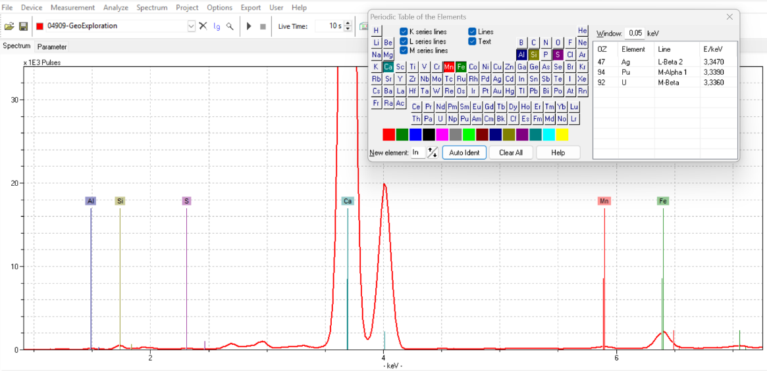
Figure 5 Elemental composition of plaster from the Annunciation Cathedral
The elevated iron content of the yellow and red pigments indicates the use of yellow and red ocher (the main color minerals are goethite α-FeOOH and hematite Fe₂O₃, respectively). The presence of silicon and aluminum in these paints indicates the presence of various clay minerals and sand.
The red paint of some samples also contains mercury and elevated iron content, suggesting that the artist likely used cinnabar (HgS) in conjunction with red ocher.
The high iron, silicon, and potassium content of the green pigment indicates the presence of green earth, which may contain minerals such as glauconite ((K,Ca)(Mg,Fe,Al)₂[(Al,Si)Si₃O₁₀](OH)₂) or celadonite (K(Mg,Fe,Al)₂[Si₄O₁₀](OH)₂).
The compound pigment "reft," a mixture of charcoal and lime, is most often used for backgrounds in mural paintings. Reft could also later be scumbled with blue, green, or red colors. Carbon cannot be detected by X-ray fluorescence analysis.
Lazurite was not detected in the blue color using the X-ray fluorescence method, but its presence was confirmed by other research methods - polarized microscopy and micro-Raman spectroscopy.
It should be noted that high calcium content was detected in the lighter areas of the painting (Table 1), indicating that the paints were whitened with lime (CaCO₃). In this situation, it is difficult to determine the paint base, since only a small amount of pigment is required to change the paint's hue.
Assumption Cathedral in Gorodok, Zvenigorod
Pigments from the turn of the 14th and 15th centuries from an archaeological excavation. A thorough analysis of the pigments and plaster composition was conducted. The results of the semi-quantitative elemental analysis and conclusions about the possible mineral composition of the primary paints are presented in Table 2.
Table 2 Semiquantitative elemental composition data for in situ XRF analysis summarized for several measuring points (MPs). Assumption Cathedral in Gorodok, Zvenigorod
Sample | MPs | Elements | Minerals
Plaster | 23 | Ca, Fe, K, Mn, Si, S, Al, Ti | Calcite
Red | 6 | Ca, Fe, K, Hg, Mn, Si, S, Al | Goethite,  Hematite,  Cinnabar  Clay/quartz
Yellow | 5 | Ca, Fe, K, Mn, Si, S, Al | Goethite  Clay/quartz
Green | 2 | Ca, Fe, K, Mn, Si, S, Al | Glauconite/  Celadonite,  Goethite
Blue | 4 | Ca, Fe, K, Mn, Si, S, Al | Goethite
Black | 4 | Ca, Fe, K, Mn, Si, S, Al | Goethite,  Clay/quartz
Grey | 5 | Ca, Fe, K, Mn, Si, S, Al | Goethite

Calcium is the dominant element in the plaster base, making lime its primary component. Silicon and aluminum impurities detected indicate the presence of clay minerals and sand.
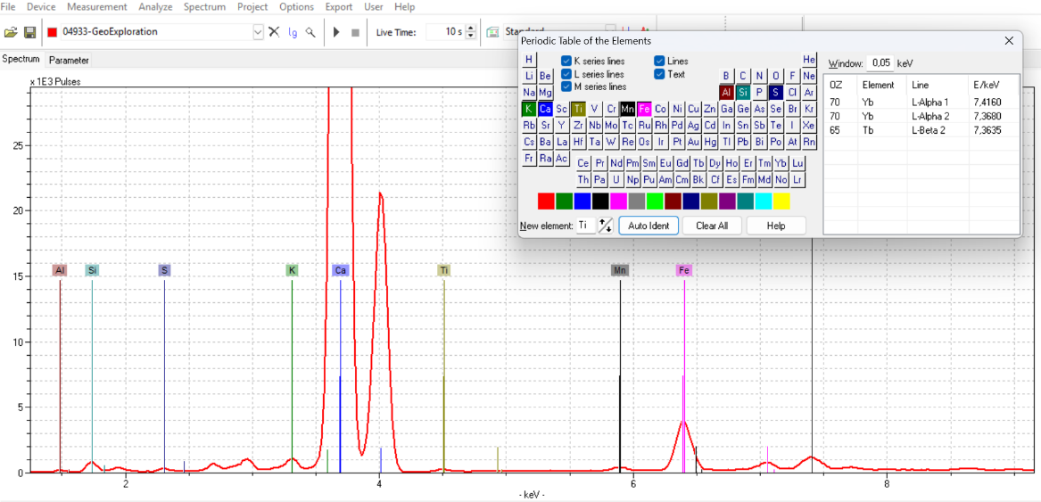
Figure 6 Elemental composition of plaster from the Assumption Cathedral in Gorodok
Yellow and red ochre, cinnabar, and green earth were found as the main pigments. Ultramarine could not be detected by this method.

Trinity Cathedral of the Trinity Lavra, Sergiyev Posad
Mid-15th century pigments from the northeast pillar of the "Annunciation" composition. A thorough analysis of the pigment and plaster composition was conducted. The results of the semi-quantitative elemental analysis and conclusions about the probable mineral composition of the primary paints are presented in Table 3.
Table 3 Semiquantitative elemental composition data for in situ XRF analysis summarized for several measuring points (MPs). Trinity Cathedral of the Trinity Lavra, Sergiyev Posad.
Sample | MPs | Elements | Minerals
Plaster | 3 | Ca, Fe, K, Mn, Si, S, Al, Ti | Calcite
Red | 6 | Ca, Fe, K, Mn, Si, S, Al, Ti, Hg, Pb | Goethite,  Hematite,  Cinnabar,  Gypsum
Yellow | 6 | Ca, Fe, K, Mn, Si, S, Al, Ti, Cu, Hg, Pb | Goethite,  Gypsum
Orange | 6 | Ca, Fe, K, Mn, Si, S, Al, Ti, Hg, Pb | Goethite,  Hematite,  Cinnabar,  Gypsum
Green | 5 | Ca, K, Mn, Si, S, Al, Ti, Cu, Pb | Malachite or verdigris,  Gypsum
Black | 6 | Ca, Fe, K, Si, S, Al, Ti, Cu, Hg, Pb | Gypsum
White | 10 | Ca, Fe, K, Mn, Si, S, Al, Ti | Calcite,  Gypsum

Calcium is the dominant element in the plaster base, making lime its primary component. Silicon and aluminum impurities detected indicate the presence of clay minerals and sand.
Yellow and red ochre, cinnabar, and verdigris were found as the main pigments.
The presence of a large amount of sulfur (S) is explained by the remains of gypsum plaster, which the restorers were unable to remove completely.
Polarized and optical microscopy
Polarization microscopy was used to confirm, and in some cases, to refine the pigment composition. This simple yet highly visual tool allows one to determine the mineral composition of paints.
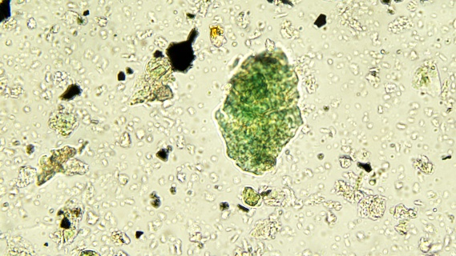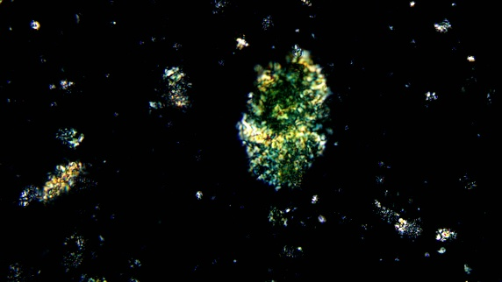
Figure 7 Glauconite/Celadonite. Annunciation Cathedral, Moscow
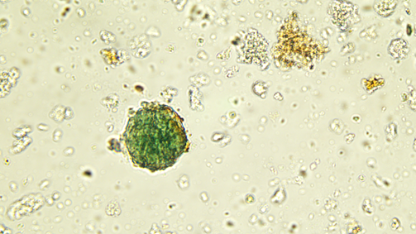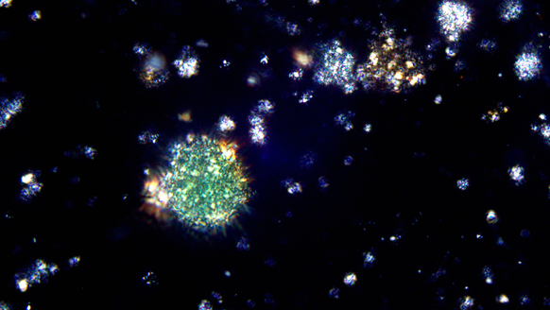
Figure 8 Glauconite/Celadonite. Assumption Cathedral in Gorodok, Zvenigorod
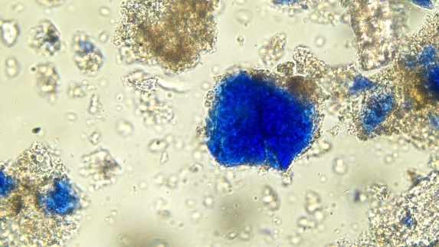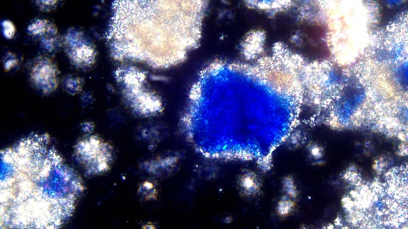
Figure 9 Lazurite. Annunciation Cathedral, Moscow
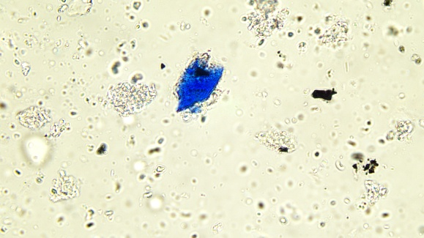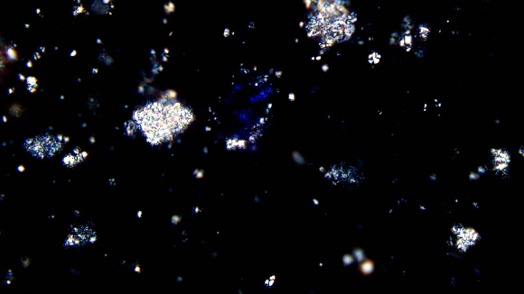
Figure 10 Lazurite. Assumption Cathedral in Gorodok, Zvenigorod
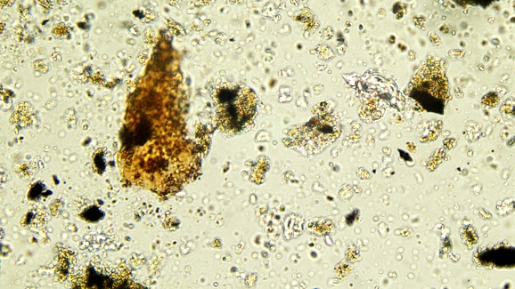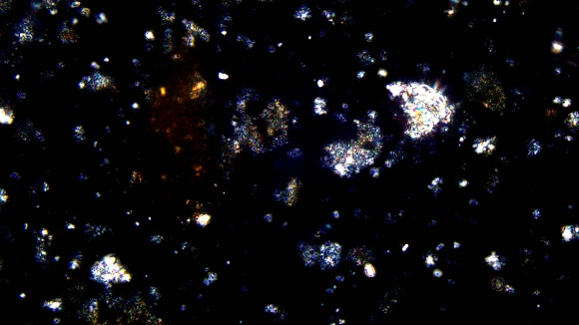
Figure 11 Goethite. Annunciation Cathedral, Moscow
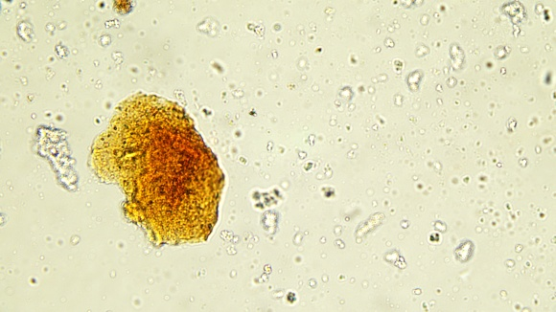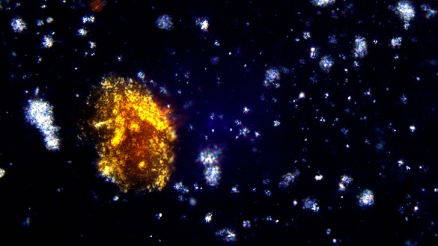
Figure 12 Goethite. Assumption Cathedral in Gorodok, Zvenigorod
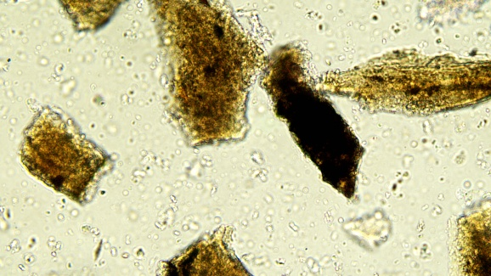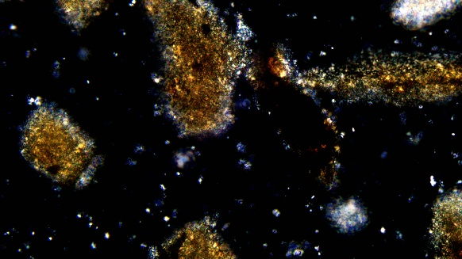
Figure 13 Goethite. Trinity Cathedral of the Trinity Lavra, Sergiyev Posad
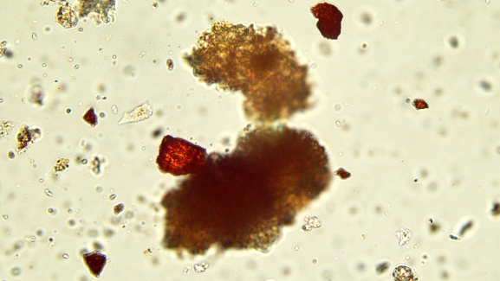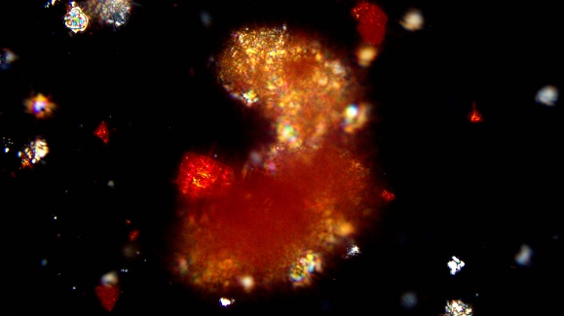
Figure 14 Cinnabar. Annunciation Cathedral, Moscow
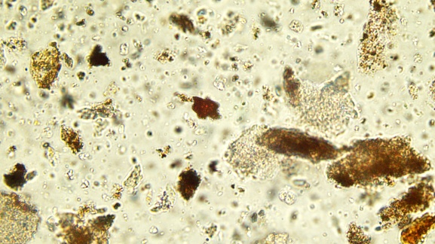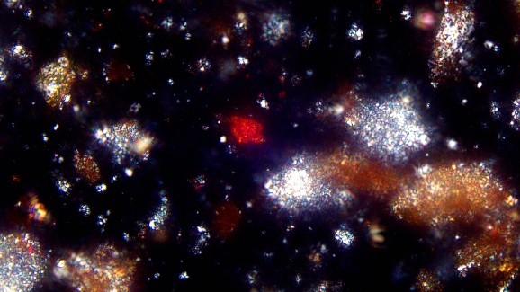
Figure 15 Cinnabar. Assumption Cathedral in Gorodok, Zvenigorod
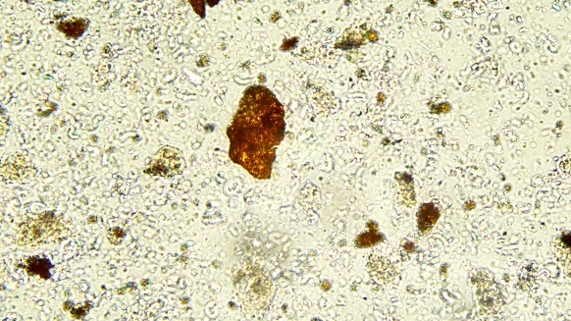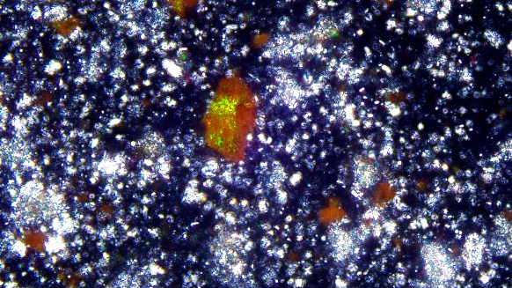
Figure 16 Red lead. Trinity Cathedral of the Trinity Lavra, Sergiyev Posad
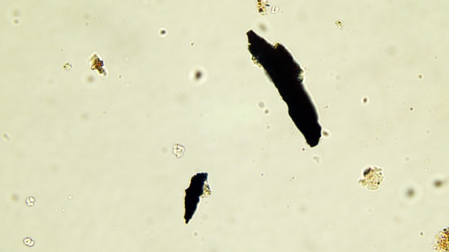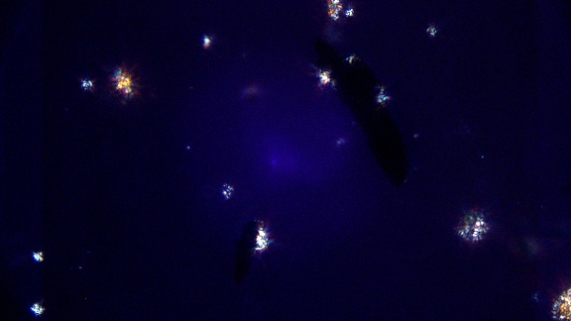
Figure 17 Coal. Annunciation Cathedral, Moscow
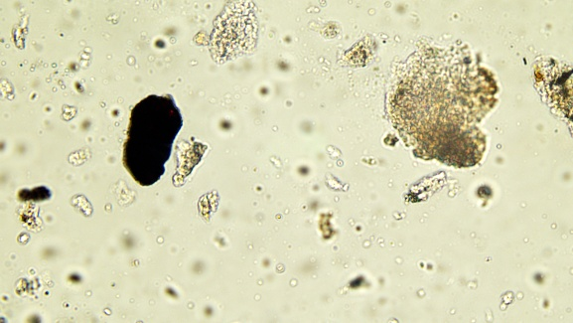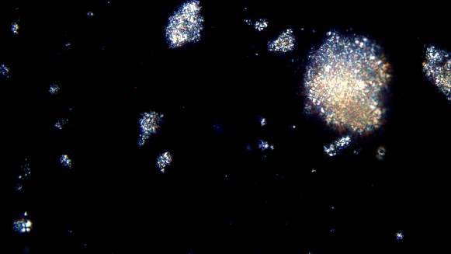
Figure 18 Coal. Assumption Cathedral in Gorodok, Zvenigorod
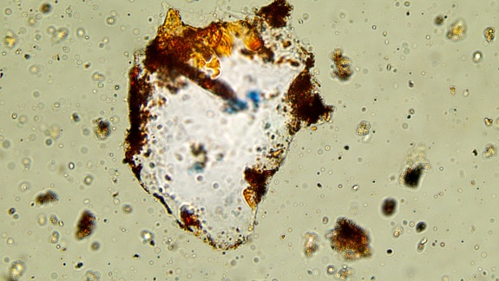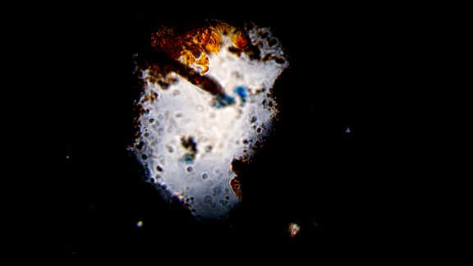
Figure 19 Clay/quartz. Annunciation Cathedral, Moscow
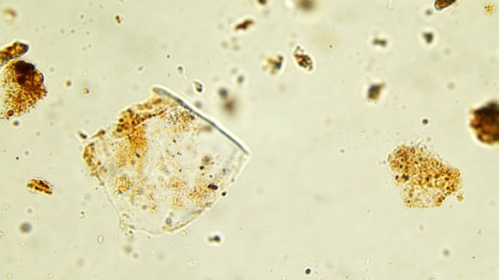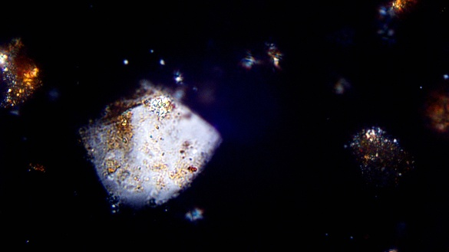
Figure 20 Clay/quartz. Assumption Cathedral in Gorodok, Zvenigorod
The specimens contain blue crystals that are not visible under crossed polarizers. These optical properties are characteristic of lazurite (Figure 9, Figure 10). Clusters of small red or yellow particles can also be seen, which retain their color and transparency under cross-polarizers (Figure 11, Figure 12, Figure 13). These properties are characteristic of ochre. The elongated black particles are carbon (Figure 17, Figure 18). The light and dark green particles, which darken under cross-polarizers, are pigments such as glauconite and celadonite (Figure 7, Figure 8). The brightly glowing red particles are cinnabar (Figure 14, Figure 15). Red lead glows green under crossed polarizers (Figure 16). Feldspar or quartz are large glassy particles that have a semi-permanent milky hue under crossed polarizers (Figure 19, Figure 20).
Optical microscopy of polished cross-sections
To determine the number and order of paint layers, polished cross-sections were examined.
Samples from all three cathedrals have no overprints, and therefore consist of three main layers: the plaster base, the paint layer, and soot (surface dirt) (. It is worth noting that the author's painting is not always single-layered, which can be seen in the cross-section.

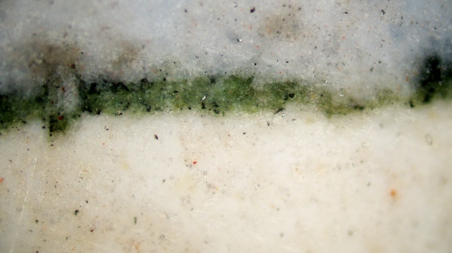
Figure 21 Cross-sections from the Annunciation Cathedral
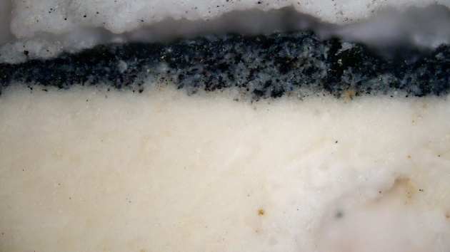
Figure 22 Cross-sections from the Assumption Cathedral in Gorodok

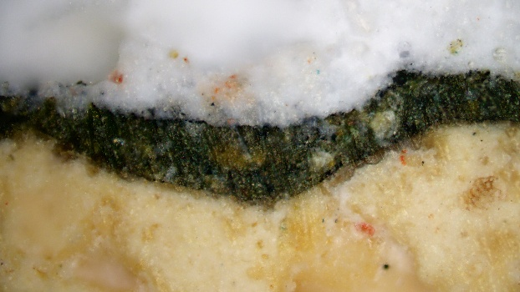
Figure 23 Cross-sections from the Trinity Cathedral of the Trinity Lavra
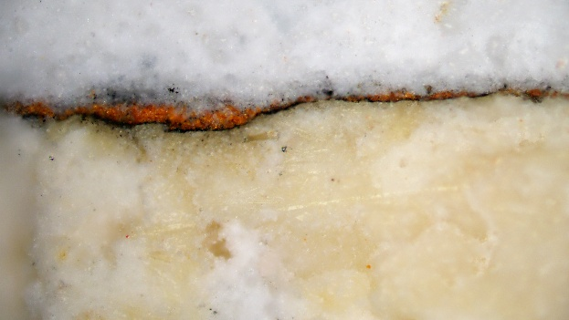
Figure 24 Cross-sections from the Trinity Cathedral of the Trinity Lavra, two layers of paintings

Micro‑Raman and Infrared spectroscopy
Micro-Raman and infrared spectra were obtained from blue-blue samples from the Annunciation Cathedral and Assumption Cathedral in Gorodok. The IR spectra contain peaks corresponding to acetate groups, indicating the use of lazurite.

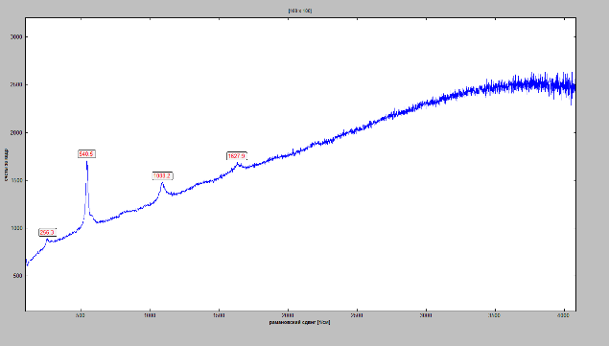
Figure 25 Micro-Raman spectra. Lazurite
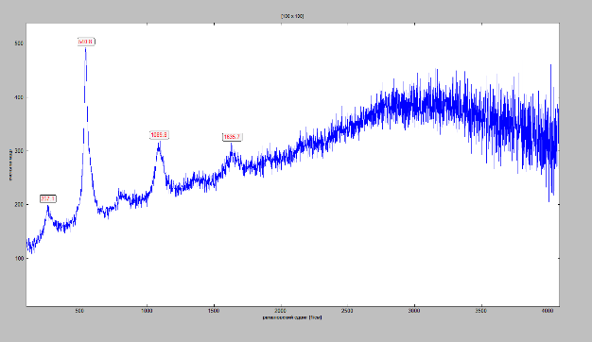
Figure 26 Micro-Raman spectra. Lazurite

Also micro-Raman and infrared spectra were obtained from blue-blue samples from the Trinity Cathedral of the Trinity Lavra. The IR spectra contain peaks corresponding to acetate groups, indicating the use of verdigris.
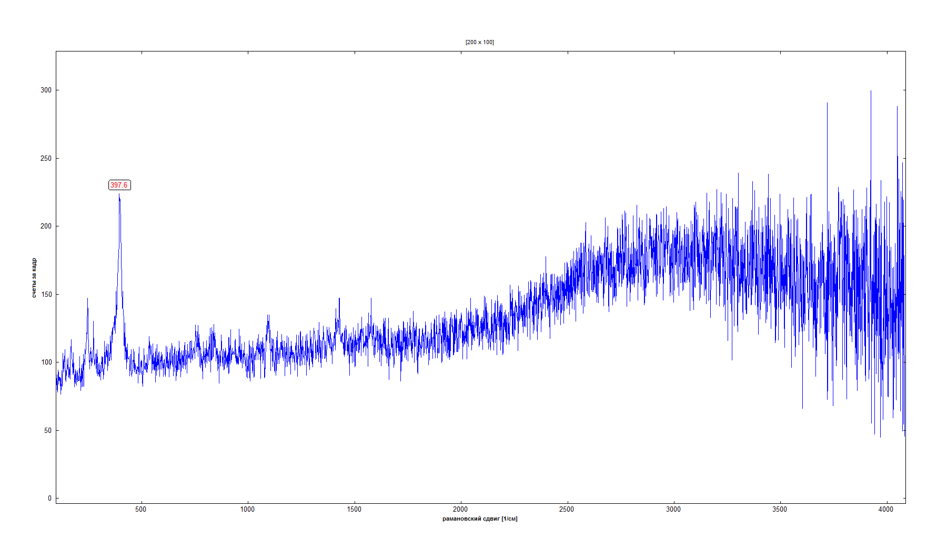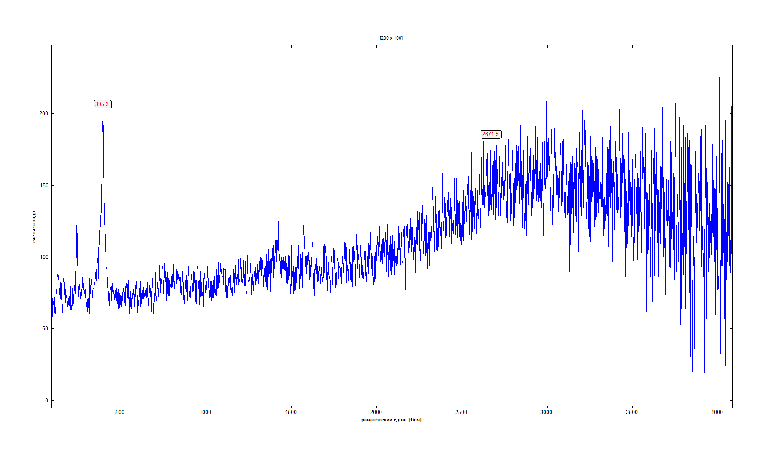
Figure 27 Micro-Raman spectra. Verdigris
Neutron activation analysis (NAA)
32 fragments of plaster bases from three Cathedrals were prepared for irradiation and transferred to the Institute of Nuclear Physics (Almaty, Kazakhstan). A full set of elemental composition data for plaster samples from the three cathedrals will be processed and obtained later due to the significant duration of the analysis process (1.5-2 months).

- Conclusion

A comprehensive physicochemical study of 14th-15th-century murals from three cathedrals was conducted: Annunciation Cathedral, Moscow (Russia); Assumption Cathedral in Gorodok, Zvenigorod (Russia); Trinity Cathedral of the Trinity Lavra, Sergiyev Posad (Russia).
Six methods were used in this study. Most fragments were examined using X-ray fluorescence analysis, polarized microscopy, optical microscopy of polished cross-sections. To clarify controversial issues, several samples were studied using Raman and IR spectroscopy. The use of various complementary methods provided a solid basis for representative results and allowed conclusions to be drawn about the pigment composition of the paints.
The basic pigment set is similar across all monuments, as these pigments were widely used and were typical for wall paintings. However, particles of the same pigments on different monuments can visually vary in color, shape, size, and brightness. Elemental analysis of the primary colors on the walls and archaeological samples, presumably dating back to the original 14th-15th century murals, revealed the main pigments used: yellow and red ochre, green earth, lapis lazuli, cinnabar, and "reft" (lime white and charcoal).
Particularly noteworthy is the discovery of verdigris using X-ray fluorescence and Raman spectroscopy, as well as red lead using polarization microscopy.
The elemental composition of some plaster bases was determined using neutron activation analysis.
The study of the murals using physicochemical methods opens up a new level of knowledge about the murals and enables accurate attribution.
- References

The Annunciation Cathedral of the Moscow Kremlin: Materials and Research / edited by L. Shchennikova. — M.: State Historical and Cultural Museum-Reserve "Moscow Kremlin", 1999. — 376 p.
Melnik A. G. On the wall painting of the Annunciation Cathedral of the Moscow Kremlin, 1566 // "The Caesar will rise in the desolate land": people, time and space of Russian history. On the 70th anniversary of Professor N.S. Borisov. Collection of scientific articles. - St. Petersburg: Aleteya, 2020. - Pp. 273-279. - ISBN 978-5-00165-171-0.
Ulyanov O. G. "The Deesis of St. Andrew's Letter by Rublev" from the Annunciation Church of the Moscow Kremlin (on the 575th anniversary of the death of the venerable icon painter) // Makarievsky Readings. Issue XII: Hierarchy in Ancient Rus'. - 2015. - Pp. 172-222.
Ognev B. A. Assumption Cathedral in Zvenigorod on Gorodok. / Materials and research on the archeology of the USSR. — Vol. 44. - M., 1955. - P. 20-58.
Sarabyanov V.D., Smirnova E.S. History of Old Russian painting. - M.: PSTGU Publishing House, 2007.
Lazarev V. N. Andrei Rublev and his school. — Moscow: Iskusstvo, 1966.
Lazarev V. N. Chapter VI, Part 17. Iconostasis of the Trinity Cathedral of the Holy Trinity Lavra of St. Sergius // Russian icon painting from its origins to the beginning of the 16th century. — Moscow: Iskusstvo, 2000. — Pp. 108-111. — 152 p.
Smirnova T. V. From the history of the restoration of the murals of the Trinity Cathedral of the Lavra // Proceedings of the State Historical Museum. Zabelin Scientific Readings – 2010. — Moscow, 2012. — Issue. 190. — Pp. 441–455.
Bal'din V. I., Manushina T. N. Trinity Lavra of St. Sergius. Architectural ensemble and art collections of ancient Russian art of the 14th-17th centuries. — Moscow: Nauka, 1996. — ISBN 5-02-012778-3.
Pavlov SS, Dmitriev AY, Chepurchenko IA, Frontasyeva MV. Automation system for measurement of gamma-ray spectra of induced activity for multi-element high volume neutron activation analysis at the reactor IBR-2 of Frank Laboratory of Neutron Physics at the Joint Institute for Nuclear Research. Phys Part Nucl Lett [Internet]. Pleiades Publishing Ltd; 2014;11:737–42. Available from: https://doi.org/10.1134/s154747711 4060107.
Pavlov SS, Dmitriev AY, Frontasyeva MV. Automation system for neutron activation analysis at the reactor IBR-2, Frank Laboratory of Neutron Physics, Joint Institute for Nuclear Research, Dubna, Russia. J Radioanal Nucl Chem. Springer Netherlands; 2016;309:27–38. Available from: https://doi. org/10.1007/s10967-016-4864-8.
Dmitriev AY, Pavlov SS. Automation of the quantitative determination of elemental content in samples using neutron activation analysis on the IBR-2 reactor at the Frank Laboratory for Neutron Physics, Joint Institute for Nuclear Research. Phys Part Nucl Lett [Internet]. Pleiades Publishing Ltd; 2013;10:33–6. Available from: https://doi.org/10.1134/s154747711 3010056.
Pisareva SA. Method of identification of primers and pigments of paintings. Izhevsk; 2017 (in Russian).
Lungina LN, Bratushko YI. The role of polished cross-sections studies for the examination of painting. Proc 5th Sci Conf “Examination Attrib Work Anc Russ Art.” 2001. p. 267–70 (in Russian).
Home | IRUG [Internet]. [cited 2021 Sep 13].
Caggiani MC, Cosentino A, Mangone A. Pigments Checker version 3.0, a handy set for conservation scientists: a free online Raman spectra database. Microchem J. Elsevier B.V.; 2016;129:123–32.
Bell IM, Clark RJH, Gibbs PJ. Raman spectroscopic library of natural and synthetic pigments (pre-∼ 1850 AD). Spectrochim Acta Part A Mol Biomol Spectrosc. 1997;53:2159–79.

