

JOINT INSTITUTE FOR NUCLEAR RESEARCH
Frank Laboratory of Neutron Physics

FINAL REPORT ON THE
START PROGRAMME

STUDIES OF RARE EARTH METAL NANOSTRUCTURES Tb

Supervisor:
Vladimir Dmitrievich Zhaketov

Student:
Danila Arbuzov, Russia
Kazan Federal University

Participation period:
October 05 – November 15,
Summer Session 2025

Dubna, 2025

Annotation
The paper presents the results of a comprehensive study of the magnetic structure of thin terbium films grown on a niobium substrate. Using complementary methods of neutron reflectometry and X-ray diffraction, it was found that the films retain a helicoidal magnetic ordering in the temperature range 220-228 K, close to the characteristics of a bulk crystal. The angle of rotation of the magnetic moment on the monolayer (21.67°) exceeding the values for the bulk sample is determined, which is explained by the influence of epitaxial stresses and reduced dimensionality. It is shown that the critical field of destruction of the spiral structure is ~650 Oe. The work demonstrates the possibility of stabilizing complex magnetic phases in thin-film systems and reveals specific effects associated with dimension limitation.
Introduction
Heavy rare earth metals from gadolinium to ytterbium represent a unique object for fundamental research in the field of magnetism. They are chemically similar, but have very different magnetic moments, which leads to a remarkable variety of their magnetic properties [1]. These metals can be in various magnetic phases, such as paramagnetic, antiferromagnetic, and ferromagnetic, with characteristic Neel and Curie transition temperatures.
In the ordered state, heavy REM, such as terbium and dysprosium, have complex magnetic structures. One of the most interesting is the helical spiral, where the magnetic moments of atoms in successive planes rotate at a certain angle, forming a helical structure [2]. A comprehensive study is needed to fully understand the magnetic properties. X-ray diffraction is used to control crystal perfection, and neutron studies are the most powerful for direct study of the magnetic structure. Neutrons, having a magnetic moment, interact very sensitively with the magnetic moments of atoms.
Among the neutron techniques for studying thin-film nanostructures and magnetic spirals, neutron reflectometry stands out in particular. This method is ideally suited for the study of thin films, allowing probing the deep magnetization profile, determining the period of the helical spiral and investigating the influence of external influences on the magnetic order.
In this work, nanostructures based on terbium and dysprosium are the object of research. The aim of this work is to comprehensively study the magnetic structure in thin-film nanostructures based on Tb, in particular, to identify and study the parameters of the helicoidal ordering using neutron reflectometry using X-ray diffraction.
The relevance of the work is due to the fact that although complex magnetic structures such as helicoidal phases have been studied in detail in bulk crystals, their behavior in thin films and nanostructures remains poorly understood. The transition to a system with a reduced dimension radically changes the conditions for the magnetic order. The limitation of thickness, the presence of interfaces, and elastic stresses strongly affect key parameters: exchange interaction, magnetic anisotropy, and, consequently, the stability and period of the helical spiral. Thus, the systematic study of magnetism in thin-film rare-earth systems is an urgent fundamental task that makes it possible to establish how thickness limitation affects the formation of complex magnetic structures.
Research methods
- X-ray diffraction
X-ray radiation with a wavelength λ of about 1 Å is used to study crystal structures, since its wavelength is comparable to the interatomic distances. Diffraction occurs due to the interference of waves scattered on a periodic lattice.
The basis of the method is the Bragg-Wolfe model (Fig.1), according to which the diffraction maximum is observed under the condition that the difference in the course of rays reflected from neighboring atomic planes is equal to an integer number of wavelengths [3]. This condition is described by the formula 2dsinθ = nλ, where d is the interplane distance, θ is the sliding angle, and λ is the wavelength. The intensity of diffraction maxima depends on the arrangement of atoms in the cell, but the Bragg-Wolfe model is sufficient for qualitative analysis. This method makes it possible to determine the phase composition, texture, and stresses in a sample.
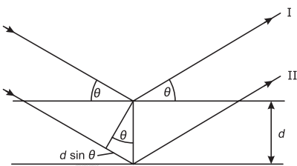
Fig. 1 – Graphical representation of Bragg's law

The experiments in this work were carried out on a PANalytical Empyrean Series 2 diffractometer in parallel beam geometry using parabolic mirrors to generate parallel radiation. The source was an X-ray tube with radiation Cu Kα₁ (λ = 1,541 Å).
- Neutron reflectometry
Unlike X-ray techniques, neutron reflectometry has direct sensitivity to magnetic ordering due to the presence of its own magnetic moment in the neutron. This makes it possible to directly study the spatial distribution of magnetization deep into the sample in the direction of the normal.
The method of polarized neutron reflectometry is of particular value, which makes it possible to quantify not only the magnitude, but also the orientation of the magnetization vector along the film depth [4]. This information is crucial for confirming the existence and detailed analysis of the parameters of the helicoidal spin structure in terbium films, such as the spiral period and its evolution under the influence of external conditions.
The experiments using polarized neutron reflectometry in this work were performed on a REMUR reflectometer (JINR LNF, Dubna). The general scheme of the device is shown in Fig. 2.
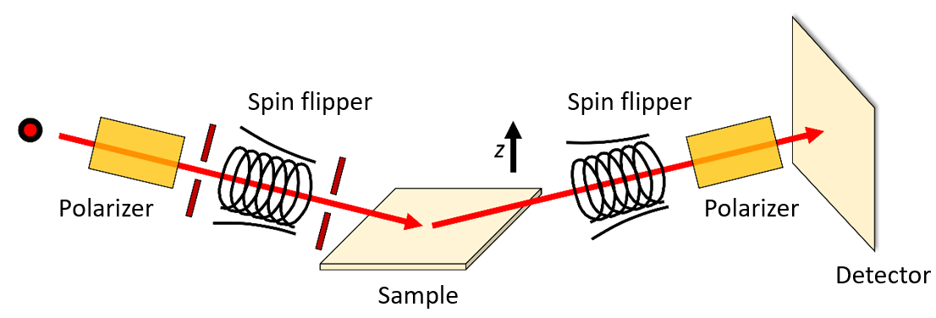
Fig. 2 – Diagram of the REMUR tool for full polarization analysis
The device operates on a pulsed neutron source, the IBR-2 reactor, which allows the use of time-of-flight (TOF) technology. Some of the neutrons passing through the moderator acquire the Maxwell spectrum and pass through the following parts of the reflectometer:
1. Polarizer: A magnetic super-mirror spatially separates the beam into spin states, reflecting, for example, the component with the spin "up".
2. Spin-flipper (incident beam): Using a combination of constant and oscillating magnetic fields, it can invert the spin of neutrons with high efficiency, allowing you to choose the initial polarization of the beam. At certain values of the field frequency and the time the neutron stays in such a field, resonance occurs and the neutron is highly likely to flip its spin.
3. Sample: The beam is collimated and falls on the sample at a fixed sliding angle.
4. Spin-flipper (reflected beam): Similar to the first one and allows you to control the state of the neutron spin after scattering on the sample.
5. Analyzer: It is similar to a polarizer and allocates only one spin component for detection.
6. Detector: A position-sensitive detector (SPD) registers neutrons depending on the coordinate and time of flight.
By controlling the spin-flipper modes, various elements of the neutron reflection matrix can be obtained.

Experimental results

1. X-ray reflectometry examination
An Empyrean diffractometer at λ = 1.54 Å (Cu Ka) was used to study the sample by X-ray reflectometry.. The data was processed in the Xpert Reflectivity program by selecting the analytical curve with the smallest discrepancy. During the fitting, the density, thickness, and roughness of each layer varied.
The results of the fitting, shown in Figure 3 and Table 1, showed that the roughness of the layers is significant and correlates with their thickness and position relative to the substrate. This leads to a rapid attenuation of intensity fluctuations after a critical angle, which degrades the data quality.

Layer | Density (fit/volume), g/cm3 | Thickness, nm | Roughness, nm
Nb₂O₅ + NbO + Nb | 7,53/ - | 26,1 | 4,71
Tb₂O₃ + TbO + Tb₄O₇ | 7,86/ - | 14,7 | 2,10
Tb | 8,28/8,27 | 78,6 | 6,30
Nb | 8,54/8,57 | 49,1 | 1,27
Al2O3(α-pl) | 3,99/3,99 | 10⁶ | 0,6
Table 1 – Sample parameters obtained by X-ray diffraction fitting

Fig. 3. Experimental and analytical curve of reflectometry

The results of diffraction in symmetrical geometry are confirmed (see Fig. 3) – the presence of terbium and niobium oxides in the film. It can be said that terbium oxides Tb2O3 and TbO form a crystalline structure, while Tb4O7 is an X-ray amorphous layer. The same can be said about the upper layer of niobium – NbO, Nb form a crystalline structure, while Nb2O5 becomes X-ray amorphous.

2. Investigation of the helicoidal magnetic ordering by neutron reflectometry
As a result of the experiment on polarized neutron reflectometry on the REMUR time-of-flight reflectometer, scattering maps were obtained in instrumental coordinates for a thin terbium film, an example of such a map in various coordinates is shown in Figures 4 and 5.
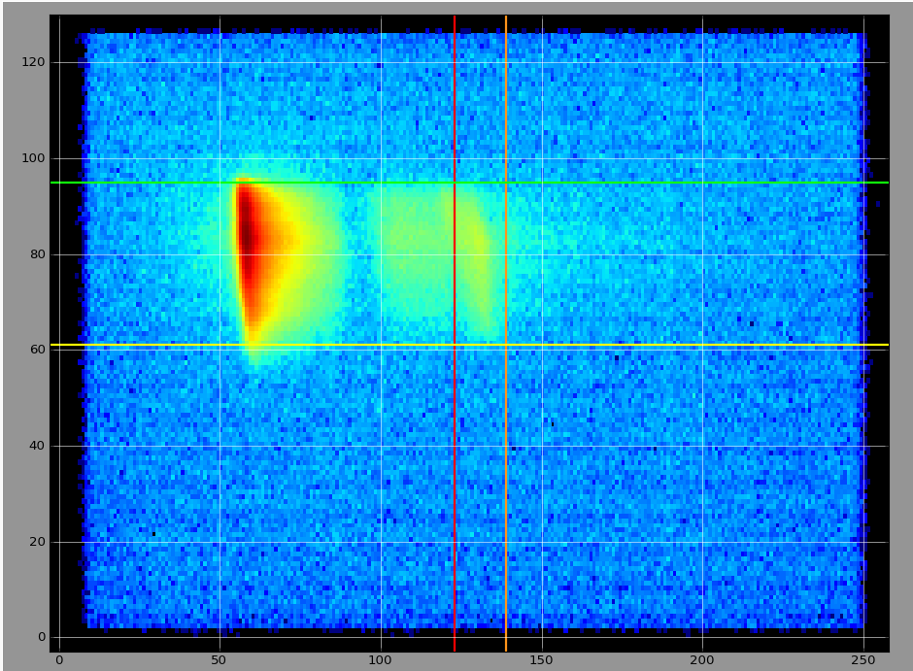
Fig. 4 – Instrumental scattering map in XY coordinates of the detector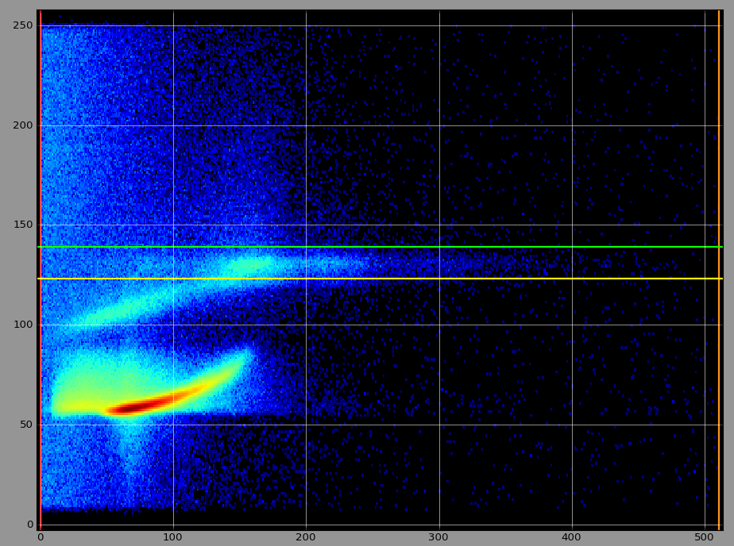
Fig. 5 – Instrumental scattering map in X-TOF coordinates

The REMUR reflectometer uses a time-of-flight technique that requires recording the coordinates of the reflected beam at the detector and the time of neutron flight to convert them to their wavelength. Data processing includes the allocation of the reflected beam along the vertical Y axis in the coordinates of the XY detector, followed by the summation of intensity. After conversion to X-TOF coordinates, the beam is isolated along the horizontal X-axis and the intensity is re-summed. The result is a dependence of the intensity on the wavelength of the neutrons, shown in Fig. 6 by the red graph.
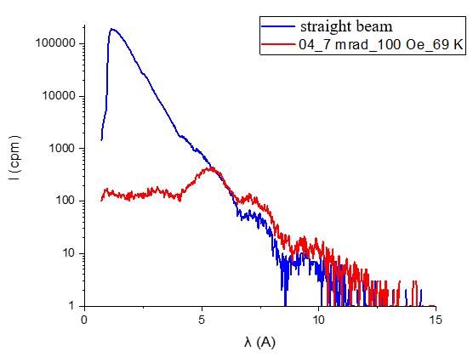
Fig. 6 – Intensity of the direct and reflected beam from the wavelength
In this case, to account for diffuse scattering, it is necessary to perform a complete transition to q-space. This transition is performed using the formulas [5], [6], [7]:
$$\begin{aligned}\begin{aligned}q_{x}=\left(\frac{2π}{λ}\right)\left(\cos{α_{f}\cos{φ}}-\cos{α_{i}}\right), \\ q_{y}=\left(\frac{2π}{λ}\right)\left(\cos{α_{f}\sin{φ}}\right), \\ q_{z}=\left(\frac{2π}{λ}\right)\left(\sin{α_{f}}+\sin{α_{i}}\right),\end{aligned}\#\left(1\right)\end{aligned}$$
where $q_{i}$ – the component of the transmitted moment; $α_{i}$ – the angle of incidence of the neutron beam; $α_{f}$ – the angle of reflection of the neutron beam; $λ$ – the wavelength of the neutron.
To process the data, a Python program code was implemented that converts the instrumental coordinates of the detector into q-space. The processed data using the program code described above is shown in Figures 7-10. In the temperature range of the existence of the helicoidal phase, a horizontal scattering band corresponding to a magnetic spiral is clearly observed. Upon transition to the ferromagnetic state, this characteristic band disappears, and only diffuse scattering is observed on the domain structure in the region of small values of the transmitted pulse. Thus, by the type of the scattering map in q-space, it is possible to accurately tell about the presence or absence of a magnetic spiral in the layer.
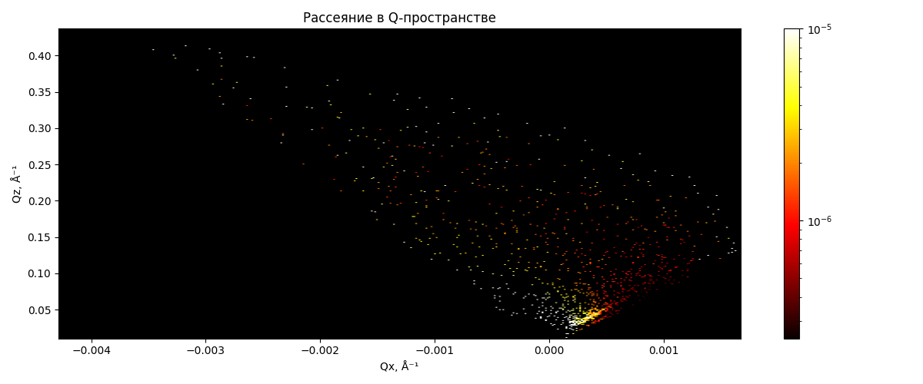
Fig. 7 – Map of neutron scattering in q space for a thin Tb film at a temperature of 210 K and a field 100 Oe 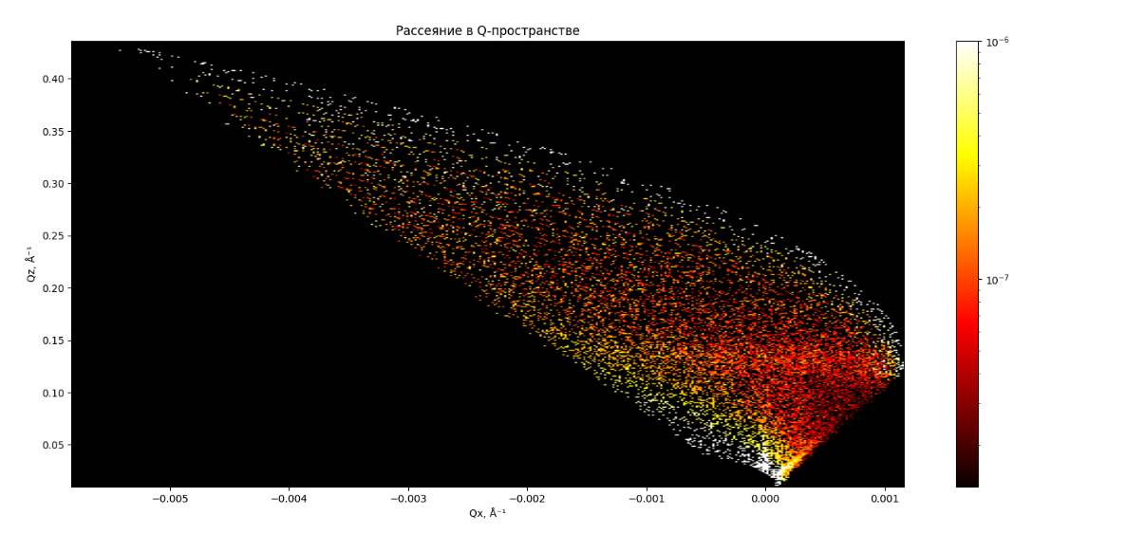
Fig. 8 – Map of neutron scattering in q space for a thin Tb film at a temperature of 225 K and a field 100 Oe
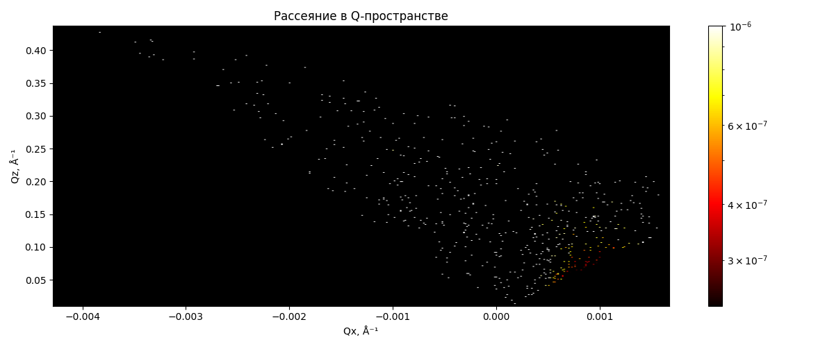
Fig. 9 – Map of neutron scattering in q space for a thin Tb film at a temperature of 240 K and a field 100 Oe

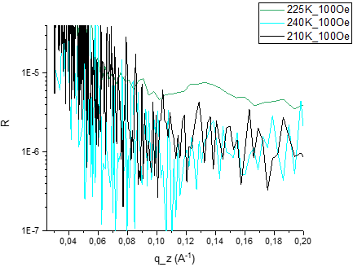
Fig. 10 – The dependence of the reflection coefficient on the z component of the transmitted pulse q for different phases of the terbium film, summarized by qx.
An analysis of the data in Fig. 7-10 confirmed the existence of a helicoidal magnetic ordering in a thin terbium film at a temperature of 225 K. At 240 K, the film becomes paramagnetic, as evidenced by the absence of magnetic ordering. The ferromagnetic state at 210 K is determined indirectly by the presence of diffuse scattering in the low-q region and the disappearance of the Bragg reflex from the spiral structure.
To quantify the dependence of the rotation angle of the magnetic moment on temperature, three reference points were selected: 221, 225, and 228 K. The temperature range of the existence of a helicoidal phase in a thin film turned out to be close to the corresponding range in a bulk terbium single crystal. The results are shown in Fig. 11 and Fig. 12.
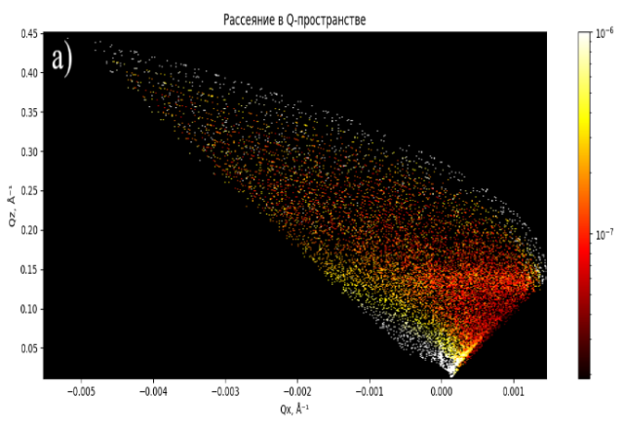 | 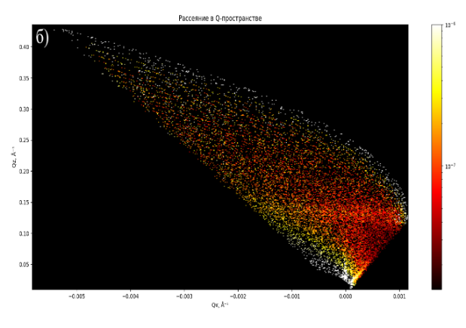
 | 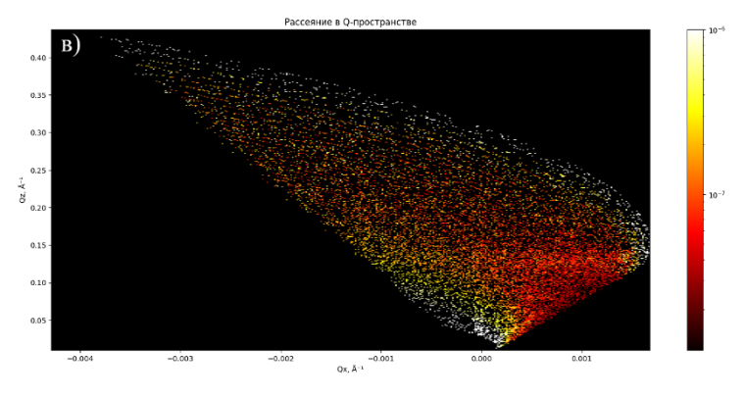
Fig. 11 – Maps of neutron scattering in space for a thin terbium film, where the sample temperature is: a) 221 K; b) 225 K; c) 228 K.
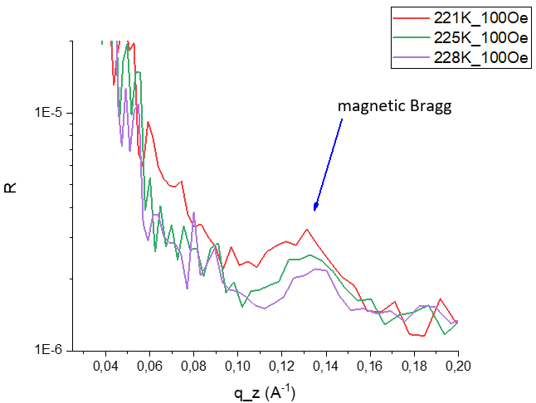
Fig. 12 – The dependence of the reflection coefficient on the z component of the transmitted pulse q, summarized by qx, for different temperatures in the range of the existence of the helicoidal ordering
Magnetic bragg indicates the presence of a periodic magnetic structure in the terbium film. Since the Bragg reflex occurs when a transmitted pulse is equal to the magnitude of the inverse lattice of the structure, in our case of a magnetic structure, we can express q in terms of the period of this structure:
$$\begin{aligned}q=\frac{2π}{d},\#\left(2\right)\end{aligned}$$
where d is the period of the magnetic structure. Using the data shown in Figures 11 and 12, the rotation angles $α_{0}$ were calculated as a function of temperature (see Fig. 13).
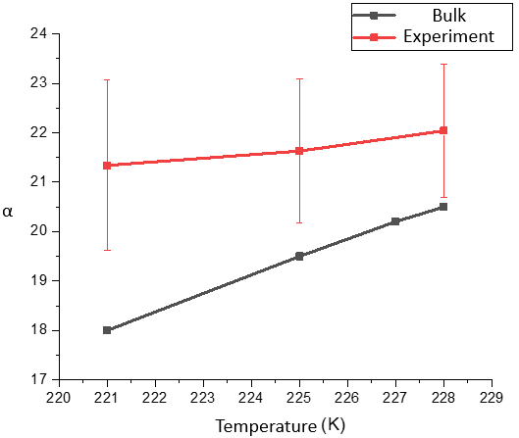
Fig. 13 – Dependence of the angle of rotation on the monolayer on the temperature in Tb
Based on experimental data, it can be concluded that in a thin terbium film, the angle of rotation of the magnetic moment on a monolayer in a helical spiral differs from the bulk sample. [8], [9], [10]. This is due to the influence of reduced dimensionality and epitaxial stresses. Within the measurement error, the rotation angle remains constant throughout the entire temperature range of the helicoidal phase. The average angle value calculated from neutron reflectometry data is $α_{0}=21,67°$, which exceeds all known values for a bulk terbium crystal.
The main reason for the change in the parameters of the magnetic spiral in the terbium film is epitaxial stresses, which cause deformation of the crystal lattice. As the yttrium buffer grows, a significant redistribution of lattice parameters occurs: an increase in parameter "a" in the reference plane is compensated by a decrease in parameter "c" by about 1%, which significantly affects the magnetic characteristics. In the case of growth on niobium, the lattice deformation is much smaller - the change in parameter "c" is only 0.1%, which explains the proximity of the properties of such a film to a bulk crystal. However, even in this case, the observed differences in the temperature range of the spiral and the magnitude of the rotation angle of the magnetic moment confirm the influence of both epitaxial stresses and reduced dimensionality on the magnetic structure of thin films.
To determine the field dependence of the helicoidal arrangement at a temperature of 225 K, the following points of the external field were selected: 70 E; 100 E; 650 E. As a result of the neutron experiment, it was determined that at a field strength of 650 E, a magnetic spiral is not observed (see Figs. 14, 15).
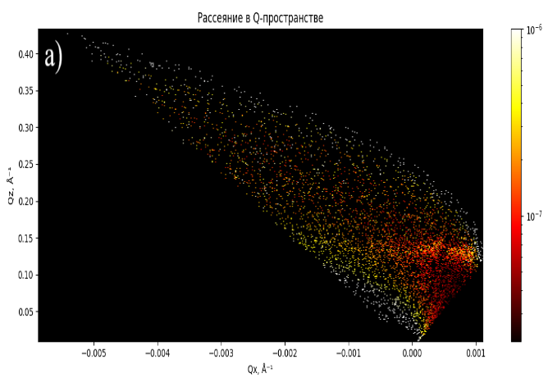 | 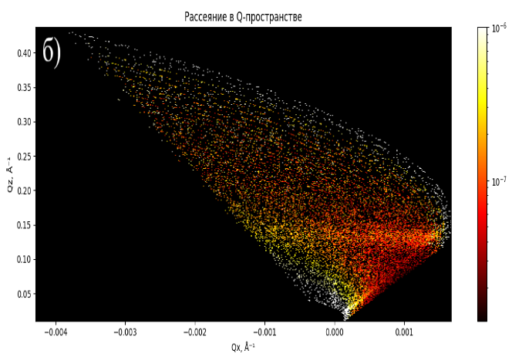
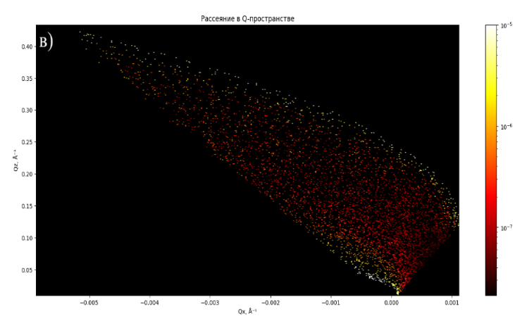
Fig. 14 – Maps of neutron scattering in space for a thin Tb film, where the field strength in the cryostat is: a) 70 Oe; b)100 Oe; c)650Oe

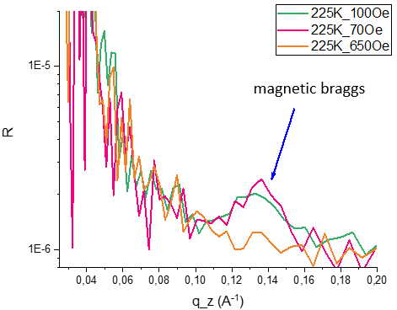
Fig. 15 – The dependence of the reflection coefficient on the z component of the transmitted pulse q for various voltages summarized by qx
Based on the experimental data presented in the figures above, it can be concluded that in a thin terbium film, the helicoidal ordering is destroyed at 650 Oe, while at 70 Oe and 100 Oe it exists. The angle of rotation per monolayer at 70 Oe is 22.20°±1.77°, while at 100Oe it is 21.63°±1.73°. From the obtained values of the rotation angle, it is difficult to judge the field dependence of the helicoidal structure, since the fields at which the magnetic spiral was observed are quite close in magnitude. A relatively large error, which, as in the study of temperature dependence, was calculated from the value of the width at half the height of the Bragg reflex, may indicate the existence of a mixture of phases of a helical magnetic ordering with different angles of rotation on the monolayer. In this case, a change in the position of the center of the Bragg reflex indicates a more favorable angle of rotation of the spiral under certain conditions: the intensity of the external field or the temperature of the sample.

Conclusion
Within the framework of the study, the temperature range of the existence of a magnetic spiral, as well as the angle of rotation of the magnetic moment on the monolayer in the helical phase at various temperatures, was determined using the neutron reflectometry method. The main methods for attesting the crystal structure of the sample under study are X-ray diffraction and reflectometry.
The conducted research demonstrates the following key results:
1. A quasi-monocrystalline terbium film grown on niobium has epitaxial stresses.
2. The temperature range of the helicoidal arrangement in such a film is 220-228 K, which is close to the characteristics of a bulk single crystal.
3. The angle of rotation of the magnetic moment on the monolayer in the film weakly depends on the temperature and exceeds the values for the bulk sample.
4. The critical field of destruction of the magnetic order in the Tb layer is about 650 Oe.

References
- J. Coey, Magnetism and Magnetic Materials, New York: Cambridge University Press, 2009.
- Тейлор К., Дарби М., Физика редкоземельных соединений, Лондон: Chapman and Hall LTD, 1972.
- Waits, R.K. Planar magnetron sputtering
- B. E. Warren, X-Ray Diffraction
- D. Korolkov, Analysis of randomly oriented structures by grazing-incidence small-angle neutron scattering
- U. R. B. T. F. O. a. T. B. Emmanuel Kentzinger, Depth-resolved investigation of the lateral magnetic correlations in a gradient nanocrystalline multilayer
- E. Kentzinger, Probing the magnetic nanoworld by grazing incidence SANS
- C. Dufour, K. Dumesnil, A. Mougin, P. Mangin и G. Marchal, Stabilization of the helical phase in Tb and DyxTb1-x in alloys films grown epitaxially on Y
- A. V. Andrianov, D. I. Kosarev и A. I. Beskrovnyi, Helical magnetic ordering in Tb completely suppressed by uniaxial tension: Evidence of electronic topological transition and support for the nesting hypothesis
- R. Gimaeva, V. Zverev и V. Mello, Magnetic properties of single-crystalline terbium and holmium – Experiment and modeling.

