

JOINT INSTITUTE FOR NUCLEAR RESEARCH
Frank Laboratory of Neutron Physics

FINAL REPORT ON THE
START PROGRAMME

Radiation Effects on Bulk Multi-Walled Carbon Nanotubes: He⁺, H⁺ and d⁺ Ion-Induced Defects and Property Changes

Supervisor:
Dr. Asif Asadov

Student:
Tutku Naz Çelik, Turkey
Middle East Technical University

Participation period:
August 12 – September 22,
Summer Session 2025

Dubna, 2025

TABLE OF CONTENTS

1. Introduction 3
1.1 Multi-Walled Carbon Nanotubes (MWCNT) 3
1.2 Irradiation Techniques and Their Effects on MWCNT 4
2. Results 5
3. Conclusion 10
References: 11

Abstract
This report presents research conducted on the irradiation effects of protons (H⁺), deuterium ions (d⁺), and helium ions (He⁺) on multi-walled carbon nanotubes (MWCNT). The study focused on the structural modifications of MWCNT under varying irradiation fluences. MWCNT samples, prepared via aerosol-assisted chemical vapor deposition, were analyzed using Raman spectroscopy to assess defect density by changes in the I_{D}/I_{G} ratio, crystallite size (La), and metallic character. The results indicate distinct ion specific impacts: He⁺ irradiation generated significant disorder, H⁺ ions promoted lattice healing at high fluences, and d⁺ ions facilitated sp² to sp³ rehybridization, implying a diamond-like phase formation. These findings demonstrate how ion irradiation can change the electronic and structural properties of MWCNT, potentially expanding their applicability in nanotechnology.
Keywords: Multi-walled carbon nanotubes (MWCNT), ion irradiation, defect formation, raman spectroscopy, fluence effects, nanomaterials.

1. Introduction

1.1 Multi-Walled Carbon Nanotubes (MWCNT)
Carbon based nanomaterials are useful in many areas because of their unique structure. One of the important types of them is multi-walled carbon nanotubes (MWCNT). Multi-walled carbon nanotubes have gained significant attention in industrial research due to their ability to enhance the thermal, electrical, and mechanical performance of polymer based materials. This material is used in fields like sensors, biomedical, nanotechnology, energy storage devices such as supercapacitors, and even in radiation shielding materials for space applications [1]. Such modifications are achieved through surface functionalization of the CNT structure.
Since their dimensions are extremely small, measuring the tensile strength and elasticity of carbon nanotubes accurately is technically challenging. The nanoscale diameter and microscale length of CNT make the observations very difficult, and slow the development of precise testing methods [2]. MWCNT are widely used in nanotechnology due to their size and shape. Their electronic and optical behavior can be optimized by making hybrids with other nanostructures. For example, Ag–MWCNT composites show increased optical absorbance and enhanced Raman response compared to pristine nanotubes [3]. These modifications are achieved through surface functionalization or by incorporating active elements in the CNT structure [3].

1.2 Irradiation Techniques and Their Effects on MWCNT
MWCNT functionalization is a widely used strategy to modify their surface chemistry, and enhance compatibility with other materials. This process involves attaching chemical groups or altering surface structures through physical or chemical means. Among various techniques, irradiation based functionalization has gained attention for its precision and ability [4].
Scientists use swift heavy ion irradiation to create defects in CNT. Different ions have different effects on CNT, such as Si⁺ ions are used to weld MWCNT together while He⁺ ions are used to link double-walled carbon nanotubes (DWCNT) [5]. Irradiation can damage the graphene walls of CNT, but this can be used to functionalize them for improving their mechanical and electronic properties. It can also help link or connect CNT for use in nanoelectronic devices. Additionally, ion irradiation helps make CNT more compatible with materials like polymers by improving their bonding. While some defects may heal over time, others remain and can be useful depending on the application [6].
Earlier studies examined that irradiation can induce structural changes from ordered nanotubes to amorphous carbon nanowires [7]. It is found that 10 kGy gamma radiation improved structural quality by reducing defects, while 20 kGy gamma, fast neutrons, and especially thermal neutrons increase disorder. Thermal neutrons cause the most severe damage, resulting in high defect density and amorphization. In contrast, fast neutrons led less degradation due to their shorter interaction time [9].
There is a grading scheme, which 0 corresponds to a pristine, defect free nanotube, while grades 1 to 2 reflect only low defect densities [12]. Mid grades 3 to 4 signify moderate to high defect accumulation, such as the appearance of multiple vacancies, small vacancy clusters, or partial wall amorphization. At the extreme end, grade 5 denotes severe damage or complete structural collapse of the CNT, the original graphitic order is destroyed [12].
Raman spectroscopy offers complementary insight by quantifying defect density through the intensity ratio of the disorder induced D band to the graphitic G band (I_{D}/I_{G}), a metric that increases with structural disorder [6].
In this study, we examined the effects of He⁺, H⁺, and d⁺ ion irradiation on the samples that are treated at different temperatures, and changing fluences of irradiation using Raman scepctroscopy. MWCNT samples were synthesized by using the aerosol-assisted chemical vapor deposition method.

2. Results
A series of irradiations of nanotubes with high-energy protons (H⁺), deuterium ions (d⁺) and singly charged helium ions (He⁺) was carried out on the EG-5 electrostatic accelerator in the Laboratory of Neutron Physics of the Joint Institute for Nuclear Research. The dose rate (fluence) of the first series (a-MWCNT) of irradiation for each type of ions was $φ_{H^{+}{, He}^{+},d^{+}}=2×{10}^{14}$ ions/cm², for the second series (b-MWCNT) of irradiation $φ_{H^{+}{, He}^{+},d^{+}}=2×{10}^{15}$ ions/cm² and for the third series (c-MWCNT) $φ_{H^{+}{, He}^{+},d^{+}}=2×{10}^{16}$ ions/cm² with an energy of 2.5 MeV (Table 1).
Heat removal from the samples during irradiation (the flux of high-energy ions was $Φ_{H^{+}{, He}^{+}}=1.2×{10}^{12}$ ions/sm²‧sec) was carried out on a copper holder, which did not lead to heating of the samples above 70 °C.

 | Sample | Temperature (T_{c}) | CNT source (raw material) | Catalyst Concentration
a | MWCNT | 950⁰C | H - Heptane | 20 mg/ml
b | MWCNT | 900⁰C | H - Heptane | 20 mg/ml
c | MWCNT | 900⁰C | Toluene | 100 mg/ml

Table 1: The synthesized samples of MWCNT will henceforth be referred to by the more straightforward nomenclature of a-MWCNT, b-MWCNT and c-MWCNT, respectively and the catalysts is Ferrocene for all three samples.

The effects of He⁺, H⁺, and d⁺ ion irradiation on multi-walled carbon nanotubes were investigated using Raman spectroscopy. Raman spectra at ambient temperature and pressure were collected using a Confotec® Duo spectrometer (SOL instruments GmbH, Augsburg, Germany) with a wavelength excitation of 532 nm emitted from the Nd YAG laser, 1200/750 grating, a confocal hole of 100 μm, range 70 cm⁻¹ – 3155 cm⁻¹, spectral resolution 4 cm⁻¹ – 4.7 cm⁻¹ and x50 objective [13]. The results are discussed in the context of structural modifications, defect formation, and the comparative resilience of the bulk MWCNT types under ion bombardment [9,10].

Figure 1. Raman spectra of a, b, c - type pristine at pre-irradiation. The pictures present the surface morphology of multi-walled carbon nanotubes (MWCNT) prior to irradiation.
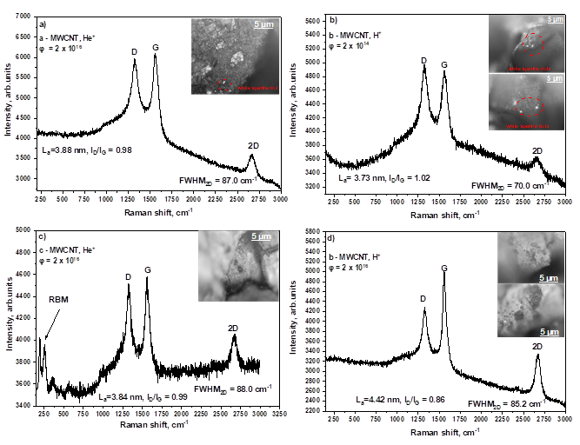
Raman spectroscopy analysis revealed that ion irradiation induces dose-dependent structural and electronic modifications in the multi-walled carbon nanotubes (MWCNT). It is obvious from early works that the Raman spectra of the irradiated MWCNT were dominated by the D, G, and 2D bands [9]. The D band in CNT samples is typically observed at approximately 1340 cm⁻¹, and also known as a disordered band and primarily associated with structural imperfections, such as defects, amorphous carbon, and nanosized graphitic planes, which disrupt the symmetry of the nanotubes [14]. The in-plane tangential stretching of carbon-carbon bonds in the graphitic structure of the nanotubes results in the formation of the G band. A weak shoulder in the G band at higher frequencies known as D’ (G’/2D) band, It is another feature caused by defects and disorder in the material [9]. Its position, shape, and full width at half maximum (FWHM) are highly sensitive to detect structural defects.
Figure 2. The presence of a) and b) white sparkling dots and c) and d) black spots was observed on the MWCNT prior to irradiation.
The intensity ratio (ID/IG) increased with fluence, confirming higher defect density. Earlier studies show that irradiation can cause graphene layers to form other carbon allotropes like diamond [8]. The adsorption of deuterium (D⁺) atoms onto MWCNT drives a structural and electronic transformation. The sp² hybridized carbon lattice is distorting toward an sp³ configuration, shortening the π plasmon excitation. This shortening suggests an electronic phase transition from metallic to semiconducting character [11].
However, a deviation from this trend was observed at higher fluences for specific MWCNT types, where a transition to a symmetric Lorentzian profile indicated a suppression of metallicity, suggestive of a partial semiconducting transition likely due to defect-mediated localization or crystallite growth.

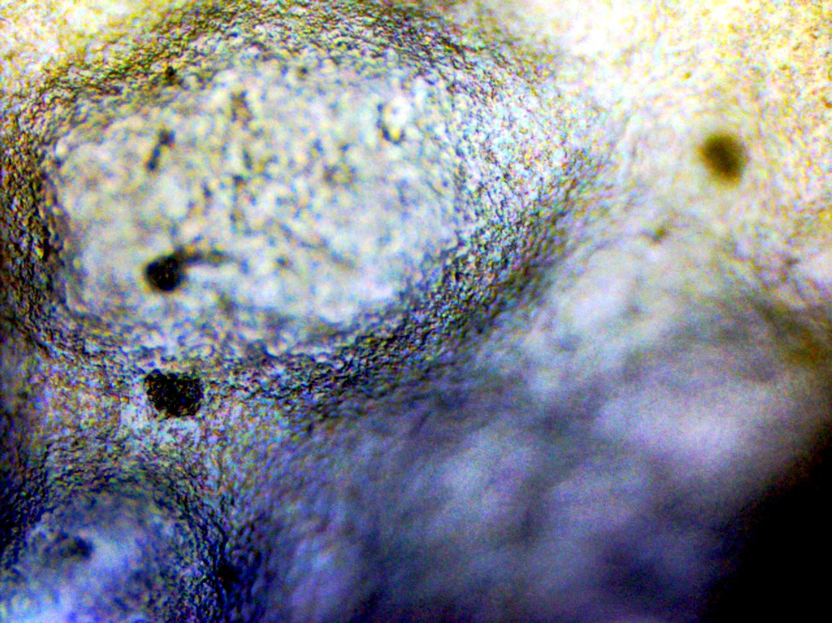
The comparative analysis between He⁺ and H⁺ irradiation highlighted distinct damage mechanisms; the heavier He⁺ ions induced disordering through significant energy transfer, while the lighter H⁺ ions promoted structural ordering at high fluences, potentially through defect passivation. Furthermore, the investigation into potential diamond nucleation sites confirmed ion-induced sp² to sp³ transitions, with observed morphological features such as fluorescent spots and dark regions suggesting localized structural alterations or defect accumulation. The differential response across the a-, b-, and c-MWCNT variants underscored the significant influence of initial structural properties, governed by synthesis parameters, on the material's resilience and transformation under ion bombardment.
Figure 3. Metallic area on MWCNT After d⁺ irradiation
It is reported in the literature that [11] there is a general broadening in the FWHM and a reduction of intensity is observed after irradiation. In some of our samples, this general broadening can be observed as the influence dose increases. But there are some examples of FWHM values decreasing which can be caused by the annealing effect of irradiation at higher temperatures [12].
In our study, we observed that He⁺ collision causes several displacement defects, such as interstitials and vacancies, accumulating with increasing fluence. H⁺ irradiation causes the ordering effect at high fluences. H⁺ ions result in less severe lattice damage because of their lighter mass. Moreover, high fluences cause hydrogen atoms to passivate defects by forming stable C=C bonds, and healing of the lattice disorders in some parts can be observed.

3. Conclusion
This study showed that ion irradiation plays a key role in modifying the properties of MWCNT. Raman spectroscopy revealed that helium ions cause strong lattice disorder because of their higher energy transfer. In contrast, protons create less defects and can even heal parts of the lattice at high fluences through defect passivation. Deuterium ions promoted sp²–sp³ rehybridization, leading to diamond-like phases. These results highlight how the type of ion and irradiation fluence effects the structural and electronic behavior of MWCNT. Overall, the findings confirm that controlled irradiation is a useful method to modify CNT properties for applications in nanotechnology. Research about the results of the experiments continues. The article that is written about the effects of He⁺ and H⁺ irradiation on MWCNT is in the last revision of Carbon Journal. Another article about d⁺ irradiation effects on MWCNT is in the process of writing.

References:
[1] Weerasinghe, J., Prasad, K., Mathew, J., Trifoni, E., Baranov, O., Levchenko, I., & Bazaka, K. (2023). Carbon Nanocomposites in Aerospace Technology: A Way to Protect Low-Orbit Satellites. Nanomaterials (Basel, Switzerland), 13(11), 1763. https://doi.org/10.3390/nano13111763
[2] Khandoker, N., Hawkins, S. C., Ibrahim, R., Huynh, C. P., & Deng, F. (2011). Tensile strength of spinnable multiwall carbon nanotubes. Procedia Engineering, 10, 2572–2578. https://doi.org/10.1016/j.proeng.2011.04.424

[3] Ahmad Shah, N. A., Diauddin, F. N., Demon, S. Z. N., Kasim, N., Krishnan, G., & Abdullah, M. (2020). Preparation and third order nonlinear optical properties of Ag coated carbon nanotubes. Materials Today: Proceedings, 29, 110–114. https://doi.org/10.1016/j.matpr.2020.05.680
[4] Alosime, E. M. (2023). A review on surface functionalization of carbon nanotubes: methods and applications. Open Chemistry, 21(1), 20230023. https://doi.org/10.1186/s11671-023-03789-6
[5] Eswara, S., Audinot, J.-N., El Adib, B., Guennou, M., Wirtz, T., & Philipp, P. (2018). Defect formation in multiwalled carbon nanotubes under low-energy He and Ne ion irradiation. Beilstein Journal of Nanotechnology, 9, 1951–1963.
https://doi.org/10.3762/bjnano.9.186

[6] Zhang, Y., Chen, L., Xu, Z., Li, Y., Shan, M., Liu, L., Guo, Q., Chen, G., Wang, Z., & Wang, C. (2012). Effects of ion irradiation on carbon nanotubes: A review. International Journal of Materials and Product Technology, 43(1/2/3/4), 231–247. https://doi.org/10.1504/IJMPT.2012.051328
[7] Ni, Z., Li, Q., Gong, J., Zhu, D., & Zhu, Z. (2007). Structural change of carbon nanotubes produced by Si ion beam irradiation. Nuclear Instruments and Methods in Physics Research, Section B: Beam Interactions with Materials and Atoms, 260(2). https://doi.org/10.1016/j.nimb.2007.04.227
[8] F. Banhart, Irradiation effects in carbon nanostructures, Report on Progress in Physics, 62 (1999) 1181. https://doi.org/10.1088/0034-4885/62/8/201
[9] U. Akbaba, A.E. Kasapoğlu, E. Gür, Gamma and neutron irradiation effects on multi- walled carbon nanotubes, Diam Relat Mater 87 (2018) 242–247. https://doi.org/10.1016/j.diamond.2018.06.011.
[10] Kalbac, M., Hsieh, Y. P., Farhat, H., Kavan, L., Hofmann, M., Kong, J., & Dresselhaus, M. S. (2010). Defects in individual semiconducting single wall carbon nanotubes: Raman spectroscopic and in situ Raman spectroelectrochemical study. Nano Letters, 10(11). https://doi.org/10.1021/nl102727f
[11] Tayyab, S. (2025). Surface modifications and functionalization of highly aligned multi-walled carbon nanotubes [Unpublished doctoral dissertation]. Sapienza University of Rome.
[12] O. Lehtinen, T. Nikitin, A. V. Krasheninnikov, L. Sun, F. Banhart, L. Khriachtchev, et al., Characterization of ion-irradiation-induced defects in multi-walled carbon nanotubes, New J Phys 13 (2011). https://doi.org/10.1088/1367-2630/13/7/073004.
[13] A.G. Asadov, D.P. Kozlenko, A.I. Mammadov, R.Z. Mehdiyeva, E. V. Lukin, S.E. Kichanov, The structural mechanisms of pressure-induced phase transitions in the Carpy- Galy phase layered perovskites, Solid State Sci 156 (2024) 107676. http://doi.org/10.1016/j.solidstatesciences.2024.107676
[14] Datsyuk, V., Kalyva, M., Papagelis, K., Parthenios, J., Tasis, D., Siokou, A., Kallitsis, I., & Galiotis, C. (2008). Chemical oxidation of multiwalled carbon nanotubes. Carbon, 46(6).
https://doi.org/10.1016/j.carbon.2008.02.012

