

JOINT INSTITUTE FOR NUCLEAR RESEARCH
Frank Laboratory of Neutron Physics (FLNP)

FINAL REPORT ON THE
START PROGRAMME

DFT-Based Workflow for Raman Spectral Analysis: A Case Study on Sumatriptan

Supervisor:

Dr. Polina Kobchikova

Student:
Svetlana Kachanovskaya, Russia, Tver State University

Participation period:
July 20 – August 30,
Summer Session 2025

Dubna, 2025
Table of contents
ABSTRACT 3
1. METHODS 5
1.1 Density Functional Theory 5
1.2 Raman spectroscopy 9
2. OBJECT 13
3. EXPERIMENTAL-COMPUTATIONAL PROTOCOL 15
4. RESULTS………………………………………………………………………………..…16
4.1 Geometry verification……………………………………………………………….….16
4.2 Raman spectra of sumatriptan (calculated and experimental)………………..…16
5. CONCLUSION…………………………….…………………………………………….19

Abstract:

Triptans form a structurally related class built on an indole scaffold, yet biophysical data—especially Raman spectra recorded and analyzed under comparable conditions—are scarce. We established a compact experimental–computational pipeline on sumatriptan as a benchmark. Raman spectra of the crystalline sample were measured with a Confotec MR200 confocal microscope (frequency calibration to Si 520.7 cm⁻¹; standard spike removal and baseline correction). Electronic-structure calculations were carried out in ORCA 6.0.0 using two DFT levels: PBE0/def2-TZVP + D3(BJ) with TightSCF and finite-difference CPKS polarizabilities, and UKS-BP86/def2-TZVP as a lower-cost comparator. The starting geometry was taken from the CCDC; theoretical stick spectra were converted to continuous curves by Gaussian convolution with a fixed FWHM in ChemCraft. Geometry checks returned N_imag = 0 for BP86 and a single tiny imaginary at –6.56 cm⁻¹ for PBE0, consistent with numerical noise on a soft torsion.
Overlaying theory with experiment reveals the expected regime dependence. Below ~150–200 cm⁻¹, agreement is poor: the crystal exhibits broadened lattice/collective modes that an isolated-molecule, harmonic model at 0 K cannot capture (also subject to Rayleigh rejection near 0 cm⁻¹). In the 500–1800 cm⁻¹ fingerprint region the match improves and both functionals behave similarly overall, though local differences in peak positions and relative intensities are visible. We do not perform band-by-band assignments; the goal here is to validate the workflow and expose sensitivities.
The exercise highlights two takeaways: (i) method and numerical choices measurably affect simulated spectra even when global error metrics are similar; (ii) different spectral regions demand different physical models (periodic/cluster treatment for low-frequency crystal modes vs isolated-molecule DFT for intramolecular bands).

Objective of the work: to conduct a comparative analysis of the experimentally obtained and calculated Raman spectra of sumatriptan in order to verify the theoretical model, identify characteristic vibrational modes, and establish a correspondence between the structure of the sumatriptan and its spectral characteristics.

Tasks:
1. To optimize the geometry of the sumatriptan molecule using DFT methods and calculate its vibrational frequencies and Raman intensities.
2. To experimentally obtain the Raman spectrum of crystalline sumatriptan using confocal Raman microspectroscopy.
3. To compare the theoretical and experimental spectra in order to identify characteristic bands, validate the computational model, and assign vibrational modes.

Relevance of the work: Although sumatriptan is a well-established therapeutic agent, its vibrational properties and structural dynamics have not been systematically explored. Raman spectroscopy combined with quantum-chemical calculations enables detailed characterization of its vibrational modes, conformational flexibility, and intermolecular interactions. Sumatriptan was chosen as a model system because it is the first and one of the most widely used triptans in migraine therapy, while its vibrational spectrum remains insufficiently characterized. Furthermore, triptans as a family represent a convenient platform for comparative biophysical studies, since their structural similarity combined with variations in substituents makes it possible to explore conformational landscapes and structure–spectra relationships across related molecules. As an initial step, this study focuses on validating DFT methods by comparing calculated and experimental Raman spectra, which is essential for selecting reliable computational models for future investigations of triptans.

1. Methods
1.1 DFT
Density Functional Theory (DFT) offers a practical route from the microscopic laws of quantum mechanics to molecular structure and spectroscopy. In quantum chemistry the behavior of atoms and molecules is ultimately dictated by their electronic structure, because the arrangement and motion of nuclei are governed by the forces that electrons exert. The exact treatment would require solving the many-electron Schrödinger equation for a wavefunction that depends on the coordinates and spins of all electrons; this object carries an exponential amount of information and renders brute-force solutions prohibitive beyond the smallest systems. DFT takes a different stance. Instead of the many-electron wavefunction, the central variable is the electron density ρ(r), a scalar field in real space that integrates to the number of electrons. The Hohenberg–Kohn theorems guarantee that the ground-state energy is a unique functional of this density and that the physical ground state minimizes that functional. Kohn and Sham translated these ideas into a working scheme by introducing an auxiliary system of non-interacting electrons that reproduces the same density as the real, interacting system. The total energy then splits into a kinetic part for the non-interacting reference, a classical Coulomb term, the interaction with the nuclei, and a residual exchange–correlation contribution that encapsulates all many-body complexity. The last term must be approximated, and the choice of this approximation—the “functional”—governs the accuracy of any DFT calculation.
Within this framework one can compute the potential energy of a molecule at an arbitrary arrangement of its nuclei and thus chart the potential energy surface (PES). The PES is the map that assigns an electronic energy to each point in nuclear coordinate space, and it is the stage on which all structural and dynamical phenomena play out. By evaluating energies and their gradients with DFT at successive geometries, one searches for stationary points of this surface. A minimum corresponds to a mechanically stable molecular structure; reaching it through iterative updates of the nuclear positions is the process known as geometry optimization. In day-to-day work this means proposing a geometry, solving the Kohn–Sham equations to self-consistency, computing the gradient of the energy with respect to nuclear coordinates, and taking a step that reduces the energy while respecting numerical stability. The interplay between an accurate description of the electrons and a robust optimization algorithm turns DFT into a reliable engine for predicting equilibrium bond lengths, angles, and conformations across a wide range of molecules.
Around such an equilibrium structure, small nuclear displacements can be analyzed by expanding the PES to second order. The second derivatives of the energy with respect to Cartesian nuclear coordinates make up the Hessian matrix. After mass-weighting and diagonalization of this matrix one obtains a set of orthogonal collective motions—the normal modes—and a set of harmonic frequencies associated with them. These frequencies are directly connected to the curvature of the PES along each normal coordinate: steep directions correspond to high-frequency vibrations such as X–H stretches, while shallow directions produce low-frequency torsions and bends. In practice, frequencies computed at the harmonic level overestimate experimental fundamentals because real molecules are anharmonic and because approximations in the functional and basis set introduce systematic biases. Empirical scaling factors tuned for a given method can compensate a large portion of the discrepancy; when higher fidelity is required, perturbative or numerical anharmonic treatments refine the spectrum by accounting for mode couplings and the asymmetry of the PES away from the minimum.
Spectroscopy links these nuclear motions to measurable signals, and DFT connects structure to spectra by providing not only energies and forces but also molecular response properties. Raman scattering probes how easily the electron cloud is distorted by an external electromagnetic field. Formally this is captured by the molecular polarizability tensor α, and within the Placzek approximation the intensity of a Raman band is proportional to specific invariants of the derivative of α with respect to the normal coordinate of the mode in question. DFT delivers the polarizability and its derivatives through response theory or, if necessary, by finite differences of analytically computed polarizabilities along small displacements of each mode. Thus, from a single, internally consistent electronic-structure framework one can obtain the equilibrium geometry, the set of normal modes with their harmonic frequencies, and the Raman activities that determine the relative heights of spectral lines under given experimental conditions.
These formal elements translate into a straightforward computational workflow. One begins with a sensible initial geometry and a choice of functional and basis set that balance cost and accuracy for the system at hand. Solving the Kohn–Sham equations yields the ground-state density and energy; updating the geometry according to the gradient leads to the nearest minimum on the PES. Evaluating the Hessian at this point—preferably with analytic second derivatives when available—produces the normal modes and harmonic frequencies. Computing the polarizability response along each mode then provides Raman activities. To compare with experiment, the calculated stick spectrum is typically converted into continuous lines by convolution with Gaussian or Lorentzian profiles whose widths reflect instrumental resolution and homogeneous/inhomogeneous broadening. When the experimental environment (solution, solid state, hydrogen-bonding networks) is known to perturb specific vibrations, implicit solvent models, explicit clusters, or periodic calculations can be introduced so that the PES and response properties reflect the relevant interactions.
The appeal of DFT lies in this coherent bridge from electrons to observables at a computational cost that scales gently with system size. Yet a healthy skepticism is essential. The exchange–correlation functional is approximate, and different approximations can shift equilibrium structures, alter curvatures of the PES, and modify polarizability derivatives in non-trivial ways. Numerical details—integration grids for meta-GGAs, thresholds for self-consistent-field convergence, and finite-difference step sizes—can imprint spurious noise on the Hessian and on Raman intensities if chosen carelessly. Low-frequency modes are particularly sensitive to such settings and to incomplete treatment of dispersion interactions; adding a physically motivated dispersion correction or choosing a functional with built-in nonlocal correlation often stabilizes floppy coordinates and improves both energies and spectral trends. Moreover, the harmonic model is only the first term of a more nuanced picture: overtones, combination bands, and Fermi resonances that are visible in high-quality Raman spectra demand anharmonic analysis if one aims for assignment beyond the strongest fundamentals.
Despite these caveats, DFT remains the workhorse for predictive spectroscopy. The conceptual economy of working with the electron density, the operational convenience of the Kohn–Sham machinery, and the direct accessibility of PES curvatures and polarizability responses make it uniquely suited for interpreting and forecasting Raman spectra. In a single calculation one learns that molecular properties are governed by electronic structure; one encodes that structure via the electron density rather than the full wavefunction; one maps the potential energy surface and locates its minima by optimization; one quantifies the curvature through the Hessian to reveal normal modes and their frequencies; and one converts those modes into intensities by differentiating the polarizability with respect to the corresponding normal coordinates. With careful methodological choices and transparent reporting of assumptions—scaling factors, grids, dispersion corrections, and environmental models—the resulting spectra do more than reproduce peaks: they explain them, attribute them to specific motions, and guide the design of molecules and conditions that achieve targeted vibrational signatures.
Looking forward, this density-based foundation is increasingly coupled to statistical sampling and machine-learned surrogates. DFT supplies high-quality reference geometries, Hessians, and polarizability derivatives at representative configurations; data-driven models then interpolate these quantities across the thermally accessible region of the PES at a fraction of the cost. Such hybrids honor the electronic-structure physics while embracing the configurational richness of realistic environments. The outcome is a predictive pipeline where DFT remains the ground truth linking electrons to Raman observables, and where the PES, vibrational analysis, and polarizability response it provides continue to anchor both interpretation and discovery.

!Note: In practice, results depend strongly on how we set up the calculation, especially the choice of exchange–correlation functional and basis set. A sensible “default” for many organic molecules is to use a well-tested hybrid functional together with a triple-ζ basis (for example, PBE0 with def2-TZVP), which usually gives reasonable geometries and vibrational frequencies for comparison with experiment. The aim at this stage is not to chase perfect numbers, but to obtain a physically consistent PES, a clean Hessian (no spurious low-frequency artifacts), and Raman activities that reproduce the main trends in the spectrum. If the system carries extra charge or is very polar, adding diffuse functions can help; if noncovalent interactions matter, a dispersion correction or a functional that includes it is advisable. Whatever the setup, it is good practice to keep numerical settings (integration grid, SCF and optimization thresholds) “tight” and to document them, and—when frequencies are compared directly to measurements—to apply the standard uniform scaling factor recommended for the chosen method.

2.2 Raman spectroscopy
Raman spectroscopy is a vibrational technique that probes how molecules inelastically scatter monochromatic light. When a sample is illuminated by a laser, the vast majority of photons are scattered elastically (Rayleigh scattering) and retain the incident frequency. A small fraction exchange energy with molecular vibrations, producing shifted components known as Stokes (energy transferred from light to vibration) and anti-Stokes (energy transferred from vibration to light) lines. The positions of these lines encode the vibrational frequencies of the molecule, while their intensities reflect how the molecular polarizability changes during each vibration, which is why Raman spectroscopy is complementary to infrared spectroscopy that is governed by changes in dipole moment.

At the theoretical level the description is compactly framed by the Placzek approximation: the intensity of a Raman band is determined by the derivatives of the molecular polarizability tensor with respect to the normal coordinates. In off-resonant conditions, where the laser frequency lies far from electronic transitions, linear response theory suffices and intensities can be computed from static or frequency-dependent polarizabilities. Under resonance, when the excitation approaches an allowed electronic transition, contributions from excited states dominate and vibrations that couple to the chromophore are selectively enhanced; the spectrum then acquires strong mode selectivity and different relative intensities. In condensed phases, additional structure arises from crystal symmetry and intermolecular interactions: relative to gas phase or solution one often observes frequency shifts and splittings, as well as low-frequency collective modes (phonons) that involve intermolecular motions.
In practice, the experiments in this work were conducted on a confocal Raman microscope. The confocal geometry restricts the sampling volume to the focal plane, improving spatial resolution and suppressing out-of-focus background. For solid-state specimens this is advantageous because it reduces spectral contamination from surface debris or underlying layers and enables mapping across micro-domains. For crystalline sumatriptan, confocal collection makes it feasible to select homogeneous regions, to investigate orientation effects with respect to the laser polarization, and to compare different crystal facets. The excitation wavelength, laser power at the sample, acquisition time, and spectral window were chosen to provide adequate spectral resolution and signal-to-noise while minimizing local heating and photodegradation. The ratio between anti-Stokes and Stokes intensities follows Boltzmann statistics and can serve as an internal thermometer; a growing anti-Stokes fraction is a practical indicator of excessive sample heating.
The main things to read from a Raman spectrum are simple:
Peak position (in cm⁻¹) tells you the vibration’s energy and reflects how “stiff” the potential energy surface is near the equilibrium geometry. Comparing these positions with calculated harmonic or anharmonic frequencies helps assign bands and spot systematic shifts due to anharmonicity, hydrogen bonding, or crystal packing.
Intensity shows how much the molecular polarizability changes during the vibration; this decides which modes are Raman-active and how strong they look. Intensities can change a lot under resonance conditions and also depend on polarization.
Linewidth and line shape contain information about broadening: finite lifetimes (homogeneous), static disorder or strain (inhomogeneous), and the instrument. In practice, bands are usually modeled with Gaussian, Lorentzian, or Voigt profiles.
Polarization features - for example, the depolarization ratio - are linked to the symmetry of the mode and help test group-theory predictions or determine crystal orientation.
Finally, baseline and fluorescence matter. They guide the choice of excitation wavelength and must be corrected carefully so that weak bands are not distorted during data processing.

!Note: In routine Raman work, intensities, linewidths/line shapes, and polarization metrics (e.g., depolarization ratios) are rarely compared quantitatively across studies because they are highly setup- and sample-dependent: laser wavelength/power, focus and geometry, polarization/orientation, detector response, baseline/fluorescence, temperature, defects/strain, and the instrument function all reshape intensities and linewidths/lineshapes (Gaussian/Lorentzian/Voigt). Polarization metrics (e.g., depolarization ratios) additionally require calibrated optics and controlled orientation (single crystals or aligned films). Consequently, most analyses prioritize peak positions and use intensity/linewidth/polarization qualitatively, unless radiometric calibration, instrument deconvolution, temperature control, and orientation averaging are explicitly enforced.

Measurement quality is set by careful metrology and data handling. Frequency calibration against a standard line, control of spectral resolution, focus stability, and laser power at the sample determine the accuracy of peak positions and the reproducibility of relative intensities. For solids, surface finish, thermal contact to the substrate, and heat dissipation are critical; compaction of powders or aggregation of particles can alter relative intensities through optical focusing effects. Raw spectra are commonly pre-processed by removing cosmic spikes, correcting the baseline, and normalizing, and all such steps should be documented because they affect the appearance of weak bands and any quantitative comparison to theory.
There are many Raman “flavors,” each useful for a different task. Standard dispersive Raman in the visible is the everyday choice for most molecules. FT-Raman at 1064 nm helps when fluorescence is a problem, though signals are weaker and detectors must be better. Resonance Raman uses a laser near an electronic transition to strongly boost the few vibrations tied to that chromophore, which helps make site-specific assignments. SERS increases signals using plasmonic metal surfaces so even trace amounts can be seen, while TERS brings a metal tip close to the sample to get Raman maps with tens-of-nanometers resolution. Nonlinear methods like CARS and SRS enable fast, chemically specific imaging for microscopy, but the signals are coherent and need careful interpretation. Other variants include UV Raman (often stronger high-frequency bands and less fluorescence), Raman optical activity for chiral molecules, and time-resolved Raman to watch structural changes after photoexcitation or during reactions.
DFT ties the measurements to theory. It gives optimized geometries, the Hessian (normal modes and harmonic frequencies), and how polarizability changes along each mode, which sets Raman activities. With a reasonable functional and basis set, the calculated stick spectrum can be broadened with realistic line shapes and lightly scaled to correct harmonic bias. If the environment matters—crystals, strong H-bonding, solvents—cluster or periodic models and implicit solvent help capture shifts and intensity changes. Clear reporting of choices (methods, scaling, line-shape parameters, preprocessing) allows a fair, quantitative comparison using simple metrics like MAE or RMSE and makes band assignments reproducible.
In short, Raman reads molecular vibrations from frequency shifts and intensity patterns in inelastic scattering. A confocal setup suits solids because it limits background. Paired with DFT, Raman is not just descriptive but explanatory: the same electronic-structure framework that defines the potential energy surface also provides normal modes and polarizability changes, letting us explain observed bands, see how structure and environment shape the spectrum, and plan measurements or materials with the vibrational features we want.

2. Object
Triptans are a structurally related class of indole-based small molecules that share a common scaffold—an indole (or indole-like) core, a polar sulfonamide (or related) group, and an amine-terminated side chain with several rotatable bonds. This mix of a rigid aromatic nucleus and a few soft torsions makes them ideal testbeds for biophysical questions about structure, dynamics, and environment sensitivity. From a physics viewpoint the class is attractive precisely because members are closely related chemically, so differences in spectra and conformational behavior can be traced to specific, localized substitutions rather than to wholesale changes in molecular topology. Despite this structural similarity, triptans show distinct side-effect profiles, which suggests that subtle physicochemical differences—conformational preferences, intramolecular H-bonding, charge localization, or packing/solvation effects—may propagate into different interaction patterns in condensed environments.
Biophysical studies on triptans are scarce: comparable Raman data and systematic analyses of structure, conformational dynamics, and environment effects are largely absent from the literature. We note this gap and, as a first step toward addressing it in future work, focus here on sumatriptan as the benchmark representative of the class.
Sumatriptan, historically the first triptan introduced clinically and a practical archetype for the series. It exists as a free base and as the succinate salt; under typical experimental conditions the protonated form is prevalent, immediately bringing acid–base equilibria into the discussion. Structurally, sumatriptan couples a relatively rigid indole ring system to a side chain with several low-barrier torsions (Figure 1). That architecture produces a conformational ensemble whose composition shifts between gas phase, solution, and crystal. In the solid state, intermolecular contacts and symmetry can split or shift intramolecular bands and introduce low-frequency lattice modes. In solution, protonation state and local H-bonding reorganize intensities and move marker bands associated with the indole and sulfonamide fragments. These are exactly the effects that Raman spectroscopy is well suited to detect, and that density functional theory can rationalize by providing geometries, Hessians, and polarizability derivatives on the same footing.
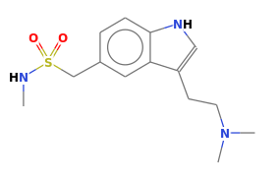
Figure 1. Chemical structure of sumatriptan (free base) showing the indole core, sulfonamide group, and dimethylamino side chain; heteroatoms are color-coded (N blue, O red, S yellow).

3. Experimental–Computational Protocol

Experimental. Raman spectra of crystalline sumatriptan were collected on a Confotec MR200 confocal Raman microscope (SOL Instruments). The confocal geometry restricted collection to the focal plane and suppressed out-of-focus background, which is advantageous for solid samples. Spectra were frequency-calibrated (Si 520.7 cm⁻¹), cosmic-ray spikes were removed, and a smooth baseline was subtracted prior to analysis.

Computational. Electronic-structure calculations were performed with ORCA 6.0.0. Our primary level was PBE0/def2-TZVP with D3(BJ) dispersion and TightSCF convergence. Raman activities were obtained by finite differences of the polarizability (CPKS) along symmetric displacements:

! NumFreq PBE0 def2-TZVP TightSCF D3BJ
%elprop Polar true end
%freq CentralDiff true; Increment 0.02 end

As a lower-cost cross-check, UKS BP86/def2-TZVP optimizations were followed by numerical frequencies and polarizabilities:

! UKS BP86 def2-TZVP Opt NumFreq
%freq CentralDiff true; Increment 0.02 end
%elprop Polar true end

DFT stick spectra were converted to continuous curves by Gaussian convolution with a constant FWHM using ChemCraft (a molecular visualization and post-processing program).

Starting structure. The initial molecular geometry was taken from the Cambridge Structural Database (CCDC) and used as the seed for all optimizations; this anchors the calculations to an experimentally determined crystal structure.

4. Results
4.1 Geometry verification.
UKS-BP86/def2-TZVP returned no imaginary frequencies. At PBE0/def2-TZVP we obtained one very small imaginary mode at –6.56 cm⁻¹. Its eigenvector corresponds to a soft torsional/librational motion of the side chain. Given the tiny magnitude and the use of a finite-difference Hessian, this is consistent with numerical noise on a very flat coordinate rather than a genuine saddle. In what follows we treat this mode as effectively near-zero (i.e., a true minimum for practical purposes), which does not affect band assignments in the 500–1800 cm⁻¹ region.

4.2 Raman spectra of sumatriptan (calculated and experimental)
As seen in Figure 2, the PBE0/def2-TZVP and UKS-BP86/def2-TZVP simulations are globally similar (theory–theory MAE ≈ 0.01, RMSE ≈ 0.05), yet local differences are evident: several lines shift by a few cm⁻¹ and relative intensities change in multiple regions. The low-frequency part (<200 cm⁻¹) is most sensitive, whereas the 500–1800 cm⁻¹ fingerprint region agrees better. This is the practical takeaway: method choices and numerical settings matter.
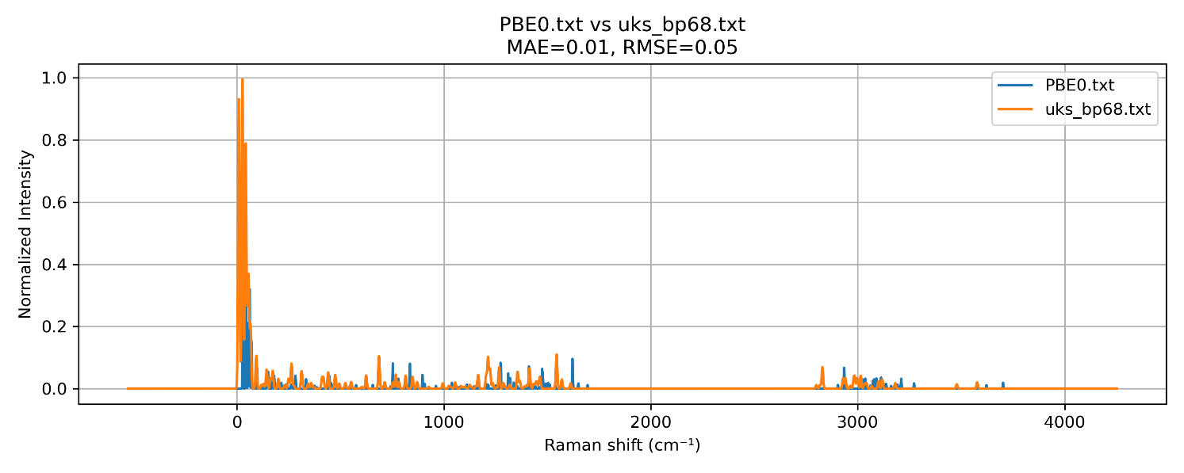
Figure 2. Head-to-head comparison of simulated Raman spectra for sumatriptan: PBE0/def2-TZVP (blue) vs UKS-BP86/def2-TZVP (orange), 0–4500 cm⁻¹. The methods agree globally (MAE = 0.01, RMSE = 0.05) but show small, systematic local differences in peak positions and relative intensities, most noticeable below ~200 cm⁻¹.

As seen in Figure 3, the measured spectrum and the two DFT simulations agree poorly below ~150–200 cm⁻¹: the experiment shows a broad envelope, whereas isolated-molecule, harmonic calculations produce many sharp lines. This low-frequency region in crystals is dominated by lattice/collective modes and finite-temperature broadening that our gas-phase model does not capture; Rayleigh rejection also attenuates signal near 0 cm⁻¹. In the 500–1800 cm⁻¹ fingerprint range the match improves—the most prominent experimental bands have nearby computed counterparts and the overall intensity trends are reasonable.
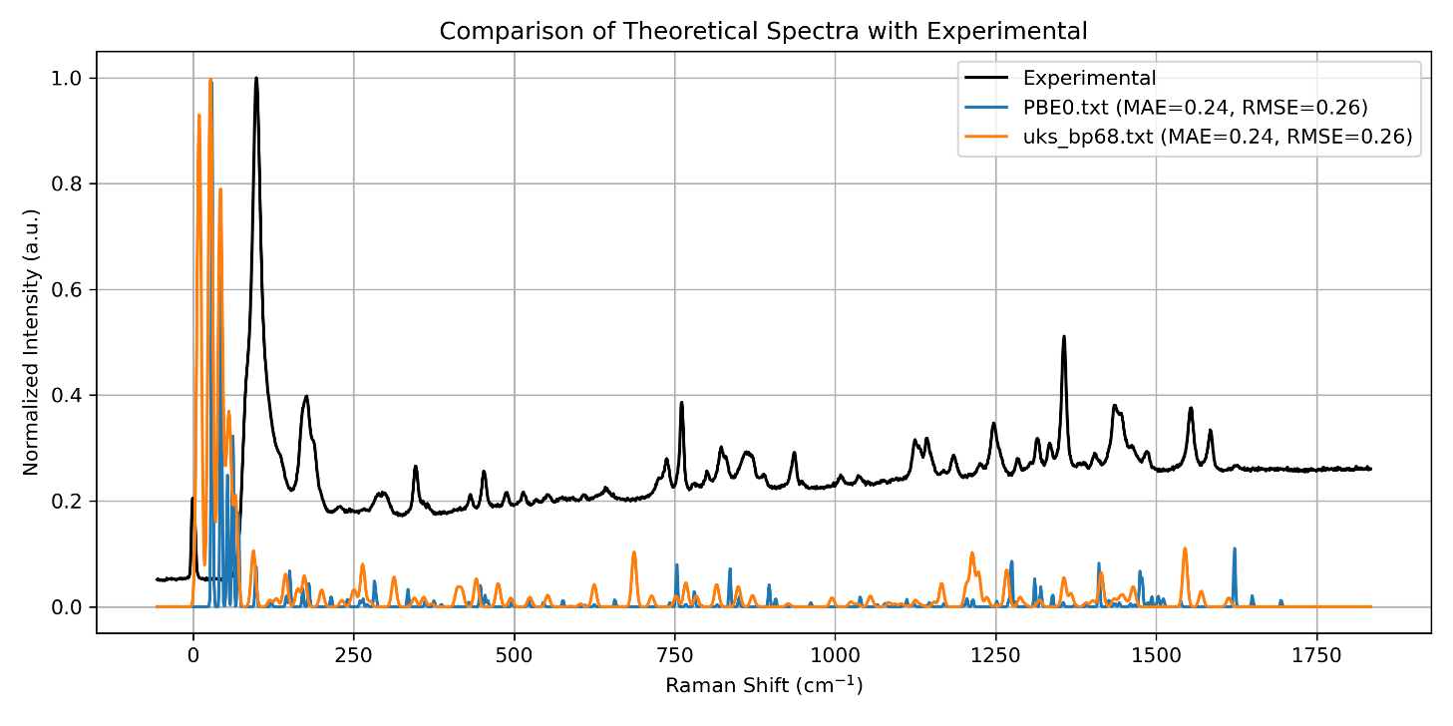
Figure 3. Experimental Raman spectrum of crystalline sumatriptan (black) overlaid with DFT simulations: PBE0/def2-TZVP (blue) and UKS-BP86/def2-TZVP (orange).

Closer look at the low-frequency region (UKS). In the figure below (Figure 4), the 0–500 cm⁻¹ window is magnified. This is exactly what we noted above: the experimental spectrum shows a broad envelope, while the UKS-BP86 calculation for an isolated, harmonic, 0 K molecule produces many narrow lines. That mismatch is expected. In a crystal, low frequencies are dominated by lattice/collective modes (phonons) and intermolecular librations; crystal packing and dispersion couple motions and broaden features at finite temperature. On top of that, Rayleigh rejection attenuates signal very close to 0 cm⁻¹. None of this physics is present in a single-molecule, gas-phase harmonic model—so sharp calculated sticks coalesce experimentally into a smooth low-frequency band. This is normal and not a failure of the calculation.
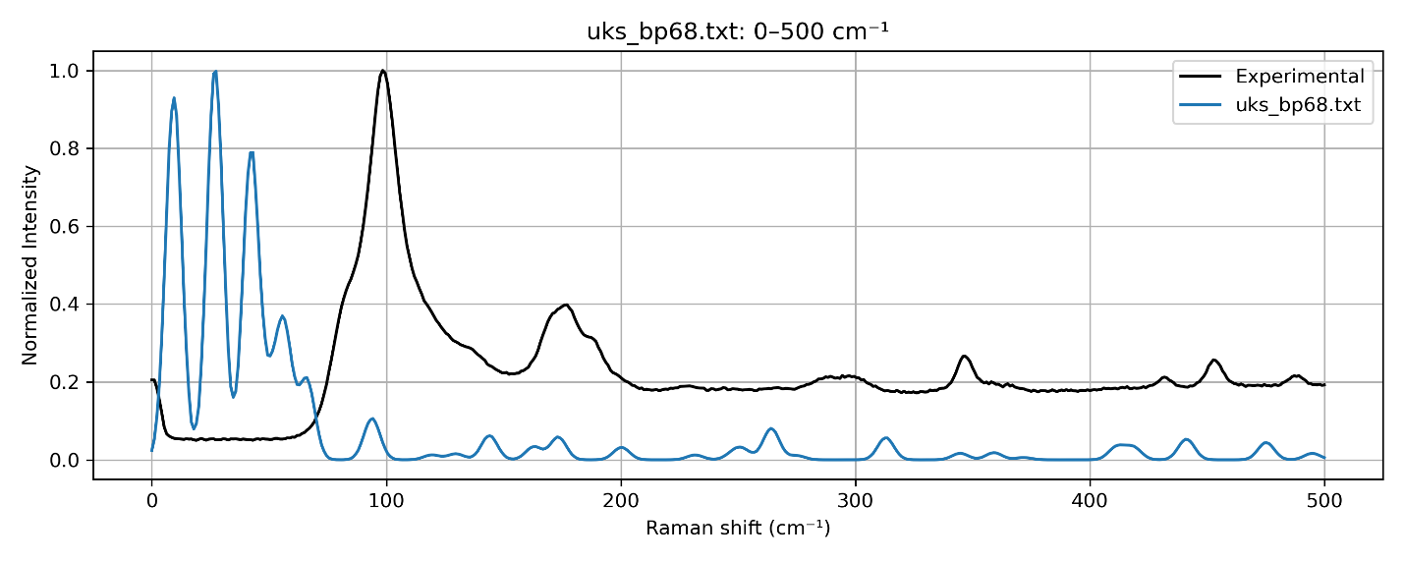
Figure 4. Low-frequency region (0–500 cm⁻¹) magnified: experimental Raman spectrum of crystalline sumatriptan (black) vs UKS-BP86/def2-TZVP simulation (blue). The experiment shows a broad envelope, whereas the isolated-molecule, harmonic calculation yields many narrow lines - consistent with missing lattice/collective modes and finite-temperature broadening; Rayleigh rejection also attenuates signal near 0 cm⁻¹.

So what range is typically analyzed? For molecule-focused comparisons it’s standard to emphasize the fingerprint region ~500–1800 cm⁻¹, where bands arise from intramolecular modes and isolated-molecule DFT performs well. The very low-frequency part (<~150–200 cm⁻¹) is usually treated cautiously or modeled with periodic/cluster approaches and finite-T broadening if it is of primary interest. High-frequency X–H stretches (≈2800–3200 cm⁻¹) are often shown as a separate panel when relevant, but in this work we restrict our analysis to 0–1800 cm⁻¹; the >2000 cm⁻¹ window is shown for completeness only (Fig. 2).

5. Conclusions
In this practicum we implemented and compared two DFT protocols for sumatriptan (PBE0/def2-TZVP/D3BJ and UKS-BP86/def2-TZVP). Both reproduce the overall Raman pattern but yield noticeably different local details (small peak shifts and redistributed intensities), underscoring that method choice and numerical settings matter. We also verified that qualitative agreement depends strongly on the spectral region: isolated-molecule, harmonic DFT performs reasonably in the 500–1800 cm⁻¹ fingerprint range, while the <200 cm⁻¹ region is dominated by lattice/collective effects of the crystal and is not well described by a gas-phase model. This separation of regimes - and the need to choose the right physical model (periodic/cluster vs isolated molecule) - is a key takeaway of the exercise.

What could be improved:
- Do a quantitative comparison, not just visual (peak matching + MAE/RMSE by regions; cross-correlation).
- Broaden the DFT sweep (e.g., B3LYP-D3(BJ), PBE0-D4, ωB97X-V, M06-2X; spot a double hybrid like DSD-BLYP-D3 for benchmarking).
- Test basis/num. settings (def2-TZVP vs def2-TZVPD/QZVP; tighter grids/SCF; smaller freq step).
- Address anharmonic/high-freq region (VPT2 for X–H; region-specific scaling).
- Model the crystal for low frequencies (periodic phonons/DFPT or a dispersion-corrected dimer/cluster; add finite-T broadening).

