

JOINT INSTITUTE FOR NUCLEAR RESEARCH
Dzhelepov Laboratory of Nuclear Problems

FINAL REPORT ON THE
START PROGRAMME

Characterization of carbon dots by oxythermography and Raman spectroscopy

Supervisor:
Dr. Ayagoz Baimukhanova

Student:
Janser Hernández Ojeda, University of Havana

Participation period:
August 03 – September 20,
Summer Session 2025

Dubna , 2025

ABSTRACT
This study presents the characterization of nitrogen-doped (N-CDs) and
phosphor-doped (P-CDs) carbon dots synthesized from sugarcane bagasse,
utilizing oxythermography and Raman spectroscopy techniques available at
the Joint Institute for Nuclear Research (JINR). Oxythermographic
analysis revealed a significantly higher concentration of oxidizable
carbon (organic and sp₂-hybridized inorganic carbon) in the N-CDs sample
(0.145 g/mL) compared to the P-CDs sample (0.034 g/mL). This result
correlates with previous observations of higher photoluminescence
intensity in N-CDs, suggesting that the dominant emission mechanism is
likely quantum confinement within the sp₂ carbon domains. Furthermore,
Raman spectroscopy confirmed the effective incorporation of heteroatoms
into the carbon nanostructure, identifying vibrational bands
characteristic of carbon-nitrogen and carbon-phosphor bonds in the
N-CDs and P-CDs, respectively. The findings demonstrate that the doping
element significantly influences the carbon core structure and,
consequently, the optical properties of the dots, with nitrogen doping
yielding a more favorable structure for enhanced fluorescence.
INTRODUCTION
Quantum dots (QDs) are quasi-spherical nanoparticles with at least one of their dimensions no larger than 10 nm. They were discovered in 1981 and since then have shown potential applications in photovoltaic devices, light-emitting diodes, photodetection, photocatalysis and imaging. However, there is concern in the international community about the effect on health and the environment that the waste of these nanomaterials that include ions such as Cd²⁺ , Pb²⁺ , In³⁺ , As³⁻ , Se²⁻ and Te²⁻.
Therefore, there has been a growing interest in the international scientific community for less hazardous alternatives. In this sense, carbon dots (CDs) promise to be a more viable option, as they are capable of ensuring similar properties, but with additional advantages in terms of the use of organic precursors with greater availability and low cost, easy waste management, lower toxicity, greater biocompatibility, high aqueous and organic solvent solubility, greater photostability , and the possibility of exhibiting electro- and chemiluminescence.
When synthesizing CDs , one of the main challenges is their characterization, since nanostructures are obtained with a certain degree of heterogeneity regarding the distribution of surface functional groups and sp2 and sp3 domains in their core . A better understanding of the structure of these nanomaterials is possible through techniques such as oxythermography and Raman spectroscopy . The first one allows the quantification of the amount of organic carbon, graphite-like inorganic carbon, and diamond-like inorganic carbon; while Raman spectroscopy allows obtaining information about the surface functional groups.
The objective of this research is to characterize carbon dots synthesized in Cuba from sugarcane bagasse. This study will employ facilities available at the Joint Institute for Nuclear Research (JINR), such as oxythermography and Raman spectroscopy.
- BIBLIOGRAPHIC REVIEW
  - Carbon quantum dots.
Carbon dots consist of sp₂/sp₃ hybrid carbon-based polymeric groups or aggregates or sp2 domains that may or may not form a defined crystalline lattice. They usually have heteroatoms (oxygen or nitrogen) in their structure, as part of the carbon itself. core or covalently bonded to it, favoring its solubility in water by forming hydrogen bonds [1].
Various experimental and theoretical studies have shown that CDs exhibit different photoluminescent centers and, therefore, different mechanisms through which the phenomenon occurs. The main mechanism is quantum confinement, which implies a dependence of the emission wavelength on the size of the carbon. core , although more rigorously depends on the effective conjugation length in the sp2 domain. An increase in the interior sp₂ domain of the carbon dot causes a greater electronic delocalization and a more uniform energy distribution, decreasing the energy gap between the highest occupied level (HOMO) and the lowest unoccupied level (LUMO). This decrease in the energy gap brings about an increase in the emission wavelength according to Einstein's equation for energy quantization [2].
$E=hv=h\frac{c}{λ}$ (Equation 1)
This mechanism is generally dominant in the case of CDs with a high degree of graphitization; however, in most cases, photoluminescence (PL) in CDs can be considered independent of their size since this term is actually associated with the effective conjugation length given by the size of the sp₂ domain and, for CDs with isolated sp₂ domains embedded in an sp3 carbon matrix, the PL does not show a correspondence with the actual size of the carbon dot [3]. Other factors may also influence the PL such as surface or molecular states [4].
Surface functional groups have several energy levels, which can give rise to a series of emissive traps. Some studies point to the PL of CDs as a superposition of two bands attributed to the intrinsic (associated with sp₂ domains) and extrinsic (associated with surface groups) states. The extrinsic state can be excited directly or by energy transfer from an intrinsic band, so that an emission wavelength longer than that due to the quantum confinement effect would be detected [5]. Furthermore, during the synthesis of these nanostructures, fluorophore molecules can be formed, which constitute independent molecular centers of photoluminescence within the carbon dot and are called molecular states [6].
CD fluorescence can be due to different mechanisms or even a combination of them. Therefore, a detailed study of CD structure is crucial to understand the dominant mechanisms underlying the fluorescence phenomenon. This will allow for decisions on possible methods to improve their optical properties and potential applications.
  - Oxythermography.
Oxythermography is a thermogravimetric method that quantifies carbon content through carbon combustion. It works at high temperatures and with a controlled flow of oxygen. Once the oxygen and carbon dioxide background is established, the samples are measured. The equipment used reaches a maximum temperature of 750 °C, sufficient to oxidize organic carbon and even sp₂ inorganic carbon to carbon dioxide [7,8].
The oxythermograph used consists of a mobile system for introducing the sample into the chamber and an independent block for moving the sample holder according to the specified time-distance profile; a tandem of two sensors (for carbon dioxide and oxygen) that allows obtaining multidimensional thermo-oxidation spectra; a pure air generator, which guarantees a significant increase in the precision and sensitivity of the method by catalytically purifying air from hydrocarbons; a high-temperature reactor capable of reaching 750 °C; and software for controlling the equipment (Fig. 1) [7,8].
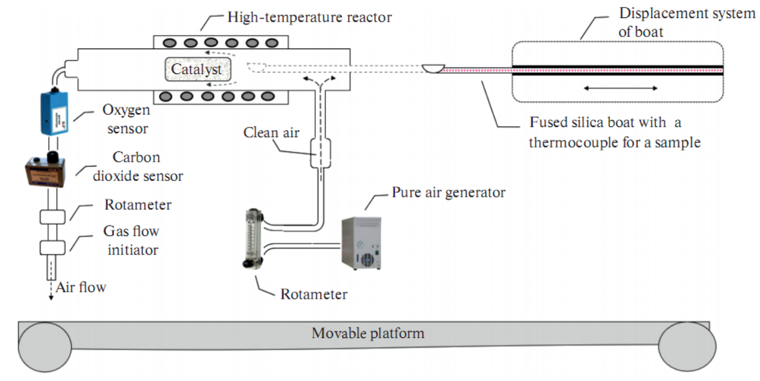
oxythermography equipment used for the determination of organic carbon and sp₂ inorganic carbon in CD samples [7].
The analyzed sample is introduced into the high-temperature reactor, through which a gas mixture with a predetermined partial pressure of oxygen is pumped (in this case, atmospheric air from a pure air generator). The sample is introduced into the reactor through a gas lock, which is created by the air flow entering the reactor through a branch located near the inlet window. This prevents the entry of ambient air into the high-temperature zone of the reactor, where organic compounds are oxidized. A catalyst is located in the high-temperature zone of the reactor. At its outlet, highly sensitive oxygen and carbon dioxide sensors are installed, which continuously monitor the amounts of these gases leaving the reactor. When a sample is introduced into the selected high-temperature zone of the reactor, it is heated and the organic substances are degassed [8].
These substances reach the catalyst with a flow of air, where they are oxidized. Oxygen and carbon dioxide sensors, located downstream of the reactor, continuously monitor the amount of oxygen and carbon dioxide in the gas flow exiting the reactor. During the oxidation of carbon substances, the CO₂ sensor records an increase in the amount of CO₂ in the gas, and the O₂ sensor records a decrease in the amount of O₂ in the gas flow exiting the reactor. A negative peak appears on the graph of oxygen concentration versus time, which characterizes the amount of oxygen consumed for the oxidation of substances in the sample. A positive peak appears on the graph of carbon dioxide concentration versus time. The analysis results are presented as an oxythermogram: the dependence of the oxygen consumed and, at the same time, the dependence of the carbon dioxide released on the time of the programmed process on temperature. Monitoring the temperature of a sample introduced into the reactor makes it possible to obtain the dependence of changes in oxygen and carbon dioxide concentrations on the temperature of the sample during its heating. These dependencies are typical of organic substances and other oxidizable substances [8].
The area of each peak is proportional to the amount of O₂ consumed and CO2 formed during combustion, respectively. Analyzing polyethylene with a molecular weight of 6000 Da, a calibration curve was constructed and Equation 2 was determined, which allows calculating the mass of carbon in grams (x) present in the analyzed sample, knowing the peak area (y) in the CO2 formation graph [7].
$y=\left(9 702 596±3 764\right)x+\left(5 914±110\right), R^{2}=0.991$ (Equation 2)
  - Raman spectroscopy .
Raman spectroscopy it is necessary to first talk about the scattering of electromagnetic radiation when interacting with matter. While an absorption process requires that the energy of the incident photon matches the energy gap between the two electronic energy levels, the scattering process does not require the presence of suitable energy levels, since this mechanism occurs when a photon interacts with a crystal lattice or a molecule, inducing a distortion of its electron cloud and changing the polarization of the species involving virtual states [9].
However, the virtual state is short-lived and decays, leaving the electron in the real electron level of the system as the photon leaves the system. If the energy of the scattered photon matches that of the incoming one and the electron involved returns in a state with the same energy as the initial one, the scattering is elastic (Rayleigh scattering); otherwise, it is inelastic. During inelastic scattering, the energy loss or gain of the photon is equal to the energy difference between the initial and final electron levels. If the outgoing photon has a lower energy than the incoming one, the scattering is Stokes; otherwise, the scattering is anti-Stokes. The energy difference between the incoming and outgoing photons is called the Raman shift (Fig. 2) [9].
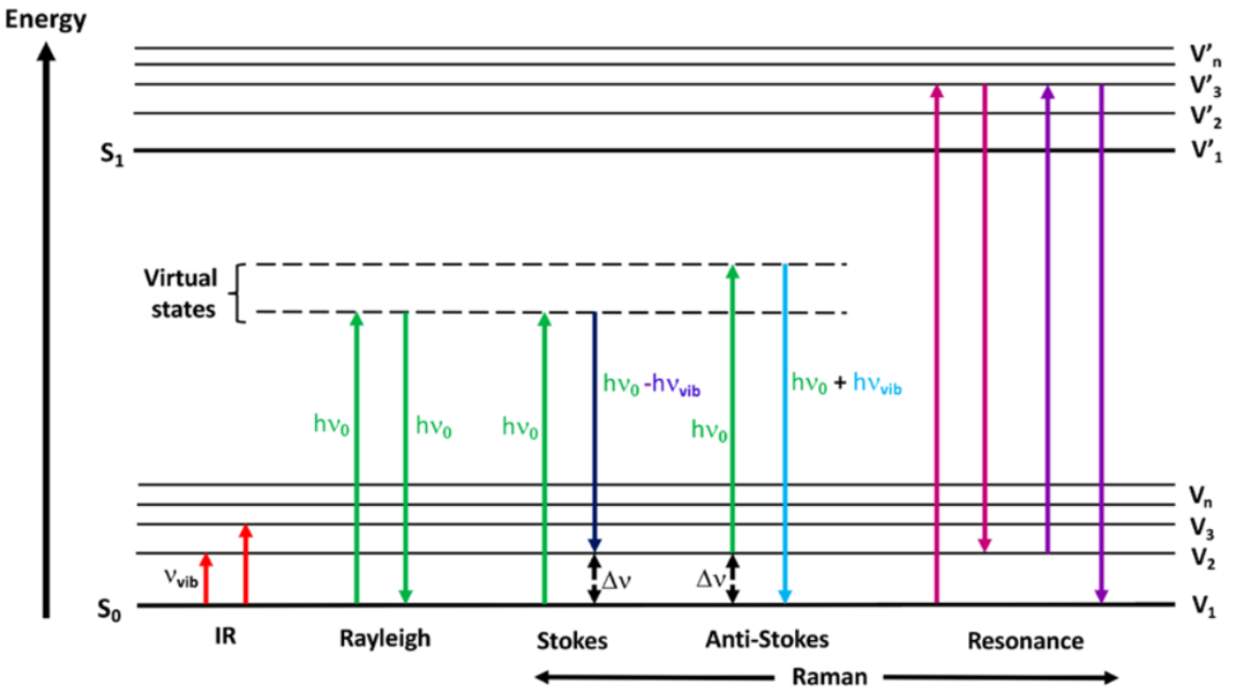
Fig. 2: Diagram showing the energy transitions during the absorption and scattering phenomena of infrared radiation [9].
From a quantum mechanical approach, the energy corresponding to each vibrational level of a diatomic molecule is described as follows:
$E_{v}=hv\left(n+\frac{1}{2}\right)$ (Equation 3)
Where $v$ is the vibration frequency, is the $h$ Planck constant, and $n$ is the integer-valued vibrational quantum number. For simplicity, the harmonic approximation expression is presented, but it has its limits. Primarily, it only allows fundamental transitions ($∆v= ±1$), and the separation between adjacent levels is assumed to be constant, which is not the case in a real diatomic molecule [9].
The matrix element defining the transition probability for a single Raman event between two electronic states is the same for both Stokes and anti-Stokes processes. The difference in the number of scattered photons is due to the different electron populations in the thermal equilibrium of the two electronic levels involved in the Raman process . At room temperature, most molecules populate the ground state, and the anti-Stokes components are much less intense than the Stokes ones [9].
If the energy of the incoming photon is such that the electron can reach a real electronic state of the molecule, the Raman is called resonant (Fig. 1) and enhancements of up to 10 ⁶ in signal intensity have been observed [9].
Raman scattering is particularly weak compared to Rayleigh scattering. Only 1 in 10⁸ photons experiences Raman scattering. For this reason, all Raman spectrometers are equipped with devices such as “notch filters” to remove the Rayleigh component [9].
Raman scattering radiation is described by the following equation:
$I_{R}∝I_{0}v^{4}N{\left(\frac{∂α}{∂Q}\right)}^{2}$ (Equation 4)
Where $I_{0}$ and $v$ are the intensity and frequency of the incident light, respectively; $N$ is the number of scattered molecules in a given state; $α$ is the polarizability; and $Q$ is the amplitude of the vibrational coordinate. The last term shows that Raman scattering can occur only if a change in polarizability occurs due to interaction with the incoming photon [9].
- MATERIALS AND METHODS
Sugarcane bagasse was used for the synthesis of the CDs. It was incinerated at 340°C for 5 hours in a muffle furnace, pulverized, and suspended in an aqueous solution containing the corresponding doping agent (nitrogen and phosphorus doping). The solution was then placed in a 600 W ultrasonic bath, and the sample was ultrafiltered to remove particles larger than 10 nm (Fig. 3).
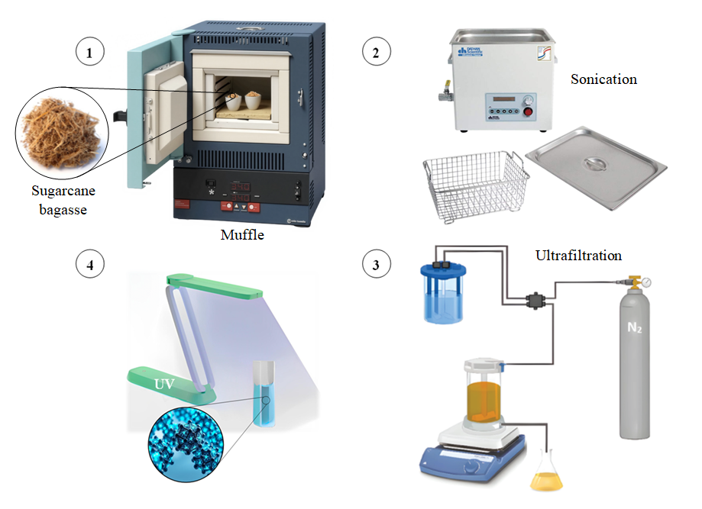
Fig. 3: Schematic of carbon dot synthesis from sugarcane bagasse.
Nitrogen-doped CDs (N-CDs) and phosphorus-doped CDs (P-CDs), respectively, were analyzed using oxythermography equipment , using a maximum temperature of 750 °C at which only organic carbon and sp2 inorganic carbon can be completely oxidized. A volume of 10 μL of each solution was used.
When analyzing the samples, a gray residue was observed on the surface of the sample holder . This may indicate the presence of sp3 inorganic carbon in the CDs , since at the working temperature it is not possible to oxidize carbon with this hybridization ; a temperature of around 1000 °C is required for efficient oxidation.
To calculate, specifically, the concentration of organic carbon, it is possible to perform a chemical oxidation with potassium persulfate at 100 °C (method named Total Organic Carbon: TOC), a process in which it is not possible to oxidize the sp₂ inorganic carbon and therefore it can be determined what part of the carbon oxidized by the oxythermography method is organic and inorganic carbon with sp₂ hybridization.
Raman spectroscopy uses visible light lasers, which is useful when working with carbon dots because it avoids interference from fluorescence phenomena that occur in the UV range.
- RESULTS
  - Oxythermography .
Figures 4 and 5 show the results obtained using oxytemrography for nitrogen- and phosphorus-doped CDs , respectively. For each case, the temperature and distance profile traveled by the sample holder over time is represented, indicating the movement of the sample within the equipment until it reaches the area of maximum temperature.
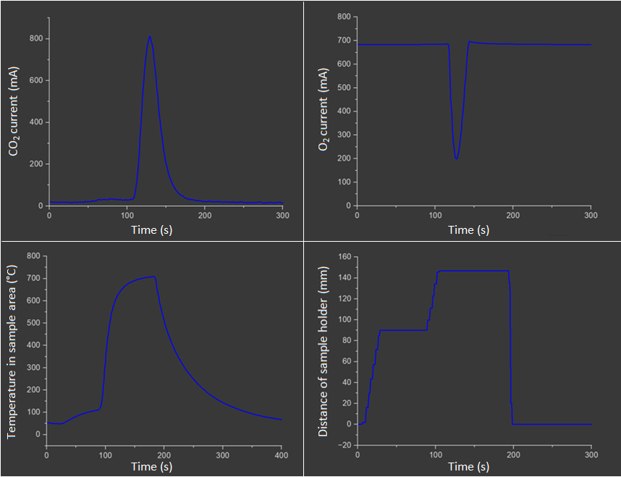
Fig. 4: Oxythermography spectra of nitrogen-doped carbon dots.
For N-CDs the peak area corresponding to CO2 formation is 19957 relative units. Therefore the mass of carbon in the 10 μL of CD solution is 0.0144734461 g and a concentration of 0.144732261 g/ mL.
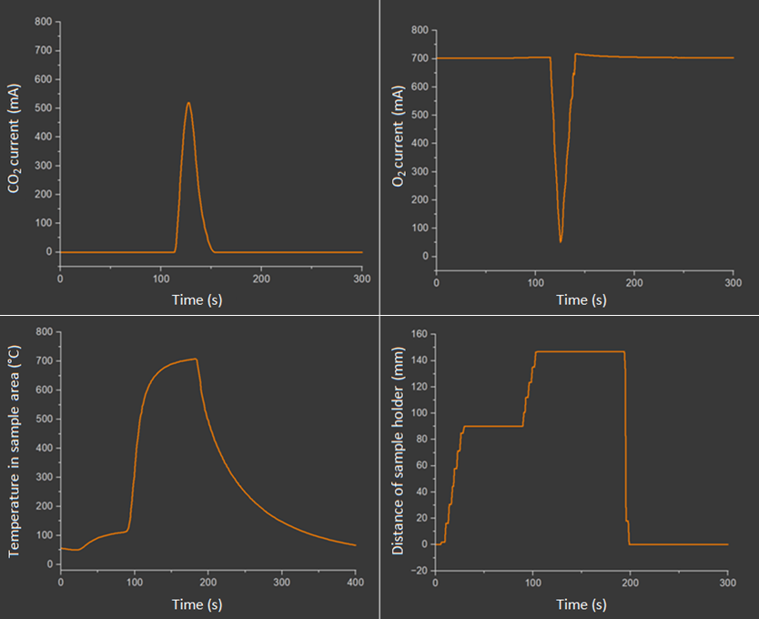
Fig. 5: Oxythermography spectra of phosphorus-doped carbon dots.
The peak area corresponding to CO₂ formation is 19957 relative units. Therefore, the mass of carbon in the 10 μL of CDs solution is 0.000340939683 g and the concentration is 0.0340939683 g/ mL.
The elevated concentration of organic carbon and sp₂ inorganic carbon in the N-CDs sample relative to the P-CDs sample is consistent with previous experimental results, where the emission intensity of N-CDs was observed to be almost three times higher than that of P-CDs. This result may indicate that the dominant PL mechanism in this case is quantum confinement of the sp₂ domains.
  - Raman spectroscopy .
The results obtained by Raman spectroscopy confirm the effectiveness of the doping processes used since bands corresponding to carbon-nitrogen bonds are observed in the N-CDs (Fig. 6, Table 1) and carbon-phosphorus bonds in the P-CDs (Fig. 7, Table 2).
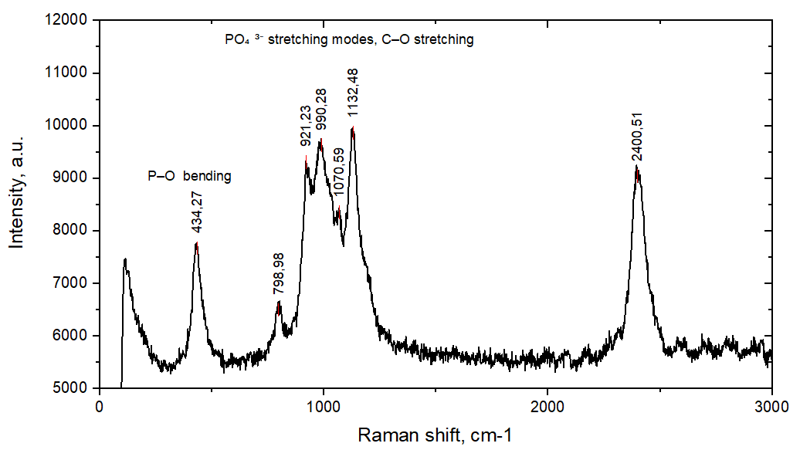
Fig. 6: Raman spectra of phosphorus-doped carbon dots.
Table 1: Band assignment in the Raman spectra of P-CDs.
Observed Raman bands (cm ⁻¹ ) | Assignment | Possible origin
434 | POP bending / symmetric bending | Polyphosphate linkages, phosphate backbone vibrations
798 | PO ₄ ³⁻ symmetric stretching | Orthophosphate groups, P–O–C bonds
921 | POH stretching | Protonated phosphate (HPO₄ ²⁻), metaphosphate structures
990 | Strong PO ₄ ³⁻ symmetric stretching | Characteristic fingerprint band of phosphate systems
1070 | Asymmetric PO stretching | Hydrated phosphate groups, P–O–C linkages
1132 | Asymmetric PO stretching | Polyphosphate chain vibrations, overlap with C–O stretch
2400 | Overtone (combination bands) | Second-order phosphate vibrations, SERS or water– nanoparticle effects

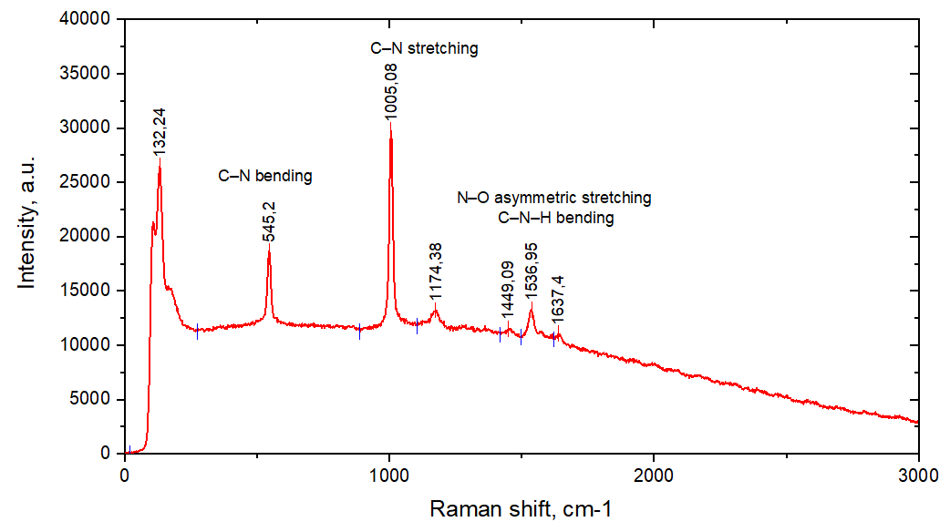
Fig. 7: Raman spectra of nitrogen-doped carbon dots.
Table 2: Band assignment in the Raman spectra of N-CDs.
Observed Raman bands (cm ⁻¹ ) | Assignment | Possible origin
132 | Lattice /phonon vibrations; skeletal CN modes | Nanocrystalline carbon–nitrogen framework
545 | CN bending / NO wagging | Amines, amides, nitrous /nitrite groups
1005 | CN stretching | Aromatic or heterocyclic nitrogen species
1174 | CN stretching + CH bending | Secondary amines, C-O-N linkages
1449 | CH₂ / CH₃ bending​ | Aliphatic chains, C-N-H groups
1536 | NO asymmetric stretching / amide II band | Nitro groups, peptide-like bonds
1637 | C=O (amide I) or C=C stretching | Amides, conjugated carbon-nitrogen structures

CONCLUSIONS
- Nitrogen-doped carbon dots show higher concentrations of organic carbon and sp₂ inorganic carbon in the dots relative to phosphorus-doped carbon dots.
- Since previous results indicate that nitrogen-doped carbon dots exhibit higher fluorescence than phosphorus-doped ones, it can be assumed that the dominant fluorescence mechanism in this case is the quantum confinement of the sp2 domains.
- The presence of carbon-nitrogen bonds and carbon-phosphorus bonds at the respective carbon sites confirms the efficiency of the doping used during the synthesis of the nanoparticles.

RECOMMENDATIONS
- Perform chemical oxidation of carbon dots to accurately determine the concentration of organic carbon in samples.
- Perform the analysis by oxythermography , using temperatures around 1000 °C to quantify the sp3 inorganic carbon at the carbon points.

BIBLIOGRAPHY
- yanhong Liu , Hui Huang , Weijing Cao, Baodong Mao, Yang Liu , & Zhenhui Kang . (2020). Advances in carbon dots: from the perspective of traditional quantum dots. Materials Chemistry Frontiers , 4, 1586–1613. 10.1039/D0QM00090F
- Ai, L., Yang, Y., Wang, B., Chang, J., Tang, Z., Yang, B., & Lu, S. (2021). Insights into photoluminescence mechanisms of carbon dots: advances and perspectives. In Science Bulletin (Vol. 66, Issue 8, pp. 839–856). Elsevier BV https://doi.org/10.1016/j.scib.2020.12.015
- Miao, X., Qu , D., Yang, D., Nie , B., Zhao, Y., Fan, H., & Sun, Z. (2018). Synthesis of carbon dots with multiple color emission by controlled graphitization and surface functionalization . Advanced Materials , 30. https://doi.org/10.1002/adma.201704740
- Ding, H., Yu, S.B., Wei, J.S., & Xiong , H.M. (2016). Full-color light-emitting carbon dots with a surface-state-controlled luminescence mechanism. ACS Nano, 10(1), 484–491. https://doi.org/10.1021/acsnano.5b05406
- Wen , X., Yu, P., Toh , Y.R., Hao , X., & Tang, J. (2013). Intrinsic and Extrinsic Fluorescence in Carbon Nanodots : Ultrafast Time-Resolved Fluorescence and Carrier Dynamics. Advanced Optical Materials , 1(2), 173–178. https://doi.org/10.1002/adom.201200046
- Strauss, V., Wang, H., Delacroix, S., Ledendecker , M., & Wessig , P. (2020). Carbon nanodots revised: The thermal citric acid/urea reaction. Chemical Science, 11(31), 8256–8266. https://doi.org/10.1039/d0sc01605e
- Vorobyeva , MY, Zuev , BK, Filonenko , VG, Rogovaya , I. v., & Filosofov , D. v. (2025). Oxythermography Method for Assessing Passive Adsorption of Organic Compounds on Surfaces of Solid Materials to Evaluate the 14C Contribution to the Background. Journal of Analytical Chemistry , 80(4), 731–737. https://doi.org/10.1134/S1061934825700157
- Zuev , BK, Zaitseva , AE, Korotkov , AS, Filonenko , VG, & Rogovaya , IV (2024). Oxythermography for exploring the thermal stability of polymer materials: a novel analytical approach. Journal of Analytical Chemistry , 79(7). https://doi.org/10.1134/S106193482470031X
- Orlando, A., Franceschini , F., Muscas, C., Pidkova , S., Bartoli , M., Rovere , M., & Tagliaferro , A. (2021). A comprehensive review on Raman spectroscopy applications. In Chemosensors (Vol. 9, Issue 9). Multidisciplinary Digital Publishing Institute (MDPI). https://doi.org/10.3390/chemosensors9090262

ACKNOWLEDGEMENTS
I would like extend a sincere thank you to employees from Radiochemistry Sector of Dzhelepov Laboratory of Nuclear Problems, especially to my supervisor Ayagoz Baimukhanova and the researchers Mariya Vorobyeva, Nijat Mirzayev, Elena Kurakina, Naomi Mokhine, Atanas Velichkov, Gazimmagomed Magomedbekov and Dmitry Filosofov. With them, my colleague Minyar and me could learn lots of things, which will be very useful in our professional life. Even, I could continue my research from Cuba here, doing these characterization techniques that I presented in this report and it´s very important to get my Master degree. I also want to say thank you to Nathalia Mazarskaya because of her interesting and funny Russian lessons. Finally, thank you to the START Programme and the Joint Institute for Nuclear Research for this opportunity; It was a real pleasure to work here and to know such wonderful people.

