

JOINT INSTITUTE FOR NUCLEAR RESEARCH

Frank Laboratory of Neutron Physics

**FINAL REPORT ON THE**

**START PROGRAMME**

*Feedback function of the IBR-2M Reactor*

**Supervisor:**

Dr. Evgeny Evgenievich Perepelkin

**Student:**

Klimenko Mikhail, Lomonosov Moscow State University

**Participation period:**

February 16 – March 29,

Winter Session 2025

Dubna, 2025

Table of contents

Abstract 3

Introduction 3

§1 Physical model 4

§2 Estimation of the impulse transfer coefficient 6

§3 Feedback 10

§4 Control theory 14

Conclusion 18

Literature 18

# Abstract

The IBR-2M is a pulsed fast reactor that generates power pulses using mobile neutron reflectors. During this pulse a high flux of neutrons is created which is then used in various experiments. Reactor operates under constant pulse rate and the stability of the system is crucial to ensure stable reactor operation at desired power output. During a pulse, an increase in power alters the reactor's reactivity, which in its turn can affect the power of subsequent pulses. This effect, known as power feedback, has been extensively studied, and several models have been developed to describe it. This report examines the numerical and analytical algorithm of the "three-exponent" model for power feedback. The problem is rigorously formulated and represented in control theory terms, with feedback modeled as a parallel connection of aperiodic links.

# Introduction

The initial formulation of the problem is to revise the "three exponent" model used to approximate the power feedback of the IBR-2 reactor. The construction of the "three-exponent" model is given in the monograph by A.K. Popov [1]. The need to revise the model is caused by the presence of incorrect approximation of the impulse response function as a superposition of three exponential functions [2].

The purpose of this report was to study the "three exponent" model, which includes the problem statement, mathematical description, estimation of physically small parameters, and numerical and analytical method of solution.

The report has the following structure. In §1 the problem formulation with respect to the neutron density function is described. The resulting system of first order ordinary differential equations has variable coefficients. As a result, a linearization of the coefficients with respect to small parameters of the physical system is made. The system consists of  equations, where is the number of delayed neutron groups. One equation in the system corresponds to the power function  , and the remaining  equations are written for functions  - of the intensities  - of the neutron groups. In further consideration, the first equation with respect to the function  is actually not considered, but is replaced by the expression for the impulse transfer coefficient , the introduction of which is described in the second paragraph. This transition is probably caused by the presence of variable coefficients in the equation for power. Note that the equations for the functions  have constant coefficients.

In §2 the power function  is interpreted as an input parameter for equations with respect to functions . Two simplest types of power input signal are considered: and  , where  is the Dirac delta function. For each input signal, exact solutions are obtained. At the same time, both types of exact solutions are in some way inconsistent with the first equation of the original system of equations. As a result, "from two evils" the solution with the "least" inconsistency is chosen. This inconsistency is a natural consequence of replacing the first equation by the expression for the impulse transfer coefficient . The expression for the coefficient is obtained approximated within the framework of small parameter expansions. For the equilibrium state, the values of  , which coincide with good accuracy with the results from [1], have been calculated.

In §3, for a simple "zero-dimensional" reactor model, an extension of the original system of equations is given by considering feedback in the form of temperature () influence on reactivity . The simplest thermodynamic equation of the heat balance is taken as a basis and rewritten through the reactivity change  . The direct solution of the obtained extended system of equations is carried out numerically and analytically using its finite difference formulation. As an example, in §3 we consider an algorithm for the numerical solution of two types of problems differing in initial conditions.

Paragraph 4 describes the control theory methods used to analyze the feedback effect in a reactor. In the simplest approximation, the physical system is considered as a "black box" whose input is a function signal , and whose output is a signal . It is assumed that the input and output signals are related by an ordinary linear differential equation with constant coefficients. Using the Laplace transform method (operational calculus), the coupling equation is mapped into an algebraic equation , where are the images of the functions and , respectively, and  is the so-called transfer function, which is a rational function. It is known from mathematical analysis that a rational function is represented as a sum of elementary fractions. In control theory, each elementary fraction corresponds to a certain block in the block diagram. Note that when a pulse is applied to the input, is true. Consequently, if the transfer function corresponds to an aperiodic block , then the output will be . Thus, the "three exponent" model arises. In §4 this formalism of control theory is considered for the extended system of equations with feedback obtained in §3. The conclusion contains the results of the report and possible prospects for further research.

# §1 Physical model

The following equation can be written for the change of neutron number density [1]:

 (1)

where  is the density of prompt neutrons,  is the density of delayed neutrons, and  is a given value characterizing the change in the neutron formation density of the external source.

 (2)

where  is the neutron multiplication factor, i.e. the ratio of neutrons of a given generation to the previous one,  is a constant value, the average lifetime of prompt neutrons,  is a constant value, the fraction of delayed neutrons from all neutrons. Function  - determines the character of processes occurring in the reactor:  - neutron number increases rapidly, reactor power increases,  - neutron number decreases, power decreases,  - critical state of the reactor.

 (3)

where - time dependence of the density of precursors of - that group of neutrons. The value is the number of groups, usually 6 or 8 groups of delayed neutrons are used for calculations, is the decay coefficient - of that group.

Let us write down the equation for the change in the density of delayed neutron groups [1]

  (4)

where is the fraction of - that group of delayed neutrons. Substituting expressions (2)-(3) into (1) and considering equation (4), we obtain a system of equations:

 (5)

One can transition from the function to the function - reactivity. The reactivity is defined as , such a transition is necessary for convenience of consideration of neutron density fluctuations near the equilibrium state. Let us transform the system (5) by substituting:

 (6)

Let's introduce the effective neutron lifetime . If , thenand . Let's estimate the value , we get

 (7)

where it is taken into account that , since . Considering the approximation (7), the system of equations (6) will take the form:

 (8)

The kinetics equations (8) describe a so-called "zero-power reactor" model, since the reactivity explicitly contains no dependence on reactor power .

Let us transform the system of equations (8) by introducing the following notations:

 (9)

where  - power,  - intensity of external neutron sources,  - intensity of the-th group of neutrons, - coefficient of proportionality between neutron density and power,  - reactivity on prompt neutrons.

Using the notations (9) the system (8) will take the form:

 (10)

# §2 Estimation of the impulse transfer coefficient

Let us represent the background reactivity

, (11)

where is the reactivity maximum in the pulse, and is the efficiency of the moving reflector. Fig. 1 shows graphs [1] of the time variation of  reactivity  on prompt neutrons and power between neighboring power pulses at an average power of 1.35 MW ( - in absolute units,  - in relative units).

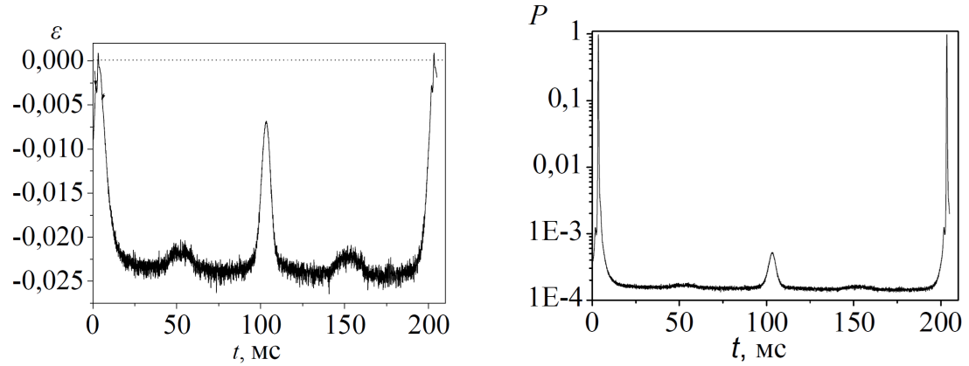

Fig. 1 Reactivity and power













Let's represent the total energy  as the sum of the energies of the power pulse  and the background :

 (12)

We estimate the total energy per pulse period  (see Fig. 1) through the average power value :

 (13)

where  is the average value of the pulse power, and  is the average value of the background power. Let us estimate the value of the background power , by considering the time interval between pulses, where , as the pulse power  (see Fig. 1, right). If we assume that the background power  varies very little on average (see Fig. 1, right, except for the median peak) during the period  , then in the intervals between pulses the first equation from the system (10) will take the form of

 (14)

from here

 (15)

where according to Fig. 1 (left)  and the representation (11) is considered. Let us represent the energy of the power pulse  from expression (12) as

 (16)

where  is the impulse transfer coefficient, which can be expressed from expressions (15) and (16):

 (17)

 (18)

The coefficients (18) depend on the function , which according to (16) is expressed through the function , satisfying the second equation of the system (10). In the right part of the equation is the power , shown in Fig. 1 on the right.

Of course, to find the functions we need to solve the system (10), since the function is a solution of the first equation. On the other hand, we can approximately construct an approximation of the solution  from experimental data and substitute it into the equation for the functions  . Having found the solution , it is necessary to check whether it agrees with the first equation of the system (10) for the power .

Let us consider two simplest ways of approximating the function . In the first case, we will assume that during a power pulse lasting a short time  , the function, where, that is  - the energy of the system during the pulse. In the second case, the pulse times are and , where  is the Dirac delta function. The solutions of the second equation from the system (10) for both approximations will take the form:

 (19)

 (20)

where  is the Heaviside function and  are constant values. The solution of (20) is found through the Green's function. The constant values require determination from the initial conditions of the Cauchy problem or can be determined from the first equation of the system (10). For the solution of (19) the constant power  gives a constant value  , i.e.

 (21)

where, by virtue of (9), it is considered that . Hence

 (22)

therefore, the solution

 (23)

Despite the consistency of the solution (23) with the equations of the system (10), it follows from it that the power  is a negative quantity. Indeed, from the first equation, we obtain

 (24)

Substitution of the solution (20) into the first equation of the system (10) gives the condition

 (25)

where it is considered that . At  condition (25) is written as

 (26)

The fulfillment of condition (26) is possible only at  and . From the physical point of view, we can consider that  when the reactor is brought to the required power level. In this case, the solution (20) will take a trivial form

 at .  (27)

As mentioned above, the results (24) and (27) were expected. Choosing from two solutions (23) and (27) we will stop on (23), since, despite the condition (24), for the solution (23) we can find the coefficients (18). Let us consider expressions (17)-(18) for the period of one pulse, i.e., at . The coefficients  and  according to (23) and (15) will take the following form

 (28)

From the representation (12) and (13) it follows that

 (29)

where the assumptions  and  are made. Note that expression (29) can be rewritten through the small value , using the expansion of  and the condition on  (9):

  (30)

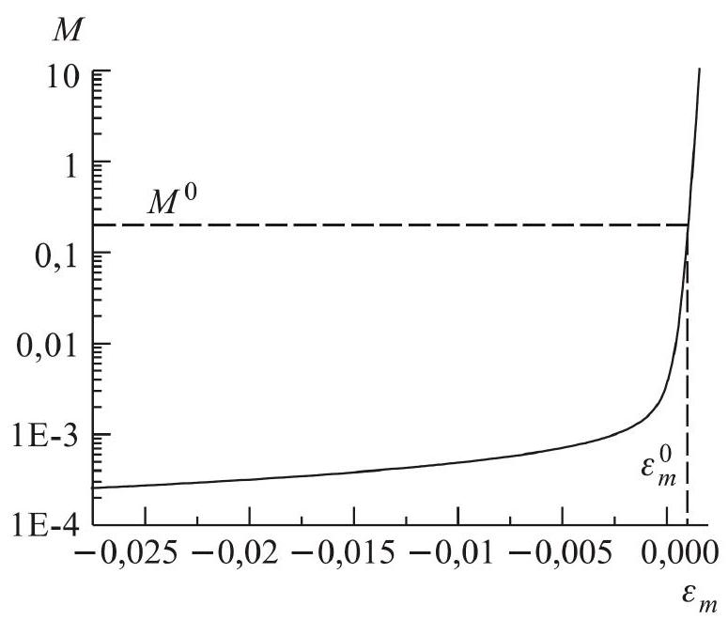

Fig. 2 Function 

Knowing the experimental values of and for different reactor operating modes (see Fig. 1), we can plot [3] the dependence of the pulse transfer coefficient on (see Fig. 2) using formulas (17), (28), and (30). Table 1 shows the calculated values of for the given values of  and  . The values of the parameters  and  are given in Table 2 for the case of 8 groups  of delayed neutrons during fission  by fast neutrons (IAEA data, 1992). The values of ,, ,  were used in the calculations.

Table 1

|  |  |  |  |  |
| --- | --- | --- | --- | --- |
|  | 0 | 0.00076 | 0.00098 | 0.00102 |
|  | 0.0027 | 0.01 | 0.1 | 1 |
|  | 0.00602 | 0.044503 | 0.151058 | 0.192524 |

Table 2

|  |  |  |  |  |  |  |  |  |
| --- | --- | --- | --- | --- | --- | --- | --- | --- |
|  | 0.0125 | 0.0283 | 0.0425 | 0.133 | 0.293 | 0.667 | 1.63 | 3.55 |
|  | 0.0287 | 0.225 | 0.0951 | 0.149 | 0.351 | 0.0370 | 0.0974 | 0.0168 |

The values of  obtained in Table 1 correspond to the values given in [1].

# §3 Feedback

Note that the system of equations (10) refers to a zero-power reactor, since it does not consider the dependence of the reactivity of the reactor  on its power. For example, on the heating of a particular reactor element. Description of such dependencies requires consideration of feedback, which reflects the effect of reactor heating. For stable reactor operation, the power feedback must be negative, since it is believed that it should prevent an unlimited increase in reactor power.

Let's extend the system of equations (10) taking into account the feedback effect. Let us introduce the reactance of the reactor with feedback , where  is the reactance of the power feedback. The explicit form of the power feedback model can be different and depends on how and in what way the heating of the reactor element is taken into account. In the simplest case, the power feedback can be represented as a single aperiodic link (see §4).

Let us consider the feedback effect on the example of the heat balance equation for fuel in an idealized "zero-dimensional" reactor model [1]

 (31)

where  is the reactor power,  is the increment of fuel heat,  is the heat released to the coolant. The amount of fuel heat  allows for the representation

 (32)

where  is the heat capacity of the fuel,  is the temperature of the fuel at the moment of time ,  is the temperature of the fuel at the initial moment of time. Heat , transferred to the coolant, is related to the temperature of fuel and coolant as follows

 (33)

where  is the heat transfer coefficient between fuel and coolant,  is the coolant temperature. Substituting (33) and (32) into (31), we obtain

 (34)

Let us rewrite equation (34) through increments with respect to steady-state

 (35)

The substitution of the representations (35) into equation (34) gives us equation

 (36)

where at the initial moment of time it is assumed that the condition

 (37)

Let the change in reactivity depend linearly on the change in temperature, fuel , and the change in coolant temperature is negligible , then substituting (22) into (21), we obtain equation:

 (38)

Note that equation (38) is an approximate description, as it was said above, of the "zero-dimensional" reactor model, which does not take into account the nature of temperature distribution inside the reactor or the dependence of heat transfer coefficients and heat capacity on temperature.

Observe that the introduction of reactivity, accounting for feedback, requires substitution in the initial equations . Consequently, these relations are valid:

 (39)

 (40)



 (41)

To add the feedback equation in the form (38), we modify the original system of equations (10) using the relation (16) and (12). In further consideration, we will neglect the value of  in comparison with . As a result, we obtain

 (42)

It was noted earlier in §2 that the function can be considered not only as a function of time , but also as a function of  (see Fig. 2), i.e.

 (43)

where the expression (40) is taken into account. Using the definition (43), we decompose the logarithmic function in expression (42) in the neighborhood of the point  into a Taylor series on the variable .

 (44)



where  is the pulse fraction of delayed neutrons. In the linear approximation of the expansion (44), expression (42) will take the form

 (45)

Using the expression (45), (15) we write the representation for the total energy (12)

 (46)

Along with expressions (45) and (46), the expression , which characterizes the relative deviations of the power pulse energy, is also used in reactor physics

 (47)

Depending on the set of known initial conditions, we consider two extended formulations of the problem (10) with feedback. Since the expressions given above were obtained in the framework of linear approximations by Taylor series expansion, it is natural to switch to the finite difference formulation. Let us rewrite the second equation from the system (10) in difference form

 (48)

where  is the time discretization step and  corresponds to the pulse number. Using the approximation  and the energy estimate of the system  , equation (48) takes the form

  (49)

The heat balance equation (38) admits a similar difference approximation to expression (49):



 (50)

or

 (51)

where in equation (51) the small order of magnitude of  is taken into account, and also  is assumed, since according to Fig. 1 (left), the time grid with step  falls on the peaks of pulses with  (40). Expressions (12), (15), (40), (41), (45), and (47) will respectively take the form:

,   

  (51)

Let us consider two possible variants of the problem solution. Let in the first variant the initial conditions for the equilibrium regime are given: , , , , and the values  and  are known for any pulse with the number . It is required to find the change of  . The numerical solution of the problem is reduced to a sequence of actions:

, , (52)

, , (53)

To move to the next pulse, we calculate:

,  (54)

Note that the action (53) admits a compact form for arbitrary pulse number 

 (55)

Consider the second variant of the problem with initial conditions: , , , , , and the value of  is known for any pulse with the number . We need to find the change of . First, we perform calculations by formulas (52), and then:

  (56)

Initial data for the next pulse:

  (60)

# §4 Control theory

Consider an arbitrary model described as a linear differential equation with constant coefficients for the input signal  and the output 

 (61)

where  are constant values, the condition is chosen for physical reasons. The singularity of the solution of equation (61) is determined by the Cauchy problem for the initial conditions, which we choose as

 (62)

Regarding the input signal  we will consider the following conditions to be satisfied

 (63)

The solution of equation (61) can be constructed using the operational method based on the Laplace transform

 (64)

where in general case , and the function  at . Note that at  for the function  under consideration, expression (64) follows from the Fourier integral transform

 (65)

Applying the Laplace transform (65) to equation (61), we obtain:



 (66)

 (67)

where is the transfer function. Expression (67) for the function  is a rational function, which is decomposed into elementary fractions. Each such fraction can be matched with a chained block of the system. As a result, the transfer function  defines the block diagram of the system with series and parallel connected elements. Series connections correspond to multiplication, and parallel connections correspond to the sum of elementary fractions. The most used elementary fractions are summarized below:

*  - booster block;
*  - aperiodic block;
*  - integrating block; (68)
*  - differentiating block;
*  - oscillating block,

where are constants.

From a practical point of view, the input signals in the form of pulses ( - functions) play an important role

 (69)

Where  are the values of the lattice function, e.g., , , then

 (70)

where . In the special case with the same values of the lattice function  (), we obtain

 (71)

If only a single pulse () is applied to the input of , then  and the output of the system will be Hence, at. Thus, the output signal  coincides with the impulse response of  with an accuracy multiplier. In this case, if the output is observed , then the link is aperiodic (67). Indeed, Fig. 3 shows a block diagram illustrating the process of the

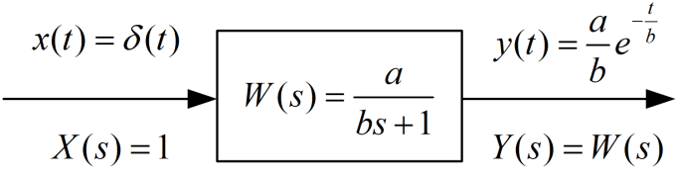

Fig. 3 Aperiodic process

 (72)

where  . If an infinite sequence of pulses (69) is applied to the input of the aperiodic system (see Fig. 3), the output will be a superposition of signals (72)

  (73)

In this case, according to the control theory (61), the output signal  (73) satisfies the differential equation

 (74)

Note that the form of equation (74) is similar to equations (10) and (38) discussed above. Consequently, equations (10) and (38) can be considered in terms of control theory. Fig. 4 shows the simplest block diagram, interpreting the solution of the second problem (52)-(54) discussed in §3. The Fourier (65) (Laplace (64)) images of the input  and output  according to (67) determine the transfer function  (see Fig. 4)

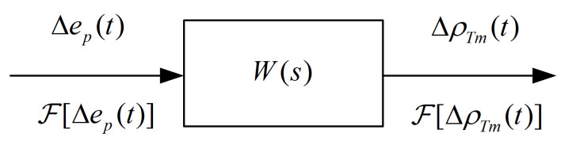

Fig. 4 Block diagram of task 1 of §3

 (75)

In the case of the discrete function  (lattice) (67), the integral transformation (75) will go to the analog of Fourier series:

 (76)

 (77)

 (78)

If the function , then according to the properties of the Fourier integral transform, the function  is even and the function  is odd. Due to the periodicity of the Fourier series (78), consider the interval . The scalar multiplication of the expansion (78) by the even harmonic of  allows us to determine the coefficients of . Indeed, considering (77), we obtain

  (79)

As an input signal  we apply a sequence of delta pulses (69) and measure  at the output (see Fig. 4). Using expression (75), we define  and calculate for it the Fourier coefficients  by formula (79). This procedure was realized for the IBR-2 reactor [1].

Fig. 5 Graph of the characteristic  

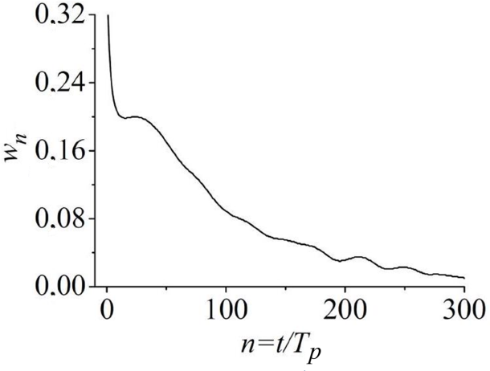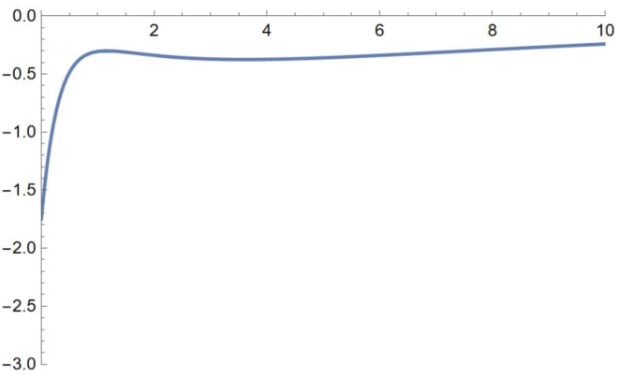

Fig. 6 Graph  from [3]

Fig. 5. shows the discrete impulse characteristic . As stated earlier, in the case of an aperiodic block, such a procedure should lead to , described by a superposition of exponential functions (73). Looking at Fig. 5 we can see that the depicted dependence graph, in the zero approximation can be approximated, for example, by three exponential functions. In Fig. 6 shows a similar graph from [3], approximated by three exponentials (72)

where . Consequently, there is a high probability that the considered system contains three aperiodic blocks connected in parallel (see Fig. 7). In this case, the difference equation (51) should be modified by adding the sum of three summands corresponding to the aperiodic blocks to it

Fig. 7 Graph of characteristic 

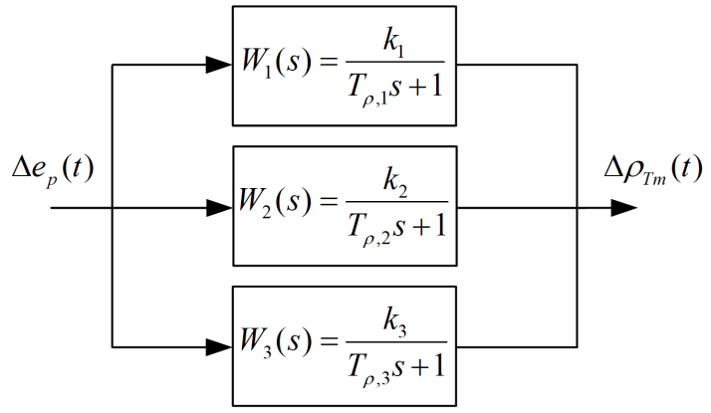

Fig. 7 Block diagram of three aperiodic blocks 

 (80)

where ,  are included in the transfer functions in Fig. 7.

# Conclusion

The "three exponent" model is based on the formalism of the linear approximation of control theory. Of course, not every system can be described by a linear differential equation with constant coefficients. As a rule, real physical systems are described by nonlinear partial derivative equations with variable coefficients. The mathematical realism of the model is determined by the assumptions made in the physical reasoning about the significant/nonsignificant influence of certain parameters (§1-3). The operational method of control theory (§4) is the simplest linear approximation of the functional units of the reactor, giving a simple transparent scheme of its operation.

Obtaining realistic characteristics of the system, taking into account contributions of higher orders, requires a transition to the consideration of equations with variable coefficients or the construction of a new model described by nonlinear equations.

# Literature

1. Popov A.K., Fundamentals of nuclear reactor control: Textbook / Moscow State University - M., 2012. - 208 с. [in Russian]
2. E.P. Shabalin, LNF Seminar.
3. Bondarchenko E.A., Pepelyshev Y.N., Popov A.K., Experimental and model study of the peculiarities of the dynamics of the pulsed batch reactor IBR-2. – Physics of Elementary Particles and Atomic Nucleus, 2004, vol. 35, vol. 4, с. 928-983. [in Russian]
4. Shabalin E.P., Antsupov N.P., Zlokazov V.B., Melnikov V.N., Pepelyshev Y.N., Popov A.K., Rogov A.D., Impulse characteristic of feedback in IBR-2, JINR Preprint received in 16.02.1990 [in Russian]