

JOINT INSTITUTE FOR NUCLEAR RESEARCH
Laboratory of Nuclear Problems named after Djelepov

FINAL REPORT ON THE
START PROGRAMM

Comprehensive research of optical properties of promising materials in the field of transmission, direct and diffuse reflection

Supervisor:
Artikov A.M.
Chokheli D.S.

Student:
Rizakulova Lola, Samarkand State University

Participation period:
October 05 –November 15,
Summer Session 2025

Dubna, 2025

Contents:
Abstract........................................................................................3
I.Introduction.............................................................................4
1.1 Main Objective…..................................................................4
1.2 Foundation of ORIGIN......................................................... 4
II. COMET(COherent Muon to Electron Transition)...........5
2.1 CRV System……..................................................................6
2.2 Irradiation of crystals and absorbed dose determination.......7
2.3 Transparency measurement...................................................8
2.4 Сomparative analysis of light transmission of films SKTN-MED and Viksint ………………………………………….…...9
III. Research of fluoroplastic membranes.............................11
Conclusion………………………………………………….....21
Acknowledgement.....................................................................21
Bibliograpy ………....................................................................22

Abstract

This characterization investigates the optical properties of advanced plastic scintillator films for use in Cosmic Ray Veto (CRV) systems in next-generation particle physics experiments. Achieving the required detection efficiency exceeding 99.99% for background muon rejection demands superior light yield and transmission from the detector materials. We focus on characterizing key performance parameters of prospective scintillator films, specifically their total transmittance, haze (diffuse scattering), and specular reflection. Optimizing these characteristics is critical for maximizing photon transport to photodetectors and ensuring uniform detector response. Our results demonstrate that engineered films with enhanced optical properties are a pivotal enabling technology for future high-sensitivity experiments like Mu2e and COMET, where suppressing cosmic background is essential to reaching target sensitivities on the order of 10⁻¹⁷. The findings establish a material selection and optimization framework for ultra-efficient active shielding.

I. Introduction

The Standard Model (SM) not only effectively describes the properties of
elementary particles and their interactions as observed in experiments, but it also
possesses strong predictive power. However, despite its successes, the SM does not
provide explanations for several phenomena, such as the presence or absence of
dark matter, the observed asymmetry between matter and antimatter, and neutrino
oscillations, among others. These processes are being explored through Beyond
Standard Model (BSM) physics, which seeks to understand phenomena beyond the
framework of the SM.
One intriguing process is the direct (neutrino-less) transition of a muon into an
electron, which would indicate a violation of lepton number conservation (Charged
Lepton Flavor Violation, CLFV)(Fig.1). This falls within the realm of BSM physics.
Currently, several experiments are planned to potentially detect CLFV processes,
such as the Mu2e experiment at Fermilab (Batavia, USA) and the COMET
experiment at KEK/J-PARC (Japan).

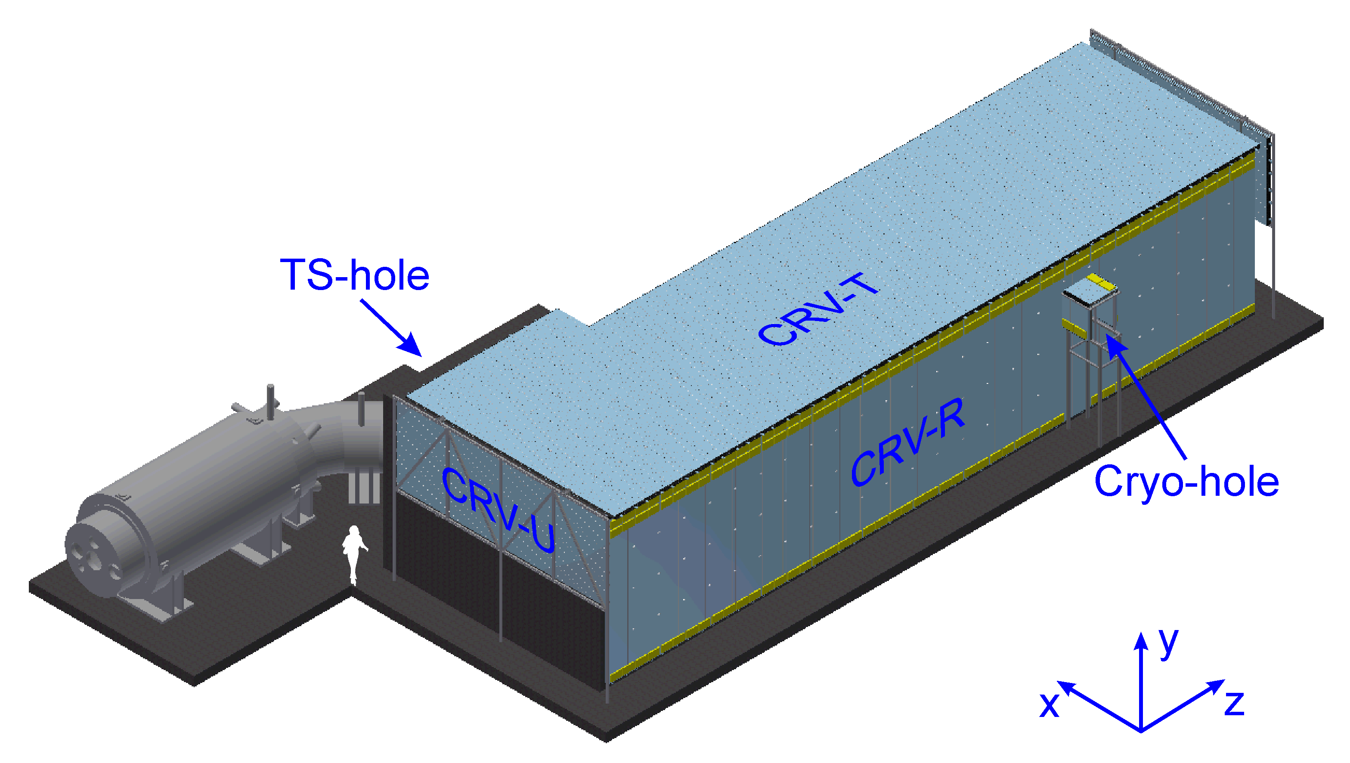

Fig.1. M2e experiment

1.1 Main Objective

The main goal of this project is to gain basic knowledge about the OriginPro 2018 (https://www.originlab.com) for use in data processing.
In addition, the main physical tasks were: firstly, to study the light transmission of sktn-med and viksint films, and secondly, to study the wrapping material made of
fluoroplast for the main optical parameters.

1.2 Foundation of ORIGINPRO
OriginPro environment is a comprehensive software platform for scientific data analysis and visualization, essential for demanding academic and industrial research. It provides extensive functionality for data manipulation, advanced statistics, and publication-quality graphing through an intuitive interface. Its key features include built-in support for Origin C and Python for algorithm development and automation, coupled with a robust project system that preserves the entire analysis workflow for full reproducibility. Due to its precision and reliability, Origin is utilized by premier research institutions worldwide, including CERN, NASA, and the Max Planck Institute, for processing experimental data, modeling, and generating reports. This overview highlights its core capabilities for tackling common scientific tasks: efficient data import, dynamic plotting, and nonlinear curve fitting. Consequently, tens of thousands of scientists and engineers rely on Origin daily to analyze, visualize, and present their findings.
II. COMET(COherent Muon to Electron Transition)
The COMET experiment is structured in two sequential phases (Fig.2). Phase-I will involve the establishment of the initial beamline segment, extending to the first 90° bending section, and the installation of the detector system. During this stage, the collaboration will perform direct beam measurements. Acknowledging the current absence of backward σπ data or real background measurements, the primary objective for Phase-I is to conduct a μ-e conversion search with an intermediate sensitivity target of approximately 10⁻¹⁵. Progressing to COMET Phase-II, the scope will expand to the completion of the entire particle transport system. This final configuration is designed to push the sensitivity of the μ-e conversion search to its ultimate, significantly higher level, enabling a more profound exploration of Charged Lepton Flavor Violation.
Fig.2. Layout of the COMET experiment
2.1 CRV System
The Cosmic Ray Veto (CRV) system (Fig.3) is composed of two distinct subsystems: one utilizing scintillator counters (SCRV) and another based on GRP chambers (BS-CRV). The SCRV subsystem, positioned atop, along the sides, and at the rear of the COMET setup, is built from extruded plastic scintillator strips interleaved with thin aluminum plates. Wavelength-shifting (WLS) fibers embedded in longitudinal grooves within the strips are used for light transmission. In contrast, the BS-CRV subsystem will be installed in the high-radiation region at the front of COMET and will comprise a system of GRP chambers.
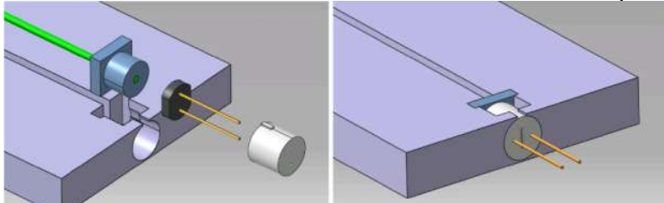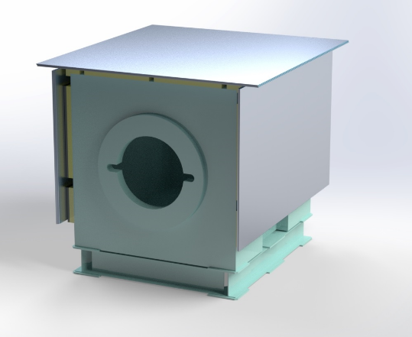
Fig.3. Preliminary design of the COMET CRV system
2.2 Irradiation of crystals and absorbed dose determination
The crystal samples were irradiated at the irradiation facility of the Institute of Radiation Problems, Baku, Azerbaijan. Two different irradiation setups with 60Co radioactive sources were employed: GFRCCA-20000 and MRCFG-25. The dose rates referenced to alanine dosimetry were 0.212 rad/s and 128 rad/s, respectively, as determined for the actual irradiation dates (Fig.4).
To estimate the ratio of the dose rate in barium fluoride to that in alanine BaF₂ and thus facilitate the absorbed dose calculation for barium fluoride, a Monte Carlo simulation was performed using the real geometry of the MRCFG-25 setup. A schematic view of the MRCFG-2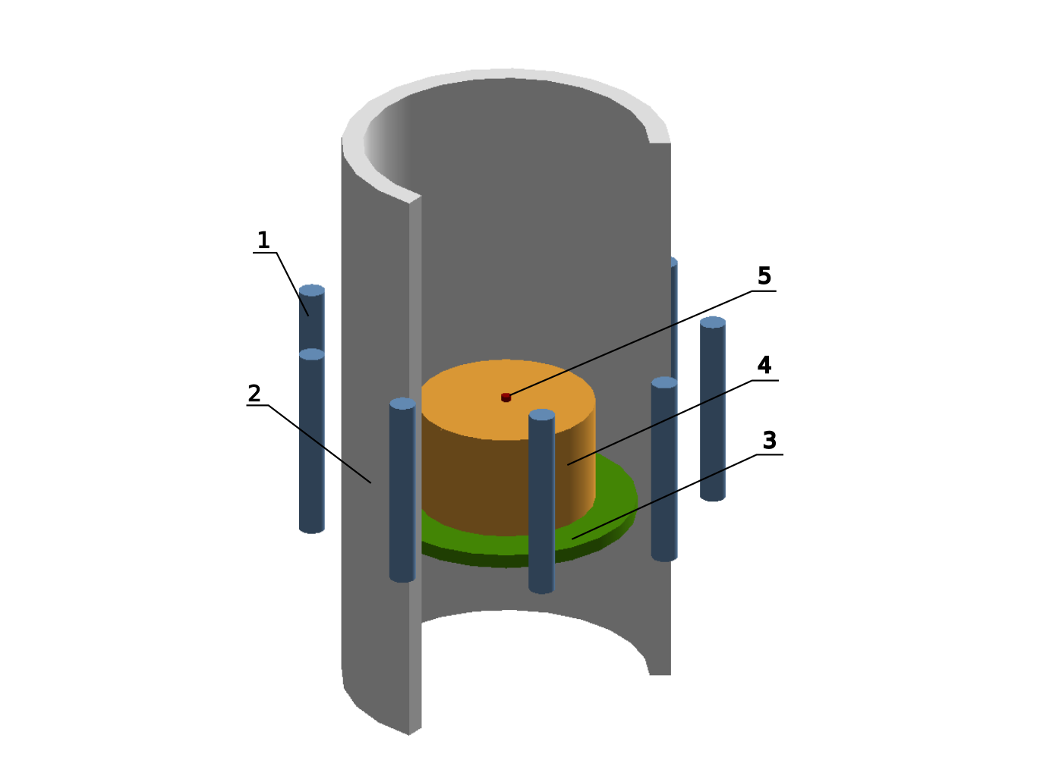
Fig.4. Schematic view of the MRCFG-25 setup. 1 - ampoule with 60Co radioactive source, 2 – irradiation chamber, 3 – chamber base, 4 – stand, 5 – irradiated sample
The setup features a cylindrical irradiator as its core component. The source assembly consists of 36 tubular cells arranged in a circle and rigidly fixed together. Tubular cells numbered 1, 5, 9, 13, 17, 21, 25, 29, and 33 were each loaded with a single 60Co source of 11mm in diameter and 81.5mm in height. The irradiation chamber has a height of 152mm and a diameter of 112mm, with a steel wall thickness of 9mm. A hollow aluminum cylinder with a diameter of 75mm, a height of 45mm, and a wall thickness of 1mm, serving as a stand, is mounted on the
chamber base (3). The sample to be irradiated (5) is placed in center of this stand.
The target absorbed doses for the BaF₂ samples were chosen as 29 rad, 290 rad, 2.9 krad, 29 krad, 290 krad, and 2.9 Mrad in alanine equivalent. To achieve a specific target dose, a group of samples was placed inside the irradiation setup for a calculated time based on the dose rate.

2.3 Transparency registration

These films were also tested for the transparency and for the reflection using a
spectrophotometer (Fig.5), the SolidSpec-3700DUV. The principal scheme is
presented in Fig.6. The wavelength range was measured from 200 to 800
nanometers. The spectrophotometer is equipped with two light sources: an infrared
source (a halogen lamp up to 2600 nm) and a deuterium lamp (from 240 nm).
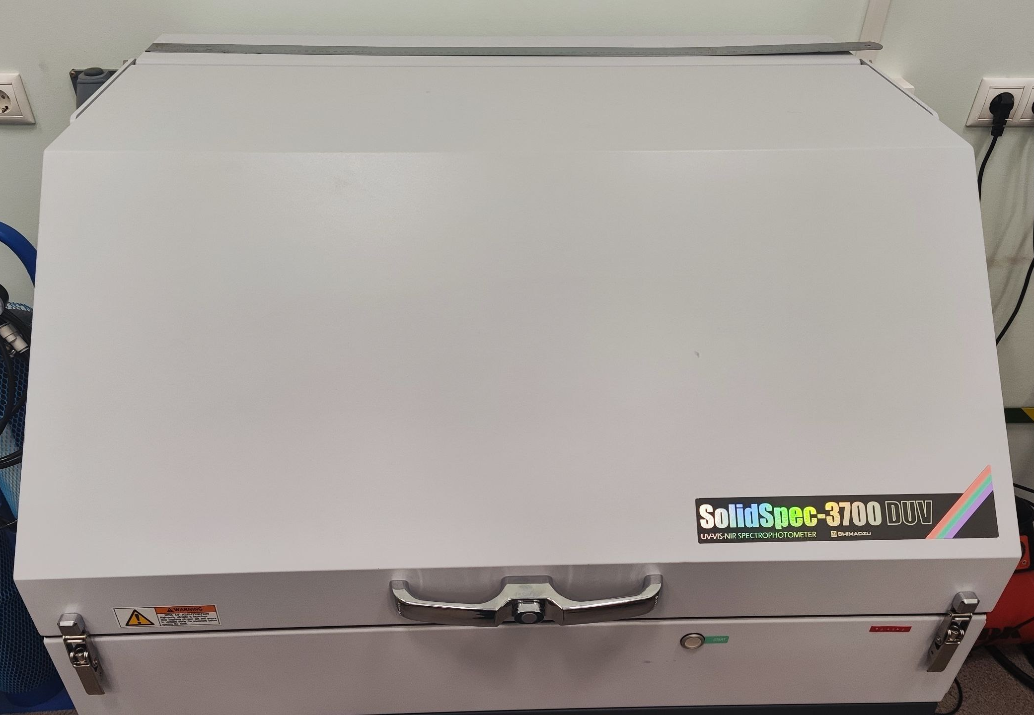
Fig. 5. SolidSpec-3700DUV – spectrometer

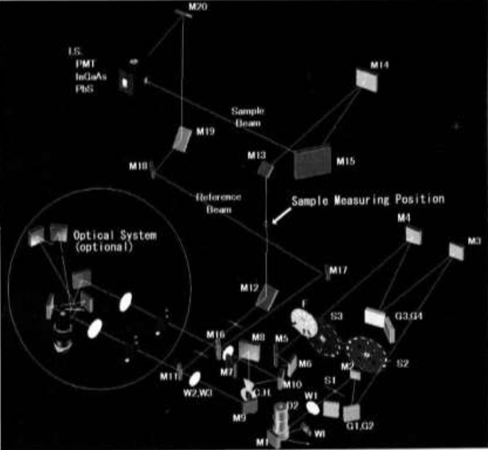
Fig. 6. Optical System: SolidSpec-3700 Series
- D2-Deuterium Lamp
- S1-Entrance Slit
- S2-Intermediate Slit
- S3-Exit Slit
- F-Filter
- G1,G2-Diffraction Grating (first spectrometer)
- G3,G4-Diffraction Grating (second spectrometer)
- C.H. - Chopper mirror
- I.S. -Integrating Sphere
- W1- Halogen Lamp
- M1-M20-Mirrors
- PbS-PbS Cell
- INGaAs-InGaAs Photo-diode
- PMT-Photomultiplier Tube
- Reference Beam-Beam on Reference Side
- Sample Beam-Beam on Sample Side
- W1-3-Windows(ф30 mm)
2.4 Comparative analysis of light transmission of samples SKTN-MED and Viksint
Fig. 7. Comparative analysis of films viksint and SKTN-MED
Viksint | 2.5 mm
Sktn-med | 2.1 mm
Table 1. Thicknesses data viksint and sktn-med
Based on the analysis of the light transmission spectra (Fig. 7) and the measured film thicknesses are summarized in Table 1., a detailed comparison of the optical characteristics of the Viksint and SKTN-Med film samples can be conducted. The most striking difference between the materials lies in their level of transparency within the visible spectrum. The Viksint samples demonstrate exceptionally high transmittance, exceeding 90% across most of the visible range. In contrast, the SKTN-Med samples (specifically, SKTN-Med 1 and SKTN-Med 2) show significantly lower values, approximately 70-80% and 60-70%, respectively. This clearly establishes Viksint as a substantially more transparent material.
The nature of the spectral curves also provides insight into the light-scattering properties of the films. The smooth, high-transmittance curve of Viksint is characteristic of materials with low diffuse scattering, where direct beam transmission is dominant. Conversely, the overall reduction in transmittance observed in the SKTN-Med samples is highly likely caused by significant light scattering within the material's volume or at its surface. This indicates that SKTN-Med possesses more pronounced light-diffusing or matte properties. When examining behavior in adjacent spectral ranges, the following trends are observed: in the ultraviolet region (wavelengths below 400 nm), all samples exhibit a decline in transmittance, though Viksint maintains its leading position. In the near-infrared region (starting from approximately 750 nm), Viksint continues to show stable, high, and uniform transmittance, while the SKTN-Med samples display a trend of moderate decline. This makes Viksint the more suitable choice for applications requiring a broad operational spectral range. Furthermore, notable differences exist between the two SKTN-Med samples themselves. The "SKTN-Med 1" sample consistently shows 5-10% higher transmittance across the entire spectrum compared to "SKTN-Med 2." This variance could be attributed to differences in thickness, specific composition, or internal microstructure between the two batches. In summary, the final material selection is directly dependent on the target application.Viksint, with its high transparency and low scattering, is an ideal candidate for tasks where maximum light transmission and minimal optical distortion are critical, such as in protective coverings for displays, optical sensors, or imaging systems. SKTN-Med, on the other hand, by virtue of its pronounced light-diffusing effect, could be successfully employed as a diffuser for achieving uniform light distribution in LED systems, for creating anti-glare coatings, or in instances where a soft reduction of light intensity is desired.
III. Research of fluoroplastic membranes
In this chapter, we present the results of a comprehensive investigation into the key optical characteristics of prospective polymer materials. The primary focus is on the quantitative analysis of parameters such as the total transmittance, characterizing the overall transparency of the material; haze (diffuse scattering), which determines the degree to which transmitted light is scattered; and specular reflection, which characterizes the fraction of light reflected from the surface without a change in angle. The conducted measurements establish a correlation between the microstructure of the materials and their macroscopic optical properties. A precise understanding of these properties is fundamental for optimizing the performance of plastic scintillator-based detectors, such as those used in Cosmic Ray Veto systems, where maximizing photon collection efficiency is paramount. The conducted measurements, performed over a relevant spectral range, establish a definitive correlation between the microstructure of the materials and their macroscopic optical properties, thereby providing a scientific basis for material selection and engineering
Transmittion
Set 1 | 3.2 × 10⁻⁴ кГр
Set 2 | 3.2 × 10⁻³ кГр
Set 3 | 0.032 кГр
Set 4 | 0.32 кГр
Set 5 | 3.2 кГр
Set 6 | 32 кГр
The characterization of the total optical transmittance of the films was performed with consideration of their radiation hardness. Transmittance spectra were measured after exposure to varying absorbed doses of radiation to quantify(Tab.2) the degradation of optical properties. The study established a correlation between the material composition and not only the initial characteristics but also its stability under radiation conditions, which is critical for applications in long-term detector systems.
Table 2. Irradiation doses distribution across experimental samples
The optical transmission spectra are presented for different absorbed radiation doses.(Fig. 8-13)

Fig.8. Transmittion spectra of films with the same thickness (0,05 mmk)
Fig.9. Transmittion spectra of films with the same thickness (0,15 mmk)
Fig.10. Transmittion spectra of films with the same thickness (0,25 mmk)
Fig.11. Transmittion spectra of films with the same thickness (0,45 mmk)
Fig.12. Transmittion spectra of films with the same thickness (0,6 mmk)
Fig.13. Transmittion spectra of films with the same thickness (1.0 mmk)
Analysis of the transmission spectra of the six polymer film samples revealed significant differences in their optical properties. In the visible spectrum region (400-700 nm), transparency ranges from 45% to 92%, with samples showing different behaviors in UV and IR regions. Samples set4 and set6 demonstrate the highest transparency (up to 96%), while set1 and set3 show the lowest values (approximately 70-75%). The obtained data indicate a substantial influence of composition and manufacturing technology on the optical characteristics of the materials, which must be considered for their targeted application in optical systems and detectors.

Diffuse reflection
The diffuse reflection of the films was removed after irradiation. It should be noted that there were no data on film samples without irradiation at the time of the experiment. Measurements of reflection were performed using BaSO₄ as the reference standard. The spectra display mean values calculated for thickness(Fig.14), alongside their standard deviations(Fig.15). Similarly, mean values(Fig.16) and standard deviations for lifetime(Fig.17) are presented
Fig.14. This picture shows the average values of the films depending on the thickness
Fig.15. Standard deviation of diffuse reflectance versus film thickness.
Fig. 16. This picture shows the spectra of films depending on the radiation time.
Fig.17. Standard deviation of diffuse reflectance versus film radiation.
The analysis reveals significant variation in the diffuse reflection coefficient across the studied samples, ranging from 35% to 41%. The maximum light scattering is observed in the set2 series (41%), while the minimum is recorded for set4 (35%). Intermediate values in the range of 37-39% were found for the remaining series. These results clearly demonstrate the substantial dependence of optical characteristics on the structural features of the materials. The observed 6% difference between extreme values confirms the necessity for precise control of production parameters to achieve target optical properties of polymer films.
Direct reflection
The direct reflection was captured on a flattened installation, where an aluminum mirror was used as a sample. Due to this, amendments were made to the experiment. This spectrum presents data for films exhibiting the minimal post-exposure dose, measured from the fluoroplastic coating side (Fig. 17). This spectrum presents data for films exhibiting the minimal post-exposure dose, measured from the side without fluoroplastic coating (Fig. 18). This spectrum shows the films with the highest post-irradiation dose from the side of the fluoroplastic layer application (Fig. 19). The spectrum displays films demonstrating the maximum post-exposure dose, measured from the side without fluoroplastic coating(Fig. 20).
Fig. 17. Film spectra vs. thickness at minimum irradiation time, measured from the coated side
Fig. 17. Film spectra vs. thickness for minimum irradiation (uncoated side).
Fig. 18. Film spectra vs. thickness for maximum irradiation (coated side).
Fig. 19. Film spectra vs. thickness for maximum irradiation (uncoated side)
Analysis of the specular reflection spectra of sample set 1 revealed significant anisotropy of optical characteristics between the external and internal surfaces. The outer side demonstrates systematically higher reflection coefficient values with a maximum of 1.0% in the visible spectrum range, which is 6-7 times greater than the parameters of the inner surface (0.15%). The observed effect is due to a combination of factors: different surface roughness and non-uniform distribution of the active substance in the polymer matrix.
Conclution
Based on the results of the conducted research, it is concluded that the investigated polymer films are highly effective as wrapping materials for scintillation crystals. The obtained values of the optical parameters and radiation resistance meet the specified technical requirements. The materials demonstrated stable characteristics and compatibility with the crystals, providing a basis for their implementation in the production process of detector element assembly in the near future. The positive outcomes of this research validate the decision to adopt these materials for practical implementation. Consequently, the studied films are recommended for integration into the production process of detector modules and are considered the primary candidate for future applications in advanced experimental setups, such as the COMET and Mu2e experiments. Their utilization is expected to enhance detector performance and reliability, contributing to the overall success of next-generation particle physics research.
Acknowledgement
I wish to extend my profound gratitude to all members of our research team whose expertise and dedication created an environment ripe for scientific discovery. I am deeply indebted to my research supervisor, Akram Artykov, whose scholarly insight and patient guidance have been invaluable throughout this endeavor. My special appreciation goes to Yuri Davydov, Head of the department, whose visionary leadership and commitment to cutting-edge research made it possible to conduct experiments on state-of-the-art equipment. I would like to extend my particular appreciation to David Chokheli for his invaluable assistance in resolving complex methodological issues, his deep analysis of the results, and his constant readiness for professional discussions, which significantly enriched this research. To Ilya Vasilyev, Vladimir Baranov, and Ozoda Inoyatillo – your brilliant suggestions and true collaborative spirit have left an indelible mark on this research. This journey would not have been possible without Samarkand State University, whose commitment to global knowledge exchange provided the foundation for this work. Finally, to the START team and especially Elena Karpova – your steadfast support and remarkable responsiveness to every query have been nothing short of extraordinary.
Bibliography
1. I.Bartoszek,et al., Mu2e Collaboration, Mu2e Technical Design Report, Tech
Rep., FERMILAB, 2014, http://dx.doi.org/10.2172/1172555, arXiv:1501.05241.
2. R. Abramishvili, et al., COMET Collaboration,COMET Phase-I Technical
Design Report , Etch. Rep. 3, KEK/J-PARC, 2020, 033C01,
http://dx.doi.org/10.1093/ptep/ptz125, arXiv:1812.09018
3. https://www.originlab.com
4. Light yield and radiation hardness studies of scintillator strips with a filler
A. Artikov, V. Baranov, J. Budagov, M. Bulavin, D. Chokheli et al. (Nov 30, 2017) Published in: Nucl.Instrum.Meth.A 930 (2019) 87-94 • e-Print: 1711.11393 [physics.ins-det]

