

JOINT INSTITUTE FOR NUCLEAR RESEARCH
Frank Laboratory of Neutron Physics
Sector of Neutron Activation Analysis and Applied Research (SNAAPI)

FINAL REPORT ON THE START PROGRAMME
Biomonitoring of atmospheric deposition of trace elements
in Yakutia and Chukotka

Supervisors:
Dr. Marina Frontasyeva
Student:
Liana Sleptsova, Russian Federation
North-Eastern Federal University in Yakutsk (NEFU)
Participation period:
August 24 – October 04,
Summer Session 2025

Dubna, 2025

Abstract
The present study is devoted to the assessment of atmospheric deposition of heavy metals and other pollutants in Yakutia and Chukotka using mosses as bioindicators. The uniqueness of Arctic and subarctic ecosystems, their vulnerability to anthropogenic impact, as well as limited data on environmental pollution in these regions determine the relevance of this work.
Neutron activation analysis (NAA) was chosen as the main method of analysis, which is a highly sensitive and multi-element method that allows determining concentrations of a wide range of elements in mosses with minimal sample preparation. The samples of Hylocomium splendens and Pleurozium schreberi moss are mainly considered, which has a high ability to accumulate heavy metals from atmospheric precipitation according to the rules of the United Nations program "Air pollution of heavy metals in Europe: assessment based on the analysis of biomonitor mosses" [1].

Contents

Introduction 3
1. Mosses as biomonitors of atmospheric precipitation of heavy metals and other toxic elements 4
2. Sampling for analytical research 6
2.1 Sampling in 2023 7
2.2 Sampling in 2024 8
2.3 Sampling in 2025 8
3. Sample selection and preparation for NAA 10
4. The NAA Method 10
Conclusion 12
Acknowledgement 12
References 12

Introduction
The Republic of Sakha (Yakutia) represents a critical mineral-resource and mining region within the Russian Federation. In terms of reserves of all types of natural resources, Yakutia ranks first nationwide. The principal economic sectors include the extraction of diamonds, gold, oil, gas, and coal. Currently, the Republic of Sakha (Yakutia) is classified among ecological risk zones within the Russian Federation. The primary atmospheric pollutants comprise carbon monoxide, particulate matter, hydrocarbons—including volatile organic compounds (VOCs), nitrogen oxides, and sulfur dioxide [2].
Biomonitoring, based on the use of biological objects (mosses, lichens, plants) to assess the level of pollution, is an effective and economical method. Moss and lichens, as filter organisms, accumulate heavy metals from atmospheric precipitation, reflecting their integral level [3].
Currently, neutron activation analysis (NAA) is one of the most sensitive and non-destructive methods for determining the elemental composition of samples. The use of the IBR-2 pulse reactor in the Laboratory of Neutron Physics (LNF) The Joint Institute for Nuclear Research (JINR) allows for high-precision analysis of a wide range of elements in biomaterials [6].
This work is devoted to the study of atmospheric precipitation of heavy metals in Yakutia and Chukotka using the method of neutron activation analysis of moss and lichen samples collected in various geographical locations. The purpose of the study is to assess the level of heavy metal pollution, identify sources, and determine the spatial distribution of pollutants.

- Mosses as biomonitors of atmospheric precipitation of heavy metals and other toxic elements
The morphological and physiological properties of mosses, along with their wide distribution, make these plants very useful bioindicators for assessing the state of the environment. They have a number of advantages over other biomonitor plants (lichens, tree bark, grass, etc.): the absence or strong change of cuticles, thinly and closely planted leaves, and poorly developed conductive tissues - all this leads to an effective accumulation of airborne materials. Mosses effectively concentrate most heavy metals and other trace elements from the air and precipitation (dry and wet precipitation). Moreover, they do not have a root system and, therefore, the contribution of sources other than atmospheric precipitation is limited in most cases. Collecting samples is simple, analyzing mosses is much easier than analyzing precipitation, and the exposure period can be determined fairly accurately.
The main problem may be elementary pollution due to wind-borne dust, and in forests it may also be due to precipitation through leaves. Thus, the transition to absolute precipitation levels is achieved by direct calibration of data relative to total precipitation.
The use of separate statistical methods for interpreting the data obtained and their combination with the analysis of the trajectories of air masses makes it possible to assess the contribution of various sources of pollution to the overall picture. The biomonitoring method was developed in the late 60s of the last century as a way to study the content of heavy metals in atmospheric precipitation.
This method has been regularly used over the past 30 years in Scandinavian countries for routine monitoring of atmospheric precipitation of metals over very large areas. Recently, it has become widespread in European countries within the framework of the International Program "Atmospheric precipitation of heavy metals in Europe: assessment based on the analysis of moss biomonitors" [3]. Its purpose is to qualitatively and quantitatively characterize the distribution of regional atmospheric precipitation in Europe, identify the location of important sources of TM pollution, and provide a retrospective comparison with the same studies repeated every 5 years.
The main biomonitor species in European studies are the mosses Hylocomium splendens and Pleurozium schreberi. These types of mosses are distributed in a wide range of temperature zones, and their growing part is such that annual growth can be easily identified.
Collecting samples is simple, and analyzing mosses is much simpler than analyzing sediments. The exposure period can be precisely determined. Usually, a three-year moss growth is taken for analysis. In Russia, the use of the moss method for monitoring metal precipitation has not yet found widespread use [4].
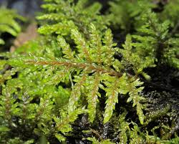 | 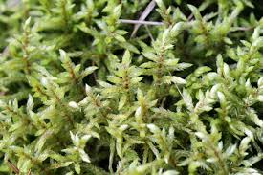
Figure 1 Hylocomium splendens | Figure 2 Pleurozium schreberi

- Sampling for analytical research
Sampling and sample preparation for analytical studies
On-site sampling should be carried out in accordance with the following principles [4]:
1. Sampling points should be located in open areas, at a distance of at least 3 m from the crowns of the nearest trees: in forests and forest plantations, outside the zone of influence of tree crowns.
2. The samples must be cleaned of impurities.
3. The points must be located at least 300 m away from major roads, villages and businesses, and at least 100 m from country roads and individual buildings.
4. It is forbidden to smoke during sampling and when working with samples in the future.
5. Polyethylene gloves are used to determine metals during sampling.
6. Samples are collected from April to October. Coordinates are determined for each sampling point, preferably longitude and latitude GMT in the 360° system.
Sampling was carried out from 2023 to 2025. The sampling plan is shown in Figure 6. Sampling points were selected in open areas away from trees, residential buildings, major roads, and populated areas. Gloves and paper envelopes were used to collect the moss. The samples were dried at room temperature. After that, the foreign plant materials were cleaned in the laboratory and unnecessary parts of the mosses were cut off. They were placed in a paper envelope and sent for analysis.

2.1 Sampling in 2023
Sampling was carried out in accordance with the Monitoring Manual [3, 4].
In 2023, from July to September, samples were taken for analysis in the Republic of Sakha (Yakutia) and the Chukotka Autonomous Okrug. A total of 29 samples, of which 4 samples were collected in Chukotka and 25 samples were taken in Yakutia (Churapchinsky, Oleneksky, Anabarsky, Tomponsky, Nyurbinsky, Suntarsky, Khangalassky, Mirninsky, Zhigansky and Neryungrinsky districts).
The following moss species were sampled in the study area: Hylocomium splendens, Pleurozium schreberi, Tomentypnum nitens, Rhytidium rugosum, Aulacomnium palustre, Aulacomnium turgidum, Shagnum, Polytrichum strictum, Racomitrium lanuginosum and Ptilidium ciliare.
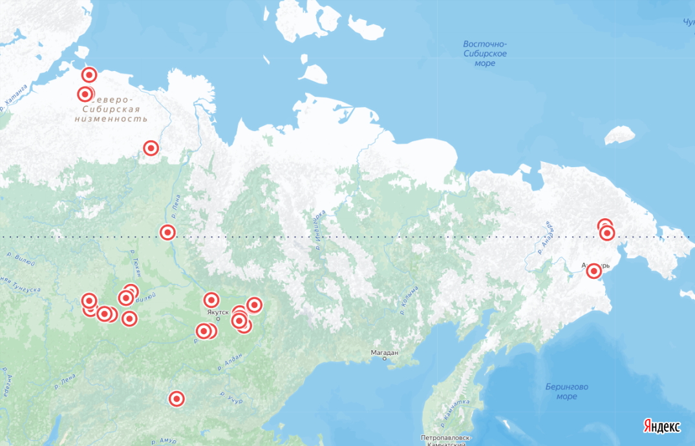
Figure 3 Sampling map for 2023

2.2 Sampling in 2024
The sampling was carried out from June to August 2024 on the territory of the Republic of Sakha (Yakutia). A total of 11 samples were taken from different districts (see Table 2) (Churapchinsky, Tattinsky, Ust-Aldansky, Megino-Kangalassky, Aldansky, Khangalassky and Anabarsky.
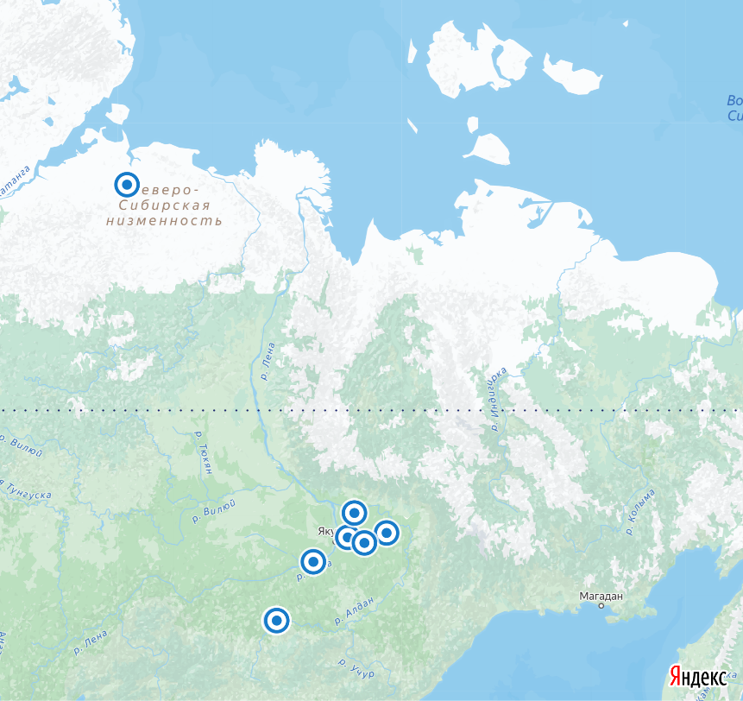
Figure 4 Sampling map for 2024

2.3 Sampling in 2025
In 2025, sampling was carried out in Yakutia from July to August in cooperation with the Ministry of Ecology of Yakutia. Moss samples were taken in 27 districts: Aldansky, Allaikhovsky, Amginsky, Anabarsky, Bulunsky, Verkhnevilyuysky, Verkhnekolymsky, Verkhoyansky, Vilyuysky, Gorny, Zhigansky, Kobyai, Lensky, Megino-Kangalassky, Mirninsky, Namsky, Neryungrinsky, Nizhnekolymsky, Nyurbinsky, Oleneksky, Srednekolymsky, Suntarsky, Tattinsky, Tomponsky, Ust-Maysky, Khangalassky and Churapchinsky.
A total of 83 samples were collected. The part of the samples with a distance of less than 20 km was averaged in accordance with the sampling rules [4]. After averaging, the number of samples decreased to 56.
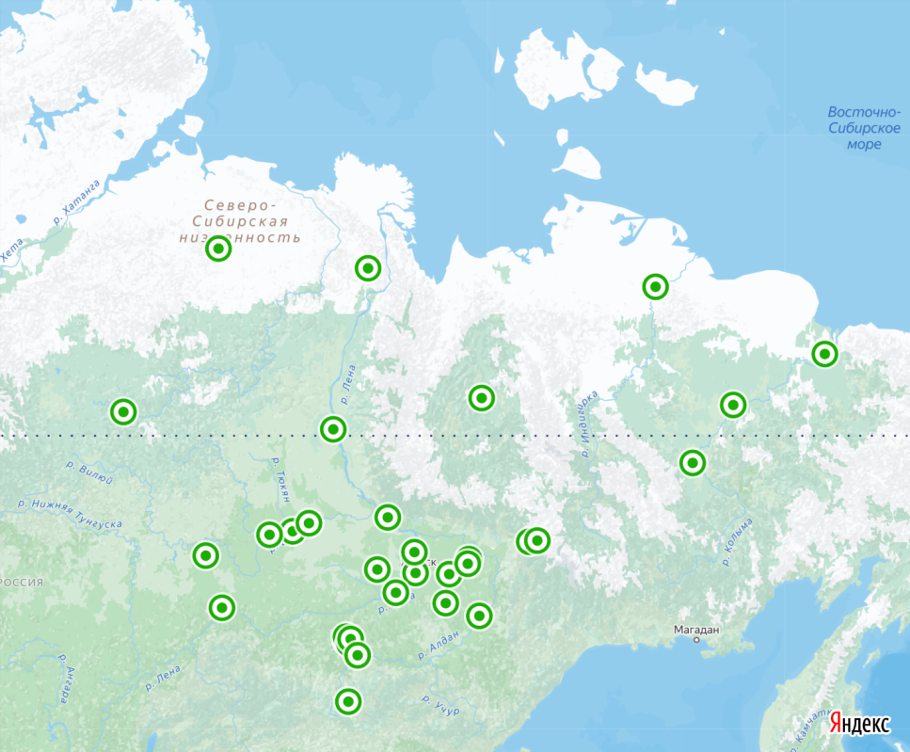
Figure 5 Sampling map for 2025

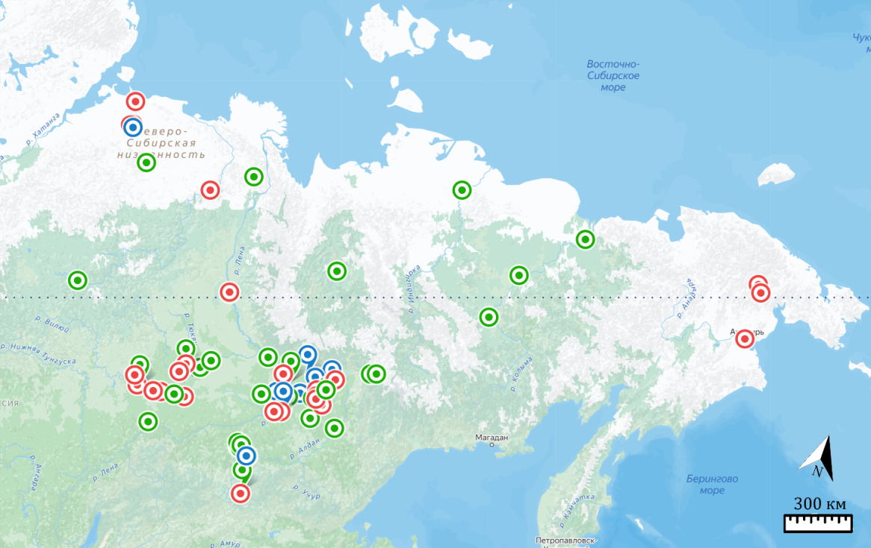
Figure 6 Sampling map in Yakutia and Chukotka for 2023-2025
In addition to the general sampling, moss samples were collected to assess the impact of the landfill of solid household waste (MSW) on the ecological condition of the village of Churapcha (Churapcha district), 11 moss samples in order to identify the distribution of pollution from MSW (Figure 7).
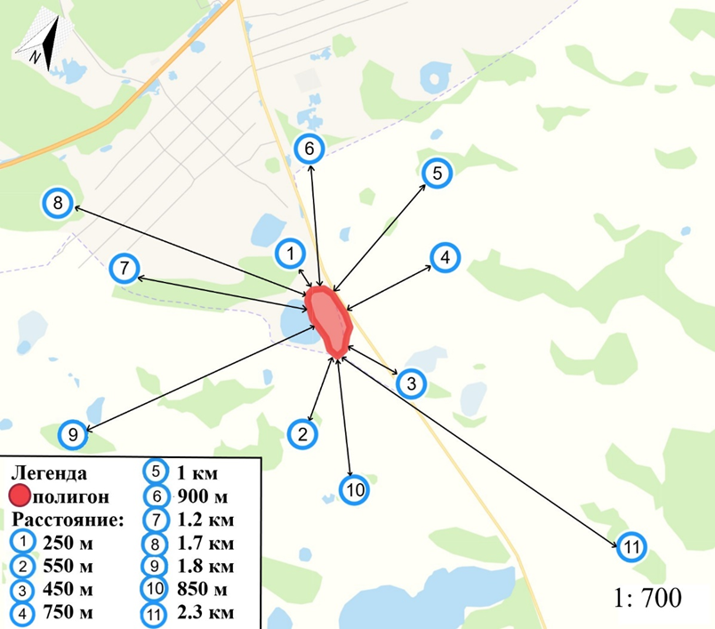
Figure 7 Sampling map on the territory of Churapchisnky ulus

Sample selection and preparation for NAA

All samples were delivered to Dubna and subjected to appropriate screening in accordance with the UNECE Vegetation Programme requirements. Following this process, the number of samples was reduced from 83 to 56..

The NAA Method [5]
I have got acquainted with the principles of analytical method - NAA - to be used for elemental determination in moss samples.
Neutron Activation Analysis (NAA) is a quantitative and qualitative method of high efficiency for the precise determination of a number of main-components and trace elements in different types of samples. NAA, based on the nuclear reaction between neutrons and target nuclei, is a useful method for the simultaneous determination of about 25-30 major, minor and trace elements of geological, environmental, biological samples in ppb-ppm range without or with chemical separation.
In NAA, samples are activated by neutrons. During irradiation the naturally occurring stable isotopes of most elements that constitute the rock or mineral samples, biological materials are transformed into radioactive isotopes by neutron capture. Then the activated nucleus decays according to a characteristic half-life; some nuclides emit particles only, but most nuclides emit gamma-quanta, too, with specific energies. The quantity of radioactive nuclides is determined by measuring the intensity of the characteristic gamma-ray lines in the spectra. For these measurements a gamma-ray detector and special electronic equipment are necessary. As the irradiated samples contain radionuclides of different half-lives different isotopes can be determined at various time intervals.
Although the development of analytical techniques has led to the expansion of new methods (ICP-AAS, ICP-MS, etc.), which can also be widely applied in analytical chemistry, NAA is still competitive in many areas. The indisputable advantage of the method is its sensitivity and accuracy especially in respect of some trace elements. The method is of a multielement character, i.e. it enables the simultaneous determination of many elements without chemical separation. In the case of instrumental determination, the preparation of samples involves only the preparation of representative samples, i.e. pulverization or homogenization in most cases, and this reduces the danger of contamination to a minimum and accelerates the whole analytical process. If the determination of some special elements or groups of elements can be carried out only through chemical separation, it is possible to carry out after irradiation. Thus the pollution caused by the different chemicals will not get activated, the chemical yield can be measured by feeding inactive carriers and the chemical processes can be better controlled. During NAA the neutrons get into interaction with the nucleus, therefore, the chemical composition and crystal structure of the substance under analysis will have an effect on the result only in exceptional cases.The development of the method has contributed to the elaboration of some very simple and accurate methods of standarization, which lead to a surpassingly accurate analysis. The widespread application of NAA is hindered, however, by some conditions. Among the different fields of application, the Instrumental Neutron Activation Analysis (INAA) following a reactor irradiation is the most competitive. In view of the increasing protest against nuclear energy, a number of research reactors have been shut down; therefore, the possibilities of irradiation are limited in many countries. The equipment needed for the analysis is rather expensive and requires special laboratories and a highly qualified staff [5].

Conclusion
As a result, 85 samples were collected for analysis in Yakutia and Chukotka in 2023-2025. Due to the fact that sample preparation begins after a decision has been made to analyze the samples. After receiving the results, a map of the distribution of pollutants will be built using GIS technologies.

While working in the Sector of NAA and Applied Research of FLNP JINR I have got acquainted with the Chemical laboratory of the Sector and visited Radioanalytical Complex REGATA at the reactor IBR-2. I also prepared the theoretical part of the Bachalor Diploma.
Together with my FLNP supervisor Dr. M.V. Frontasyeva I have prepared an Application for irradiation of moss samples collected in 2023-2025.

Acknowledgement
I am grateful to the staff of the Sector of NAA and Applied Research for kind attention and useful discussions during my staying at JINR.

References
- International Cooperative Programme on effects of air pollution on natural vegetation and crops https://icpvegetation.ceh.ac.uk/
- Kovalev L. N., et al. (2016). Mineral reserves and resources of the Republic of Sakha (Yakutia). https://www.researchgate.net/publication/306020807_Mineral_reserves_and_resources_of_the_Republic_of_Sakha_Yakutia
- Emel Sert, et al. (2011). Biomonitoring of 210Po and 210Pb using lichens and mosses around coal-fired power plants in Western Turkey. https://www.sciencedirect.com/science/article/abs/pii/S0265931X11000270
- MONITORING OF ATMOSPHERIC DEPOSITION OF HEAVY METALS, NITROGEN AND POPs IN EUROPE USING BRYOPHYTES, MONITORING MANUAL 2020 SURVEY. https://icpvegetation.ceh.ac.uk/sites/default/files/ICP%20Vegetation%20moss%20monitoring%20manual%202020.pdf
- A.Vértes, S. Nagy, K: Süvegh, Nuclear Methods in Mineralogy and Geology, Plenum Press, New York and London (1998)
- Frontasyeva M., Harmens H., Uzhinskiy A., Chaligava O. and participants of the moss survey, Mosses as biomonitors of air pollution: 2015/2016 survey on heavy metals, nitrogen and POPs in Europe and beyond. Dubna: JINR, 2020, 136 p. ISBN 978-5-9530-0508-1

