JOINT INSTITUTE FOR NUCLEAR RESEARCH
Frank Laboratory of Neutron Physics

FINAL REPORT ON THE
START PROGRAMME

Search for
thermoelastic martensitic transformations
in Ti-Nb-Zr alloy in low temperature range

Supervisor:
Dr. Roman Vasin

Student:
Buchkov Anatoly, Russia
Tula State University

Participation period:
February 11 – March 23,
Winter Session 2024

Dubna, 2024
Contents
Abstract
1. Introduction
2. Sample preparation, experimental setup and method of analysis
3. Main part
3.1 Superelastic β-Ti alloys
3.2 Thermoelastic martensitic transformations
4. Results
Acknowledgments
References

Abstract
Development of better materials for biomedical applications, e.g., implantation, is an actual problem of materials science.
Among currently studied materials are superelastic β-Ti alloys, which demonstrate a specific combination of physical properties making them very perspective for such application: they combine good mechanical properties, relatively low elastic modulus (compared to traditional materials used for production of implants), excellent corrosion resistance and biocompability.
An important task is to choose an optimal fabrication method of the alloys due to Ti sensitivity to impurities, which can significantly affect its properties. One of the promising methods is calcium hydride synthesis, which produces high-quality powder materials. It is necessary to study the influence of synthesis and subsequent thermomechanical processes on materials structure and microstructure. Additionally, there are reports on possible phase transitions in β-Ti alloys in the negative temperatures range.
Therefore, in this work sintered and cast Ti-18Zr-15Nb alloy samples with different porosity will be investigated by X-ray diffraction method to establish the crystal structure, assess microstructural parameters, their changes with temperature and search for possible phase transformations.

1. Introduction
A wide variety of materials is used in modern medicine. Metal materials occupy an important place among them, and are used to manufacture various devices, instruments, and implants. At the same time, it is important to mention that special requirements needed for such biomedical materials. This is especially true for metals and alloys used in implantology and prosthetics [1-4].
Titanium-based materials were introduced for medical applications during the past century. Titanium was chosen as the basis for many alloys used in this field due to its high strength, light weight because of low density, as well as high corrosion resistance and lack of toxic effects. However, in its raw state, titanium as a material for various implants lacks some necessary characteristics.
Biological compatibility is the main limitation factor when choosing a material for biomedical use. Two conditions are especially important r1egarding intraosseous implants: biomechanical compatibility and biochemical compatibility. For bone tissue, biomechanical compatibility means the ability to perceive significant deformations with following restoration of shape, as well as in a relatively low modulus of elasticity (for cortical bone, Young's modulus is about 30 GPa) [5] In the simplest case, biochemical compatibility is the absence of toxic effects on the body over time.
Titanium alloys have been used in medicine for quite a long time. The most successful alloys were VT6 (Ti-6Al-4V) and nitinol (TiNi). VT6 alloy generally fulfils the biomechanical requirements, however, there are concerns that after a long period of use, toxic ions V and Al may be released into the body. There are studies that confirm an increase in the risks of developing various degenerative diseases, such as arthritis or osteoporosis, when ions of these metals are present in the body [6]. At the same time, nitinol is a well-studied shape memory alloy and, unlike VT6, exhibits superelasticity, which even better approximates the alloy's elastic properties to bone tissues. However, nickel is also a known toxic element, so the service life of such implants is limited too [7].
Thus, there is a necessity to develop new alloy compositions for biomedical applications, which wouldn’t have negative impact in the long run. Quite promising group of materials are beta-titanium alloys, in particular ternary Ti-Nb-Zr systems.
All elements composing this alloy are biologically inert in the environment of the human body. In addition, the mechanical properties of the alloys of this system satisfy the condition of biomechanical compatibility. Also, compared with the aforementioned VT6 (Ti-6Al-4V) alloy, Ti-Zr-Nb alloys have lower Young’s modulus. In various publications, there is evidence of the realization of shape memory (SM) and superelasticity effects (SE) in these kinds of alloys [6, 8, 9] (Fig. 1). These special properties are manifested in alloys due to thermoelastic martensitic transformation.
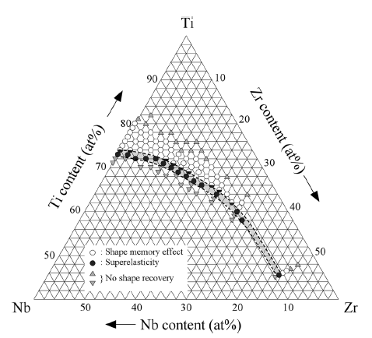
Figure 1. Composition dependence of shape memory effect and superelasticity for Ti-Nb-Zr alloys [10].
Due to recognized potential for practical applications, nickel-free beta-titanium alloys are currently thoroughly investigated. Work on the topic is carried out by scientists from different countries, new publications appear regularly both directly on the subject of research and on related topics.
An important problem is the optimal manufacturing process to obtain alloys of the desired chemical composition. Most publications describe vacuum arc remelting (VAR) as a best method for producing ingots of beta-titanium alloys. Along with the VAR, in some studies alloys were obtained by casting with subsequent remelting, or powder metallurgy methods.
Modern methods of producing powdered alloys allow for the creation of materials with a unique set of physical and mechanical properties. When it comes to the development of alloys for medical applications, the use of powder-based materials may be very promising solution. This approach allows for the creation of implant materials that closely resemble bone structures, with low density, a certain level of porosity, and a low Young's modulus, all of which are essential characteristics for producing a reliable implant. Therefore, the synthesis of beta-titanium alloys by powder metallurgy methods can ensure the production of a material that would meet all the biochemical requirements, while remaining economically viable.
The main goal of this work is to perform X-ray diffraction analysis of Ti-18Zr-15Nb alloy samples obtained by casting and powder metallurgy methods. The study will be conducted in order to compare the phase transformations specifics of different processed samples in low-temperature range.

2. Sample preparation, experimental setup and method of analysis
In this study, the alloy of the specific composition Ti-18Zr-15Nb was considered. Five alloy samples were manufactured: one was produced by casting, and four were synthesized using calcium hydride syntheses under various sintering conditions. Therefore, the powder-based alloy samples have varying degrees of porosity: 2%, 22%, and 35%, and one sample was subjected to rotary forging after sintering at 700°C, which produced a material with porosity of less than 1%. Sintering procedure were as follows: 180 minutes at 1400°C for a sample with 2% final porosity; 150 minutes at 1200°C for sample with 22% porosity; and 200 minutes at 900°C followed by 60 minutes at 1000°C for sample with 35% porosity. The deformed sample underwent rotary forging at a temperature of 700°C with a true strain ε = 0.63.
The samples for X-ray diffraction analysis were prepared in the form of ellipsoidal cylinders with measurements approximately 7 x 5 x 2 mm. The surface of the specimens was prepared through a series of grinding and polishing steps. Grinding was performed using a set of abrasives, with particle sizes ranging from P400 to P2500. Polishing took place on cloth with addition of an aqueous solution containing chromium oxide (Сr₂O₇). After polishing, the specimens subsequently underwent ultrasonic cleaning.
X-ray diffraction was carried out with utilizing PANalytical Empyrean diffractometer equipped with PIXcel3D detector (Fig. 2). Measurements were conducted with Cu-Kα radiation featuring Ni-filter. 0.02° Soller collimator was applied to both incident and diffracted beams, as well as a 10-mm mask to define the beam in the horizontal plane. A slit of 1/4° and 1/2° was installed in the diffracting plane.
The diffractometer was equipped with an Oxford Cryosystems Phoenix cryostat, which allows measurements at temperatures up to 5 K (-268.15°C). In this work, the samples were examined in the temperature range from 20°C to -250°C. Cooling and subsequent heating were done at 6°C/min. rate. After reaching a certain temperature value, the sample was allowed to equilibrate for 5 min., afterwards, the diffraction pattern was measured for 1 hour in the interval of scattering angles 2θ = 30-100°.

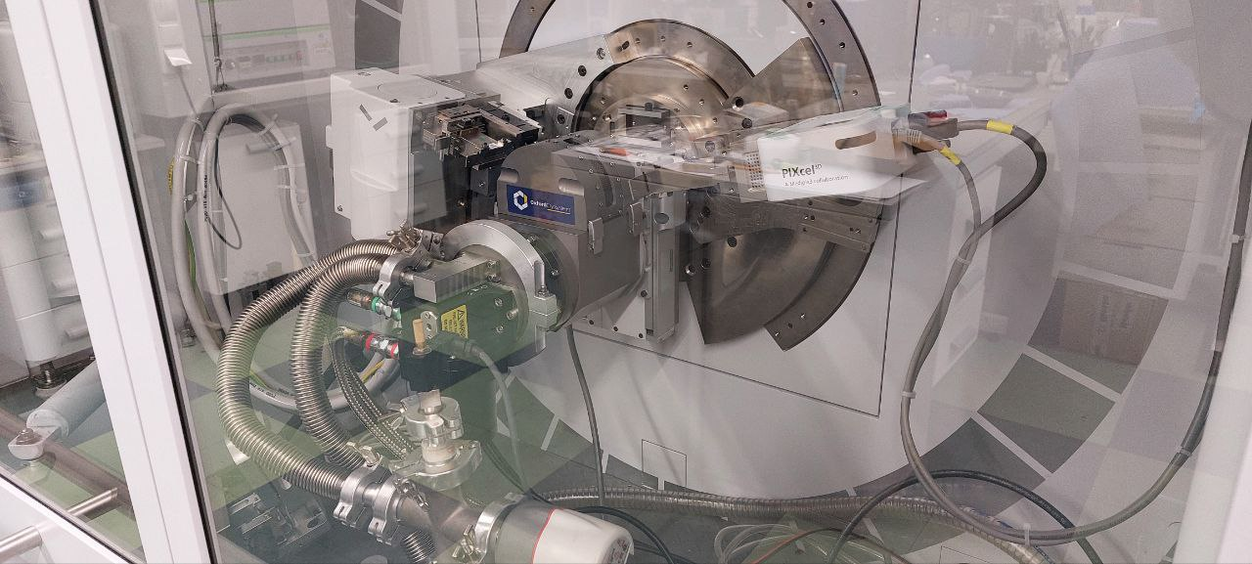
Figure 2. PANalytical Empyrean diffractometer with PIXcel3D detector and Oxford Cryosystems Phenix cryostat.

Obtained diffraction patterns were analyzed in the MAUD software [11], which utilizes the well-established Rietveld method [12]. The method uses a minimization procedure to refine parameters of a model diffraction pattern until it matches the measured pattern. Usually, the minimized quantity is a weighted sum of squares:
$$WSS=\sum_{i}{w_{i}{\left(I_{i}^{exp}-I_{i}^{calc}\right)}^{2}}$$
This summation is over all data points i in the diffraction pattern. $I_{i}^{exp}$ is the measured intensity value, $I_{i}^{calc}$ is the model intensity value, $w_{i}$ is the statistical weight, which for independent intensity measurements is equal to 1/$I_{i}^{exp}$. Refined parameters include different physical characteristics of the sample, such as microstructural parameters, unit cell parameters, atomic coordinates, etc.
To construct the model diffraction pattern, it is necessary to know the parameters of the X-ray diffractometer, such as present wavelengths, instrument-dependent peak shape (scattering angle-dependent ratio of Gaussian and Lorentzian profiles), broadening and asymmetry, instrument-related errors in diffraction peak positions, etc. These parameters were determined using the diffraction pattern of the standard LaB₆ scatterer (NIST SRM 660b), which is practically free of crystal structure defects, has a well-defined unit cell parameter (a = 4.15689 Å) and coherently scattering domain size (7000 Å). During the LaB₆ refinement, it was determined that copper K_{β} line and K_{α34} satellite are present, and their fractions (< 0.1% of the main copper K_{α1} line intensity) were defined. The processed LaB₆ diffraction pattern is shown in Figure 3. In further refinements, instrumental parameters were kept fixed.
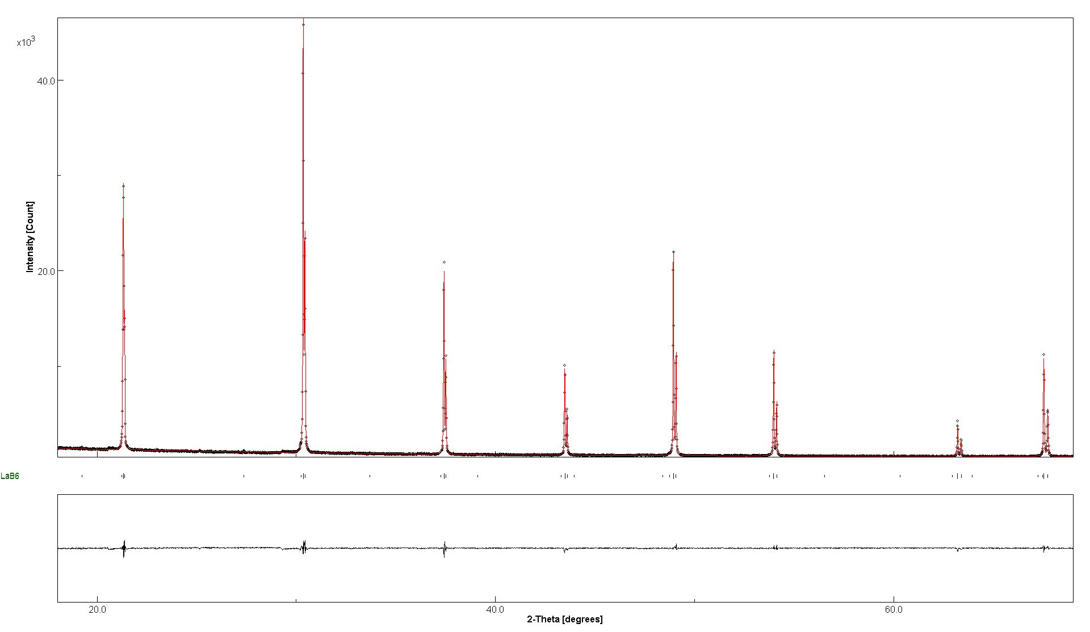
Figure 3. Refinement of LaB₆ diffraction pattern in MAUD

3. Main part
3.1 Superelastic β-Ti alloys
Titanium has two structure modifications: α (hexagonal close-packed HCP) below 882°C and β (body-centered cubic, BCC) above 882°C. Accordingly, titanium alloys can be classified as α, α+β and β alloys depending on their phase composition at room temperature. The phase composition depends on the type and quantity of alloying elements. Alloying elements, in turn, can be divided into three groups: α-stabilizers such as aluminum (Al), oxygen (O), nitrogen (N) and carbon (C); β-stabilizers such as molybdenum (Mo), vanadium (V), niobium (Nb), tantalum (Ta), iron (Fe), tungsten (W), chromium (Cr), silicon (Si), nickel (Ni), cobalt (Co), manganese (Mn), hydrogen (H); and neutral ones such as zirconium (Zr), hafnium (Hf). In turn, the properties of titanium alloys are highly dependent on the phase structure and, accordingly, the composition of the alloy.
In this study, the attention is focused on the beta-titanium alloy. As the content of beta-stabilizing elements in the alloy increases, the phase composition at room temperature will be BCC beta-titanium (Fig. 4).
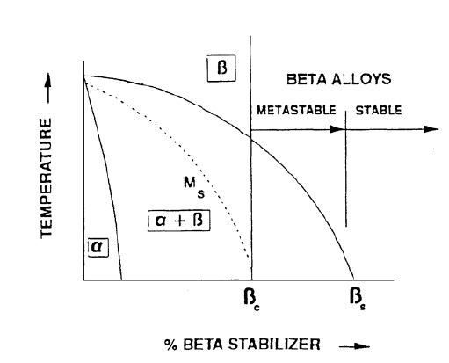
Figure 4. Pseudo-binary phase diagram Ti-β + stabilizer [13].

In turn, beta-titanium alloys can be divided into two subgroups: metastable and stable. The difference is in the fact that stable alloys do not change their phase composition under the influence of thermal and mechanical treatment, while metastable alloys can undergo phase transformation (alpha phase separation or other changes). In fact, all commercially available beta alloys are metastable due to the potential for phase transformation under external loads or temperature changes.
Thermomechanical processing of metastable alloys is relatively simple. After treatment to solid solution state, metastable β-alloys undergo aging in the temperature range of 450-650°C to partially transform the β-phase into the α-phase. The α-phase appears in the form of small inclusions within the initial β-phase. This enhances the strength of the alloy. In fact, titanium β-alloys do have some disadvantages. They have a higher density than α+β alloys and a lower creep resistance as well as lower ductility when aged. However, despite their low ductility, their toughness is generally higher than that of α+β alloys with the same yield strength. As materials for implants, β alloys have a unique combination of high corrosion resistance, low Young's modulus, and significant ductility (Fig. 5).
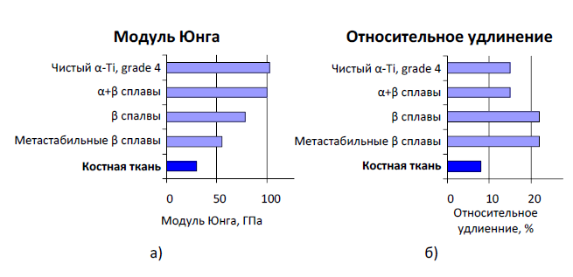
Figure 5. Comparison of Young’s modulus (a) and elongation (b) of pure titanium and some Ti alloys with the bone tissue [13].
At the moment, one of the most popular biomedical materials for research are nickel-free alloys based on Ti and Nb, which acts as an isomorphic beta stabilizer, as mentioned above. Evidence of the effects of superelasticity and the shape memory effect in titanium-niobium alloys with different chemical compositions were obtained quite a long time ago (Fig. 6-8). In [14], orientation relations during phase transitions in Ti-35Nb alloys were investigated.

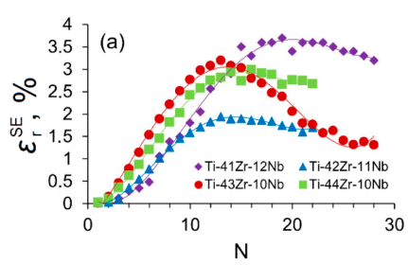
Figure 6. Superelasticity depending on concentration of Zr in different alloys [15].
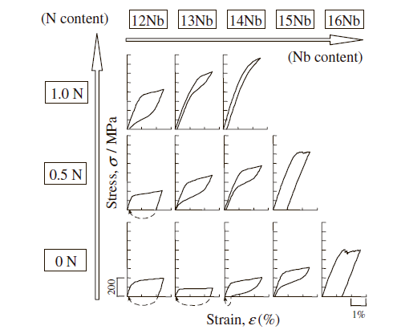
Figure 7. Effect of N on superelasticity in Ti-Nb alloys [16].
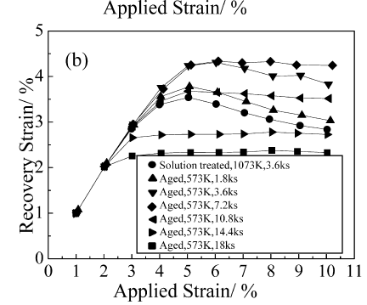
Figure 8. Amount of recovery strain depending on time of age treatment [17].

3.2 Thermoelastic martensitic transformations
In Ti-Nb and similar alloys the effects of shape memory and superelasticity are realized due to a special type of phase transitions – thermoelastic martensitic transformations.
According to the well-established definition, martensitic transformation is a cooperative movement of atoms along certain crystallographic directions over distances not exceeding the interatomic spacings. Based on this displacement, a shift occurs that determines appearance of a new phase with a different crystal lattice. The first to describe such phase shifts was G.V. Kurdyumov [18].
Afterwards the possibility of reverse martensitic transformations was also proved, which made it possible to consider martensitic transformations as phase transformations in a single-component system characterized by an ordered, cooperative, interconnected nature of atomic movements over distances less than interatomic without exchanging atoms in positions, so that the neighbors of any atom in the initial phase remain its neighbors in a new phase both during direct and reverse transformations.
The superelasticity and shape memory effects are based on the thermoelastic character of the martensitic transformation. During such thermoelastic martensitic transformation, a thermoelastic equilibrium is observed, which is due to formation of elastic martensite crystals, the boundaries of which, in the transformation temperature range, with a change in temperature and (or) stress field, move towards the martensitic or initial phase with a simultaneous reversible change in the geometric shape of the formed crystalline regions.
Kinetics of martensitic transformations is considered athermal, as indicated by the features established during Kurdyumov's research [18]. These include:
1) High transformation rate, regardless of temperature;
2) Broad temperature range of the martensitic transformation. The amount of formed martensite depends on the degree of overcooling below the temperature, at which the transition begins;
3) No delay in the martensitic transformation even during extremely rapid cooling. The starting point of the transformation is practically unaffected by the cooling rate;
4) An increase of volume of the new phase is not related to the growth of existing grains, but rather to the formation of new crystals. Furthermore, the formation of these crystals occurs almost instantaneously.
Martensitic transformations are characterized by two points: the starting point (Ms) and the finishing point (Mf) of martensitic transformation. The phase transition starts after the material's temperature reaches the Ms temperature.
This temperature depends mainly on the chemical composition of the alloy. For Ti-Nb-Zr alloys, both niobium and zirconium (to a lesser extent), stabilize the β-phase of titanium and also reduce the start temperature of the transformation. For example, when 1 atomic % niobium is added to an alloy, the Ms temperature decreases by 40 K, and when 1 atomic % zirconium is added, it decreases by approximately 30 K [19, 20].
It must be mentioned that the orientation relations between initial and martensite phases in beta-titanium alloys are well known (Fig. 9). During transformations of BCC, titanium can transform into HCP α’-martensite or orthorhombic α’’-martensite. The appearance of a particular phase depends mainly on the content of alloying elements [21].
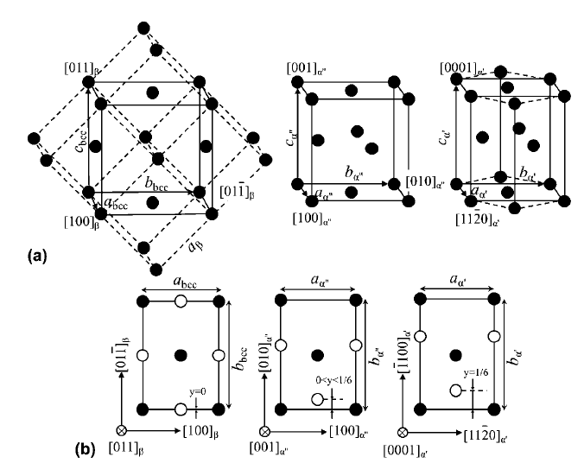
Figure 9. (a) Schematic representation of the crystal structures of b, a’ and a'' phases (conventional unit cells are indicated by dashed lines) and (b) their lattice correspondences (the solid and empty circles located respectively, at adjacent (011) planes for the b phase, (001) for the a’’ phase and (0001) for the a’ phase [21].

Results
As a result of X-ray diffraction analysis, a set of diffraction patterns were obtained for various samples across a range of temperatures from 20°C to -180°C (in some cases up to -250°C). No martensitic transformations were detected in either the compact or powdered samples, as no additional peaks appeared in the diffraction pattern, which would have indicated the formation of a new phase with different crystal lattice.
It should be noted that some samples exhibit irregular diffraction peaks in the range of Bragg angles from 41º to 51º. Experimentally, these reflexes were found to originate from the sample stage of the cryostat. When samples were measured without a cryostat on a different stage, these peaks were not observed.
Processing of diffractograms of both powdered and compressed samples at room temperature revealed that the alloy is entirely composed of the BCC β-phase, space group Im$\overline{3}$m.
Figure 10 shows diffraction patterns of the sintered Ti-18Zr-15Nb alloy sample with 35% porosity.
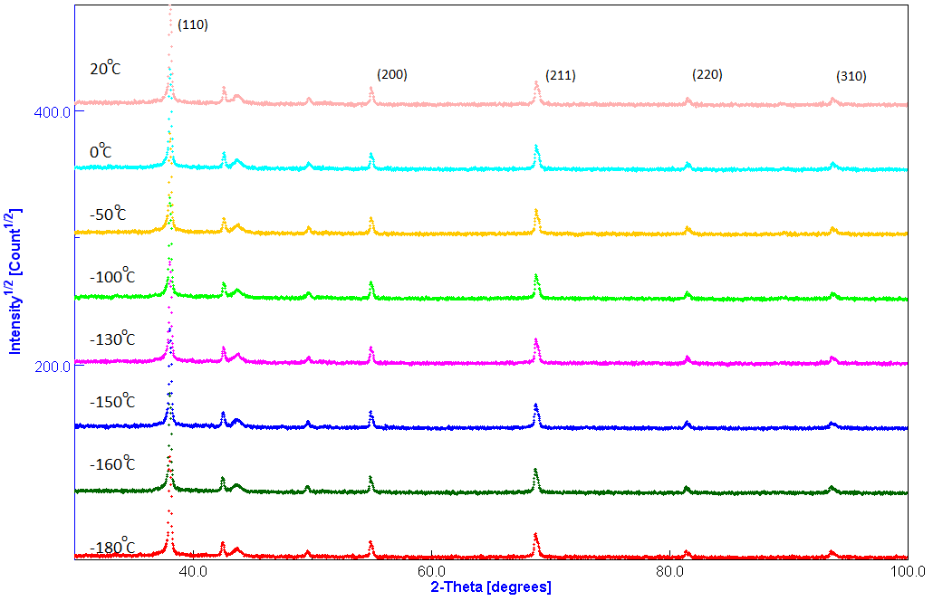
Figure 10. Diffraction patterns of the Ti-18Zr-15Nb alloy sample with porosity of 35% at different temperatures
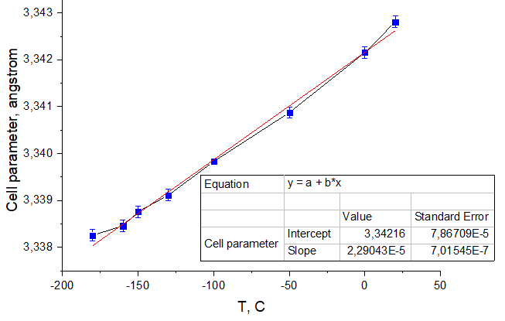
Figure 11. Dependence of unit cell parameter of the bcc phase of the Ti-18Zr-15Nb alloy sample with porosity of 35% on temperature

Comparing the X-ray patterns at different temperatures, we can conclude that there are no phase transitions (Figure 10). Angular shifts in the peaks, most notable at small angles, are due to decrease in the lattice parameter as the temperature decreases.
Here are some parameters of the material as calculated in MAUD: a = 3.3428 Å (room temperature), the average crystallite size is approximately 1000 Å. By plotting the dependence of lattice parameter a on measurement temperature T (Figure 11), we can determine the temperature coefficient of thermal expansion (CTE), since this dependence is nearly linear and the graph can be approximated with a straight line. The slope of this line gives us the CTE value: α = 6.85·10⁻⁶ K⁻¹.
Figure 12 shows diffraction patterns of the sintered Ti-18Zr-15Nb alloy sample with 2% porosity. Unlike the others, the most intensive peak of this sample in larger scale has a much more asymmetrical shape, what may indicate that there is a considerable amount of the second phase in material (Fig. 12, 13). Absence of new peaks lets us suppose, that new phase has identical BCC crystal structure with slightly different cell parameter (due to, possibly, slightly different chemical composition).
Estimated amounts of both phases are ~60% for 1st cubic phase and ~40% for 2nd phase. Here are presented calculated cell parameters and crystallite size at room temperature: 1st BCC phase - a₁ = 3.3419 Å, crystallite size ~1500 Å; 2nd BCC phase - a₂ = 3.3564 Å, crystallite size ~250 Å.
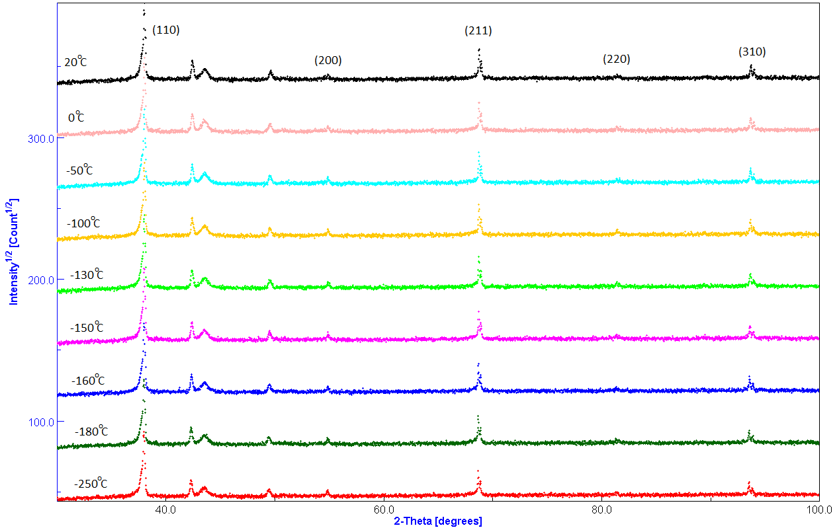
Figure 12. Diffraction patterns of the Ti-18Zr-15Nb alloy sample with porosity of 2% at different temperatures
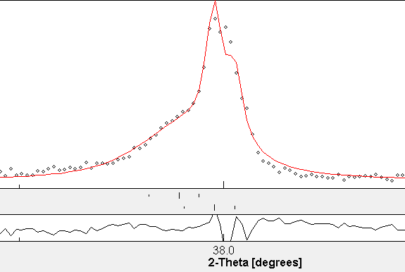
Figure 13. (110) BCC peak in larger scale

Figure 14 shows diffraction patterns of a cast sample of Ti-18Zr-15Nb alloy.
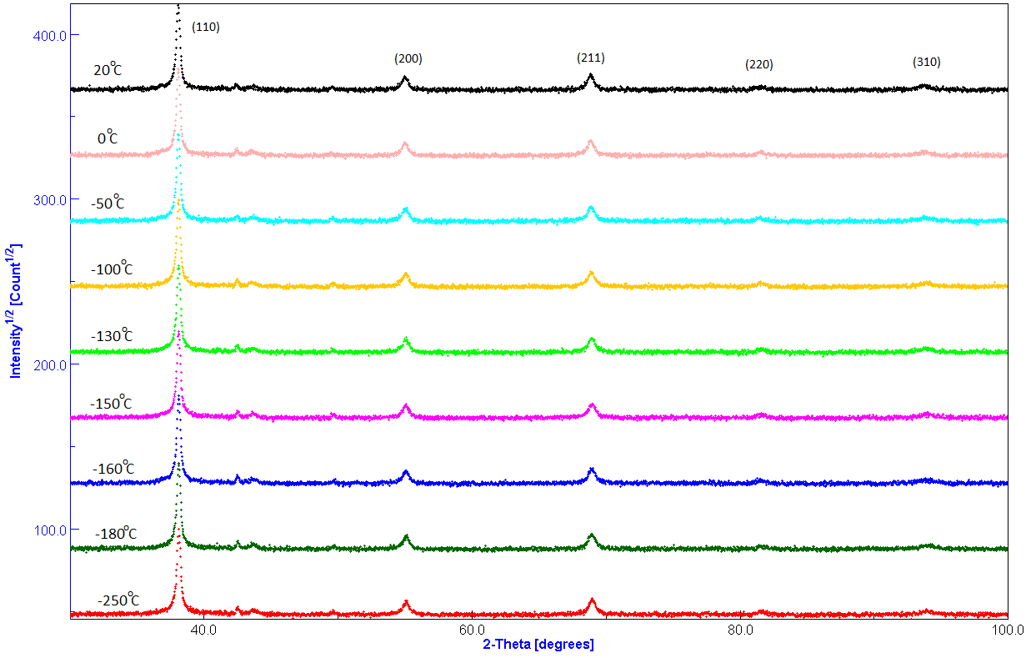
Figure 14. Diffraction patterns of the cast Ti-18Zr-15Nb alloy sample at different temperatures
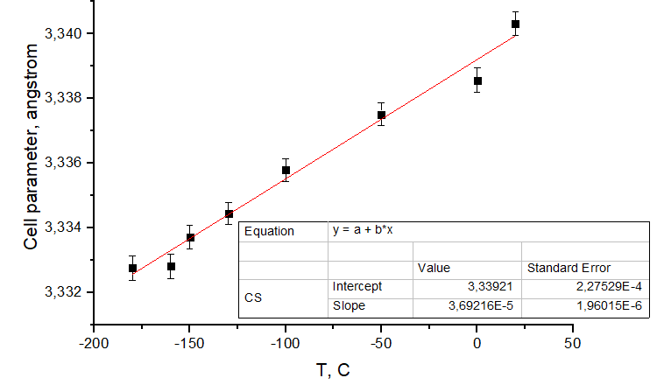
Figure 15. Dependence of unit cell parameter of the bcc phase of the cast Ti-18Zr-15Nb alloy sample on temperature

In diffraction patterns, as in the first case, when the temperature decreases, no new peaks are observed – a new phase does not appear (Fig. 14). The dependence of the lattice parameter a on temperature is also close to linear (Fig. 15). Here are some calculated parameters of the sample at room temperature: a = 3.3402 Å, the average size of the crystallites approximately is 400 Å, CTE α = 11.05·10⁻⁶ K⁻¹.
Let us now consider the data for a powder sample of Ti-18Zr-15Nb alloy, which underwent a rotary forging operation after sintering. As a result of this treatment, the porosity of the material becomes less than 2%.
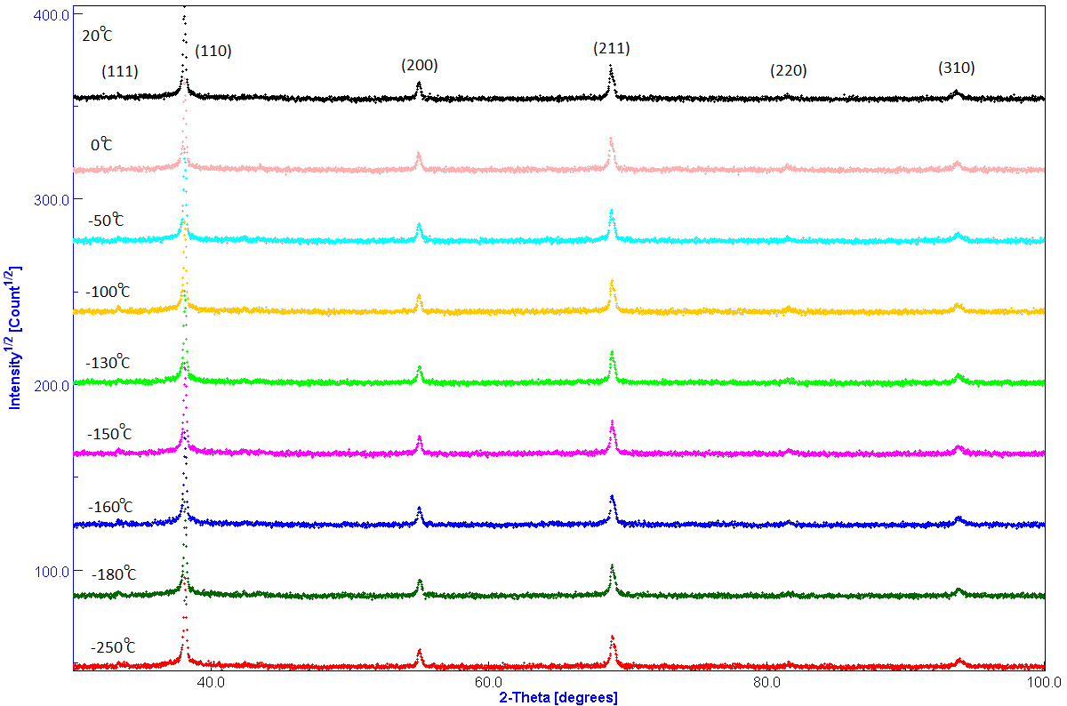
Figure 16. Diffraction patterns of the sintered Ti-18Zr-15Nb alloy sample after rotary forging at different temperatures

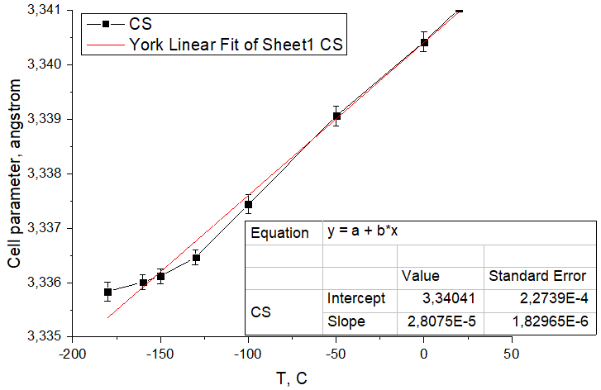
Figure 17. Dependence of unit cell parameter of the bcc phase of the sintered Ti-18Zr-15Nb alloy sample after rotary forging on temperature

Unlike the previous ones, the diffractograms of this sample have a new diffraction peak at an angle of 33° (Fig. 16), which, however, is not a reflex from the martensitic phase. There is also some distortion of the reflex (110) austenite. It is possible that these features are caused by the presence of an additional FCC phase with a unit cell parameters of 4.650±0.001 Å, most likely, Ti(Zr,Nb)O oxide or Ti(Zr,Nb)C carbide. Thus, there are also no phase transitions in this sample.
The dependence of the lattice parameter a at first is also close to linear, but after temperature of 130ºC line is bending (Fig. 17): the behavior which requires additional examination. Here are some characteristics of the alloy: a = 3.3402 Å (room temperature), average crystallite size ~800 Å, CTE α = 8.4·10⁻⁶ K⁻¹.
Table 1. Structure parameters of different processed samples (room temperature)
 | Cell parameter a, Å | R.m.s. microstrain | Crystallite size, Å
Cast | 3.3377 | ~8·10⁻⁶ | ~400
Rotary forged | 3.3400 | ~6·10⁻⁴ | ~900
2% porosity  1st phase:  2nd phase: | 3.3419  3.3563 | ~10⁻⁷  ~2·10⁻³ | ~1500  ~250
22% porosity | 3.3429 | ~4·10⁻⁴ | ~1400
35% porosity | 3.3428 | ~4·10⁻⁴ | ~1000

When analyzing the diffraction patterns of all samples, it can be considered that the martensitic transformation did not occur in any of the porous or compacted samples. Based on this observation, several assumptions can be made regarding the reasons for the suppressed phase transition.
In the case of the highly porous samples, the suppression of martensitic transformation is likely due to the porosity of the material, which may completely prevent the development of internal accommodation processes within the material due to weak of elastic interaction between grains.
For the both cast and sintered samples the influence of impurities within material cannot be completely excluded. The phase transformation can be significantly influenced by the amount of oxygen present in the material, and with increasing concentrations, the formation of martensite can be completely suppressed.
It can also be noted that in [11] and [23] X-ray diffraction analysis of similar alloys were conducted using a special device which allowed for the application of mechanical stress to the specimens even at very low temperatures. Notably, the effects of superelasticity and shape memory may be induced through this method.
Given that no phase transitions were observed during cooling without applying mechanical stress, it is reasonable to propose that thermo-elastic martensitic transformations in these alloys may only be initiated in presence of externally applied stress fields. These observations may provide a basis for initiating new researches in this field, which may yield a more precise understanding of the origins and mechanisms of phase transitions and, in turn, pathways to regulate the functional properties of these materials.

Acknowledgments
First of all, I am grateful to JINR for opportunity to participate in START programme. It is a great chance for student to take their first steps into science and become familiar with serious investigations that are being carried by scientists.
I want to thank my supervisor Dr. Roman Vasin for his guidance and support during our work. I have obtained many useful information from him, which have developed deeper understanding of certain ideas and concepts. Also I’ve been taught at basic level some practical skills, such as data processing of diffraction patterns. Dr. Roman Vasin has demonstrated great professionalism and deep knowledge in the field of physics condensed matter alongside with proper methodical approach for teaching.
Also I want to thank staff of Frank Laboratory of Neutron Physics for providing interesting lectures about different kinds of investigations that being carried inside of laboratory. It has given me wider perception of how one phenomenon can be utilized in several ways.

References
1. Biomedical applications of polymer-composite materials: A review / S. Ramakrishna, J. Mayer, E. Wintermantel, K.W. Leong // Composites Science and Technology. ‒ 2001. ‒ Vol. 61, No. 9. – P. 1189‒1224.
2. Biomaterials Engineering and Devices: Human Applications / ed. by D.L. Wise, D.J. Trantolo, K.-U. Lewandrowski, J.D. Gresser, M.V. Cattaneo, M.J. Yaszemski. ‒ Berlin, Germany: Humana Press, 2000. ‒ P. 205–319.
3. Park J.B. Biomaterials: Principles and Applications / ed. by J.B. Park, J.D. Bronzino. ‒ Boca Raton, FL: CRC Press, 2003. ‒ P. 1–241.
4. Биоимплантаты на основе пористого титана с алмазоподобными пленками для замещения костной ткани / А.П. Рубштейн, Э.Б. Макарова, И.Ш. Трахтенберг, Ю.М. Захаров. ‒ Екатеринбург: РИО УрО РАН, 2012. ‒ 136 с.
5. Spatz, H.-C., O’Leary, E. J., & Vincent, J. F. V. (1996). Young’s Moduli and Shear Moduli in Cortical Bone. Proceedings of the Royal Society B: Biological Sciences, 263(1368), 287–294
6. M. Niinomi, Recent biocompatible metallic materials, in: M. Niinomi, T. Okabe, E.M. Taleff, D.R. Lesuer, H.F. Lippard (Eds.), Structural Biomaterials for the 21st Century, TMS, 2001, pp. 3–14.
7. Жукова Ю. С., Филонов М. Р., Прокошкин С. Д. Новые биосовместимые сверхупругие титановые сплавы для изготовления медицинских имплантов // Нанотехнологии и охрана здоровья, Том IV, № 2 (11) – 2012, с. 10-15
8. A.S. Konopatsky, S.M. Dubinskiy, Yu.S. Zhukova, V. Sheremetyev, V. Brailovski, S.D. Prokoshkin and M.R. Filonov, Ternary Ti-Zr-Nb and quaternary Ti-Zr-Nb-Ta shape memory alloys for biomedical applications: structural features and cyclic mechanical properties, Materials Science & Engineering A
9. Investigation of the Structure Stability and Superelastic Behavior of Thermomechanically Treated Ti–Nb–Zr and Ti–Nb–Ta Shape_Memory Alloys // V.A. Sheremetyev, S.D. Prokoshkin, V. Brailovski, S.M. Dubinskiy, A.V. Korotitskiy, M.R. Filonov, M.I. Petrzhik, 2015, published in Fizika Metallov I Metallovedenie, 2015, Vol. 116, No. 4, pp. 437–448
10. Kim, Hee Young & Jie, Fu & Tobe, Hirobumi & Kim, Jae Il & Miyazaki, Shuichi. (2015). Crystal Structure, Transformation Strain, and Superelastic Property of Ti–Nb–Zr and Ti–Nb–Ta Alloys. Shape Memory and Superelasticity.
11. L. Lutterotti, S. Matthies, H.-R. Wenk, A.S. Schultz, and J.W. Richardson, Combined texture and structure analysis of deformed limestone from time-of-flight neutron diffraction spectra. J. Appl. Physics, 1997, V. 81, P. 594-600
12. Rietveld, H.M. A profile refinement method for nuclear and magnetic structures. Journal of Applied Crystallography, 1969, V. 2, P. 65-71
13. Дубинский С.М. Формирование наноструктур методами термомеханической обработки и повышение функциональных свойств сплавов Ti-Nb-Zr, Ti-Nb-Ta с памятью формы. Диссертация на соискание ученой степени кандидата технических наук
14. Baker: The Shape-Memory Effect in a Titanium-35 wt.- % Niobium Alloy
15. Barilyuk, D.; Bazlov, A.; Arkharova, N.; Teplyakova, T.; Konopatsky, A.; Prokoshkin, S. Novel Zr-Rich Alloys of Ternary Ti-Zr-NbSystem with Large Superelastic Recovery Strain. Metals 2022, 12, 185
16. Masaki Tahara, Hee Young Kim, Tomonari Inamura, Hideki Hosoda, Shuichi Miyazaki, Effect of Nitrogen Addition on Superelasticity of Ti-Zr-Nb Alloys, MATERIALS TRANSACTIONS, 2009, Volume 50, Issue 12, Pages 2726-2730, Released on J-STAGE November 25, 2009
17. Niinomi, M.; Liu, Y.; Nakai, M.; Liu, H.; Li, H. Biomedical titanium alloys with Young’s moduli close to that of cortical bone. Regen. Biomater. 2016, 3, 173–185
18. Kurdyumov, G.V.; Khandros, L.G. On thermoelastic equilibrium during martensitic transformations. Rep. Acad. Sci. USSR 1949, 66, 211–214
19. Kim, Kyong Min & Kim, Hee Young & Miyazaki, Shuichi. (2020). Effect of Zr Content on Phase Stability, Deformation Behavior, and Young’s Modulus in Ti–Nb–Zr Alloys. Materials
20. Kim, H.Y. & Ikehara, Y. & Kim, J.I. & Hosoda, H. & Miyazaki, Shuichi. (2006). Martensitic transformation, shape memory effect and superelasticity of Ti–Nb binary alloys. Acta Materialia. 54. 2419-2429
21. Mei, Wei & Sun, Jian & Wen, Yufeng. (2017). Martensitic transformation from β to α′ and α″ phases in Ti–V alloys: A first-principles study. Journal of Materials Research
22. Kawano, Sota & Kobayashi, Sengo & Okano, Satoshi. (2019). Effect of Oxygen Addition on the Formation of α′′ Martensite and Athermal ω in Ti–Nb Alloys. MATERIALS TRANSACTIONS
23. Конопацкий А.С. Получение и исследование сверхупругих сплавов Ti-Nb-Zr-Ta медицинского назначения. Диссертация на соискание ученой степени кандидата технических наук

