JOINT INSTITUTE FOR NUCLEAR RESEARCH
Frank Laboratory of Neutron Physics

FINAL REPORT ON THE
START PROGRAMME

Multi-element analysis of soils with complex mineral composition by the NAA method based on the IREN facility, FLNP JINR

Supervisor:
Dr Andrey Yurievich Dmitriev

Student:
Nikita Markin, Far Eastern Federal University

Participation period:
September 24 –November 04,
Summer Session 2023

Dubna, 2023

Abstract
The evaluation of the possibility of implementing multi-element neutron activation analysis at the IREN facility (FLNP JINR) on the example of mineral waste from mining and processing enterprises of the Far East of Russia was carried out. It was shown that using the facility it is possible to determine more than 20 elements. The method is characterized by high sensitivity, selectivity and accuracy of measurement results. This makes it possible to solve a wide range of applied tasks, including the search and evaluation of minerals and the determination of the level of soil contamination with heavy metals.

Content

Abstract 2
Content 3
1 Introduction 4
1.1 Activation analysis on thermal and resonance neutrons 4
1.2 Relative method for determining the elements mass fraction 4
1.3 The group standard method 5
1.4 The IREN facility 5
1.5 The REGATA-2 pneumatic transport system 6
1.6 Measurement complex 7
2. Materials and methods 9
2.1 Sample preparation 9
2.2 Sample irradiation and measurement parameters 9
2.2 Data processing 10
3. Results and discussion 11
4 Conclusion 15
5 References 16

Introduction
Activation analysis (AA) is a method for determining the elemental composition based on the measurement of induced radiation that occurs during the nuclei transformation under the action of nuclear particles or gamma quanta with sufficient energy.
In activation analysis, the excitation (activation) of stable nuclei of the elements being determined is used for analytical purposes when the analyzed materials are irradiated with fluxes of nuclear particles or γ-quanta. According to the type of nuclear particles used to affect the nuclei of elements AA is divided into neutron activation analysis, photoactivation analysis and activation analysis using charged particles.
Neutron activation analysis (NAA) – activation of elements under neutron irradiation. This method is one of the leading methods of activation analysis [1].

Activation analysis on thermal and resonance neutrons
Neutrons are divided into several conditional energy groups: thermal (with energy <0.55 eV), epithermal or resonance neutrons (with energy 0,55÷10⁵ eV), fast neutrons (with energy 10⁵÷25⋅10⁶ eV).
The first works on activation analysis field were carried out using thermal neutrons. This variant of NAA occupies a leading place among activation methods and has the several important advantages.
Firstly, about the irradiation of the most elements only one nuclear reaction proceeds - is the reaction of radiation neutron capture (n,γ). As an irradiation result a radioisotope of the source element is formed. This reduces the number of radionuclides that can be obtained by multi-element analysis, and in the absence of reactions associated with changes in the charge of the nuclei, eliminates the effects of interference of spectral lines of various elements.
Secondly, most nuclides are β-emitters, emitting gamma quanta as well.
Thirdly, according to the reaction (n,γ), the overwhelming number of elements of the periodic system produce radioisotopes, which gives the method a certain universality.
Finally, analytical determination is possible not only by the radiation of radioisotopes, but also by the instantaneous radiation of radiation capture, and this in a certain way expands the possibilities of the method. Due to the large reaction cross-sections (n,γ), a high sensitivity of the method is achieved [1].

Relative method for determining the elements mass fraction
The relative method involves irradiation of the analyzed samples and the standard. The standard – is the sample with an exactly known amount of the element to be determined. After irradiation, the induced activity spectra of the standard and test samples are measured and the isotope activity is calculated. The concentration of the element in the sample is calculated from the ratio:
$C_{sample}=C_{stand}\frac{A_{sample}^{*}}{A_{stand}^{*}}$ (1)
where: $C_{sample}$ – concentration of the element in the test sample, $C_{stand}$ – the concentration of the element in the standard, $A_{sample}^{*}$, $A_{stand}^{*}$– the nuclide activities in test samples and standards adjusted for the time of decay, activation and measurement.
The adjusted value of the activity of radionuclides is determined by equation:
$A^{*}=\frac{N λ }{qε\left[1-e^{-λ t_{ir}}\right][1-e^{-λ t_{meas}}]} e^{λ t_{cool}}$ (2)
where: N is the total absorption peak area, q is the quantum yield of the radiation of the corresponding energy group, ε is the detection efficiency of the detector, λ is the radionuclide’s decay constant, t_{meas} is the duration of the spectrum measurements, t_{ir} is the duration of activation, t_{cool} is time from the end of irradiation to the beginning of measurements.
The relative method facilitates the NAA and increases the accuracy of determining the concentration of elements in the samples under study. Some errors that are significant when using the absolute method do not affect the final results [2].

The group standard method

The group standard method used in the practice of mass multi-element NAA at the FLNP JINR is an original improved version of the classical relative method.
Due to the fact that the multi-element NAA involves the qualitative and quantitative determination of several dozen elements, it is necessary, as a rule, to simultaneously use several standards containing, sometimes, the same elements. When determining concentrations, it is necessary to repeat the calculations as many times as the standards were taken. The final table with concentrations is compiled manually from the resulting set of tables for different standards.
The group standard method is used to optimize work with standards. It allows you to select the best of the irradiated standards for each element, reduce the number of calculations and operations performed to compile the overall analysis result, reduce the errors in determining concentrations, and also get a result for all the elements being determined at once [2].

The IREN facility

The IREN facility [3] uses the LUE-200 electron accelerator and let to obtain neutrons or gamma quanta depending on the type of target. The electron energy currently reaches 120 MeV. The facility operates in a pulsed mode with a burst frequency of 25 or 50 Hz at an average current of 5 μA.
The neutron-producing target is a cylinder made of a wolfram alloy with a diameter of 40 mm and a height of 100 mm, placed inside an aluminum tank with a diameter of 160 mm, through which distilled water is pumped from a closed loop to cool the target and slow down neutrons (Fig. 1).
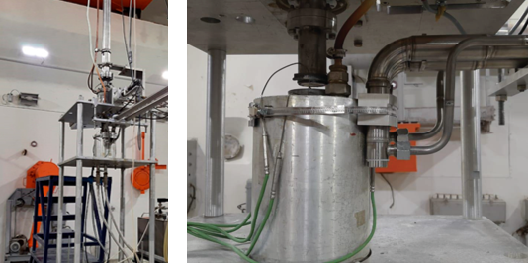
Figure 1 – The neutron-producing target of the IREN facility
The facility allows to generate resonance and thermal neutrons. The maximum neutron flux density is reached at a height of 5 cm from the target edge. At this height, the N1 and N2 channels were positioned for neutron activation analysis [4].

The REGATA-2 pneumatic transport system

The REGATA-2 pneumatic transport system (PTS) was developed in the Development and Implementation Base – Physics of the Bulgarian Academy of Sciences for the applied use of the neutron or photon fluxes. The project for the placement of the PTS in the rooms of the IREN facility was created at JSC VNIPIET.
The main purpose of the PTS is to deliver the container with the sample to the irradiation position and back. The return delivery time should be kept to a minimum to allow research on short lived isotopes. It is also important that the irradiation time is limited only by the operation time of the accelerator.
The system consists of a box with a loading and unloading station. A polyethylene transport channel with a length of about 40 m departs from the box. The transport channel is divided by splitters into three channels that enter the target hall and end with channels for irradiation made of stainless steel. Two channels, N1 and N2, are designed for irradiation in neutron flux, channel «G» let to work with gamma quanta. The channels are attached to the truss where the neutron moderator is located.
A polyethylene transport container with a height of 42.5 mm, an inner diameter of 17.4 mm, an outer diameter of 24 mm is moved along the transport channels using compressed air. The waste air from the transport system is removed to a special ventilation.

Measurement complex

Two spectrometers are used for γ-spectra measurement. All of them are equipped with sample changers. Each sample changer consists of a two-axis linear positioning module M202A by DriveSet (DriveSet.de, Germany) company and a disk with 45 slots for containers with samples manufactured in JINR workshops [5].
Each module M202A is fixed above two metal tables with adjustable feet by means of the Bosch Rexroth aluminum module profile system. On one of the tables, a rotating disk with samples is installed. The dewar with the detector is placed below another table, and the head of detector is above the surface of the table. The disk with samples, as well as the detector, are surrounded with a shielding (Fig. 2).
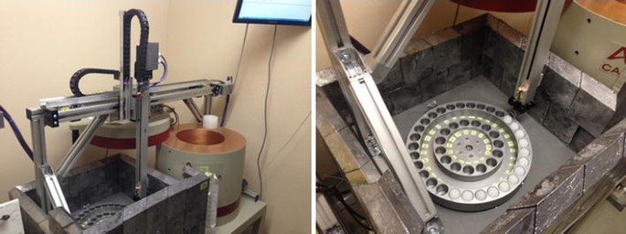
Figure 2 – Sample changer: appearance
The disk is rotated by a stepper motor EPL64/2 with a two-way shaft from Nanotec (nanotech.com) company. On one side, the shaft of motor is connected with the shaft of the disk by means of a coupling. An incremental encoder is mounted on the other side of motor shaft. The initial cell in the disk is determined by an electromagnetic sensor while an increment encoder controls the selection of any other cell with samples on the disc. Positioning accuracy of the disc can reach 0.01°.
The movement of containers from the disk to the detector and back is carried out by a device M202A manufactured by DriveSet company. It comprises horizontal and vertical linear positioning modules. Each axis is made of high-strength aluminum profile with integrated hardened steel rods. A carriage with precision guide rollers moves along the track. The carriage of each module moves by means of a screw with trapezoidal thread, which is rotated by a stepper motor. The brake for the vertical axis is not needed because of the self-locking trapezoidal thread. Each axis is provided with two ends and one reference sensor as well as with a linear incremental encoder, which allows the determination of the position of the carriage. The end sensors exclude the possibility of damage of the devices while moving to the physical boundaries of the axes. Reference sensors allow one to specify the initial positions of the modules. Positioning accuracy can reach 0.1 mm. Maximum speed of movement along both axes is 0.08 m/s and acceleration up to 1 m/s with a maximum load of 1 kg. The maximum vertical movement for this module is 400 mm and for the horizontal one 800 mm. Harnesses are laid into movable cable-channels. The special spring-pressed grab is used to capture the container from the disk.

Materials and methods

Sample preparation

Samples of mineral waste from the gold recovery factory No. 2 in Baley, Zabaikalsky region of Russian Federation were selected for investigation. The choice of the research object is due to the complex mineral composition of the waste. In accordance with the work [6], the factory produced gold from several deposits with different mineral composition at once. As a result, the processing tailings are a set of minerals of various chemical elements mixed in various proportions.
Soil was sampled by the author in the summer of 2022. Soil samples were taken on a regular grid with an average density of 2 points per hectare. The size of the test site was 10×10 m². From 7 to 10 single samples were taken. The combined sample was obtained by quartering. The mass of the combined sample was 300-400 g.
The samples were dried to a constant weight in a drying cabinet at a temperature of 45 C. Samples was preliminarily grinded to a homogeneous state with a particle size less than 0.1 mm in a vertical planetary ball mill XQM-0.4A (“TENCAN”, China).
Samples for NAA were packed in double plastic bags, which were placed in a standard container. The mass of the samples was 3÷3.2 g. Information about the samples (stages of sample preparation, weight, purpose) was recorded in the NAA database [7]. To minimize the spectrum background component, the irradiated samples were repackaged into non-irradiated containers before measurement.

2.2 Sample irradiation and measurement parameters

The induced activity spectra were collected using Canberra HPGe detectors GC10021 for short-lived radionuclides and GC4018 for medium-lived radionuclides The induced activity was measured in the 3-5 ml samples placed in plastic container with the inner diameter of 17.4 mm. The samples were fixed at a height of 2.5 cm from the detector cover. Various hardware (sample changer [7, 8]) and software (program for mass fractions calculation [9, 10], the NAA database [11], sample weights registration tool [12]) were used for NAA automation.
The irradiation of unknown and standard samples for the determination of short-lived radionuclides was carried out using the «REGATA-2» pneumatic transport system. The duration of irradiation of each sample was 40 minutes. The exposure time of the samples after irradiation did not exceed 4 minutes, the measurement duration (live time) was 35 minutes.
Irradiation of unknown and standard samples for the determination of medium-lived radionuclides was performed directly on the target moderator surface. To fix the samples, a tape was made from a polyethylene film, on which the samples were fixed. The samples were fixed using adhesive tape. The maximum number of samples for simultaneous training was 14 units. The duration of irradiation varied from 12 to 23 hours. The exposure time of the samples after irradiation was 24 hours, the measurement duration (live time) was 2 hours. Measurements were performed using the automatic sample change system.

Data processing

The analysis of the measured gamma-ray spectra was performed using Genie-2000 software. To create a group standard, standard rock samples were used. To determine the concentration of elements analyzed by short-lived isotopes, the following standards were used:
- OREAS-199; Ni-Co laterite ore (Nyngan, Western Australia); OREAS, Australia;
- OREAS-123; Uranium ore (Mantra Resources Nyota Prospect, Tanzania); OREAS, Australia;
- OREAS-23b; Granodiorit Blank rock (Upper Devonian Lysterfield granodiorite complex, Australia); OREAS, Australia;
- OREAS-243; Gold Ore (Frogs Leg Gold Mine, Western Australia); OREAS, Australia;
- OREAS-681; Platinum Group Element (Bushveld Complex, South Africa); OREAS, Australia.
To determine the concentration of elements analyzed by medium-lived isotopes, the following standards were used:
- OREAS-147; Pegmatitic Li-Nb-Sn ore (Talison Lithium Ltd, Western Australia); OREAS, Australia.
- OREAS-197; Ni-Co laterite ore (Nyngan, Western Australia); OREAS, Australia.
- SZR-1; Sample of the composition of gold-bearing ore; Research Institute of Applied Physics, Irkutsk State University; Russia.
The selection of the standards was performed using the Standard Search software, the compilation of the group standard file was performed using the Concentration software.
The calculation of the concentration of the analyzed elements and the error of their determination was performed by the relative method (Eq. 1) using the Concentration software.

Results and discussion

The presented data (Fig. 3) indicate the uniformity of the macro-component composition of the samples. The soil is mainly represented by aluminosilicates. The main rock-forming mineral is silica, which is indicated by the high content of silicon in the rock. Soils are characterized by an increased, relative to Clark, magnesium content with a reduced content of alkaline minerals.
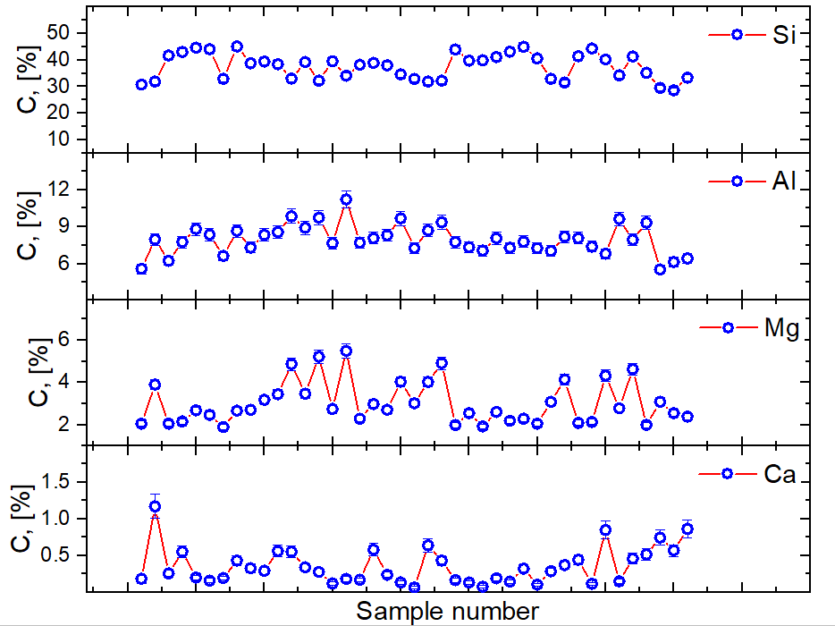Figure 3 – Distribution of Si, Al, Mg and Ca in the analyzed samples
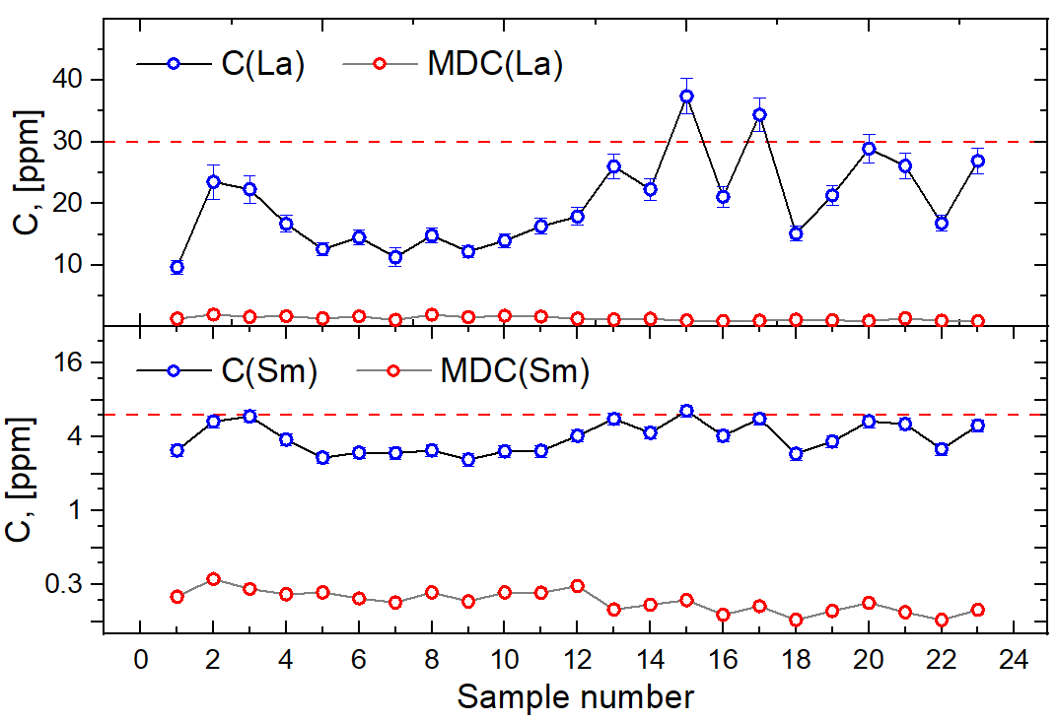
Figure 4 – Distribution of La and Sm in the analyzed samples
The dash line shows the Clark of the corresponding element
The micro-component composition is characterized by an increased level of heterogeneity. Thus, the content of rare earth elements varies from 9.67 to 37.4 ppm at a median value of 17.9 ppm for La and from 2.62 to 6.54 ppm at a median value of 3.81 ppm for Sm. It should be noted that the minimally detectable concentration of the elements under consideration is significantly lower (more than 30 times) than their Clark content.
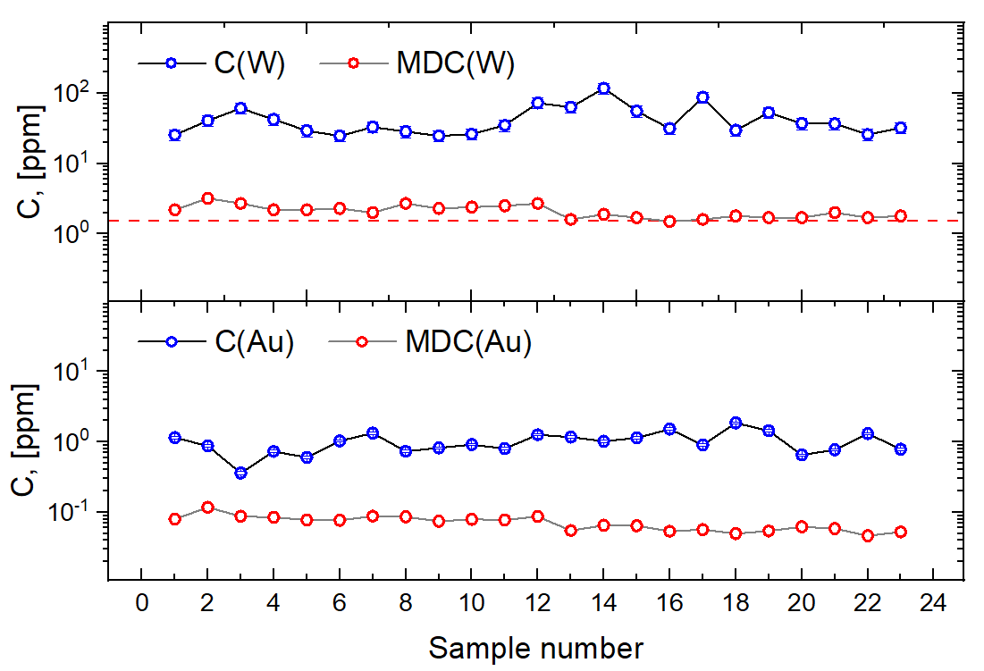
Figure 5 – Distribution of W and Au in the analyzed samples
The dash line shows the clark of the corresponding element
In addition, it was found that the analyzed soils are characterized by an increased gold content. The gold content varies in the range 0.362-1.86 ppm at a median value 0.916 ppm. This allows us to consider the analyzed mineral waste as a technogenic gold deposit. Increasing the feasibility of processing gold mining tailings is possible through the use of an integrated processing approach. It was found that in addition to gold, the analyzed tails are characterized by an increased content of tungsten. Its base fluctuates in the range of 24.7-117 ppm with a median value of 34.9 ppm. The joint extraction of gold and tungsten-containing minerals will make it possible to economic benefit large from the development of a technogenic deposit. However, a large amount of research is required on the forms of finding the elements in question in the tailings under study, an assessment of the profitability of the joint production of gold and tungsten.
In addition to valuable components, the analyzed gold mining tailings are characterized by high concentrations of toxic arsenic and antimony. The arsenic content varies from 370 to 1750 ppm. The maximum permissible concentration (MPC) of As in soils is 2 ppm. Thus, the gross content of the element in the tailings exceeds the MPC by more than 165 times. The antimony content ranges from 47-300 ppm. The maximum permissible concentration of Sb in an amount of 4.5 ppm. Thus, the multiplicity of exceeding the concentration of this element above the permissible level is at least 10.
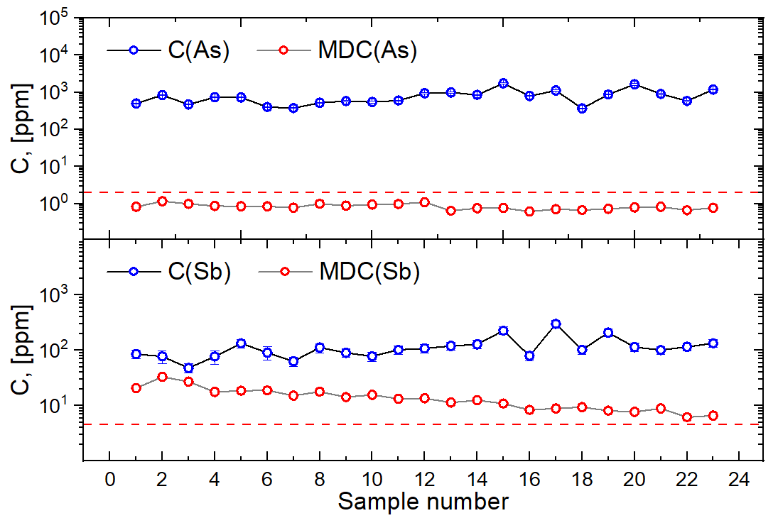
Figure 6 – Distribution of As and Sb in the analyzed samples
The dash line shows the maximum permissible concentration of the corresponding element
It can be seen that the minimum detectable concentration (MDC) of arsenic is lower than the maximum permissible concentration in soils. This makes it possible to use the NAA method based on the IREN installation for the tasks of environmental monitoring of territories subject to contamination with arsenic and its compounds.
In the case of determining the concentration of antimony in soils, the situation is somewhat different. The minimum detectable concentration exceeds the maximum permissible value by several times. It is possible to achieve a decrease in MDC by increasing the exposure time of samples to several days and increasing the measurement time.
In addition to the listed elements, during the analysis of the tailings of the former gold recovery plant, it was possible to obtain information about the concentrations of the following elements: Na, K, V, Ba, Ti, Eu, Rb, Sr, Mn, In, Cl, U.

4 Conclusion
As a result of the work, it was shown that qualitative and quantitative determination of more than 20 chemical elements using the NAA method implemented on the basis of the IREN facility is possible. It is demonstrated that the method allows solving the problems of determining the micro-quantity of valuable elements in mineral raw materials with complex chemical composition. It is established that the productivity of the method is about 45 samples per week excluding sample preparation and processing of gamma spectra.
Thus, the NAA method based on the IREN installation is an effective tool for solving a wide range of applied tasks such as geological exploration of valuable elements (Au, W, La, Sm, Eu, In) or environmental monitoring of areas subject to heavy metal pollution (Mn, V, As, Sb).

5 References
- Frontasyeva M.V. Neutron activation analysis at the IBR-2 reactor of LNP JINR. – Dubna: 2009. 352 p.
- Dmitriev A.Yu. Development of an automated complex for mass multi-element neutron activation analysis at the IBR-2 reactor of the LNP JINR: abstract of the dissertation of the Candidate of Physical and Mathematical Sciences. – Dubna: 2015. – 30 p.
- Sumbaev A. et al. LUE-200 accelerator—A photo-neutron generator for the pulsed neutron source “IREN” //Journal of Instrumentation. – 2020. – Vol. 15. – №. 11. – p. 11006.
- Lobachev, V.V., Dmitriev, A.Y., Borzakov, S.B. et al. Pneumatic Transport System REGATA-2 for Automation of Activation Analysis at the IREN Facility, FLNP JINR. Phys. Part. Nuclei Lett. 20, 1064–1072 (2023). https://doi.org/10.1134/S1547477123050503
- Pavlov S.S., Dmitriev A.Yu., Frontasyeva M.V. (2013) Automation of reactor neutron activation analysis. Commun JINR D18-2013-87, Dubna
- Юргенсон, Г. А., Шумилова, Л. В., Хатькова, А. Н. (2021). Лежалые золотоносные хвосты комбината "БалейЗолото": проблема утилизации. Вестник Забайкальского государственного университета, 27(4), 45-54.
- Pavlov S.S., Dmitriev A.Yu., Frontasyeva M.V. Automation system for neutron activation analysis at the reactor IBR-2, Frank Laboratory of Neutron Physics, Joint Institute for Nuclear Research, Dubna. Russia J Radioanal Nucl Chem. 2016;309:27–38. https://doi.org/10.1007/s10967-016-4864-8
- Pavlov S.S., Dmitriev A.Y., Chepurchenko I.A., Frontasyeva M.V. Automation system for measurement of gamma-ray spectra of induced activity for multi-element high volume neutron activation analysis at the reactor IBR-2 of Frank Laboratory of Neutron Physics at the Joint Institute for Nuclear Research. Phys Part Nucl Lett. 2014;11:737–42. https://doi.org/10.1134/s1547477114060107
- Dmitriev AY, Borzakov SB. Software for calculation of elements mass fractions in investigated samples by absolute method of neutron activation analysis. Phys Part Nucl Lett. 2019; 16:772–8. https://doi.org/10.1134/s1547477119060438
- Dmitriev AY, Pavlov SS. Automation of the quantitative determination of elemental content in samples using neutron activation analysis on the IBR-2 reactor at the Frank Laboratory for Neutron Physics, Joint Institute for Nuclear Research. Phys Part Nucl Lett. 2013;10:33–6. https://doi.org/10.1134/s1547477113010056
- Dmitriev A.Y., Pavlov S.S. Software for automation of neutron activation analysis at the IBR-2 reactor of FLNP, JINR. J Nucl Meas Inf Technol. 2012; 4:54–66

