JOINT INSTITUTE OF NUCLEAR RESEARCH
Laboratory of Information Technologies

FINAL REPORT ON THE
START PROGRAMME

Devising an Algorithm for the Detection of Λ⁰ and Κ⁰_{S} Particles in the NICA MPD Experiment

Asya Hunanyan
Yerevan State University
A Alikhanyan National Laboratory
Yerevan, Armenia
Supervisor: Dr. Alexander Ayriyan
Session: Summer 2022
24 July – 17 September

Dubna, 2022
Table of Contents

Abstract 3
Introduction 4
Project goals 7
Methods 7
Results 8
Conclusions 9
References 11
Acknowledgements 12
Appendices 13

Devising an Algorithm for the Detection

of $Λ^{0}$ and $K_{S}^{0}$ Particles in the NICA
MPD Experiment

ABSTRACT

Of great importance in "NICA" is particle identification, i.e. obtaining information from the "traces" left by a particle that has passed through the detector and determining the type of this particle. This report presents the output of the "k0" and "lambda0" identification algorithms. "Root" was used to derive the algorithm, and the "Armenteros-Podolanski plot" was used to derive the final result. The final graph, which should also have a curve for particles "¯(Λ^0)", has no curve, because the scope of the work falls in high energy physics with UrQMD Monte Carlo data in the 9.2 GeV range.

INTRODUCTION

The goal of the project is to develop an algorithm for detecting neutral kaons and lambda baryons with a multi-purpose detector. To this end, the project will use data modeled by the Monte Carlo method, as well as the analysis and testing of various algorithms on them using MPD software resources. This particular source code used various ROOT libraries for general plotting and calculation purposes, as well as specialized MpdRoot libraries (mainly under the MpdDst package) to access certain features of the MPD detection system.
The main goal of the source code is to use the information available to the MPD detector to search for potential particles K_S^0 and Λ^0, the lightest neutral mesons and baryons, respectively, containing a strange quark. The detection of these particles could play a crucial role in the study of quark-gluon plasmas, where their strangeness can help check for the strangeness production enhancement [1] that is known to happen in QGP.
Unstable, neutral particles cannot be directly registered by the detector, as they are not influenced by the magnetic field. For this reason, it is unstable neutrally charged particles that are most often found by measuring the secondary daughter particles into which they decay. Therefore, the development of the algorithm involves searching for and filtering potential pairs of such secondary particles through a series of cuts.
The $K_{S}^{0}$ kaon [2], also known as the K-short, is an unstable meson consisting of a down quark and a strange antiquark. It has a lifetime of $8.958×{10}^{-11}s$ and most often decays into a pair of pions as such:
$$K_{S}^{0}→ π^{+}+π^{-}$$
$$K_{S}^{0}→ π^{0}+π^{0}$$

Consideration of the second decay mode requires finding the tertiary particles into which the neutral pions have decayed, tracking them to the secondary peaks, and then tracking them to the primary peak. Since the errors associated with such calculations would be too big, this decay mode was excluded from the algorithm, and only kaons decaying into pions and antipions were considered. This decay mode makes up for (69.20 ± 0.05)% of all total decays.
The Lambda baryons are subatomic particles consisting of 3 quarks – an up quark, a down quark, and an additional higher generation quark. The variations of lambda particles are $Λ^{0}$ with composition $uds$, $Λ_{b}^{0}$ with composition $udb$, $Λ_{c}^{+}$ with composition $udc$, and $Λ_{t}^{+}$ with composition $udt$. This paper is concerned with $Λ^{0}$ [2], the first discovered and longest living variation of the lambda baryon with a measured lifetime of $2.631×{10}^{-10}s$. The two decay modes, accounting for >99% of decays of the strange lambda baryon are shown below.

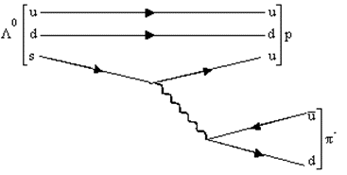

Figure 1.Lambda decay by the weak force

$$Λ^{0}→ p^{+}+π^{-}$$
$$Λ^{0}→n^{0}+π^{0}$$
Once again, due to the difficulties associated with detecting neutral pions and especially neutrons, only the first decay mode, which accounts for (63.9 ± 0.5)% of all possible decays, will be considered. The decay under consideration is mediated by the weak interaction, which is typical of particles in this lifetime range, and includes the decay of the strange quark into an up quark and a W^ boson. The up quark combines with the remaining ud quarks to form a proton, and the W^ boson decays into a π^ meson (see Fig. 1).
Therefore, in the case of both particles, the algorithm will deal with detection of two oppositely charged pairs of tracks that come from a common secondary vertex region. The accuracy of the algorithm in correctly spotting pairs will be tested through the Armenteros-Podolanski plot [3], a method proposed in in 1954 for the dynamic analysis of various V^0 particles. It provides a neat graphical representation for the distinction of Λ^0 and K_s^0 particles and performs dynamic analysis based on daughter particle momenta alone, with no assumptions regarding mass.
The method considers a dimensionless $α$ parameter against the transverse momentum $p_{t}^{Arm}$ of one of the daughter particles. The alpha parameter gives a relation between the longitudinal momenta of the daughter particles. It is calculated as:
$$α=\frac{p_{L}^{+}-p_{L}^{-}}{p_{L}^{+}+p_{L}^{-}}$$
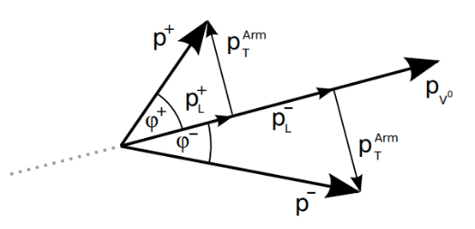
where $p_{L}^{+}$ and $p_{L}^{-}$ are the longitudinal momenta of the positive and negative daughter particle respectively. The second parameter, $p_{t}^{Arm}$, gives the component of the daughter particles’ momenta which are perpendicular to the direction of the neutral particle’s momentum [4]. The two parameters and their relations to instantaneous momenta at the secondary vertex are shown in the figure below.

Figure 2. Geometric representation of components used by Armenteros-Podolanski [4]

The transverse momentum of the particle is measured in units of GeV/c. Given correct application of the Armenteros-Podolanski method, the theoretically allowed values for $Λ^{0}$ and $K_{s}^{0}$ generate a plot like Figure 3 below.
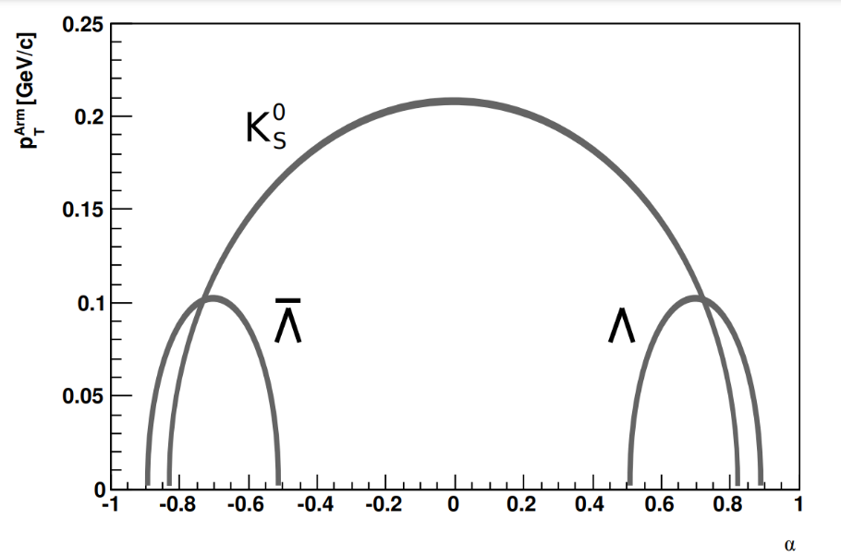

Figure 3. Theoretical values for $α$ and $p_{t}^{Arm}$ of the particles [5]

As the figure shows, the lambda particle has a theoretical peak at $p_{t,Arm}=0.2 GeV/c$, while the kaon has a peak around $p_{t,Arm}=0.1 GeV/c$. In terms of the $α$ parameter, given $M→m_{1}+m_{2}$, Armenteros and Podolanski derive the mean $α^{*}$ value for a particle to be:
$$α^{*}=\frac{m_{1}^{2}-m_{2}^{2}}{M^{2}}$$
As $K_{s}^{0}$ decays into two oppositely charged pions with the same mass, this directly implies a centrality at $α=0$. The central value for $Λ^{0}$ can also be derived similarly and shown to fall around $α=0.692$.
With its derived algorithm and applied cuts, this project was able to regenerate plots for the particles which match the aforementioned theoretical values. There is, however, a high background which needs to be cleared out with additional cuts.

PROJECT GOALS

The project falls under the preparation for the NICA MPD experiment and has the main goal of using the MPD software, simulations and Monte Carlo data to recreate experimental conditions and attempt to perform successful detection under these conditions. As mentioned above, the precise detection of target particles can be crucial in the study of quark-gluon plasmas, since their number can serve as an indicator of the increase in strangeness.
Therefore, the main goal is efficient, fast and accurate detection of particles K_s^0 and Λ^0. A series of cuts will be applied to reduce the background and identify the target particles. The efficiency of the algorithm will be tested by its ability to regenerate the theoretical curves shown in Figure 3. Plotting all resulting pairs on an Armenteros-Podolanski plot will help to visualize the K_s^0 and Λ^0 particles present after applying the cuts.

METHODS

The MPD MiniEvent package provides a built-in calculation of the main vertex and the magnetic field of each event. These, along with the number of tracks, are retrieved as event constants in the source code for use in subsequent calculations. The distance of closest approach (DCA) of a track to the primary vertex is verified by tracing back its helical path to the primary vertex region and checking the distance of closest approach in 3D space. Along with the filtering of primary particles, two cycles were skipped over all tracks. To reduce the number of iterations performed and avoid returning double data for each pair, one cycle was assigned to positive tracks and the other to negative ones.
The next important step in checking whether two particles form a pair is finding the DCA between their tracks. For this, the tracks’ PhysicalHelix [6], an MpdRoot class containing information regarding the helical trajectory of each track, was retrieved. This was then used to retrieve coordinates of the tracks at the point of closest approach between their helices and, finally, calculate the DCA between them. See Appendix 3 for the relevant section of the source code. Subsequently, after confirming the tracks as a potential pair, we must add their momenta and reconstruct the straight-line path of the neutral particle that they were born from. This step, presented in Appendix 4, involves constructing a straight-line equation using the total momentum vector and the secondary vertex coordinates. Using a similar process, a final cut regarding the neutral particles DCA from the primary vertex was applied. Cut parameters were defined separately in the code and can easily be adjusted given the specific experiment.
After successful application of all cuts, necessary data for the calculation of Armenteros-Podolanski data must be retrieved. To maintain a compact code in this section of the calculations, the C++ vector library was used.
The projection of the daughter particles’ longitudinal momenta on the center of mass axis is first calculated. These projections are transferred to calculate the parameter α. Then, using the total momentum direction as a reference axis, perpendicular components of the daughter momenta are calculated. To check the correctness of the calculations, an additional test was performed to ensure that the transverse components are equal for both daughter particles.
The source code can take both .root or .ls files as input, enabling it to run one or more data files at a time. The outputted data is also saved in a .root file in order to enable further work with these calculations, should the need for such work arise.

RESULTS
Prior to the generation of the final plot, values of most cuts were manually adjusted to fit the background levels in the provided UrQMD data files. Figure 1 shows the primary vertex DCA for all particles (left), primary particles (middle), and secondary particles (right) in an arbitrary data file.
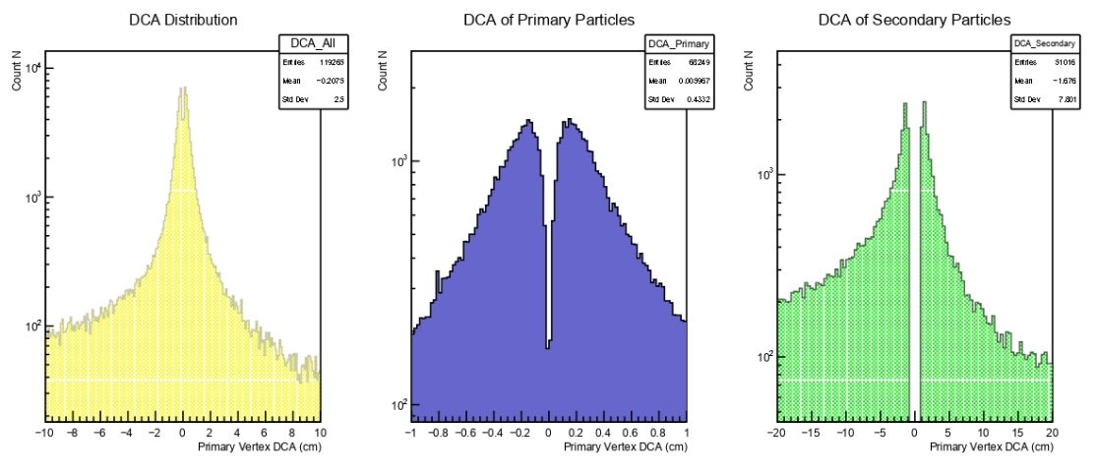

Figure 4. DCA from Primary Vertex for all tracks

The final cut values selected are summarized and displayed in Appendix 2 as they appear in the code. Using these cut values on 20 data files, the image seen in Figure 5 was generated. It contains $4×{10}^{4}$ entries and displays the theoretical curves for $Λ^{0}$ and $K_{s}^{0}$.
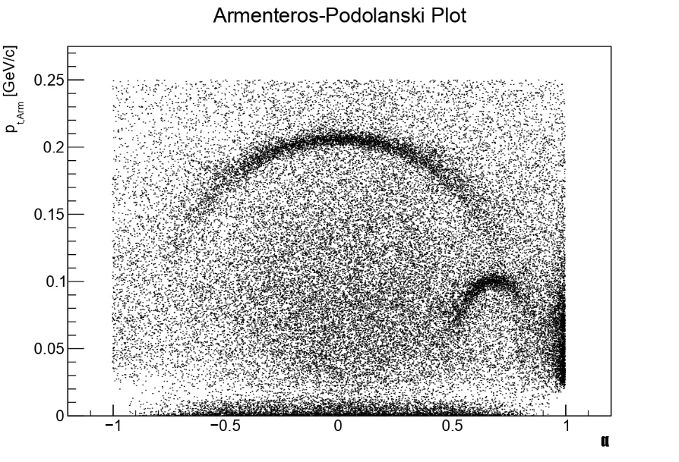
Figure 5. Application of selected cuts on ${10}^{4}$ events

Conclusions

The results of all applied cuts over the $2.16×{10}^{8}$ events provided is shown below. An intrinsic limitation of the study is that the algorithm’s specifications were adjusted to data from UrQMD generations of 9.2GeV Bi+Bi collisions. Therefore, any selected parameters will likely have to be adjusted for the analysis of Au+Au collisions in MPD experiments, as there will be differences in energies and differences in ratios of particles produced (hence, a difference in background).
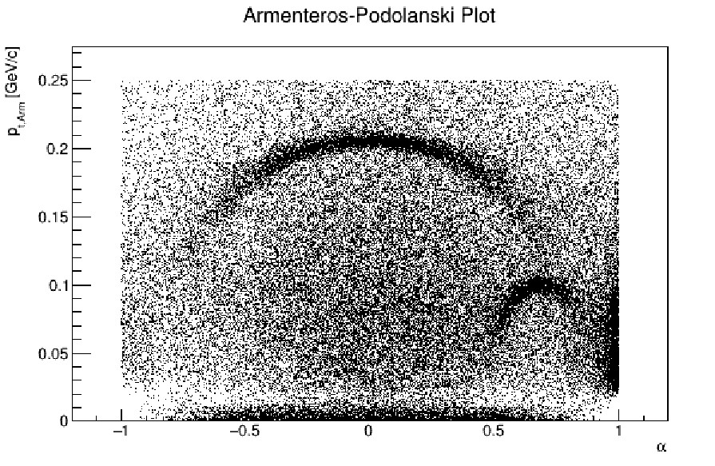
Figure 6. Armenteros-Podolanski plot over all data files (85042 found points)
As the figure 6 displays, the larger curve is centered at $α=0$, and has a peak around the 0.2 GeV/c line. Both of these properties align with theoretical descriptions of $K_{s}^{0}$ decay, which outlines that since the decay products are oppositely charged daughter particles with identical mass, the difference of their longitudinal momenta (and, consequently, $α$) should approach 0. The theoretical central value for $Λ^{0}$, meanwhile, should be at $α=0.692$, as calculated above. This is also reflected in the generated plot, which displays a central value in the $α≈0.7$ region. The transverse momentum for $Λ^{0}$ daughter particles peaks around 0.1GeV/c, which, once again, matches the theoretical plot shown in Figure 3. Consistencies with theory are an indicator of the algorithm’s effectiveness in spotting the target particles.
Nevertheless, despite effective spotting of target particles, there is an ineffective elimination of background, calling for additional cuts. Prospects for further improvement of the algorithm and the application of further cuts require separating $Λ^{0}$ and $K_{s}^{0}$ particles and applying additional cuts that are specific to the properties of either target particle. Proposed improvements

REFERENCES

[1] | J. Rafelski and B. Muller, “Strangeness Production In The Quark-Gluon Plasma,” Phys. Rev. Lett, vol. 48, no. 1066, 1983.
[2] | R. L. Workman, V. D. Burkert, V. Crede, E. Klempt, U. Thoma, L. Tiator, K. Agashe, G. Aielli, B. C. Allanach, C. Amsler, M. Antonelli, E. C. Aschenauer, D. M. Asner, H. Baer, S. Banerjee, R. M. Barnett, L. Baudis, C. W. Bauer and J. J. Beatty, “Particle Listings in Review of Particle Physics,” Prog. Theor. Exp. Phys, vol. 083C01, no. 2022, pp. 1123-2184, 2022.
[3] | J. Podolanski and R. Armenteros, “III. Analysis of V-events,” Lond. Edinb. Dublin philos. mag. j. sci., vol. 45, no. 360, pp. 13-30, 1954.
[4] | Е. А. Строковский, “Критерий Арментероса-Подолянского,” in Лекции по основам кинематики элементарных процессов, Москва, Московский Государственный Университет, 2010, pp. 101-104.
[5] | T. Czopowicz, “Study of K0S meson production in NA61 experiment at the CERN SPS,” Warsaw University of Technology, 2010.
[6] | G. Nigmatkulov, MpdMiniPhysicalHelix class: Parametrization of a physical helix that uses ROOT classes, Joint Institute of Nuclear Research, 2020.

ACKNOWLEDGMENTS

I would like to deeply thank Dr. Alexander Ayriyan for supervising this project and for being a helpful and understanding consultant during its difficult stages. His regular checkups helped us move along the project while keeping our knowledge in check.
I would also like to extend warm thanks to Dr. Alexey Aparin and Dr. Artem Korobitsin for introducing us to the problem and helping with the usage of the MpdDst package. Through their guidance and provision of resources, they both assisted hugely in turning my theoretical understanding of the project into a compact code.
Finally, I would like to thank Elena Karpova, Julia Rybachuk, and the rest of the START team for organizing this great opportunity and enrichening our stay with various excursions and events.

APPENDICES

Appendix 1. C++, ROOT, and MpdRoot Libraries Used
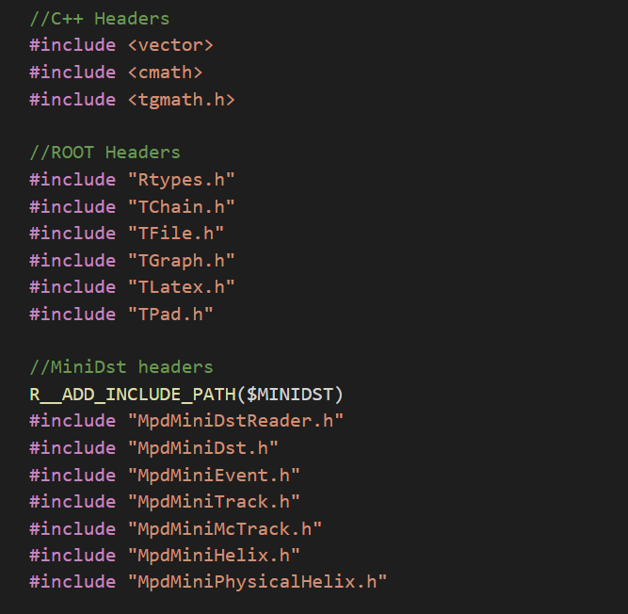

Appendix 2. Final cut constants
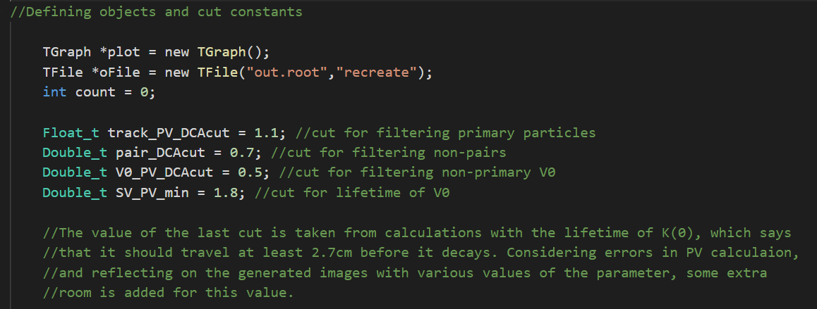
Appendix 3. Sample code: Applying cut on the DCA between oppositely charged tracks
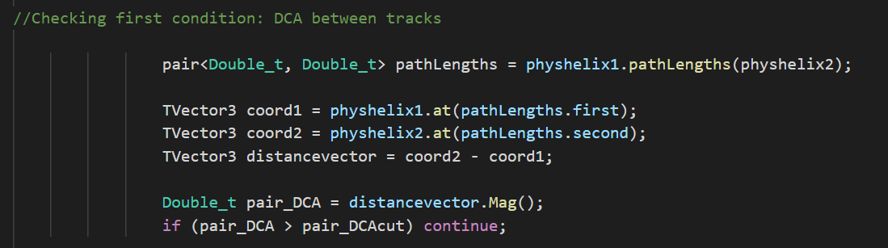

Appendix 4. Sample code: Applying cut on the DCA of the neutral particle’s path from the primary vertex
