JOINT INSTITUTE FOR NUCLEAR RESEARCH
Laboratory of Neutron Physics named after I.M. Frank

FINAL REPORT ON THE
START PROGRAMME

Calculation of ionizing radiation fields for the irradiation unit of Channel №3 at the time of shutdown of the IBR-2 research reactor

Supervisor:
Mr. Alexey Galushko

Student:
Natallia Demenchuk, Belarus
Belarusian State University

Participation period:
September 11 – October 22,
Summer Session 2022

Dubna, 2022
Table of contents
Introduction 3
Chapter1. The principle of operation of semiconductor detectors. Detector types 4
Chapter 2. Fundamentals of the theory of interaction of gamma quanta with matter 7
Chapter 3. Materials and methods of research 9
3.1 Neutron activation analysis 9
3.1.1 Thermal neutron activation analysis 9
3.1.2 Neutron activation analysis for fast neutrons 12
3.2. Description of the IBR-2 and the irradiation unit of channel № 3 12
3.3 FWT-60-00 radiochromic dasimeters and FWT-92D photometer 16
3.4 Canberra GC10021 Spectrometer and Genie 2000 17
Chapter 4. Results of determination of ionizing radiation fluxes 19
2.1 Measurement of absorbed gamma radiation dose 20
2.2 Measurement of thermal and resonant neutron flux densities 22
2.3 Measurement of fast neutron flux density 23
Conclusion 24
References used 25

Introduction

In 1977, the Joint Institute for Nuclear Research physically started the IBR-2 pulse reactor, which is a fast neutron reactor with a stationary capacity of 2 MW with a sodium coolant. Plutonium dioxide tablets of two types are used as fuel - with and without a central hole, compacted in rod fuel elements (fuel elements), which are combined into FAS. This reactor is used for beam research in the field of condensed matter physics (solids and liquids), biology, chemistry, materials science, earth sciences.
Starting in 2018, the reactor capacity began to decline and reached 1.55 MW, therefore, in September 2021, the operation of the reactor was suspended due to its instability, but at the time of reactor shutdown, it is not safe to be near it and near the irradiation plant of channel №3, due to the presence of induced activity due to the activation of part of the equipment, systems of structural and protective materials, as well as, in part, contamination with radionuclides during operation, therefore, it makes sense to determine the characteristics of ionizing radiation fields at an average zero reactor power, which is the purpose of this work.

Chapter1. The principle of operation of semiconductor detectors. Types of detectors

The effect of semiconductor detectors is similar to that of ionization chambers. The ionizing particle caught in the detector produces electron-hole pairs that are collected by an electric field applied to the detector electrodes. The magnitude of the corresponding electrical pulse is proportional to the energy lost by the particle or γ -quant in the detector [1].
Detectors have a number of significant advantages over cameras:
1. The energy required to obtain one pair of carriers in the detector is much less (2.96 eV in Ge and 3.66 eV in Si) than in the gases filling the chambers (∼ 30 eV). Therefore, the number of generated pairs in the detector is correspondingly larger.
2. The material density of the semiconductor detector is much greater than the density of gases filling the ionization chambers. Therefore, even small detectors can record high energy particles and γ quanta.
3. The rise time of the electric pulse in the detectors is much shorter than in the ionization chambers, since the mobility of the carriers in the semiconductor is much greater than the mobility of ions and electrons in the chambers.
However, semiconductor detectors have relatively little resistivity even at a liquid nitrogen temperature (77 K). For example, p-type silicon samples having an impurity atom concentration of 10¹³ cm ⁻ ³ have a resistivity of 1400 Om·sm. This leads to a large current strength already at a small applied voltage, and recording weak pulses from ionization is difficult. To increase the specific resistance of the detectors, various methods have been developed to reduce the number of carriers caused by the presence of impurities in Si and Ge [2]. These methods are based on creating a p-n junction with a small number of carriers in the detector. A serious disadvantage can be the dead layer, since some of the energy of the particle can be lost before the particle reaches the active region of the detector. Two main types of detectors have appeared: diffusion and surface barrier.

Diffuse detectors.
Consider the charge distribution in a semiconductor in which there are two n- and p-type boundary regions (Picture 1). In thermal equilibrium, electrons are in the n-region, where they compensate for the spatial charge of donors, and holes are concentrated mainly in the p-region, where they neutralize the spatial charge of acceptors. A double electric layer is formed between the p- and n-regions, which creates an electrical potential that prevents carriers from penetrating from one region to another.

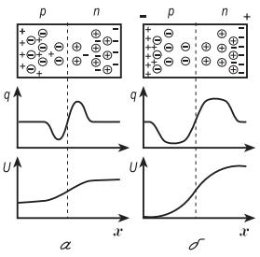

Picture 1. Distribution of charges q and potential U in semiconductor with n-p junction without applied bias (a) and with applied bias (b) [2]

The applied reverse voltage biases the free carriers from the transition region, and a carrier-depleted layer is formed there. In diffuse detectors, the n-p junction is located near the surface of the crystal, so the particle does not need to pass through a thick insensitive layer of substance. The diffuse detector diagram is shown in picture 2. As an n-impurity in diffuse detectors, phosphorus is used, which is applied on the surface of p-type silicon.

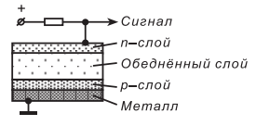

Picture 2. Scheme of the diffusion detector [2]

A thin layer of phosphorus compensates for p-conductivity in excess and an n-p junction is formed at a distance equal to the diffusion thickness. The inverse displacement applied creates a lean layer with a thickness of ∼ 1 mm. It is possible to create an n-p junction by diffusion of a p-material (B or Ga) in an n-type crystal.
Surface barrier detectors are similar to diffuse detectors. They are manufactured as follows: on the surface of an n-type material, a p-layer is created (usually by etching). A thin layer of gold is then applied to the surface. It is known that when the metal is in contact with the semiconductor, an electrostatic barrier arises at their border, preventing the penetration of carriers from the semiconductor into the metal, and vice versa. When back voltage is applied to the boundary of the metal conductor, a carrier-depleted layer arises, the thickness of which in Si can be brought to several millimeters. Surface barrier detectors can be made on the basis of Si or Ge, but in the case of Ge they are used only at the temperature of liquid nitrogen (T = 77 K) due to the large leakage current at room temperature. Si-based detectors can be used at T = 300 K (room temperature).

Chapter 2. Fundamentals of the theory of interaction of gamma quanta with matter

As is known, gamma quanta are secondarily ionizing radiation. This means that the gamma-ray quanta themselves do not give rise to electron-hole pairs in the volume of the semiconductor detector. They transfer their energy to electrons and positrons through the following reactions: The Compton-effect, the birth of an electron-positron pair, and the photoeffect. Already secondary radiation ionizes the environment and gives rise to electron-hole pairs in the detector volume.
Photoeffect - the process of transferring the energy of an incident gamma quantum to a connected electron, which flies out of an atom with kinetic energy equal to:
$T_{e}=hν- I_{i}$ (1)

where I_{i} is the ionization energy of the shell on which the electron was located; hν is the energy of the incident gamma-quantum.
The probability of a photo effect strongly depends on the charge of the atom (Z) on which the photo effect occurs, $σ_{f}\sim$Z⁵ [3]. This strong dependence is explained by the fact that in light elements the electrons in the atom are connected weaker than in heavy ones. Therefore, the photoeffect is very significant in heavy substances, where it comes with a noticeable probability and at high gamma quantum energies.
The Compton effect is to change the energy of a gamma quantum in its elastic collision with an electron. According to the Compton theory of scattering, gamma-ray cables are considered as separate material particles that move at the speed of light. As a result of the collision, it loses part of its energy, thereby increasing its wavelength. The Compton effect is observed on free or weakly bound electrons, for which the binding energy to the nucleus is much less than the energy of the incoming gamma quantum, therefore, Compton scattering occurs mainly on the electrons of the outer shells of the atom. As a result of scattering, the gamma quantum acquires energy:

$hν^{'}=\frac{hν}{1+\frac{hν}{m_{0}с^{2}}(1-\cos{θ})}$ (2)

where $ν^{'}, ν$ – are the frequencies of incident and scattered quanta, $θ$ is the scattering angle, and $m_{0}$ is the rest mass of the electron.
If $\frac{hv}{m_{0}с^{2}}≫1$, then the effective cross-section assigned to 1 atom is reduced to the following formula:

$σ_{k}\sim \frac{Z}{hv}$ (3)

When gamma radiation interacts with the electromagnetic field of an atomic nucleus, it is possible to generate a pair - an electron and a positron by absorbing the energy of a gamma quantum. The process is possible only at energies of γ -quants exceeding 2m₀c². The birth of pairs is accompanied by the complete absorption of the gamma quantum.
The stronger the field with which the quantum interacts, the more likely these pairs are to form. The cross-section of the process increases with increasing atomic number, as σ_{op} ~ Z²:

$σ_{op}\sim \frac{Z^{2}}{137}r_{e}^{2}\ln{\frac{hv}{m_{e}c^{2}}}$ (4)

Chapter 3. Materials and methods of research

3.1 Neutron activation analysis

Activation analysis is a method for determining the elemental composition based on the conversion of stable nuclei to radioactive ones through nuclear reactions, and measuring the induced activities of the final products. In neutron activation analysis, nuclear reactions occur when neutrons are absorbed by the nuclei under study [5].
The neutron activation analysis method makes it possible to determine the elemental composition of a substance based on the characteristics of radiation emitted by radioactive nuclei formed after neutron irradiation. The main process of interaction of neutrons with nuclei, which leads to the formation of unstable nuclei, is radiation capture:

$${}_{0}^{1}{n+{}_{Z}^{A}{X→{}_{Z}^{A+1}{X+γ}}}$$ | (5)

In order to determine the composition of the analyzed sample in an absolute way, an accurate value of all physical quantities on which the activity of the isotope depends is necessary. Such values are the irradiation time, the time elapsed after the termination of irradiation to the moment of measuring activity, the number of activated particles passing through the sample per unit of time, the isotope composition of the chemical element, the effective cross-section of the nuclear reaction, the T_{1/2} of the resulting radioactive element, but this method is rarely used due to the difficulty of determining all the necessary values. Therefore, most often, irradiation of the test sample occurs together with a special standard in which the content of the determined element is accurately known. After that, the activity of the sample and the reference are compared and the required value is found.

3.1.1Neutron activation analysis based on thermal neutrons

As a result of inelastic interaction of the thermal neutron with the nucleus, the formation of a composite nucleus occurs. Often the nucleus is in an excited state, the energy of which is determined by the neutron coupling energy in the nucleus. De-excitation occurs by emitting one or more gamma quanta called instantaneous. In many cases, the nucleus formed is unstable with respect to β decay. If, after decay, the daughter nucleus is in an excited state, then it emits gamma quanta called delayed. It follows from this that neutron-activation analysis can be carried out both on instantaneous gamma-quantum and on detainees formed after β-decay, but since neutron-activation analysis is more sensitive on instantaneous gamma-quantum, the second method is most applicable.
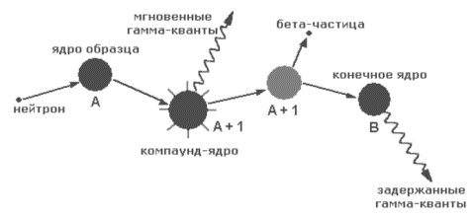
Picture 3. Radiation capture reaction

Let us consider neutron activation analysis based on instantaneous gamma quanta using the example of Au¹⁹⁷. As a result of radiation capture of neutrons by target nuclei with the number 79 and atomic weight 197 ${}_{198}^{79}{Au nuclei are formed}$ in the excited state:

${}_{0}^{1}{n+{}_{79}^{197}{Au→{}_{79}^{198}{Au+γ}}}$ (6)

The excitation is removed by emitting instantaneous gamma rays. The ground state of the formed nucleus is unstable with respect to β-decay:

${}_{198}^{79}{Au}→ {}_{198}^{80}{Hg}+e^{-}+\overline{v_{e}}$ (7)

As a result, we get an excited ${}_{198}^{80}{Hg}$, which transforms into the main one by emitting delayed gamma quanta with an energy of 411.8 keV. These gamma rays are recorded by the Canberra GC10021 spectrometer, and the mass of the element ${}_{198}^{79}{Au}$is determined by the energy of gamma rays and their intensity, as well as the radiation capture cross-section${}_{198}^{79}{Au}$.

The main equation of activation analysis is:

$$\frac{dN}{dt}=R∙N_{t}-λN$$ | (8)

where N_{t} is the number of target cores,

$$λ=\frac{ln2}{T_{1/2}}$$

R is the reaction rate, since usually neutrons with different energies fall on the sample, then R can be determined by the formula:

$$R=\int_{0}{φ\left(E_{n}\right)σ_{ny}\left(E_{n}\right)dE_{n}=}σ_{th}F_{th}+I_{res}F_{res}$$ | (9)

$I_{res}=\int_{E_{Cd}}{\frac{σ(E)}{E}}dE$-resonance integral - a value characterizing the interaction of resonance neutrons with target nuclei. The upper limit can be considered equal to infinity, since both the flow density and the capture section decrease with increasing energy.
The number of radioactive nuclei formed, obtained as a result of solving the equation: ${}_{0}^{1}n+{}_{Z}^{A}X→{}_{Z}^{A+1}X+γ$ is equal to:

$$N\left(t\right)=\frac{N_{t}R}{λ}[1-exp⁡(-λt)]$$ | (10)

The number of detector samples (line area) is:

$$N_{γi}=ε(N_{γi})∙γ_{i}\int_{0}^{t_{m}}{A(t)dt}$$ | (11)

Here we take into account the probability of emission (output) of a certain gamma line γ and the detector efficiency ε(E_{γ}). According to the law of radioactive decay, the activity is equal to λ×N(t). In addition, it should be taken into account that during the time elapsed from the end of irradiation to the beginning of the t_{d} measurement, the activity decreased:

$$A\left(t_{d}\right)=A(t=t_{irr})∙e^{-λt_{d}}$$ | (12)

Calculating the integral in formula (11), we obtain:

$$N_{γ}=N_{t}∙R∙(1-exp⁡(-λt_{irr}))∙e^{-λt_{d}}∙ε∙γ1/λ(1-exp⁡(-λt_{m}))$$ | (13)

Knowing the number of detector samples for a line with a certain energy, you can determine the number of nuclei of the desired element in the irradiated sample. The number of nuclei of the desired element in the sample can be expressed by the mass of the desired element:
$$N_{t}=\frac{m_{x}θ}{M}N_{A}$$ | (14)

θ - the isotope content in the natural mixture,
M is the atomic mass of the desired element,
N_{A} - Avogadro's number,
m_{x} is the mass of the desired element in the sample.

Taking these factors into account leads to the following expression:

$$m_{x}=\frac{N_{γ}(E_{γ})∙M∙λ∙e^{λt_{d}}}{N_{A}∙γ∙ϵ(E_{γ})∙θ∙(σ_{th}Ф_{th}+I_{res}Ф_{res})(1-exp⁡(-λt_{irr})∙(1-exp⁡(-λt_{meas}))}$$ | (15)

t_{irr} - time of exposure,
t_{td} is the time after irradiation before the measurement starts,
t_{meas} - measurement time,
N_{γ} is the number of detector samples for a particular line.

3.1.2 Neutron activation analysis for fast neutrons

Fast neutrons are commonly referred to as the energy range1-20MeV. The main reactions for fast neutrons are $(n, n^{'}y)$, $(n, p)$ , and $(n, 2n)$ reactions with a threshold of several MeV.
To determine the fast neutron flux density, the neutron activation analysis method was used; the satellite sample was Ni. The natural mixture contains Ni⁶⁰ and Ni⁵⁸, so we will consider the following reactions $\left(n, p\right)$ and $(n, t)$, which are in the fast neutron energy range.

${Ni}^{60}+n→t+{Co}^{58}$ (16)

${Ni}^{58}+n→p+{Co}^{58}$ (17)

3.2. Description of the IBR-2 and the irradiation unit of Channel №3

IBR-2 is a fast pulse reactor of periodic action; its main purpose is to study the properties of condensed media on derived neutron beams. This reactor has one of the highest neutron fluxes ~ 10¹⁶ n/cm²/s with 1850 MW of peak power. Reactivity is modulated using two reflectors: the main movable reflector and the additional movable reflector. The rotors of these two reflectors rotate at different speeds in opposite directions. A power pulse is generated at the moment of alignment of both reflectors near the reactor zone. Table 1 shows some of the IBR-2 parameters.
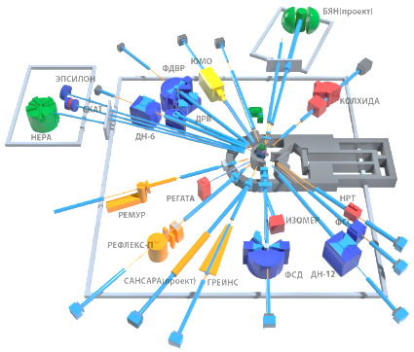

Picture 4. Diagram of the derived beams of the IBR-2 reactor with a set of spectrometers [6]

Table 1. Parameters of the IBR-2 [7]
Average power, MW | 2
Fuel type | PuO₂
Thermal neutron flux density from the moderator surface:  - time-averaged  - maximum in pulse | ~10¹³ n/см² sec  ~10¹⁶ n/см² sec
Background, % | 7,5
Pulse frequency, Hz | 5;10

To conduct scientific research, 13 channels for neutron and γ output were built around the core (Picture 4). In the zone of channel №3 there is an irradiation plant, the scheme of which is shown in Picture 5.

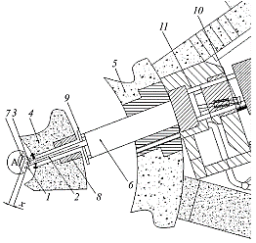

Picture 5. Diagram of the irradiation unit
1 – metal container for attaching samples; 2-transport I-beam; 3 - samples for irradiation; 4-first biological protection; 5-second biological protection; 6- body part of irradiation unit filled with water; 7-water moderator; A - active zone of the IBR-2 reactor; x-distance from the surface of the moderator to the samples; 8 – biological protection gate; 9-emergency stops; 10-visible mechanical stop; 11-rail track [9].

To eliminate a significant dose load on personnel, a system was put into operation based on a robotic manipulator with a grip, capable of moving highly active samples from the structural elements of the irradiation plant to the storage. The automated robotic manipulator system is shown in Picture 6.

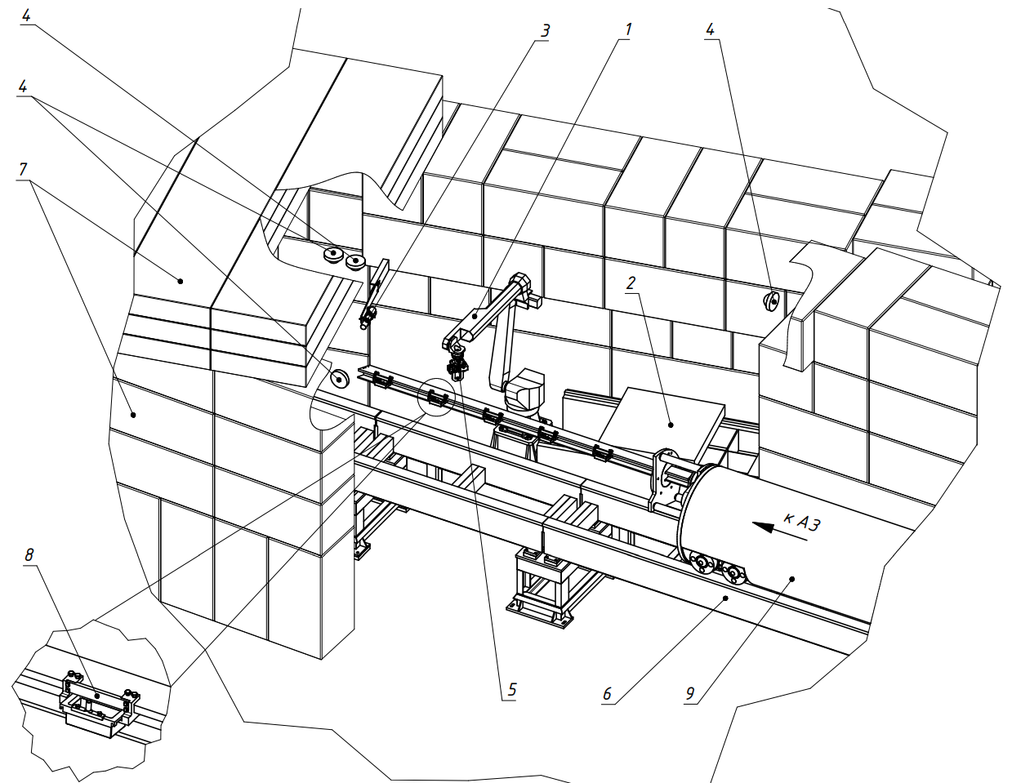

Picture 6. Robotic arm system in the IBR-2 controlled area: 1-robot, 2 – SRW storage, 3-ionizing gamma radiation sensor detection unit, 4-high-resolution video surveillance cameras, 5-pneumatic gripper with laser designator and high-resolution video camera, 6-rail track, 7-biological protection KZ, 8 – sample containers placed on the transport I-beam (L = 3 m) of the irradiation unit, 9-irradiation unit, AZ-core with water moderator of the IBR-2 reactor [10]

3.3.3 Radiochromic dosimeters FWT-60-00 and photometer FWT-92D

The absorbed dose rate was estimated at different distances from the water moderator using radiochromic dosimeters FVT-60 (Picture 7) and a photometer FVT-92D (Picture 8).
Radiochromic dosimeters consisting (by weight) of 63.7% C, 12.0% N, 9.5% H and 14.8% O [11] are colored in a different color under the influence of gamma radiation and the more intense the color, the higher the dose received this dosimeter [12].
Picture 7. Appearance of dosimeters

A radio chromic FWT-92D reader with two wavelengths [13] is used to read readings from radiochromic dosimeters. On the digital display of this device, we obtain the optical density value, from which the absorbed dose of gamma radiation is quantified. Radiochromic dosimeters are read at two wavelengths: 510 nm and 600 nm.

Picture 8. Photometer FWT-92D

Table 2. Ratio between wavelengths and dose range [13]
Wavelength, mm | Dose range, kGr
510 | 10-200
600 | 1-30

3.4.4 Spectrometer Canberra GC10021 and Genie 2000 software

CANBERRA semiconductor gamma spectrometers for measuring X-ray and gamma radiation are designed to measure the energies of gamma quanta emitted by radionuclides. Algorithms implemented in the spectrometer software allow determining the activity and specific activity of radionuclides in measured samples, this feature allows you to quantitatively compare the specific activity of the neutron-activation analysis satellite and the corresponding neutron flux density. The range of recorded energies is from 40 to 10⁴ keV.
The spectrometer is made of ultrapure germanium, since the cross section of the interaction of gamma quanta with matter strongly depends on the charge number Z (the cross section of the photoeffect is proportional to Z⁵; cross-section of the process of formation of pairs is proportional to Z², and the cross-section of the Compton effect - Z), then the use of germanium having a large value of the charge number Z (Ge) = 32 ensures the maximum efficiency of gamma quantum detection.

Table 3. Main characteristics of the GC10021 detector [14]

Relative recording efficiency, % not less | than PSHPV for peak, keV, not more |  | than Peak ratio/Compton, no less | than the PSHPV ratio/PSHDV for peak 1332 keV | Detector chamber diameter
 | 122 keV | 1332 keV
100 | 1.2 | 2.1 | 80 | 1.9 | 95
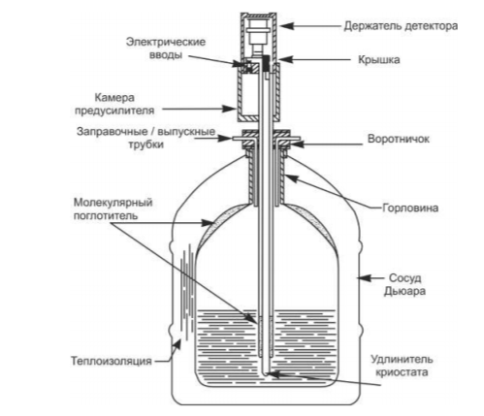
Picture 9. Design of the detection unit in a vertically submerged cryostat with nitrogen cooling [14]

Germanium used in detectors has a relatively small band gap, so detectors based on it must be cooled to cryogenic temperatures in order to reduce the thermogeneration of charge carriers in the depleted region to an acceptable signal-to-noise value and the detector's thermal current. Otherwise, the thermogeneration current causes noise, against which the signals from the gamma quanta become indistinguishable. A typical cooling means for such detectors is liquid nitrogen, the boiling point of which is -196 ⁰C
To reduce the load of the detection system, a part of the samples is located at a certain height h above the detector surface, for which a tripod was used. This height is chosen so that dead time does not exceed 4%, which corresponds to a load of 1000-1200 pulses per second. After that, the spectrum measurement is started.

Chapter 4. Results of determination of ionizing radiation fluxes

For the experiment, a tape with a size of 50 cm was prepared (picture 10), which housed: radiochromic dosimeters FVT-60 every 10 cm, with their help the dose rate of gamma radiation is measured; Ni, which is a sample of N.A.A. (neutron activation analysis) to determine the densities of fast neutron fluxes; Au with which thermal and resonant neutrons are captured; Au + Cd, precisely with the help of the 113Cd isotope, which has a thermal neutron capture section of 20,000 Barn and a small capture section for resonant neutrons, experimentally separate thermal and resonant neutrons.

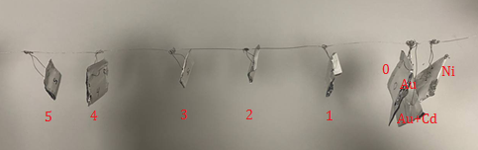
Picture 10. Appearance of the sample feed

This tape was attached to the end of the transport I-beam (Picture 11) 100 mm wide, 82 mm high, 2.7 m long, made of aluminum alloy. Transport I-beam is connected to irradiation plant by means of flange connection. The irradiation unit was moved along the rail track using an electrically driven splitter mechanism.
The exposure duration is 15 days, since saturation in gold is achieved during the exposure period corresponding to 4-5 half-lives (2.7 days (T1/2 (Au)) * 5 = 13.5 days).
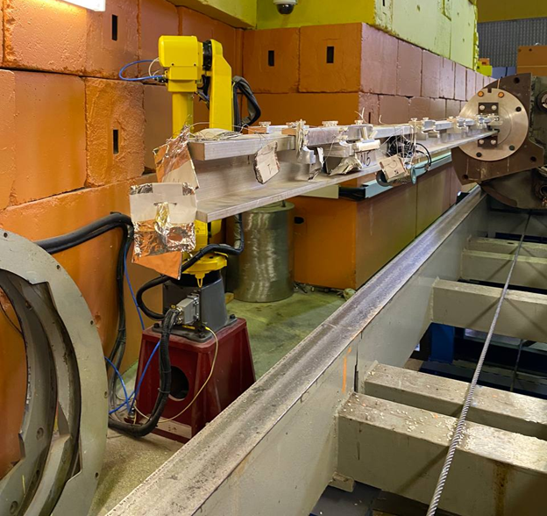
Picture 11. Samples placed on the transport I-beam

2.1 Measurement of absorbed gamma radiation dose rate

To calculate the absorbed dose rate of gamma radiation, it was necessary to find the difference between two measurements: the optical density of dosimeters before irradiation and after irradiation. Initial dose data are obtained in Mrad, which are then transferred to Gr/s with taking into account the exposure time.

Table 4. Results of determining the absorption capacity
doses at different distances from the water moderator

 | distance from water moderator, mm | Absorbed dose rate, Gr/s
1 | 100 | 0,003695
2 | 110 | 0,003306
3 | 120 | 0,002882
4 | 130 | 0,002115
5 | 140 | 0,001912
6 | 150 | 0,001337

From Picture 13, it can be seen that the maximum dose is received by a sample placed at a distance of 100 mm from the water moderator and the further from the water moderator, the smaller the dose is received.
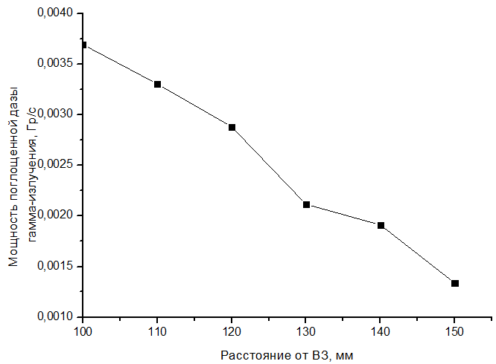

Picture 13. FVT absorbed dose rate -60 gamma radiation near water moderator

2.2 Measurement of thermal and resonant neutron flux densities

To quantify the content of unknown elements, it is necessary to determine the fluxes of thermal and resonant neutrons. To do this, indicators are irradiated together with the sample, that is, elements with well-known sections, in our case - Au. Indicators of the same type are irradiated in a shell from Cd and without it under the same conditions.
From measurements of the activity of an indicator with a mass of m2 irradiated in cadmium protection, it is possible to determine Φ_{res}:

$$Ф_{res}=\frac{N_{γ2}∙M∙λ∙e^{λt_{d2}}}{m_{2}∙N_{A}∙γ∙ε∙θ∙I_{res}}∙(1-exp⁡(-λt_{irr})∙(1-\exp\left(-λt_{meas}\right))$$ | (18)

Measurements of the activity of the indicator irradiated without cadmium give a value proportional to the value of the $X=σ_{th}Ф_{th}+I_{res}Ф_{res}$, since activation is carried out by both thermal and resonant neutrons. Measurement of the activity of indicators irradiated in and without Cd protection is carried out for the same time. This means that the contribution of resonant neutrons must be subtracted. As a result, we will get:

$$F_{th}=\frac{X-I_{res}F_{res}}{σ_{th}}=\frac{r}{σ_{th}}(N_{γ1}\frac{\exp\left(λt_{d1}\right)}{m_{1}}-N_{γ2}\frac{\exp\left(λt_{d2}\right)}{m_{2}})$$ | (19)

$$r=\frac{M∙λ}{N_{A}∙γ∙ε∙θ∙(1-exp⁡(-λt_{irr})∙(1-\exp\left(-λt_{meas}\right))}$$

Table 5. Experimental density data
flux of thermal and resonant neutrons

Average reactor power, MW | Thermal neutron flux density, n/(cm²s) | Resonance Neutron Flux density , n/(cm²s)
0 | 1,1∙10³ | 1,5∙10²

2.3 Measurement of fast neutron flux density

The density of the fast neutron flux is determined using the NAA (neutron activation analysis) method. A sample of HAA (neutron activation analysis) for determining the densities of fast neutron fluxes was Ni. Under the action of fast neutrons, it is activated to Co⁵⁸, from the activity of which we will determine the flux density. Co⁵⁸ has a half-life of 70.86 days, and the energy of the gamma quantum that we will register is 810 keV.
The formula for calculating the fast neutron flux density taking into account the transition coefficients is:

$N=\frac{(α × A_{k})}{\left(ρ∙l∙σ\left(1-2^{-t/T}\right)\right)}$ (20)

l is the wire length (cm).
$σ$ –is the effective cross-section (mBarn).
A_{k} – activity at the end of irradiation (Bc);
$p$ – is the volume density of the satellite.
$α$ – is the transition coefficient.
t – is the time of exposure.
T – is the half-life.

The activity of the sample is determined by the corresponding spectrum.

Table 6. Experimental data on fast neutron flux density

Average reactor power, MW | Fast flow density  neutrons, n/(cm²s)
0 | 5,1∙10¹

Conclusion

In the course of this work, the following results were obtained:

1. The device and principle of operation of the pulse reactor on fast neutrons of the IBR-2 are considered, as well as the principle of operation of semiconductor detectors and an irradiation plant located on channel № 3;
2. The method of obtaining and processing data with FWT-60 radiochromic dosimeters using FWT- 92D photometer was mastered;
3. Methods for measuring the density of fast, resonant and thermal neutrons are described;
4. An experiment was conducted to determine the field of ionizing radiation for the irradiation plant of channel No. 3 at the time of shutdown of the IBR-2 research reactor (< W > = 0 MW) and the characteristics of these fields were obtained.

Literature used

- Bagaev V. N. Materials for the course of MiUDI and MSRB. Semiconductor detectors: lectures / V. N. Bagaev, Yekaterinburg, UrFU, 2009.
- Kuzminov V. V., Khokonov A. Kh., Masaev M. B. Semi-conductor detectors in the nuclear physics experiment/ Kabardino-Balkar State University, 2017-24 p.
- S. G. Srebryakov, D. D. Khodkevich "Fundamentals of atomic and nuclear physics and elements of solid state physics". 2011 -291 pages.
- K. N. Mukhin. Experimental nuclear physics. Volume 1: Physics of the atomic nucleus, Moscow, 1993
- S. B. Borzakov, Activation analysis at the IRENE and IBR-2 facilities, JINR, Dubna, 45 s
- "Scientific installations of the IBR-2 reactor": [Electronic resource] // . http://flnph.jinr.ru/ru/facilities/ibr-2/instruments://flnph.jinr.ru/ru/facilities/ibr-2/instruments, (accessed 30.09.2022))
- "Parameters of the IBR-2 reactor" [Electronic resource] // . http://flnph.jinr.ru/ru/facilities/ibr-2/parameters://flnph.jinr.ru/ru/facilities/ibr-2/parameters, (accessed 30.09.2022))
- M. V. Bulavin, K. A. Mukhin, A. Ysakov, A.D. Rogov, A.V. Galushko, V. A. Skuratov, and I. A. Smelyansky, Some features of operation of a mezatilene-based ball cryogenic moderator at the IBR-2 pulsed fast reactor/, Surface. X-ray, synchrotron and Neutron Studies, 2022, No. 1, pp. 3-9
- "Irradiation unit for studying the radiation resistance of materials at the IBR-2» reactor | /Text|//Letters to ECHAYA. T 12, No. 2 (193). pp. 517-523. Dubna, 2015.
- M. V. Bulavin, P. A. Dorofeev, A. V. Galushko, A. V. Altynov//Automation system for transporting highly radioactive samples of the irradiation facility of the IBR-2 reactor//Physics of particles and nuclei letters. -2021.-Vol.18, №2
- McLaughlin W. L. The Gamma-Ray Response of Pararosaniline Cyanide Dosimeter Solution International Journal of Applied
- Miller A., Laughlin W. L. On a radiochromic dye dosimeter//Riso National Laboratory. №2254. 1980
- «Model FWT-92. Radiochromic Reader" [Electronic resource] // http://https://www.fwt.com/racm/support/92://https://www.fwt.com/racm/support/92D_MAN_MAN.PDF,(accessed 07.10.2021)
- The detection units are spectrometric with germanium detectors. User manual. CAN-GSP-HPGE-004-PЭ

